Understanding and Negotiating
Book Publication Contracts
  - Presenter Notes

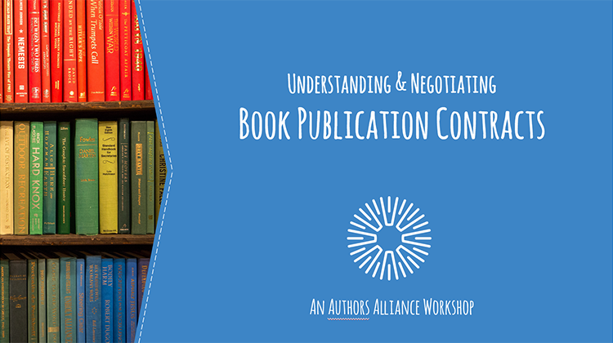
1. Understanding and Negotiating Book Publication Contracts
Today’s presentation is about book publication contracts. The terms of a publication contract deserve careful attention because they will dictate your rights and obligations related to your book for many years to come. This presentation will help you to understand common terms in publication contracts and how to negotiate for author-friendly variations.

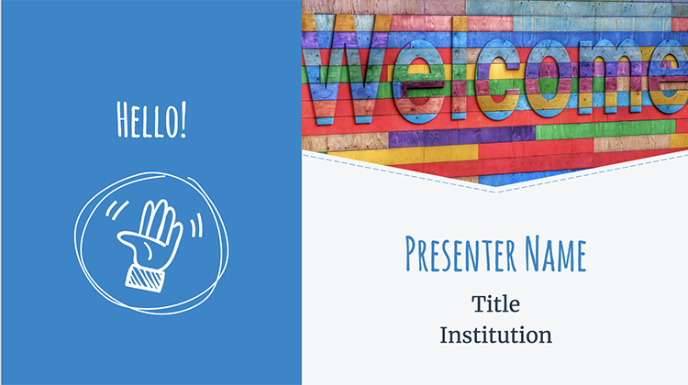
2. Hello!

Introduce presenter(s).

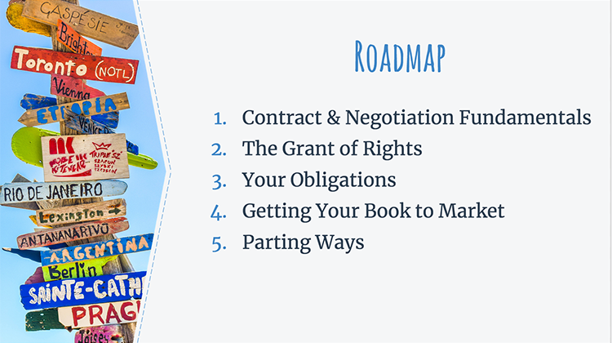
3. Roadmap
Here’s a roadmap for today’s presentation: To start, I’ll provide some basic background on contracts and negotiation techniques. After that, we’ll turn to our deep dive into contract terms. We’ll start with the grant of rights, which spells out what rights you as an author are giving to your publisher. We’ll then cover your obligations to your publisher and the terms that control getting your book to market. Finally, we’ll cover terms that outline what happens if you and your publisher decide to part ways.

Throughout today’s presentation, I will offer concrete examples of terms that you can propose to make your contract more author-friendly and share a few success stories from authors who have successfully negotiated for favorable terms. By the end of today’s presentation, you will gain an understanding of common clauses that appear in publication contracts, recognize how those terms might affect your goals, and formulate and negotiate for author-friendly variations of contract terms.
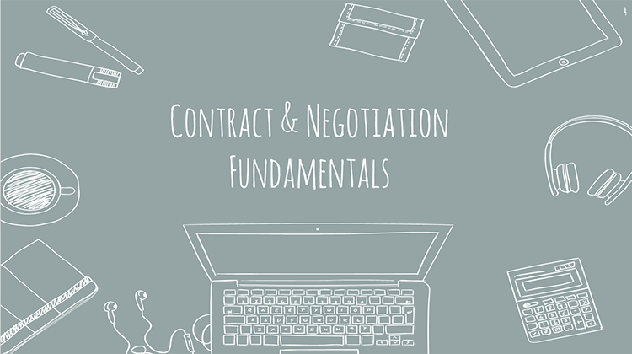

4. Contract & Negotiation Fundamentals

Let’s get started by discussing contract and negotiation fundamentals.

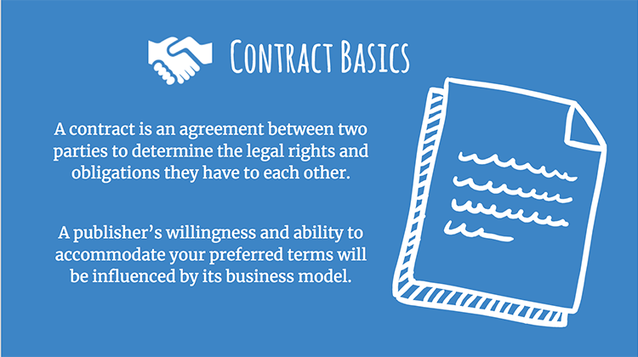

5. Contract Basics
At its core, a contract is simply an agreement between parties to determine the legal rights and obligations they have to each other. Contracts can be formed in many ways, but a best practice for book contracts is to make sure that everything is written down and that everyone signs the document reflecting this agreement. This provides a record of the agreed-upon terms and helps ensure that everyone understands the substance of the agreement.

It is important to remember that there is no such things as a “standard” contract that is applicable to all types of publishers and all books. It is a good idea to research potential publishers before you or your agent start shopping your book so that you can determine if the publishing needs are aligned with a particular publisher’s business goals. For example, it is uncommon for university presses to offer a sizeable advance payment to authors (most don’t offer an advance at all), so if an advance payment is important to you, you may want to look into publishing with a trade publisher. On the other hand, university presses may be more amenable to allowing books to be distributed under open access licenses (like Creative Commons licenses) since they are usually less concerned about maximizing profits and open access may align with their academic mission.

The bottom line is that it pays to consider your goals and do your research before selecting a publisher. When your interests align with the publisher’s business model, it is more likely that you’ll successfully negotiate a publication contract that meets your needs.

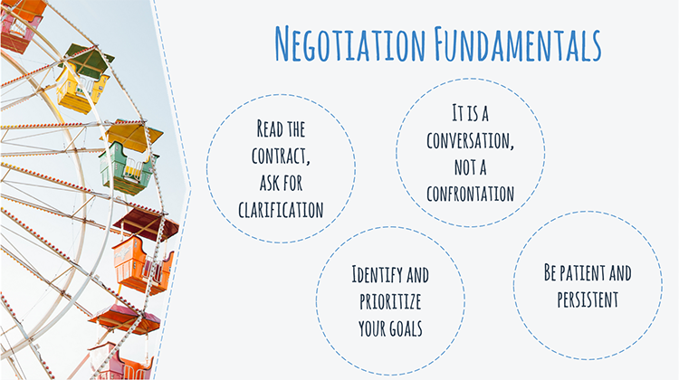
6. Negotiation Fundamentals
Read the contract, ask for clarification. Once you have an agreement in front of you, the first step is to read it and to understand its contents. This presentation will help you decipher common clauses in publication contracts, but if you still don’t understand the terms you may want to ask for clarification from your agent, attorney, or publisher.

The key to any successful negotiation is preparation. Before you begin to negotiate, consider what you hope to gain from the relationship with your publisher. Identify and prioritize your goals. What authors hope to get out of a publishing deal may vary significantly. Whether it is retaining certain rights to your book, providing input in design choices, or making your work openly accessible or available at an affordable price, your publishing goals are personal and not necessarily reflected in a template contract.

After that, you should consider negotiating for terms that are most consistent with your goals. For many people, the prospect of negotiation is intimidating. But negotiation does not have to be confrontational and tense. Negotiation is a conversation, not a confrontation. It may help to think of the negotiation as a conversation in pursuit of a shared goal: a successful book! In most cases, the worst that can happen is that your publisher says “no” to your requests. You can then decide whether to try to reach a compromise with an alternative version of your request, work with a different publisher, or seek additional assistance with the negotiation. Or you may choose to accept the terms and sign the contract, knowing that at least you tried to craft it to fit your goals.

Be patient and persistent. Contract negotiations often proceed in fits and starts. Don’t be surprised if it takes longer than you expect, or if the publisher initially resists making some of the changes you propose. Here persistence pays off, as does a willingness to compromise. During this process, remember to be patient, particularly while you’re waiting for the publisher to respond to proposed changes or to answer questions.
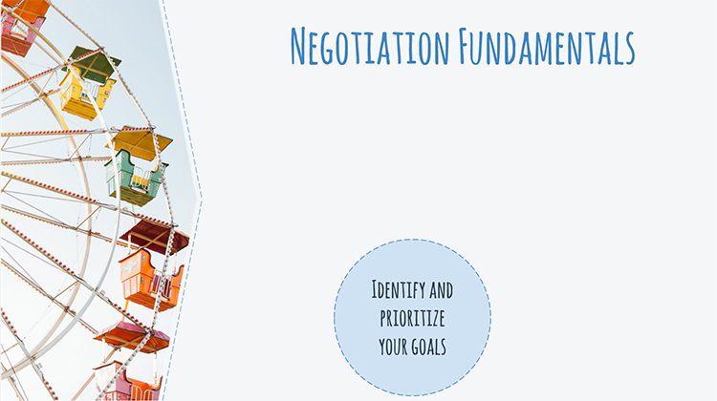

7. Negotiation Fundamentals
I want reiterate the concept of prioritizing your goals for the negotiation. This presentation will provide many options for altering provisions in a contract to make them more author-friendly – and this might seem like an overwhelming array of negotiation points. But this presentation is not meant to be a checklist of everything you need to negotiate to end up with the perfect contract. Not all of the options we talk about today will be relevant to you, your book, or your goals. It is unlikely that you’ll be able to successfully negotiate for everything you want, so it is important to focus your negotiation energy on the areas of the contract that matter the most to you.

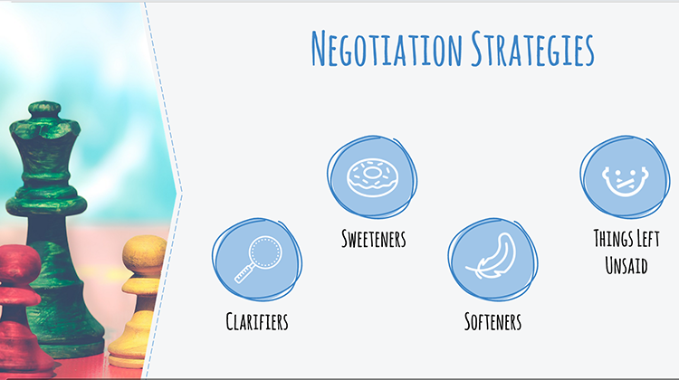
8. Negotiation Strategies
Let’s turn to some general negotiation strategies. Throughout the presentation, I’m going to share author-friendly variations to clauses you might find in a publication contract. Most of these fall into one of four categories: clarifiers, sweeteners, softeners, and things left unsaid. The examples we’ll cover today are not exhaustive, so I’m going to take a moment to introduce these general categories so that you can keep these four negotiation strategies in mind and employ them creatively as you negotiate.

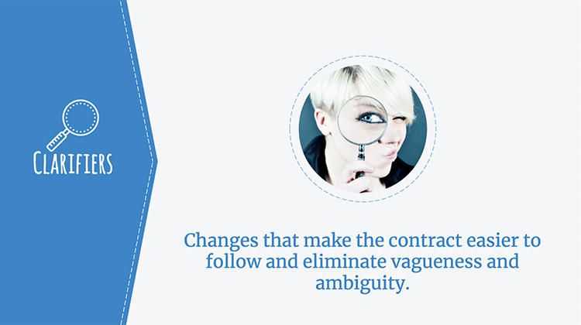
9. Clarifiers
Clarifiers are changes in particular terms that make the contract easier to understand—and follow—and that eliminate vagueness and ambiguity. For example, say your contract reads: “Author shall receive 50 percent of the amount received from translations of the Work.” Does this mean that the Author gets half of the publisher’s gross revenues from the book, or half of the net profits once the publisher has deducted its expenses? In this case, it would be better to say “Author shall receive 50 percent of the net amount received from translations of the Work” so there’s no confusion.

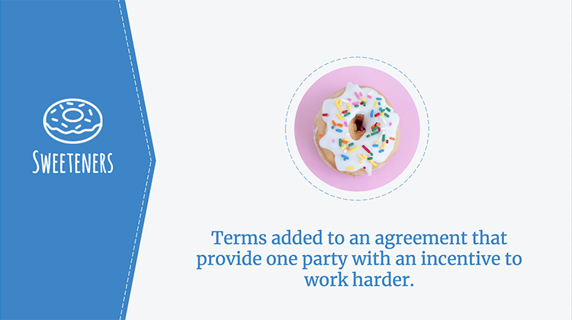
10. Sweeteners
Sweeteners are terms added to an agreement that provide one party with an incentive to work harder. Sweeteners are often phrased as conditional statements—i.e., “if Artie does X, then Paige will do Y.” If, for instance, your publisher is anxious to get your book to market quickly, it may be willing to offer you a bonus if you complete your manuscript ahead of schedule. Or, maybe you want your publisher to aggressively market your book to particular audiences, in which case you could offer to take a lower royalty rate in exchange for the publisher making specific marketing commitments.

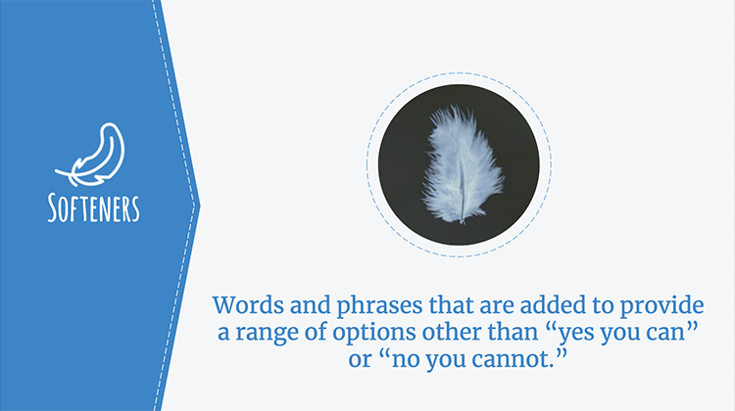
11. Softeners
Softeners are words and phrases that are added to existing contract language to provide a range of options other than “Yes-You-Can-Do-This” or “No-You-Can’t.” These phrases can be powerful. For instance, a publisher might be unwilling to give you unfettered control over your book’s jacket design, but it would be willing to grant you a “right to approve, not to be unreasonably withheld.” This is a subtle difference, but a significant one. As you analyze and negotiate your contact, think about places where you could modify the contract with softening or qualifying language to give yourself either more control or more “wiggle room,” and also places where you might be willing to soften your requests if your publisher initially says no.

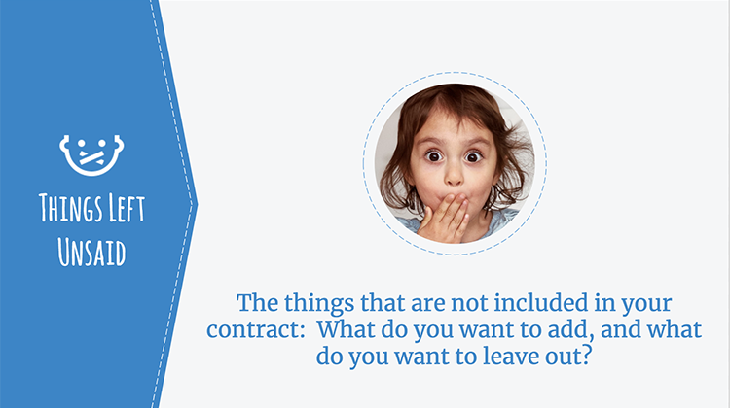
12. Things Left Unsaid
Lastly, think about what isn’t included in your contract. Many agreements contain a provision that states that the written contract is the final agreement between the parties. This means that any promises made during the negotiation process are, in most cases, unenforceable if they aren’t included in the final written document. This can be either a good or bad thing for an author, depending on what has been left unsaid. For example, if your contract is silent on your publisher’s marketing obligations, then you could end up having to plan (and fund) your own promotional events. If something is important to you, get it in writing. Conversely, there might be certain terms that you don’t want included. For example, multi-book options are generally written to favor publishers over authors, so if your contract doesn’t include an option clause you might want to leave this unsaid.

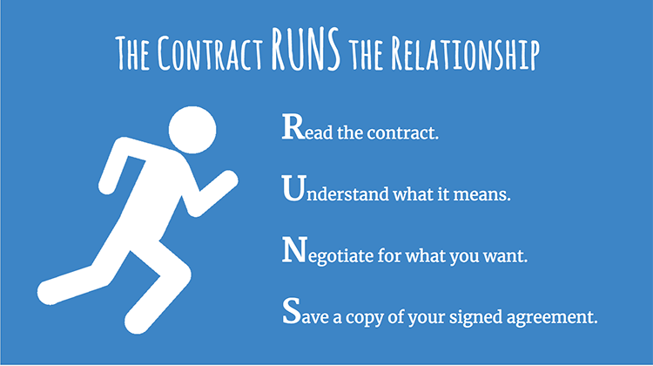
13. The Contract RUNS the Relationship
Finally, keep in mind this simple mnemonic: The contract RUNS the relationship, so make sure you read everything, understand what it means, negotiate for what you want, and save a copy of your signed agreement. You will likely need to refer to your agreement in the future—for example, to check a deadline for submitting your manuscript, to verify how you’ve divvied up your rights, or to check whether you are eligible to get your copyrights back—so its important to keep a copy in a safe place.

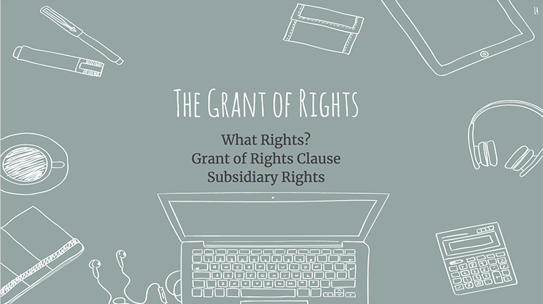
14. The Grant of Rights
In this section, we will cover the grant of rights, which is the heart of your publication contract. This provision specifies exactly what rights in your work you are giving to the publisher and what it can do with those rights. In this section, I will provide a brief overview of what copyrights you have as an author, the different ways you can “grant” your copyrights to your publisher, and introduce ways that your publisher may divide your copyright into industry-specific “slices” called subsidiary rights.

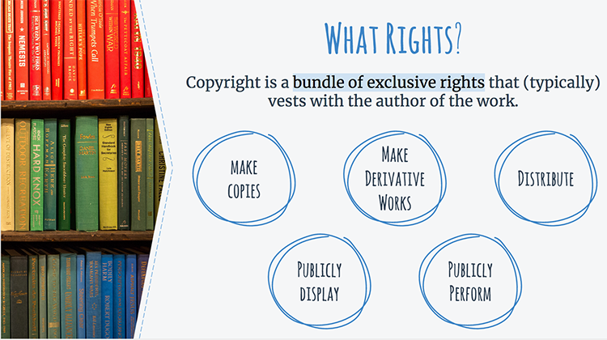
15. What Rights?
When you write a book, an article, or some other work of original expression, you generally will have a copyright in that work from the moment you commit that expression to paper (or save to your computer, as the case may be). These days, there is no need to register your work with the Copyright Office or place a copyright symbol on your work before it is eligible to receive copyright protection. With some exceptions (such as writing something at the behest of your employer), you will generally hold the copyright to that work simply by being the author of the work.

Copyright is a bundle of exclusive rights that only the copyright holder, or someone authorized by the copyright holder, can exercise—unless their use falls under an exception to copyright law (like fair use). These rights include the right to make copies of that work and the right to make other works derived from that work, such as translations, abridgements, or movie adaptations. These rights also include the rights to distribute, publicly display, and publicly perform the copyrighted work.

However, the copyright owner can authorize others to do these things, or can even transfer ownership of the copyright to someone else. This authorization is usually handled in the publication contract.

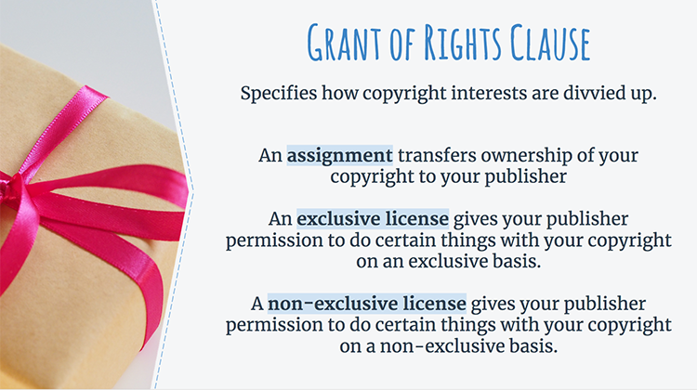
16. Grant of Rights Clause
Since your publisher will need to use some of your copyrights to publish your book, it will need your permission to do so. This permission is spelled out in the grant of rights clause, which specifies how the copyright interests are divvied up.

The first kind of grant is an assignment of rights, which means the transfer of ownership of one or more of your copyrights to a new owner. It is important to know that following an assignment, the author of the work no longer owns the parts of the copyright that were assigned and cannot exercise those rights or license them to someone else. So, if you assign the reproduction rights to your publisher, you no longer have the right to make copies of your manuscript without its permission.

Like an assignment, an exclusive license gives a publisher the sole right to exercise the licensed rights. For example, with an exclusive license, the publisher has the right to stop a third party from issuing competing editions (including you). However, an exclusive license does not transfer ownership of copyrights. For this reason, some authors feel strongly about keeping their copyrights and prefer to grant an exclusive license rather than an assignment, even if the end result is largely the same.

Though not common in book publication contracts, it is also possible to license your copyrights on a non-exclusive basis. If you do this, you will still be able to use these rights, and you can grant these rights to an endless number of different non-exclusive licensees. Because the license is non-exclusive, you can still do whatever you want with your book, including making and distributing copies yourself.

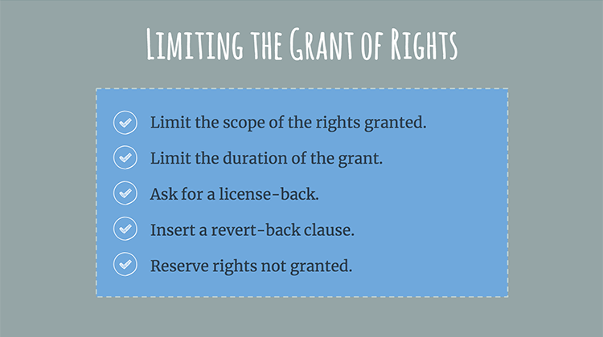
17. Limiting the Grant of Rights
In general, book publishing business models strongly favor assignments or exclusive licenses. But even if your publisher insists on an assignment or exclusive license of your copyrights, you can still try to negotiate author-friendly changes to the grant of rights. This is vital if holding on to certain rights is important to you for personal or professional reasons, if your publisher is unlikely to be able to exploit certain rights, or if you (or your agent) have another opportunity lined up to use certain rights.

Limit the scope of the grant: A grant can narrowly define what medium (print book or audiobook, for example) the grant covers, what the publisher can do within that medium, and in which geographic area the rights apply. For example, a publisher’s grant of rights could be limited to print and electronic editions published in North America. At a minimum, take care that you aren’t assigning or exclusively licensing rights that your publisher will not be able to exploit (for example, if your publisher is not in the business of producing or licensing audiobooks, you probably don’t want to hand over audiobook rights).

Limit the duration of the grant: Many agreements will grant rights to the publisher “for the whole term of the copyright and any extensions.” This is a very long time! In the United States, for works created by individuals after 1978, copyright lasts for the life of the author plus 70 years. For many projects, handing over copyright for the full term of copyright does not make sense since most books have a very short commercial life. Therefore, an author might want to grant an exclusive license that lasts only for a specified amount of time rather than the full life of the copyright. If you get strong resistance from your publisher to limiting the term of the grant, another option is to negotiate for a strong rights reversion clause so that you can get your rights back if the work goes out of print or is not selling well. We’ll turn to rights reversion clauses later in the presentation.

Ask for a license-back: Even if you must assign or exclusively license all or large parts of your exclusive rights to your publisher, your publisher may be amenable to licensing specific rights back to you for certain purposes. This type of provision is known as a license-back. For example, you might ask for a license-back to make copies of some parts of the book for nonprofit educational uses.

Insert a revert-back clause: Another tweak you might make to soften the grant of rights language in your contract is to insert a “use it or lose it” clause, also called a revert-back clause. Essentially, you’re stipulating that if the publisher does not use or license a right within a specific period of time, then that right will revert back to you.

Reserve rights not granted: It is a good idea to have a clause in the contract that clarifies that all rights not granted to the publisher are kept by the author.

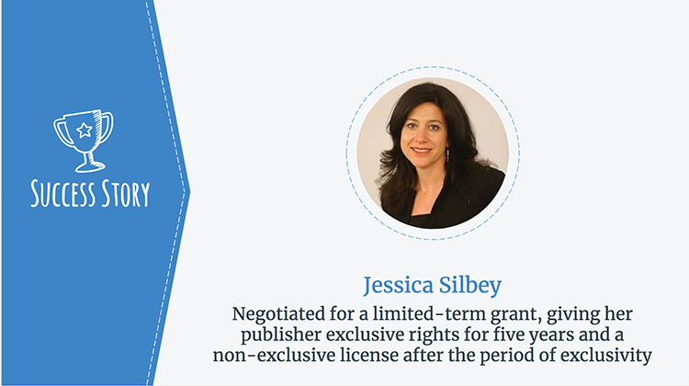
18. Success Story
When she published her book The Eureka Myth: Creators, Innovators and Everyday Intellectual Property, law professor Jessica Silbey negotiated for an innovative grant of rights to her publisher. Under the terms, her publisher obtained the exclusive right to publish the book for five years. After five years, Professor Silbey will automatically regain her copyrights and her publisher will keep a non-exclusive right to continue selling the book (under the same royalty terms). Although Silbey initially asked for the publisher’s exclusive rights to be limited to three years, she was persuaded by its legitimate business interest in having exclusive rights for the first five years. This arrangement enabled her publisher to fulfill its sales objectives, while also allowing Silbey to realize her goal of making The Eureka Myth widely available to readers in a Creative Commons-licensed online version after five years.

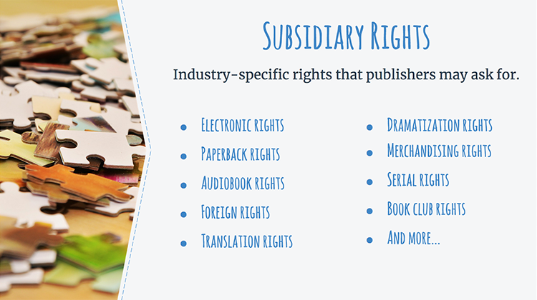
19. Subsidiary Rights
Subsidiary rights are industry-specific rights that publishers may ask for, either to use themselves or to license to others. There is not a standard way to address these rights, and each publishing contract will differ in how these rights are organized (or if they are even included). Standard subsidiary rights are listed on this slide, and include electronic rights, paperback rights, audiobook rights, foreign rights, translation rights, and more.

In general, it’s preferable to give your publisher only the rights that it can reasonably expect to use. For instance, if your publisher has never licensed translation rights, you may want to retain these rights and negotiate with a firm more experienced in handling these rights.

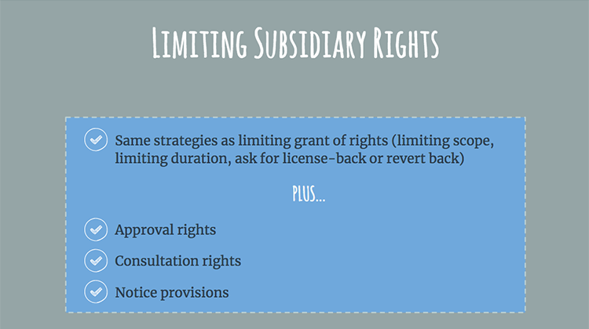
20. Limiting Subsidiary Rights
The same options we talked about for limiting the grant of rights also apply to subsidiary rights: limiting the scope, limiting the duration, or asking for a license-back or revert back clause. In addition, authors often negotiate for approval or consultation rights if their works are licensed for specific uses. For example, you might not want to be asked to approve every reproduction of your work for educational purposes, but want to approve any other uses. Some publishers may not agree to give you approval rights, in which cases asking for the publisher to consult with you prior to a decision being made might be a good compromise. If nothing else, it is a good idea for your contract to include a notice provision that requires your publisher to provide you with timely notice of any uses of your work, including licensed uses by third parties.

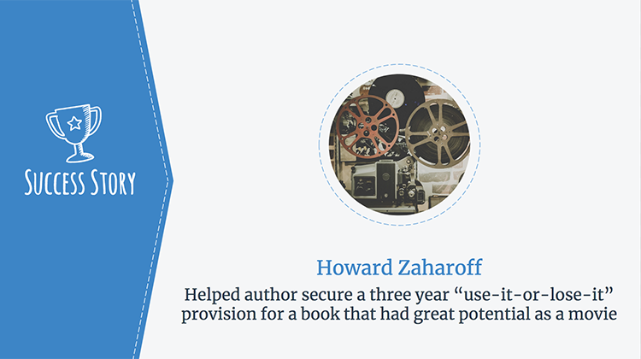
21. Success Story
Literary attorney Howard Zaharoff worked with an author who wrote a book that had great potential to be turned into a movie. The author was therefore hesitant to sign over motion picture rights for fear the publisher would not exploit them. But the publisher also saw the potential for a Hollywood hit and was keen to try to sell movie rights. To resolve this tension, Zaharoff helped the author secure a “use-it-or-lose-it” provision that satisfied both parties: The publisher was given three years to place the movie rights, but if the publisher did not do so in this timeframe, the author could reclaim the rights.

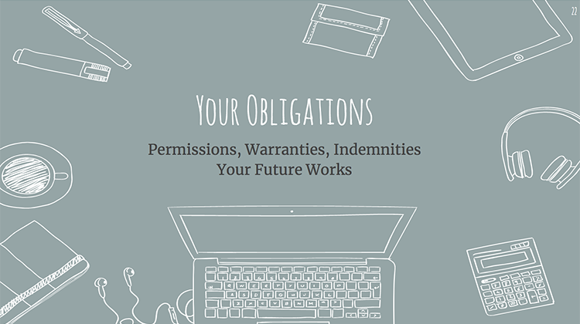
22. Your Obligations
In this section, we’ll cover some of your obligations to your publisher that are outlined in your contract, including commitments you’ll make to your publisher regarding permissions you’ve obtained and warranties you make about the content of your book, as well as promises you are making about potential future works.

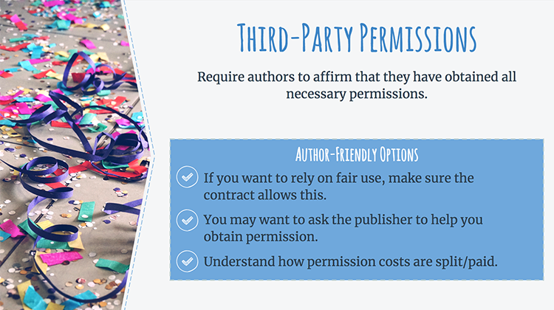
23. Third-Party Permissions
It is common for book contracts to include terms requiring authors to deliver documents to their publishers showing that they have obtained all necessary third-party permissions; that is, that the author is legally authorized to use any materials owned by third parties that are incorporated into the book.

Under certain circumstances, an author’s use of a reasonable amount of another’s work to prove or illustrate the author’s point may be fair use, which does not require third-party permission or payment. If you plan to rely on fair use, you may want to ask that the permissions clause allows you to rely on fair use, where applicable.

Although many publishers will assist their authors in obtaining necessary permissions, it is still quite common for the contract to place the ultimate burden on the author. If you are unsure how to get the required permissions, you might want to propose that the contract include language requiring your publisher to provide guidance and supply the required permission request forms.

Finally, you’ll want to make sure you understand how permissions fees will be paid (by you, by the publisher, or split), and consider negotiating for cost sharing if your permissions will be expensive and this will be a hardship for you.

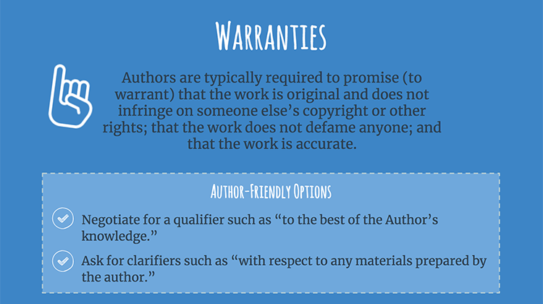
24. Warranties
Authors are typically required to promise (to warrant) that the work is original and does not infringe on someone else’s copyright or other rights; that the work does not defame anyone; and that the work is accurate. Publishers typically reserve the right to terminate a contract if authors breach any of these warranties.

It can be hard to get publishers to relax the warranties provision, but here are a couple of options. One option is to ask for a qualifier such as “to the best of the Author’s knowledge” to be added to a warranty clause. Another option is to try to clarify the warranties to make sure that you don’t end up promising something over which you have no control (for example, the cover art selected by your publisher).

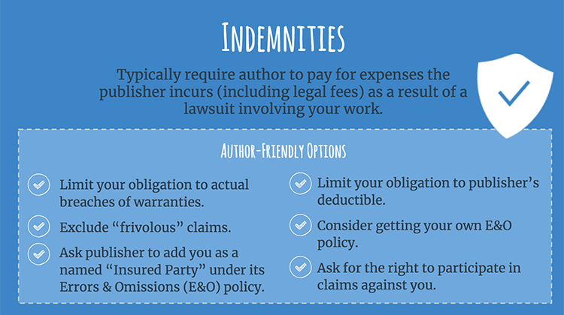
25. Indemnities
In general, to indemnify someone means that you agree to compensate that person in the event of a harm or a liability that she incurs. In a typical indemnity provision in a publication contract, you promise to pay for any expenses your publisher incurs (including legal fees) as the result of a lawsuit involving your work.

Some indemnification clauses are very broad, requiring the author to indemnify the publisher against any claims, lawsuits, or demands that come from expansively defined events, such as “the publication or sale of the work”. If your publisher proposes an indemnification provision this broad, consider asking for alternative language that limits your obligation to actual breaches of your warranties, rather than covering any lawsuit or claim that might arise.

One possible way to further soften this provision is to propose an exclusion of “frivolous” lawsuits from the clause. (A frivolous lawsuit is one that is without merit because of a lack of a supporting legal argument or factual basis for the claims.) If you exclude frivolous lawsuits from the indemnification clause, it means that you will only be required to indemnify your publisher in the event that a claim has merit.

However, some publishers may be reluctant to alter their indemnification clauses because their insurance policies require specific indemnity language be included in their author contracts. In this case, you could ask your publisher to add you as a named “Insured Party” under its Errors & Omissions (“E&O”) insurance policy (sometimes called a “special perils” policy) so that you would be covered in the event of a lawsuit. Alternatively, you could try to add language to the contract saying that your indemnification obligation is limited to paying a portion of your publisher’s E&O insurance deductible.

And if your publisher won’t soften your indemnity obligations, consider getting your own E&O policy to protect you in the event of a lawsuit. And finally, you may want to ask for the right to participate in any claims or lawsuits against your publisher where the outcome will affect you.

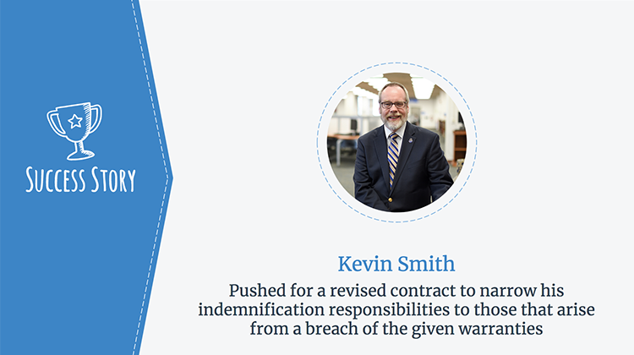
26. Success Story

Kevin Smith’s publisher insisted he sign an overly broad indemnification clause in the contract for his book that would hold him liable for all claims related to the publication or sale of his book, even if he did not have control of the issue that led to the claim. Not one to let sleeping dogs lie, Smith wrote about this experience on his blog, and his thoughtful arguments caused his publisher to offer to revise his contract. The revised indemnification clause reads as follows: “Author shall indemnify and hold harmless against claims, liability, loss, or expense (including reasonable attorneys’ fees) arising from a breach of the above warranties.” Now the indemnification clause is tied to a breach of the given warranties, making it clear what Smith is, and isn’t, responsible for.

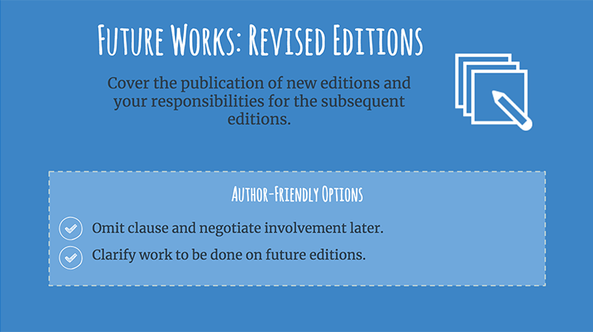
27. Future Works: Revised Editions
Many publication contracts, especially those for non-fiction and academic works, contain a revised edition clause that covers publication of new editions. If your book is likely to have subsequent editions, think carefully about what you might want to do with it in the future. Some authors will want to continue writing later editions of their books; others find this to be a grind and would rather go on to other projects. Either way, your agreement should reflect what you’re willing to do for your publisher in the future when and if revisions occur.

One option is to punt: Omit the revised edition clause and negotiate your involvement in the next edition when the time comes. If your publisher won’t agree to this, then you may want to try to include language that clarifies your future obligations for revisions. You will want to ensure that you have enough time to put the new edition together, so include a realistic revision timetable in your contract. You might also consider including terms that limit how much text you will be required to change in each update. Be clear on the amount of royalties you can expect in the revised edition. And if the publisher reserves the right to hire another author to work on the revised edition if you are unable or unwilling to write it yourself, be clear on how that edition will be credited.

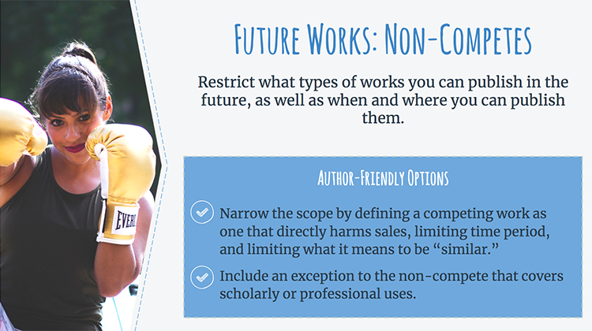
28. Future Works: Non-Competes
Non-compete provisions restrict what types of work you can publish in the future, as well as when and where you can publish them. A standard non-compete provision restricts authors from publishing new works on the same topic as the work covered by the publishing agreement. This provision may last for a specific length of time, but it could also extend for the “life of the agreement.” How strict the non-compete provision is will vary from contract to contract. Some provisions restrict you from writing anything even remotely related to your original topic, whereas others might prevent you from writing a very similar book within a set period of time.

Academic authors and nonfiction authors may need to pay particular attention to these terms because their ability to pursue a scholarly research agenda by publishing new works on similar topics could be directly affected by these provisions.

Authors can narrow the scope of non-compete provisions by defining a competing work as one that directly harms the sale of the earlier work, by limiting the time period of the non-compete, and by limiting what it means for the work to be “similar.” In addition, as an academic author, you may want to include an exception to the non-compete clause that covers scholarly or professional uses so that your contract does not unnecessarily interfere with your career.
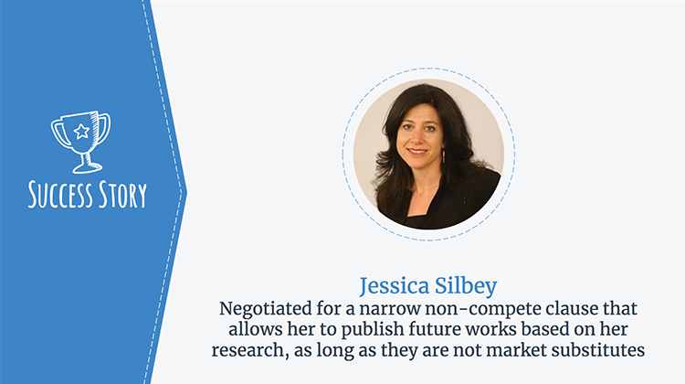

29. Success Story
As an academic author, Jessica Silbey was concerned that a standard non-compete clause would unduly limit her ability to publish other works based on her research and data. When she placed The Eureka Myth: Creators, Innovators and Everyday Intellectual Property, Professor Silbey negotiated a narrowed non-compete clause that allows her to publish future works based on her research, as long as these do not function as market substitutions. This revised non-compete clause protects her publisher’s investment in her book and enables Silbey to realize the dissemination goals that are crucial to her academic career.

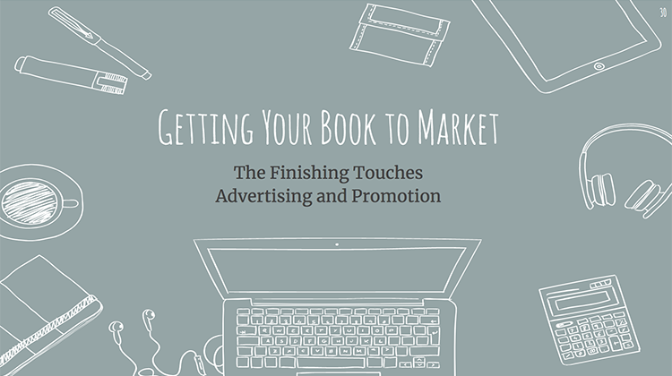
30. Getting Your Book to Market
Once you’ve finished your manuscript, it will be time to be thinking about the finishing touches that will get your book to market. In this section, we’ll discuss issues that relate to how your book is priced and packaged. We’ll also talk about terms that relate to advertising and promoting your work.

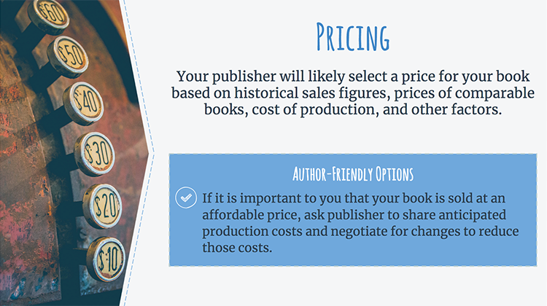
31. Pricing
Your publisher will likely select a price for your book based on historical sales figures, prices of comparable books, cost of production, and other factors. This may work well for you, but if it is important to you that your book is sold at a specific price, you can ask your publisher to share its anticipated production expenses and sales projections for your book. Once you better understand its pricing strategy, you can use this information to negotiate. For instance, it may be important to you that your book be available at a price that is affordable to students. If you understand what factors are driving your publisher’s pricing decision, you could negotiate for specific changes to help keep the price low—such as agreeing to a lesser page count, using fewer illustrations, or releasing in paperback or e-book form rather than hardcover.

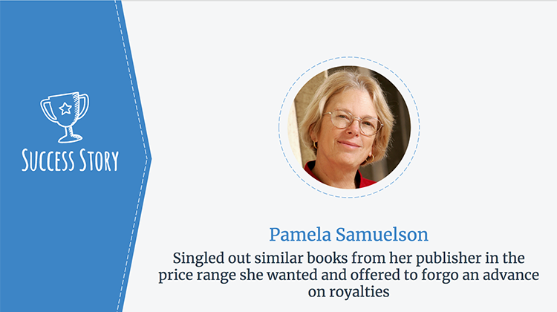
32. Success Story
When law professor Pamela Samuelson negotiated the contract for her forthcoming book, making it available at an affordable price in both hardcover and paperback editions was one of her key concerns. Therefore, before negotiating she looked at the price of other books on similar subject matter issued by the publisher. Professor Samuelson singled out those books that had a price within her acceptable range and whose page count and format were comparable to hers, and then told her publisher she wanted her work to be priced like those books. To sweeten the deal, she offered to forgo an advance on royalties, which would reduce her publisher’s upfront costs. As a result, Samuelson was successful in getting her publisher to agree to price the book in the range that she wanted.

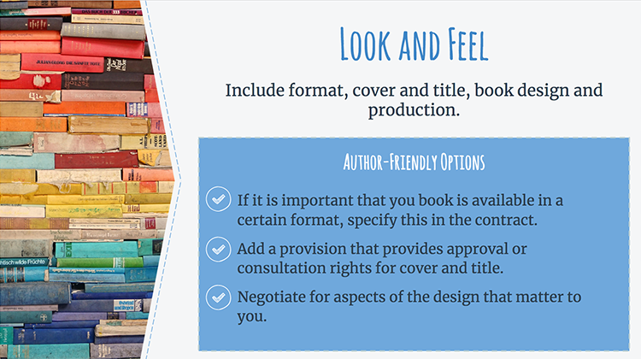
33. Look and Feel
Some authors want to have some influence over the “look and feel” of their books. If this is a priority for you, you’ll want to make sure this is written into your contract. If it is important to you that your book be available in a certain format (like e-book, enhanced ebook, paperback, etc.), you may want to discuss this with your publisher to make sure it will accommodate your preferences. Cover design and title are another area where you’ll want to include consultation or approval rights if you want to have some say in these decisions – but be sure to take into account your publisher’s commercial instincts: who knows what success Fitzgerald’s Great Gatsby would have enjoyed under its original working title, Trimalchio in West Egg!

Similarly, if you care about the book’s final design and production (things like paper quality and color printing), you’ll need to negotiate these aspects of the design into the contract.

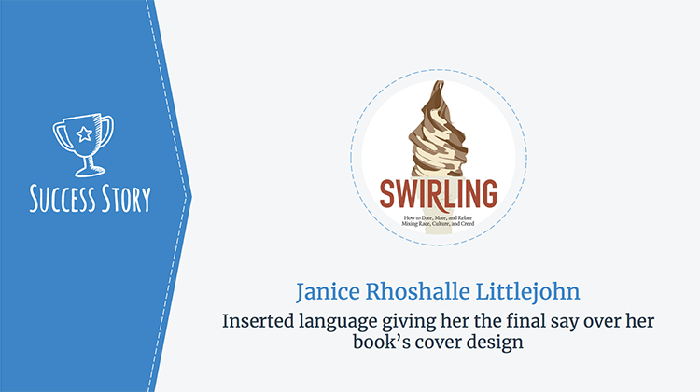
34. Success Story

When author Janice Rhoshalle Littlejohn negotiated the contract for her book Swirling: How to Date, Mate, and Relate; Mixing Race, Culture, and Creed, she encountered a provision that would allow her to pick a book cover out of three options. Because she knew that her book’s theme would be challenging to portray artistically, she crossed out this provision and added in language giving her final say over the book’s cover. Her publisher accepted this change. Later, when her publisher sent Janice three unappealing book covers to choose from, Janice proposed that a graphic designer she knew should design the cover instead. Her publisher initially balked, but when she pointed out that she had final approval rights her publisher relented and gave Janice the cover she wanted.

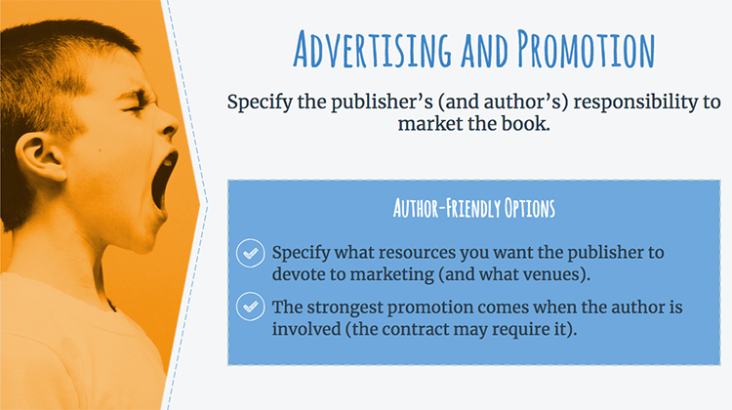
35. Advertising and Promotion
Advertising and promotion are likely to play key roles in the success of your book. But know that, in general, publishers don’t have a duty to promote your book beyond a minimal effort. A publisher basically satisfies this obligation by listing your book in its catalogs and sending out a few promotional copies. This means that if there isn’t specific language in your contract regarding marketing, advertisement, or promotional events, your publisher is under no obligation to provide extensive marketing services.

So, if you want to ensure that your publisher devotes certain resources to marketing your book, you can try to negotiate that into the contract. But be aware that even if your publisher does offer marketing services, don’t assume that this takes the burden off of you to promote your own work. Often, the strongest promotion comes when there is involvement from the author. In fact, you might encounter a provision in your contract that requires you to assist in promoting your book, such as by attending events like book signings.

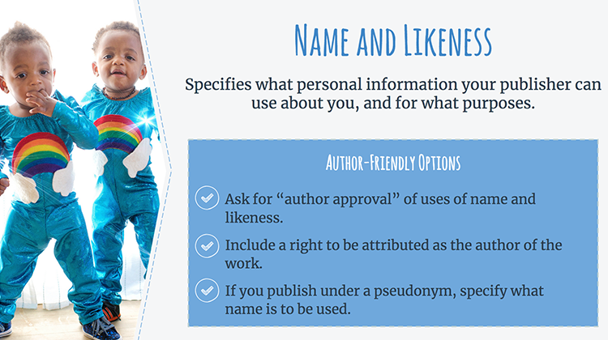
36. Name and Likeness
To help promote your work, your publisher may ask you for a photograph to include on the book jacket and in promotional materials and for a short personal biography. This bio typically includes your name, professional experience, any past works you’ve published, and other details that would be helpful or interesting to potential readers. Contracts may include a name and likeness clause that specifies what personal information your publisher can use about you, and for what purposes.

You may be concerned about how your name and likeness will be used by your publisher. For instance, you may worry that your publisher will want to use your photograph to promote your book in a way that you find distasteful or that is inconsistent with your professional image. If so, you could include some “author approval” language into this section that requires your publisher to get permission for each use of your name or likeness.

Relatedly, you may want to require that the publisher associates your name with the work, and might even specify that your name appears on the title and cover page of the book. Lastly, if you publish under a pseudonym, make sure your contract explicitly states what name will be used in all promotional materials.

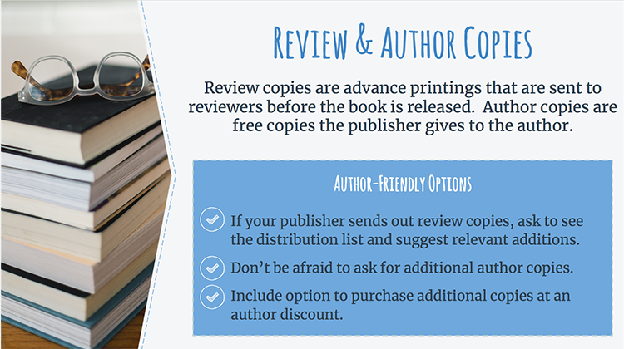
37. Review & Author Copies
Review copies are advance printings that are sent out to reviewers before the book is released. The goal is to bring attention to the book, which hopefully will result in positive reviews and media attention. In addition, authors typically receive a set number of free author’s copies of their work from their publishers. For the review copies, if your publisher is sending them out you may want to ask to see the distribution list. If important reviewers in your field are not included, you can ask for them to be added. As for the author’s copies, don’t be afraid to ask for additional author’s copies if you want them. Once the freebies are gone, you’ll have to purchase additional copies like everyone else, but you can negotiate for an author discount on those copies, typically 40-60% off retail.

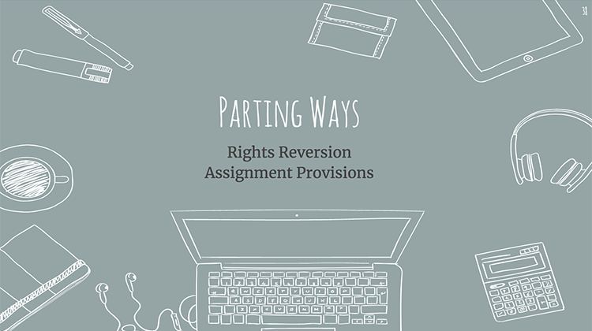
38. Parting Ways
Even in the happiest of author-publisher relationships, there may come a time when interests in a book diverge. It doesn’t have to be an unhappy split—often, it happens because a book has simply completed its commercial life and the publisher is no longer interested in making new copies available. In this section, we’ll cover rights reversion provisions, clauses that allow authors to get their copyrights back from a publisher if the book falls out of print or another triggering condition is met. We’ll also cover assignment provisions. These are the terms that control whether your book can be transferred from your original publisher to another publisher.

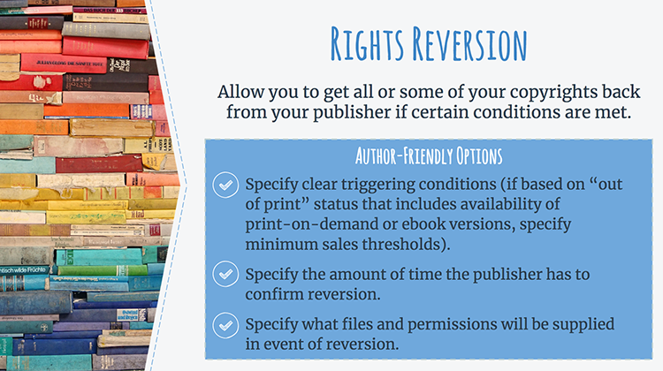
39. Rights Reversion
Rights reversion provisions, sometimes called out-of-print or discontinuance clauses, allow you to get some or all of your copyrights back from your publisher if certain conditions are met. As we discussed at the start of this presentation, if you assign or exclusively license your copyrights to your publisher, your publisher controls the rights to your work, even if it is not actively exploiting those rights. For that reason, rights reversion provisions can be a tremendous advantage for an author whose books have fallen out of print or whose sales are vanishingly small.

Generally, a rights reversion clause will contain a triggering condition that must be satisfied before you have a contractual right of reversion. Since the reversion of your copyrights generally depends on the triggering condition being fulfilled, it is in your interest to precisely detail these conditions so there is no confusion about whether they’ve been met. One important note here: “out of print” triggering conditions are common in reversion clauses. Under this type of trigger, a book becomes eligible for reversion when the publisher ceases to keep a book “in print.” Before print-on-demand and e-book technology, this usually meant that the triggering condition for reversion was satisfied when the publisher stopped printing copies of the book. Since print-on-demand and e-book technology can effectively keep a book “in print” indefinitely, it is a good idea to specify minimum sales or revenue thresholds if your book is only available in these formats.

After notice is received, the publisher may be allowed a certain amount of time—typically two to six months—to “cure” the triggering event and avoid reversion. Make sure your contract specifies this amount of time. It is a good idea to include language that specifies that the publisher must provide the author with a letter within a set time confirming that all rights granted under the agreement have reverted to the author.

Finally, it is a good idea that the clause specifies that you can acquire the production materials and digital files, together with the intellectual property rights, that you would need to produce additional copies of your book.

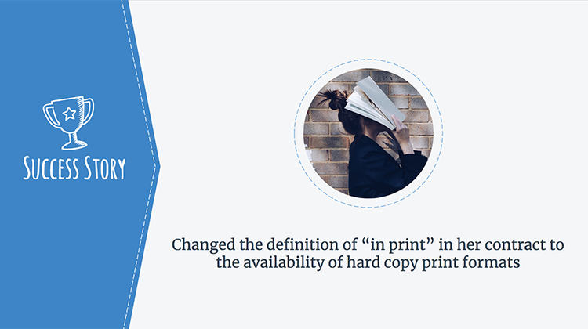
40. Success Story

An author interviewed for the Authors Alliance guide to Understanding and Negotiating Book Publication Contracts recognized the importance of a clearly defined triggering condition for reversion. Her publisher’s standard contract had a rights reversion clause that was triggered by a work’s in-print status, but it didn’t specify what it meant for the work to be in print. In particular, she was concerned that “in-print” could include digital formats. After raising this concern with her publisher, the publisher inserted a provision into the author’s contract that linked the definition of “in print” to the availability of hard copy print formats.

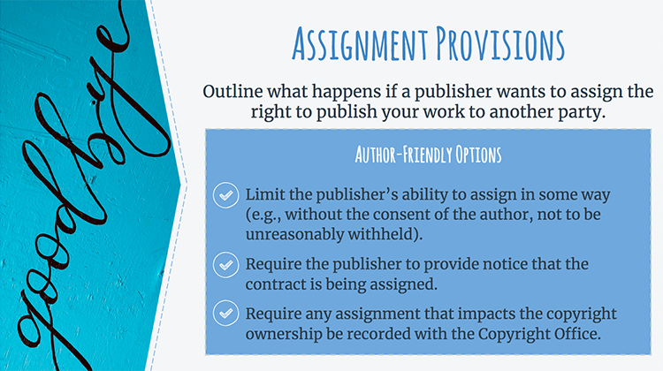
41. Assignment Provisions

Assignment provisions cover the transfer of contractual rights from one party to another. These typically come into play when your publisher is acquired or goes out of business and wants to assign the right to publish your work to another party. If you are concerned about this eventuality, it is possible to limit the publisher’s ability to assign in some way. For example, the contract may stipulate that the publisher cannot assign the contract without your consent. If your publisher will not agree to make assignment subject to your consent, another option is to add language that requires your publisher to provide you with notice if your contract is assigned. That way, even if your publisher doesn’t have to get your permission ahead of time, it will still have to let you know if an assignment happens. Also, you could add a provision requiring that any transfer that impacts the copyrights in the work (e.g., your publisher assigns its rights to a third party) be recorded with the U.S. Copyright Office. Doing this will help maintain a clear chain of title for the copyrights.

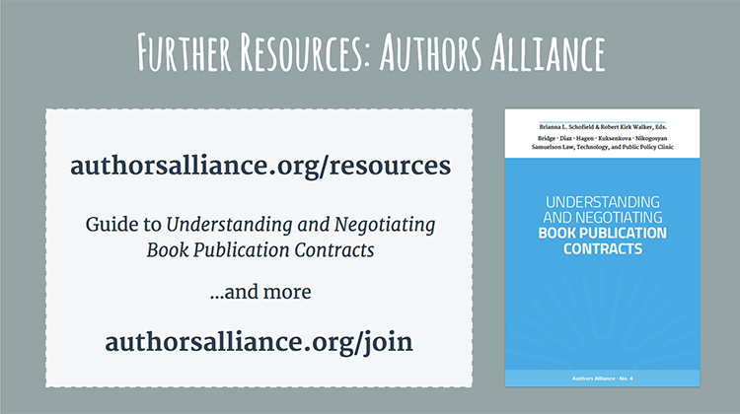
42. Further Resources: Authors Alliance
I hope today’s presentation encourages you to negotiate for terms that are right for you and your book. For a deeper dive into understanding and negotiating book publication contracts, including a look at provisions we did not have time to cover here today and sample contractual language, I encourage you to check out additional resources created by Authors Alliance, a nonprofit organization that helps authors understand and manage their rights. The Authors Alliance comprehensive guide to Understanding and Negotiating Book Publication Contracts provides additional information, tips, and strategies on how to understand and negotiate for contract terms. Authors Alliance also has information for authors on copyright basics, fair use, open access, getting rights back, and more.

Authors Alliance membership is free; please consider joining as an individual member to receive updates about their new resources and to learn more about leveraging your rights as an author.

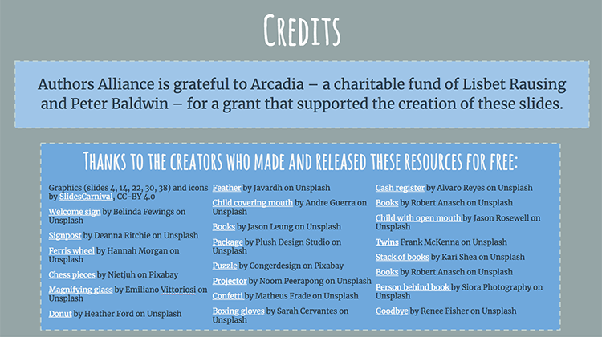
43. Credits

.

. Authors Alliance is grateful to Arcadia—a charitable fund of Lisbet Rausing and Peter Baldwin—for a grant that supported the creation of these materials.

