Understanding and Negotiating
Book Publication Contracts
  - Presentation Notes

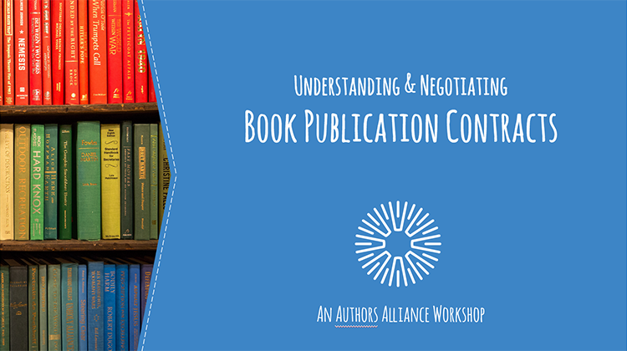
1. Understanding and Negotiating Book Publication Contracts

____________________________________________
____________________________________________

____________________________________________

____________________________________________

____________________________________________________________________________________

____________________________________________________________________________________

2. Hello!

____________________________________________
____________________________________________

____________________________________________

____________________________________________

____________________________________________________________________________________

____________________________________________________________________________________

3. Roadmap

____________________________________________
____________________________________________

____________________________________________

____________________________________________

____________________________________________________________________________________

____________________________________________________________________________________

4. Contract & Negotiation Fundamentals

____________________________________________
____________________________________________

____________________________________________

____________________________________________

____________________________________________________________________________________

____________________________________________________________________________________

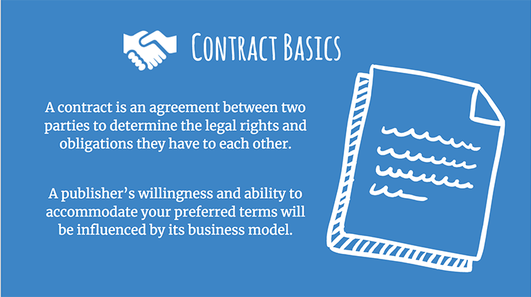

5. Contract Basics

____________________________________________
____________________________________________

____________________________________________

____________________________________________

____________________________________________________________________________________

____________________________________________________________________________________

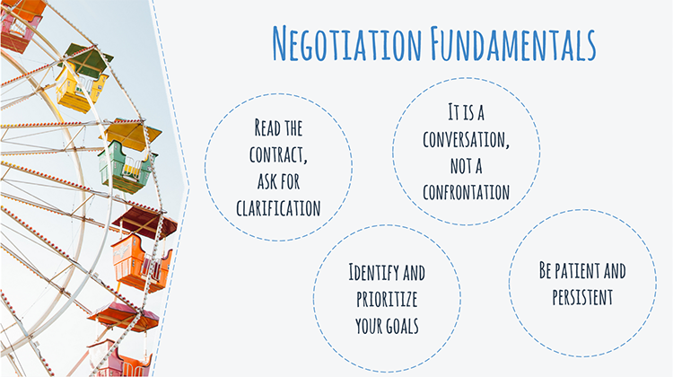
6. Negotiation Fundamentals

____________________________________________
____________________________________________

____________________________________________

____________________________________________

____________________________________________________________________________________

____________________________________________________________________________________

7. Negotiation Fundamentals

____________________________________________
____________________________________________

____________________________________________

____________________________________________

____________________________________________________________________________________

____________________________________________________________________________________

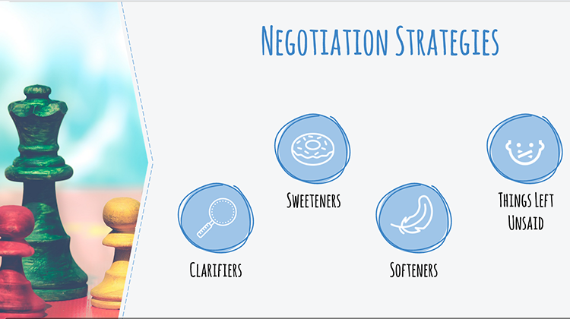
8. Negotiation Strategies

____________________________________________
____________________________________________

____________________________________________

____________________________________________

____________________________________________________________________________________

____________________________________________________________________________________

9. Clarifiers

____________________________________________
____________________________________________

____________________________________________

____________________________________________

____________________________________________________________________________________

____________________________________________________________________________________

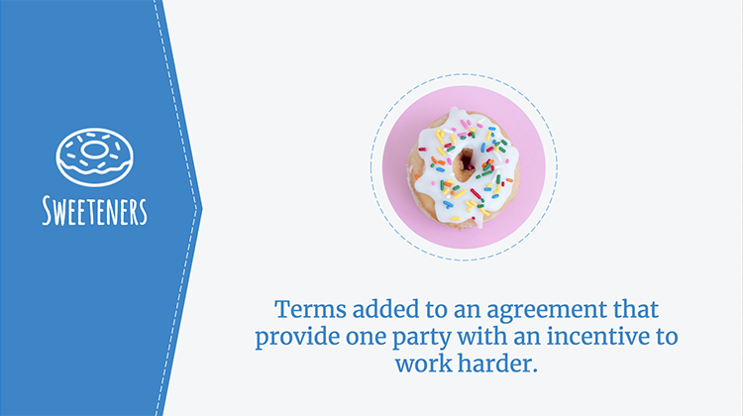
10. Sweeteners

____________________________________________
____________________________________________

____________________________________________

____________________________________________

____________________________________________________________________________________

____________________________________________________________________________________

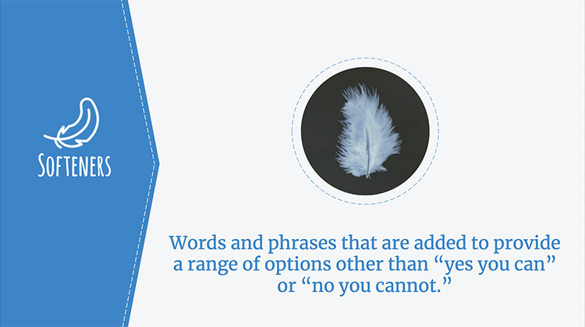
11. Softeners

____________________________________________
____________________________________________

____________________________________________

____________________________________________

____________________________________________________________________________________

____________________________________________________________________________________

12. Things Left Unsaid

____________________________________________
____________________________________________

____________________________________________

____________________________________________

____________________________________________________________________________________

____________________________________________________________________________________

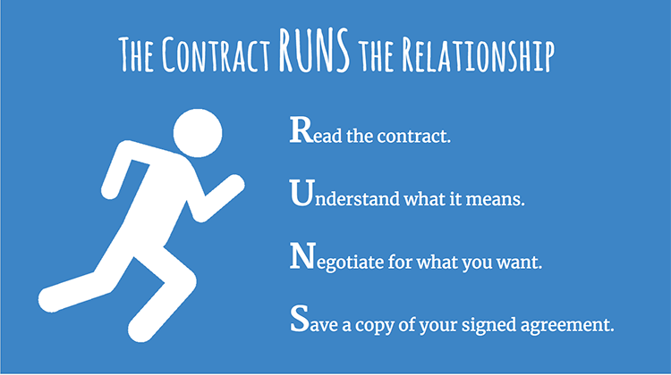
13. The Contract RUNS the Relationship

____________________________________________
____________________________________________

____________________________________________

____________________________________________

____________________________________________________________________________________

____________________________________________________________________________________

14. The Grant of Rights

____________________________________________
____________________________________________

____________________________________________

____________________________________________

____________________________________________________________________________________

____________________________________________________________________________________

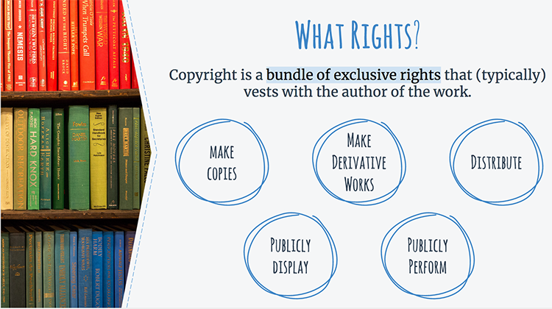
15. What Rights?

____________________________________________
____________________________________________

____________________________________________

____________________________________________

____________________________________________________________________________________

____________________________________________________________________________________

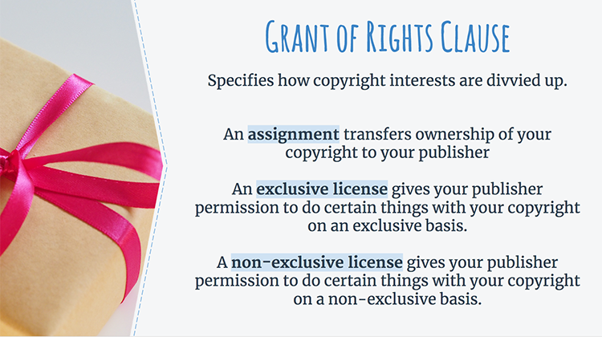
16. Grant of Rights Clause

____________________________________________
____________________________________________

____________________________________________

____________________________________________

____________________________________________________________________________________

____________________________________________________________________________________

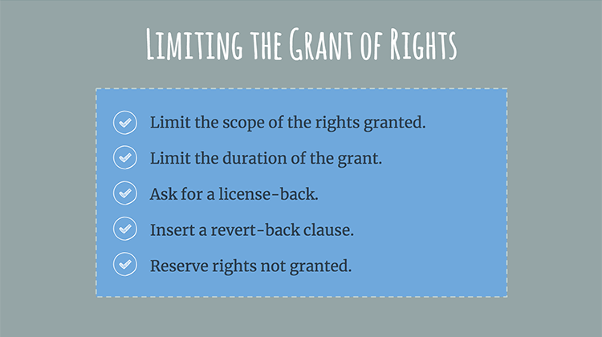
17. Limiting the Grant of Rights

____________________________________________
____________________________________________

____________________________________________

____________________________________________

____________________________________________________________________________________

____________________________________________________________________________________

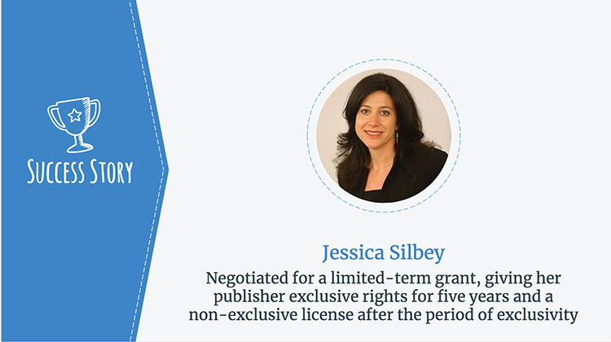
18. Success Story

____________________________________________
____________________________________________

____________________________________________

____________________________________________

____________________________________________________________________________________

____________________________________________________________________________________

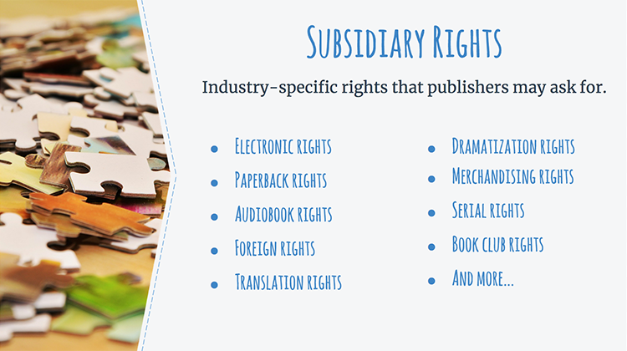
19. Subsidiary Rights

____________________________________________
____________________________________________

____________________________________________

____________________________________________

____________________________________________________________________________________

____________________________________________________________________________________

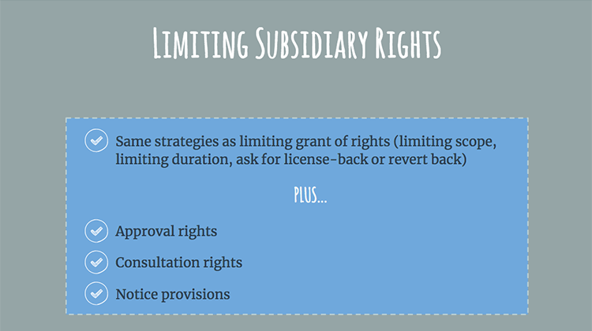
20. Limiting Subsidiary Rights

____________________________________________
____________________________________________

____________________________________________

____________________________________________

____________________________________________________________________________________

____________________________________________________________________________________

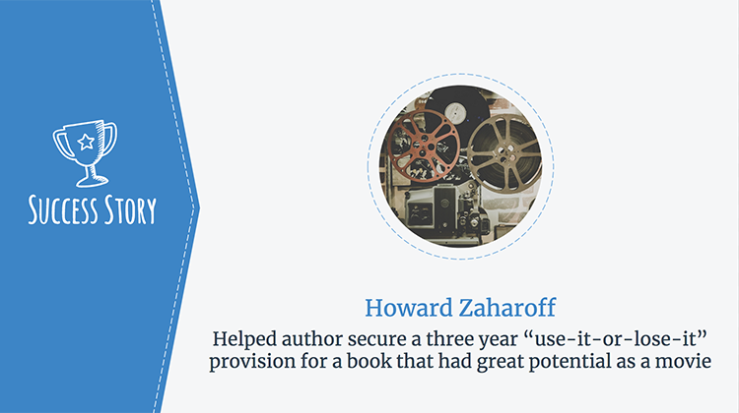
21. Success Story

____________________________________________
____________________________________________

____________________________________________

____________________________________________

____________________________________________________________________________________

____________________________________________________________________________________

22. Your Obligations

____________________________________________
____________________________________________

____________________________________________

____________________________________________

____________________________________________________________________________________

____________________________________________________________________________________

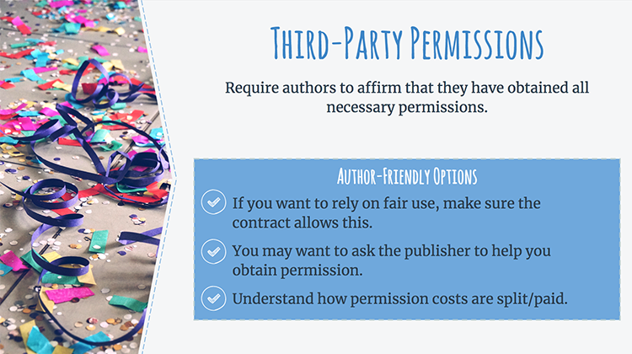
23. Third-Party Permissions

____________________________________________
____________________________________________

____________________________________________

____________________________________________

____________________________________________________________________________________

____________________________________________________________________________________

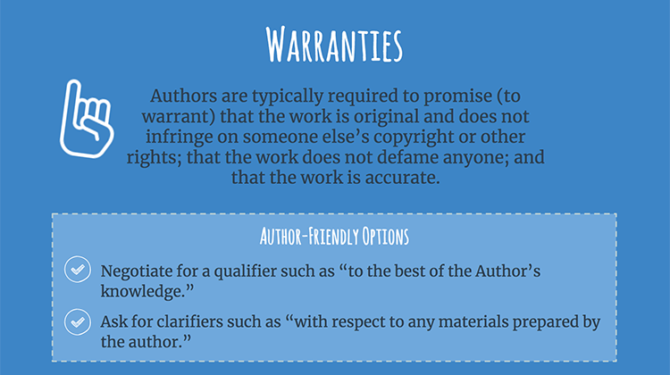
24. Warranties

____________________________________________
____________________________________________

____________________________________________

____________________________________________

____________________________________________________________________________________

____________________________________________________________________________________

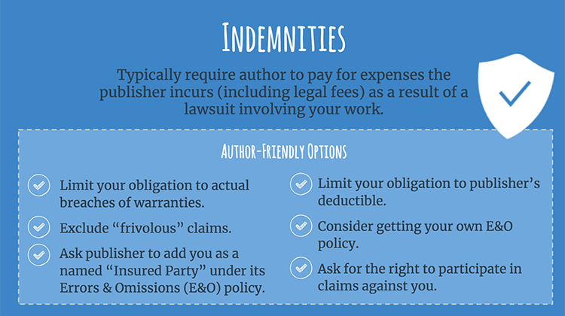
25. Indemnities

____________________________________________
____________________________________________

____________________________________________

____________________________________________

____________________________________________________________________________________

____________________________________________________________________________________

26. Success Story

____________________________________________
____________________________________________

____________________________________________

____________________________________________

____________________________________________________________________________________

____________________________________________________________________________________

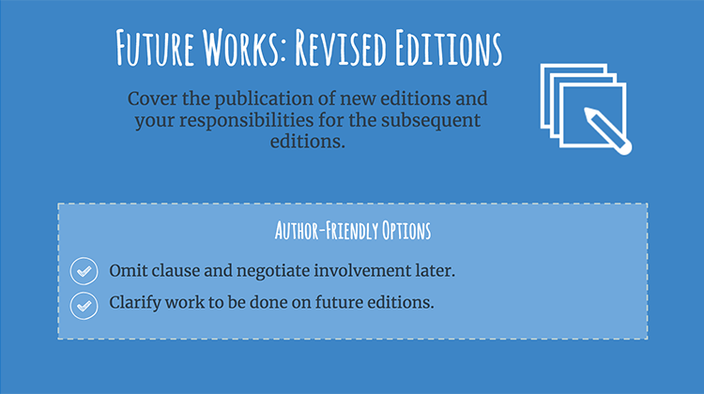
27. Future Works: Revised Editions

____________________________________________
____________________________________________

____________________________________________

____________________________________________

____________________________________________________________________________________

____________________________________________________________________________________

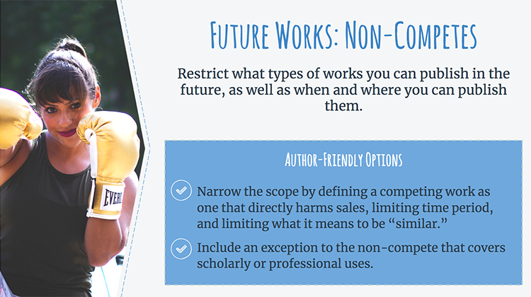
28. Future Works: Non-Competes

____________________________________________
____________________________________________

____________________________________________

____________________________________________

____________________________________________________________________________________

____________________________________________________________________________________

29. Success Story

____________________________________________
____________________________________________

____________________________________________

____________________________________________

____________________________________________________________________________________

____________________________________________________________________________________

30. Getting Your Book to Market

____________________________________________
____________________________________________

____________________________________________

____________________________________________

____________________________________________________________________________________

____________________________________________________________________________________

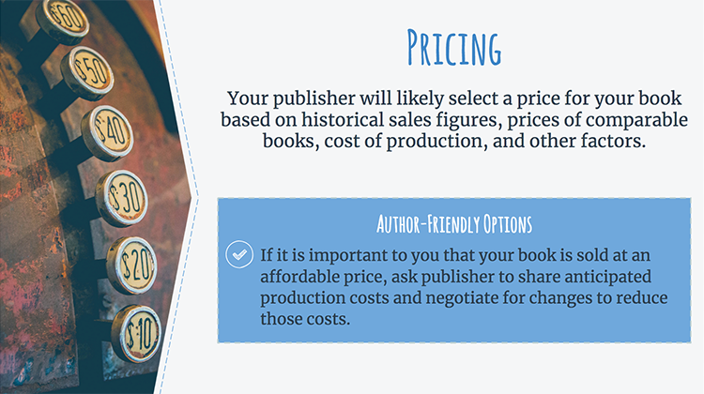
31. Pricing

____________________________________________
____________________________________________

____________________________________________

____________________________________________

____________________________________________________________________________________

____________________________________________________________________________________

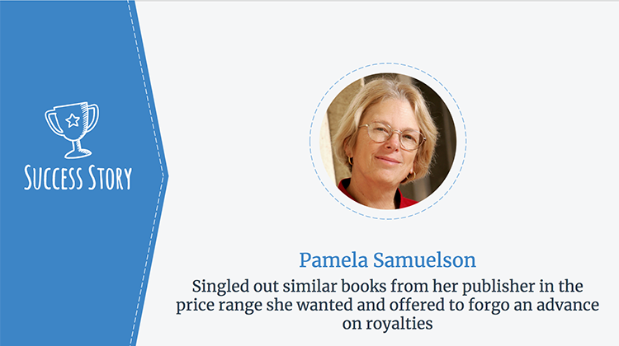
32. Success Story

____________________________________________
____________________________________________

____________________________________________

____________________________________________

____________________________________________________________________________________

____________________________________________________________________________________

33. Look and Feel

____________________________________________
____________________________________________

____________________________________________

____________________________________________

____________________________________________________________________________________

____________________________________________________________________________________

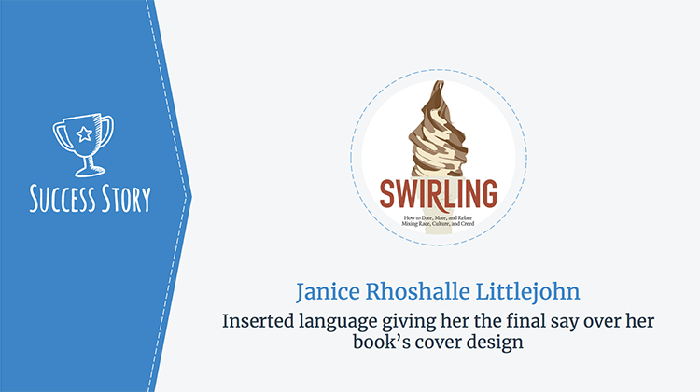
34. Success Story

____________________________________________
____________________________________________

____________________________________________

____________________________________________

____________________________________________________________________________________

____________________________________________________________________________________

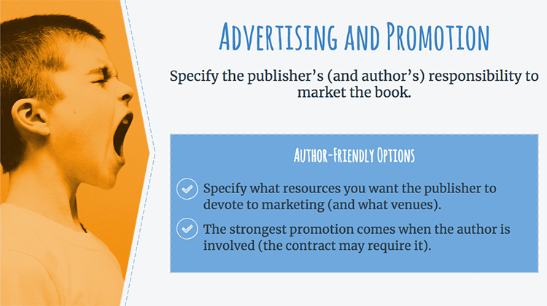
35. Advertising and Promotion

____________________________________________
____________________________________________

____________________________________________

____________________________________________

____________________________________________________________________________________

____________________________________________________________________________________

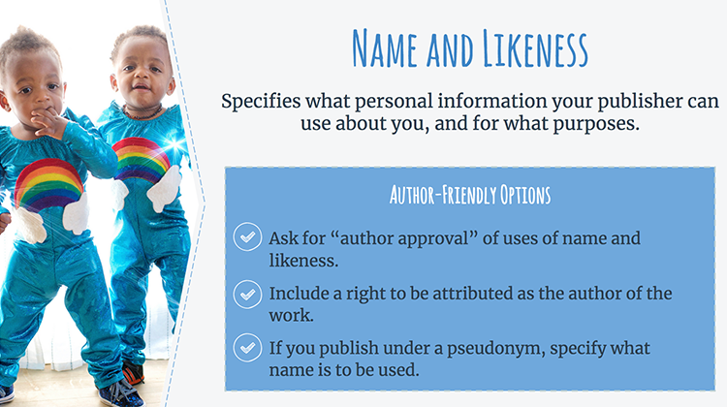
36. Name and Likeness

____________________________________________
____________________________________________

____________________________________________

____________________________________________

____________________________________________________________________________________

____________________________________________________________________________________

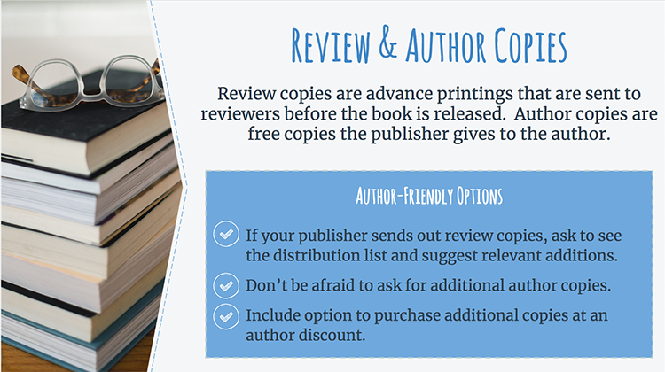
37. Review & Author Copies

____________________________________________
____________________________________________

____________________________________________

____________________________________________

____________________________________________________________________________________

____________________________________________________________________________________

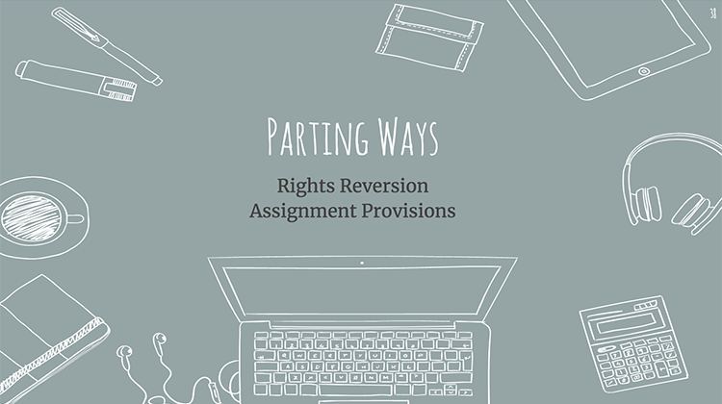
38. Parting Ways

____________________________________________
____________________________________________

____________________________________________

____________________________________________

____________________________________________________________________________________

____________________________________________________________________________________

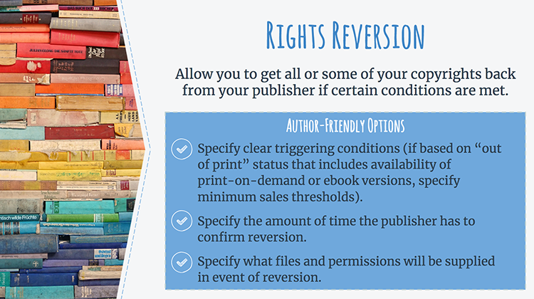
39. Rights Reversion

____________________________________________
____________________________________________

____________________________________________

____________________________________________

____________________________________________________________________________________

____________________________________________________________________________________

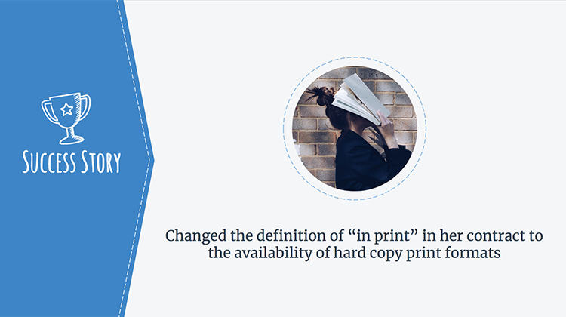
40. Success Story

____________________________________________
____________________________________________

____________________________________________

____________________________________________

____________________________________________________________________________________

____________________________________________________________________________________

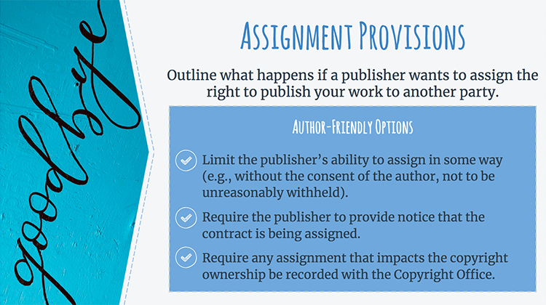
41. Assignment Provisions

____________________________________________
____________________________________________

____________________________________________

____________________________________________

____________________________________________________________________________________

____________________________________________________________________________________

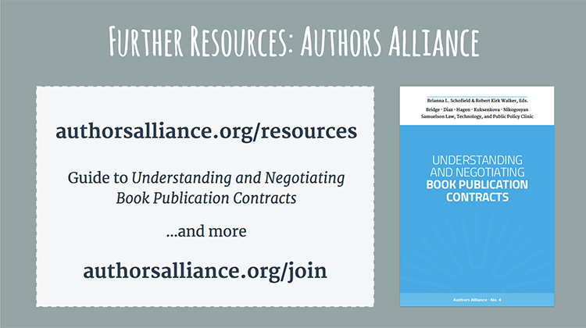
42. Further Resources: Authors Alliance

____________________________________________
____________________________________________

____________________________________________

____________________________________________

____________________________________________________________________________________

____________________________________________________________________________________

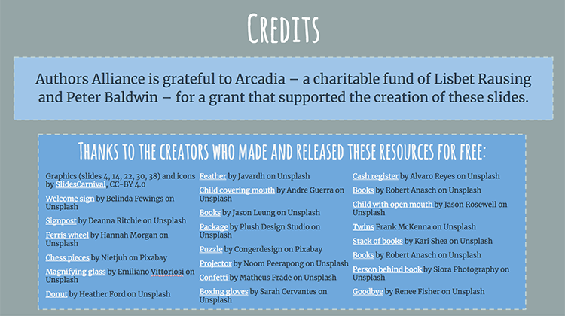
43. Credits

____________________________________________
____________________________________________

____________________________________________

____________________________________________

____________________________________________________________________________________

____________________________________________________________________________________

.

. Authors Alliance is grateful to Arcadia—a charitable fund of Lisbet Rausing and Peter Baldwin—for a grant that supported the creation of these materials.

