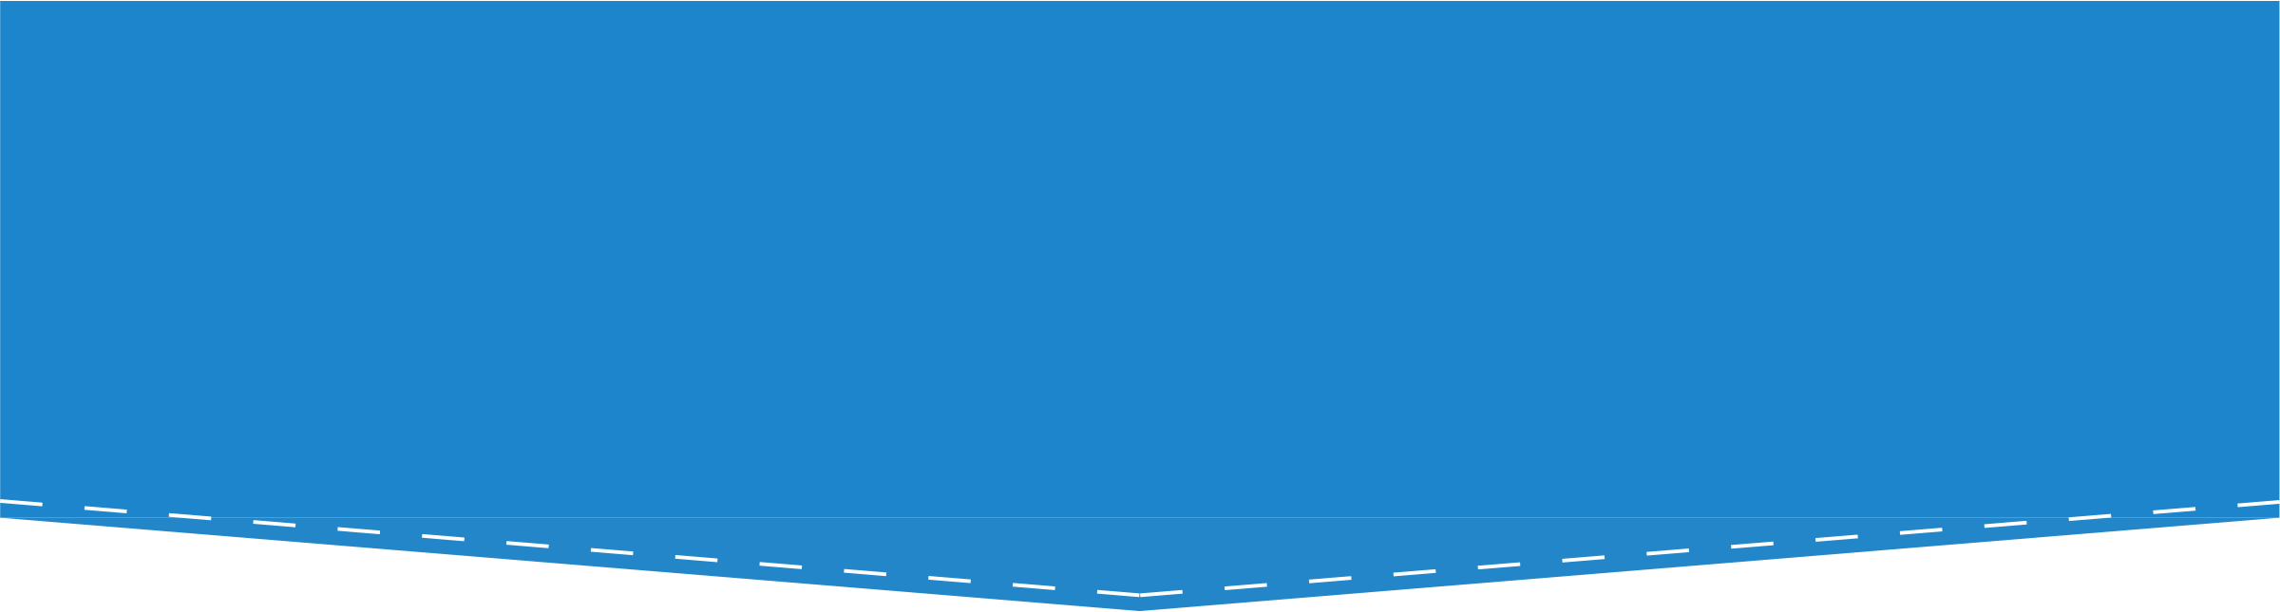Understanding and Negotiating  
Book Publication Contracts

Hands-On Exercise: Scenario #3

# Marvelous Mollusks

Professor Sam Snail is excited to have an offer to publish their new book, *Marvelous Mollusks,* with a prestigious press. Sam intends to assign five chapters of the book to the students in their *Invertebrates 101* class, so they want to make sure that their book is affordable to students.

Identify some ways that Sam may be able to ensure that their publication contract supports this goal. After you have brainstormed some options for Sam, compare your suggestions with the negotiation options provided on the next page.

# Negotiation Options

Sam wants to make sure *Marvelous Mollusks* is affordable to their students. There’s no one right answer, and you may have come up with other options for Sam, but here are some options they can consider when negotiating their publication contract:

* Sam may want to explore the option of licensing their rights to their publisher on a non-exclusive basis. This would allow Sam to work with the publisher to publish and distribute copies of *Marvelous Mollusks* through the publisher’s normal channels (for example, by selling printed copies), but also to make the book available free of charge online under a Creative Commons license. Making the book openly available online would help Sam ensure that the book was freely available to students.
* If making and distributing copies of five chapters of *Marvelous Mollusks* to students in their *Invertebrates 101* class would exceed fair use and the publisher won’t agree to a non-exclusive license for the entire book, Sam could negotiate for a way to make just those chapters freely available to their students. Here are two options:
  + Sam can consider negotiating with the publisher to non-exclusively license the five chapters of *Marvelous Mollusks* that they would like to make available to students to the publisher, while offering an exclusive license to the remainder of the chapters.
  + Sam could negotiate for a “license-back,” specifying that the publisher licenses Sam to make and distribute copies of those five chapters to the students in their class.
* Sam could ask for additional information about the publisher’s anticipated production expenses and sales projections to better understand its pricing strategy and look for opportunities to keep the price of the book down—such as reducing the page count, releasing in paperback format, or using fewer illustrations.

[1].

1. . **Authors Alliance is grateful to Arcadia—a charitable fund of Lisbet Rausing**

   **and Peter Baldwin—for a grant that supported the creation of these materials.**