Understanding Rights Reversion

Workshop on Why, When & How to  
Regain Copyright and Make Your Work  
More Available

**Have you written a book that has fallen out of print,**

**or isn’t selling as well as it used to?**

Would you like to open that content to a wider audience, perhaps by creating a digital edition, re-releasing a print edition, or making the work available under an open access license?

If so, join ________________________ for a workshop will cover when, why, and how to regain copyrights from your publisher so that you can make your books more available in the ways that you want.

**DATE**

**TIME**

**PLACE**

**INSTRUCTOR**

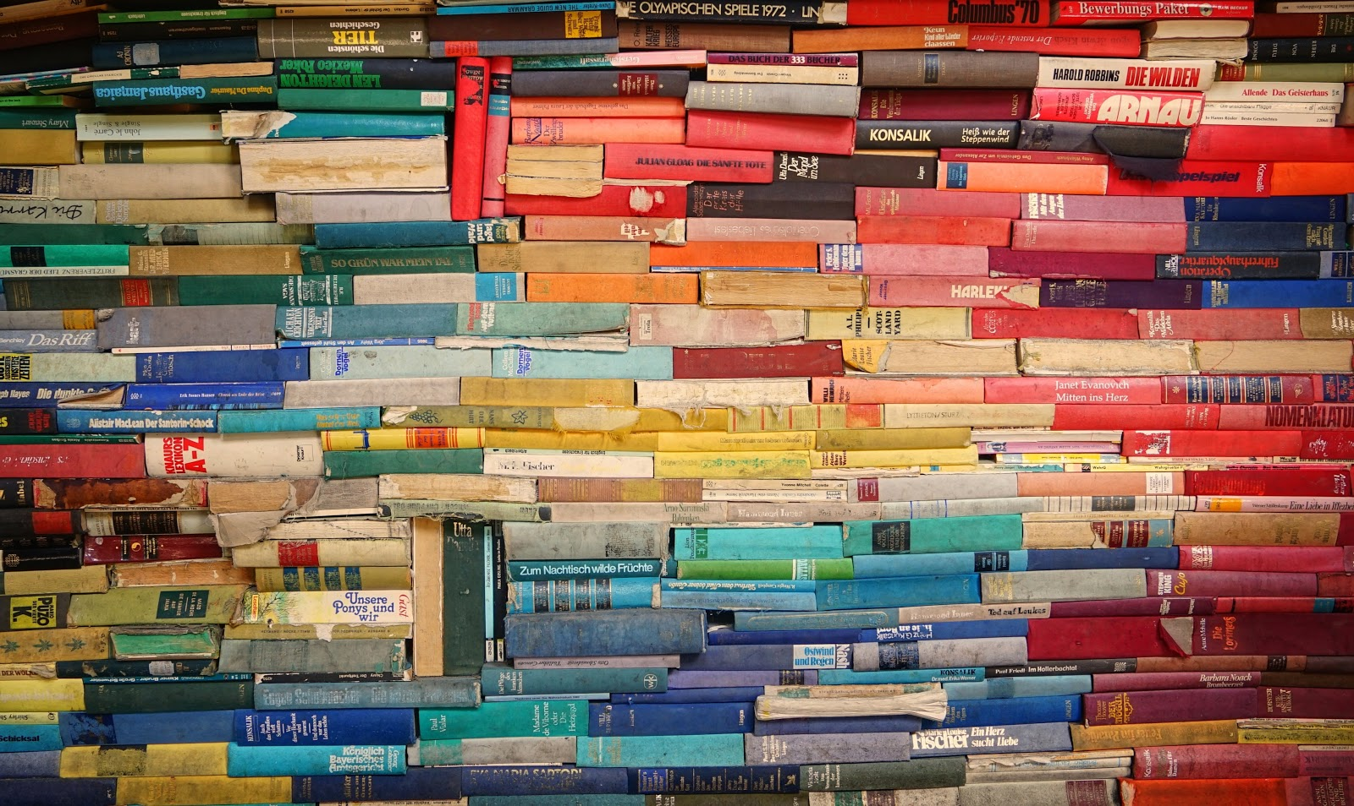  
Photo by [Robert Anasch](https://unsplash.com/@diesektion) on [Unsplash](https://unsplash.com/photos/McX3XuJRsUM)