Fair Use For Nonfiction Authors
  - Presenter Notes

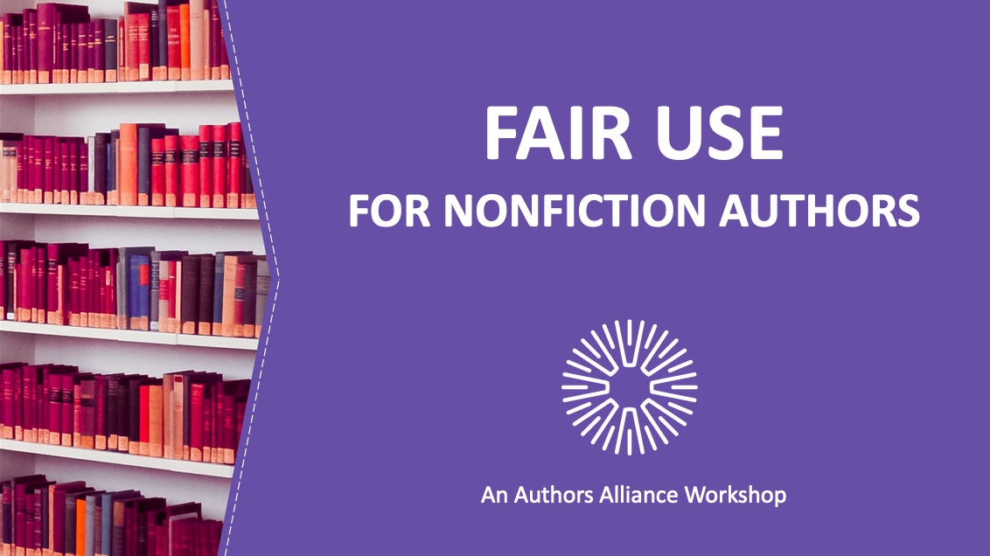

1. Fair Use for Nonfiction Authors
Nonfiction authors often use existing material in their works. Sometimes, authors need to seek permission or pay for a license to use this material. In other situations, unlicensed use may be legally permitted by virtue of the “fair use” doctrine, a limitation to copyright in the United States. This presentation will help nonfiction authors understand when they can rely on fair use when incorporating copyrighted works into their writings.

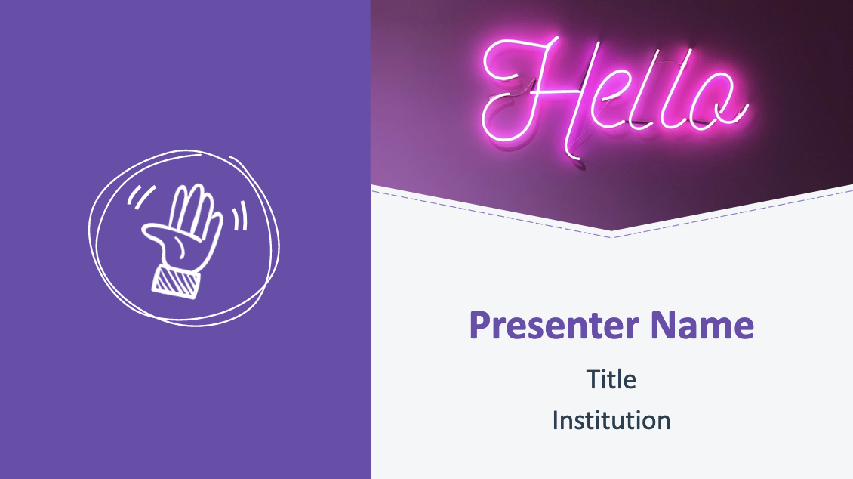

2. Hello!

Introduce presenter(s).

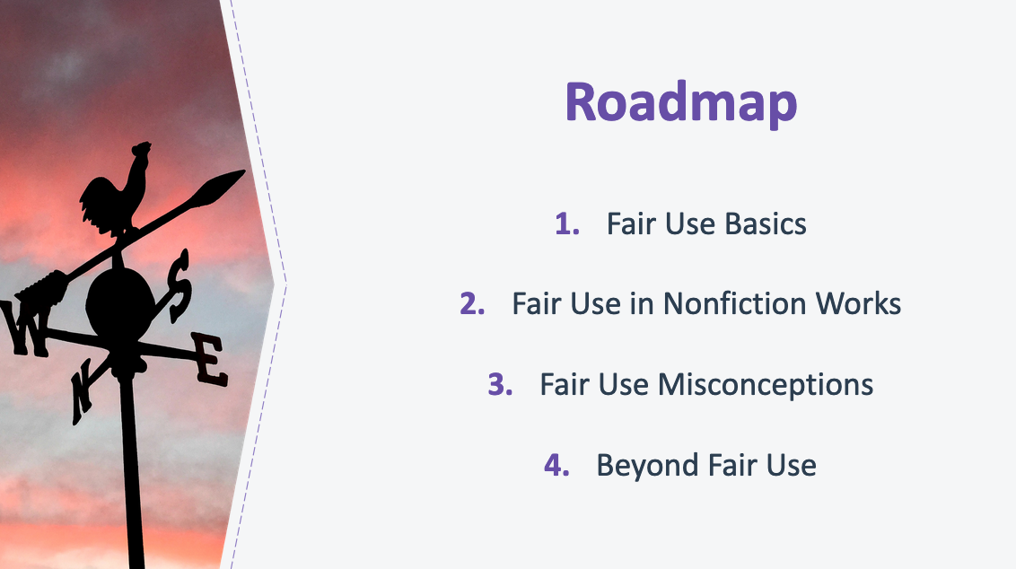

3. Roadmap
Today’s presentation has four parts. We’ll start by covering the basics of fair use—why it is a part of our copyright law and how it works generally. We’ll then turn to common situations faced by nonfiction authors where fair use may apply, discussing the fair use principles and limitations that apply to these situations. Next, I’ll clear up some common misconceptions about fair use. Finally, we’ll turn to some alternative approaches to incorporating existing materials into your work if you don’t have a strong case for fair use and bring your attention to a few non-copyright considerations.

By the end of this presentation, you’ll have a better understanding of when you can rely on fair use to do things like include song lyrics in an academic paper discussing musical trends, quote from a novel to analyze the author’s use of metaphors in a work of literary criticism, incorporate a photograph in an article about the photographer’s use of light and shadow, or quote from unpublished letters in a memoir.
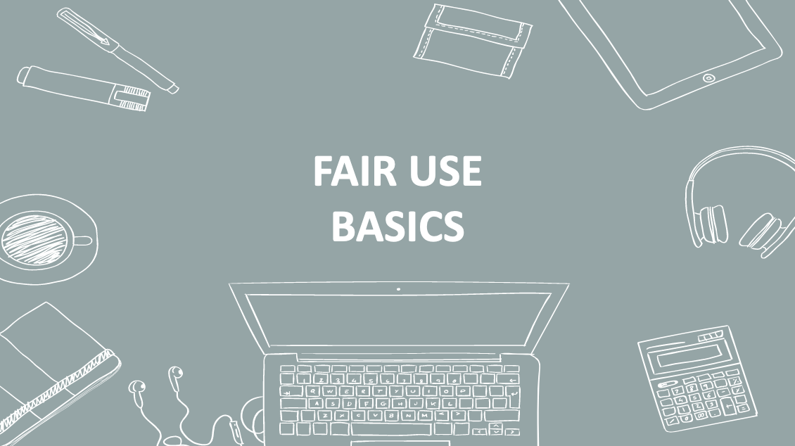

4. Fair Use Basics
Let’s get started with an overview of fair use.

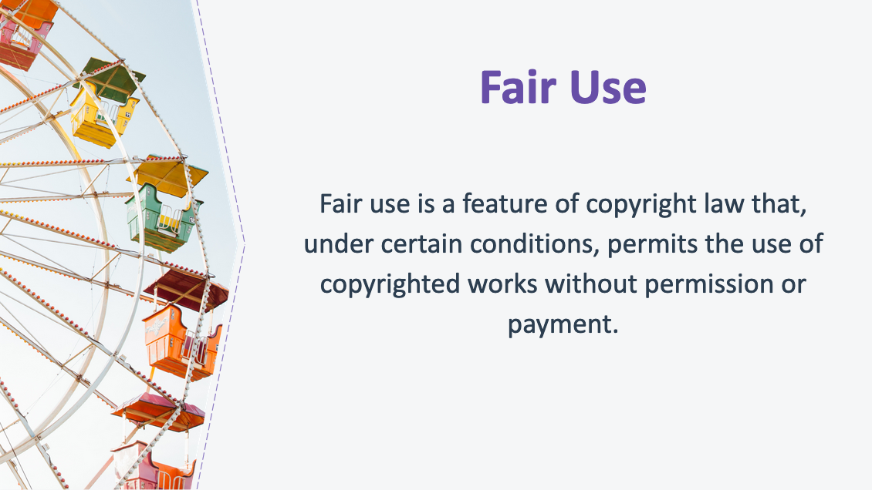
5. Fair Use
Fair use is a feature of copyright law that, under certain conditions, permits the use of copyrighted works without permission or payment.

Copyright law protects creative works in order to foster the creation of culture. Its best-known feature is protection of owners’ rights. But copying, quoting, and generally reusing existing cultural material is critically important to generating new culture. In fact, the cultural value of copying is so important that it is written into the social bargain at the heart of copyright law. The bargain is this: We as society give limited rights to creators to encourage them to produce culture; at the same time, we give other creators the chance to use that same copyrighted material, without permission or payment, in some circumstances.

So fair use can be seen as a safety valve that is built into copyright law to prevent copyright from stifling onward creativity.

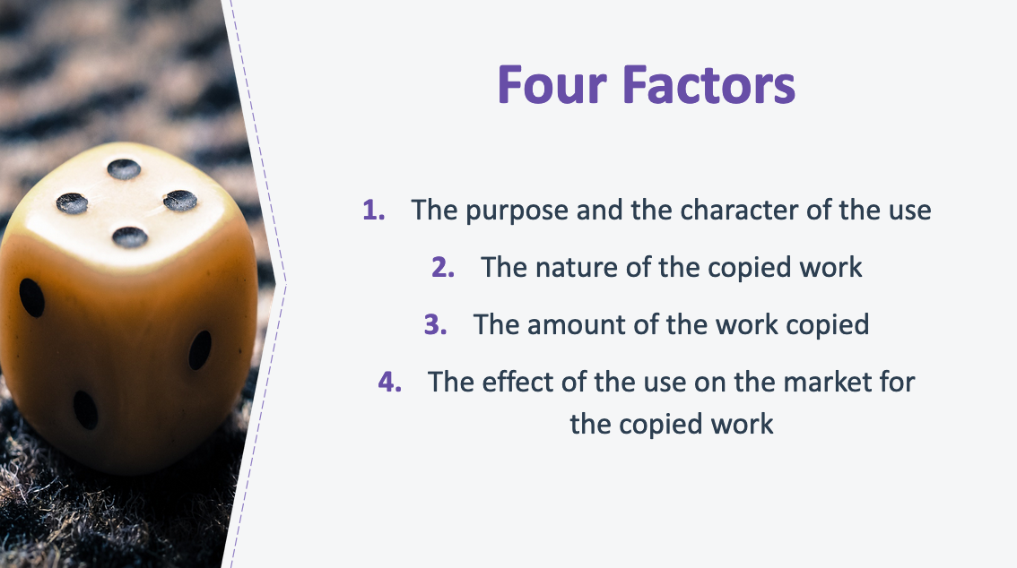

6. Four Factors
To decide whether a use is fair, courts must consider at least four factors that are specifically mentioned in the Copyright Act.

The first factor is the purpose and character of the use. Here courts ask whether the material has been transformed by adding new meaning or expression, or whether value was added by creating new information, meaning, or understanding. When a work is used for a different purpose than the original, the factor will likely weigh in favor of fair use. If it simply acts as a substitute for the original work, the less likely it is to be fair. Courts may also look at whether the use of the material was for commercial or noncommercial purposes under this factor, but this is rarely a determinative consideration.

The second factor looks at the nature of the copyrighted work. Here courts look at whether the copyrighted work that was used is creative or factual in nature (a song or a novel vs. technical article or news item). The more factual the work, the more likely this factor is to weigh in favor of fair use. On the flip side, the more creative the copyrighted work, the more likely this factor is to weigh against fair use. Courts may also consider whether the copyrighted work is published or unpublished. If the work is unpublished, this factor is less likely to weigh in favor or fair use.

The third factor is the amount and substantiality of the portion taken. Under this factor, courts look at how much of the work was taken, both quantitatively and qualitatively. Quantitatively, courts look at how much of the original work was used (e.g., all the pages, the entire work of art). Qualitatively, courts look at whether the “heart” of the work was taken (e.g., the essential bit of the work that is why people want to engage with it—the juicy revelations in a tell-all book). The more that is taken, quantitatively and qualitatively, the less likely the use is to be fair. That said, copying a full work can still be fair. And conversely, in some cases, even if a small amount is used if it is the “heart” of the work this can weigh against fair use.

Finally, the fourth factor is the effect of the use on the potential market. The essential question courts ask here is whether this use will undermine the market, or potential market, for the work that was copied. In assessing this factor, courts consider whether the use would hurt the market for the original work (for example, by displacing sales of the original) and/or whether the use could cause substantial harm if it were to become widespread.
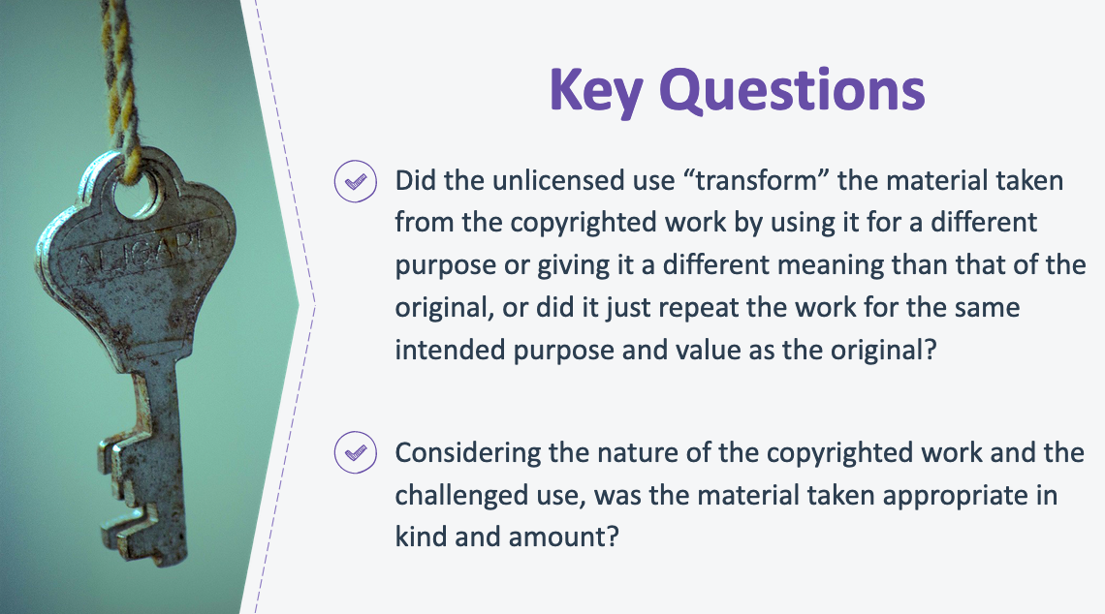

7. Key Questions
The four factors are not mechanically applied or weighed equally. By design, fair use is flexible and courts take into account all the facts and circumstances of a specific case to decide if an unlicensed use of copyrighted material is fair.

Despite its flexibility, however, fair use is not unreliable. In reviewing the history of fair use litigation, scholars have found that judges return again and again to two key questions:

- Did the unlicensed use “transform” the material taken from the copyrighted work by using it for a different purpose or giving it a different meaning than that of the original, or did it just repeat the work for the same intended purpose and value as the original?

- Considering the nature of the copyrighted work and the challenged use, was the material taken appropriate in kind and amount?

If the answers to these two questions are “yes,” a court is more likely to find a use fair.

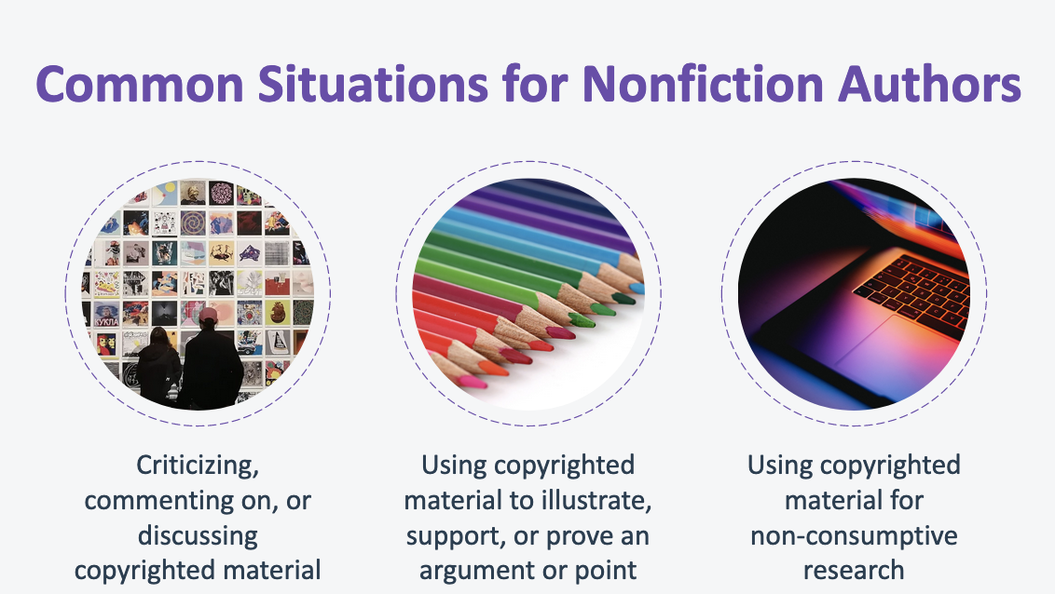

8. Common Situations for Nonfiction Authors
While there are seemingly endless ways that a copyrighted work might be used, nonfiction authors often want to either (1) criticize, discuss, or comment on copyrighted material or (2) use the copyrighted material to support a point made in the author’s work. Another use that is increasingly relevant to nonfiction authors is (3) using copyrighted material for non-consumptive research (e.g., copying works into digital databases in order to perform computational analysis across texts and/or images).

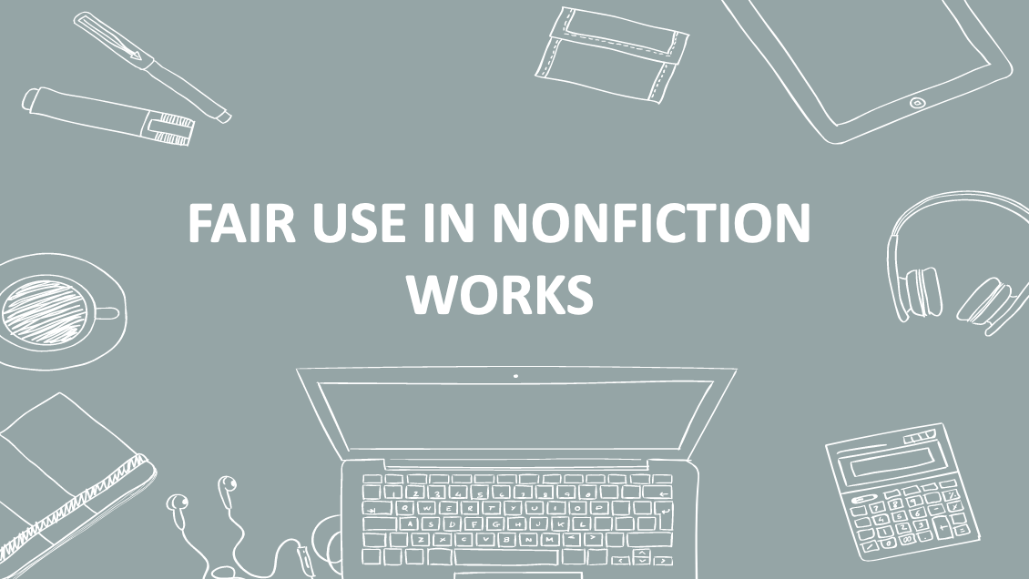
9. Fair Use in Nonfiction Works
Let’s take a closer look at each of these situations to examine how fair use applies.

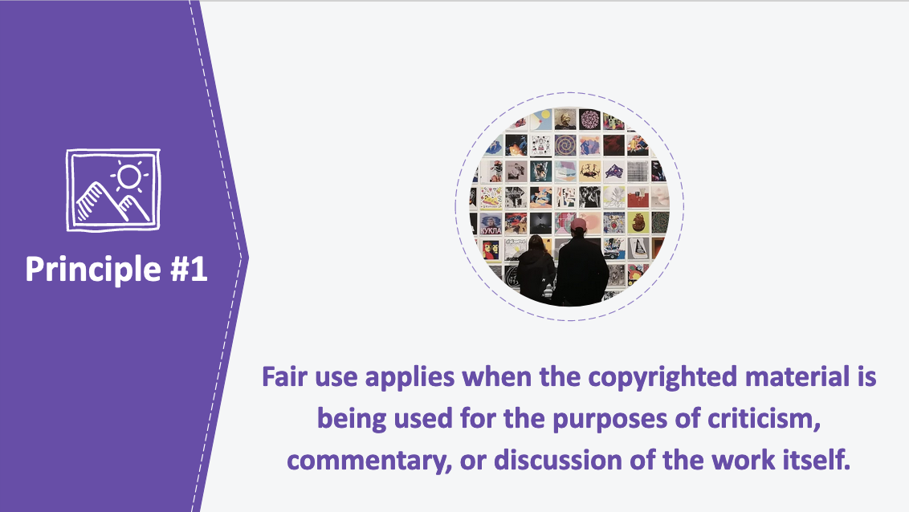

10. Principle #1
Nonfiction authors often engage in critical analysis of specific copyrighted works and want to use some or all of that material in their new works. In these cases, nonfiction authors are specifically discussing the copyrighted material: the copyrighted work is itself the focus of their social, political, or cultural critique. This type of critical engagement is exactly what fair use is meant to allow.

Best practices guides and court decisions strongly support the principle that fair use applies when the copyrighted material is being used for the purposes of criticism, commentary, or discussion of the work itself (subject to limitations we’ll discuss shortly).

Sometimes copying is essential to an author’s purpose and, without it, a reader wouldn’t be able to understand her critique. Also, on a broader level, the ability to freely investigate and criticize existing materials is considered essential to freedom of expression. For these reasons, courts often refer to fair use as a “safety valve” that prevents copyright law from being used as a tool of intimidation to silence unpopular or critical ideas. But it is also important to note that criticism, commentary, or discussion does not have to be negative to be eligible for fair use; fair use protects positive criticism, commentary, and discussion as well.

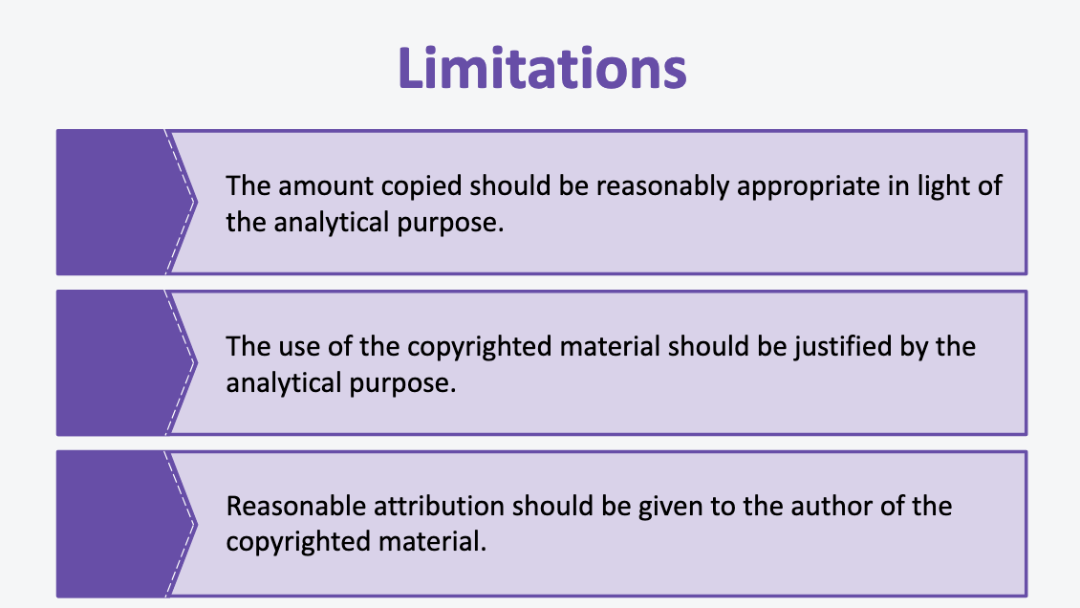

11. Limitations
The right to criticize, discuss, and comment on copyrighted material is not absolute. Creative communities and courts have identified several important limitations that can guide authors.

A key limitation is that authors should only use as much of the copyrighted work as is reasonably appropriate to enable the reader to understand the criticism, commentary, or discussion. The amount copied should be reasonably appropriate in light of the analytical purpose.

Another limitation is that there should be a clear connection between the criticism, commentary, or discussion and the use of the copyrighted material. Authors should be able to explain the relevance of the copyrighted material to the critical comment being made. The use of copyrightable material should be justified by the analytical purpose.

Finally, it is considered best practice that reasonable attribution should be given to the author of the copyrighted material. You should note that U.S. copyright law does not require attribution. However, courts may weigh the fact that a work is attributed in favor of fair use, and authorial communities consider it a mark of integrity—and just good manners—to acknowledge sources. Any attribution given should be in the form and manner customary to the relevant authorial community.

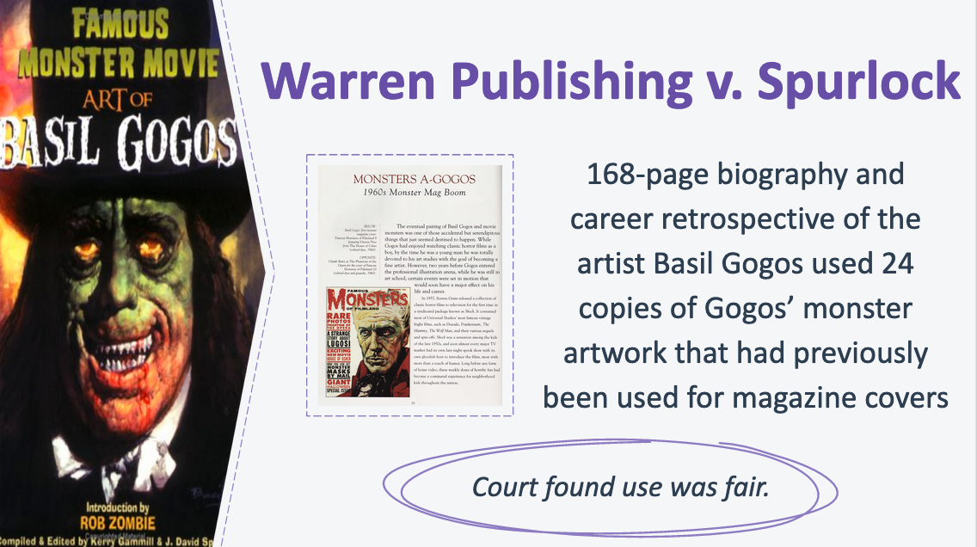

12. Warren Publishing v. Spurlock
This principle was at play in the case of Warren Publishing v. Spurlock. When an author wrote a 168-page biography and career retrospective of the artist Basil Gogos, he included 24 copies of Gogos’ monster artwork that had previously been used for magazine covers. A court found this use to be a fair use, in part because the author used Gogos’ illustrations “to pay homage to his artistic accomplishments” and included commentary from those in the movie industry who discussed the quality of his work. The court also observed that the author used only a “small portion” of the original magazines, and that he was not required to change the images to black-and-white or use smaller sizes because “making these changes would directly thwart one of the key purposes of the book....”

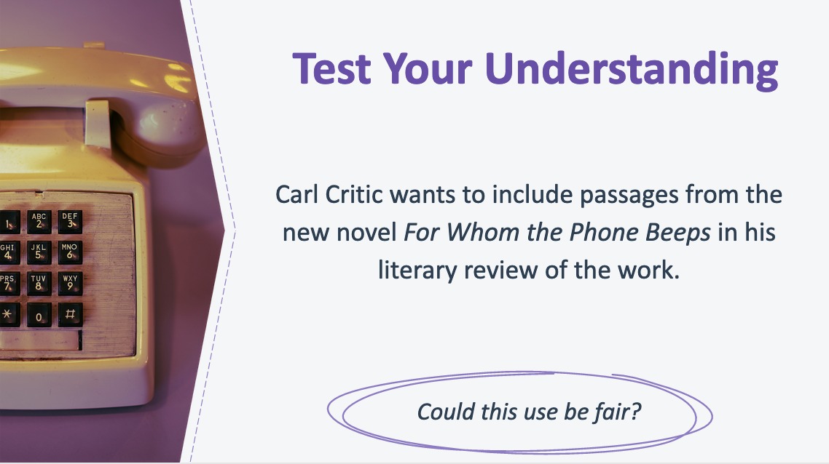

13. Test Your Understanding
Let’s take a stab at applying this principle. Here’s the scenario: Carl Critic wants to include passages from the new novel For Whom the Phone Beeps in his literary review of the work. Does fair use apply?

Answer: Carl Critic’s use is fair-use eligible because he is commenting on For Whom the Phone Beeps in his literary review. But Carl will still need to review the limitations to this principle. When he does, Carl will find that he should limit the length of passages he uses from the book to those that are reasonably appropriate to help his readers understand the point he is making in his review. He should also tie the passages he uses to his critical analysis of the novel, and he should give reasonable attribution to the novel’s author.

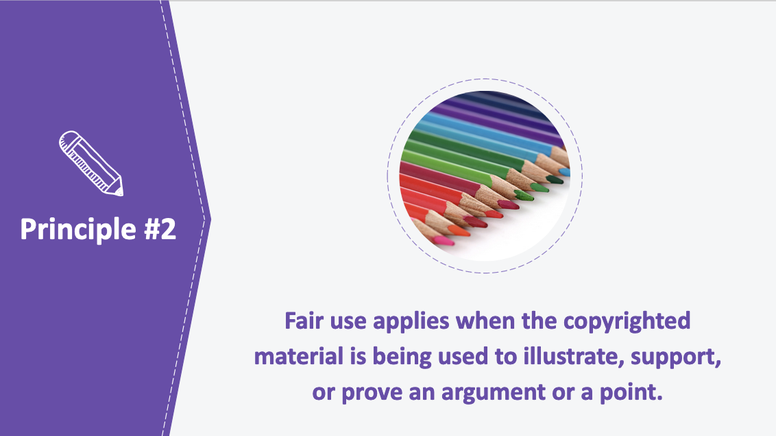

14. Principle #2
Nonfiction authors regularly use copyrighted material to illustrate, support, or prove an argument. Unlike when an author is criticizing, discussing, or commenting on the copyrighted material, here the material being used is not itself the object of the author’s commentary. Rather, the material is being used to support a related point made by the nonfiction author. In other words, nonfiction authors want to use copyrighted material to “show their work” and lend credibility to their theories and arguments. For example, a non-fiction author may want to use passages from letters to support her theory that Percy Poet’s poems about fatherhood were based on his close relationship with his daughter.

Best practices guides and court decisions support the principle that fair use applies when the copyrighted material is being used to illustrate, support, or prove an argument or a point (subject to the limitations we’ll discuss shortly).

The principle recognizes that authors’ arguments are much stronger and clearer when they are supported by examples.

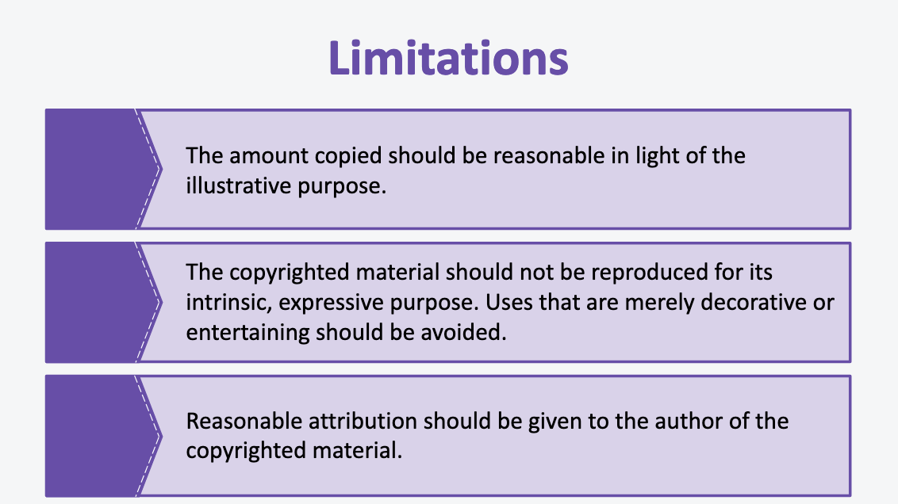

15. Limitations
Again, a key limitation is that authors should only use as much of the copyrighted work as is reasonably appropriate for the reader to assess the validity of their point. The amount copied should be reasonable in light of the illustrative purpose.

Another limitation is that merely decorative or entertaining uses of copyrighted material under the guise of illustration are inappropriate. Instead, there should be a clear connection between the copyrighted material and the point being made. The copyrighted material should not be reproduced for its intrinsic, expressive purpose. Uses that are solely decorative or entertaining should be avoided.

Finally, although not required by law, reasonable attribution should be given to the author of the copyrighted material.

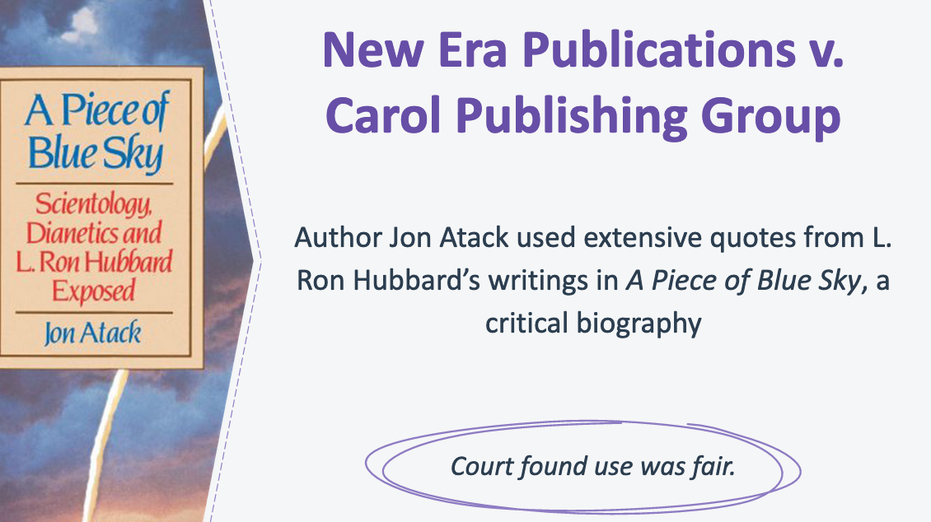

16. New Era Publications v. Carol Publishing Group
Let’s take a look at this principle at work in the case of New Era Publications v. Carol Publishing Group. In this case, the court held that an author’s use of L. Ron Hubbard’s writings in A Piece of Blue Sky, a critical biography, was a fair use, in part because the author used the quotes to support the points he was making about Hubbard’s character. The court stated that some of the quotations were used “to convey the author’s perception of Hubbard’s hypocrisy and pomposity,” and that these qualities “may be best (or only) be revealed through direct quotations.” Further, the court found that the author used only a “small percentage” of Hubbard’s work and that “some conjuring up of the copyrighted work is necessary” for the author’s purposes.

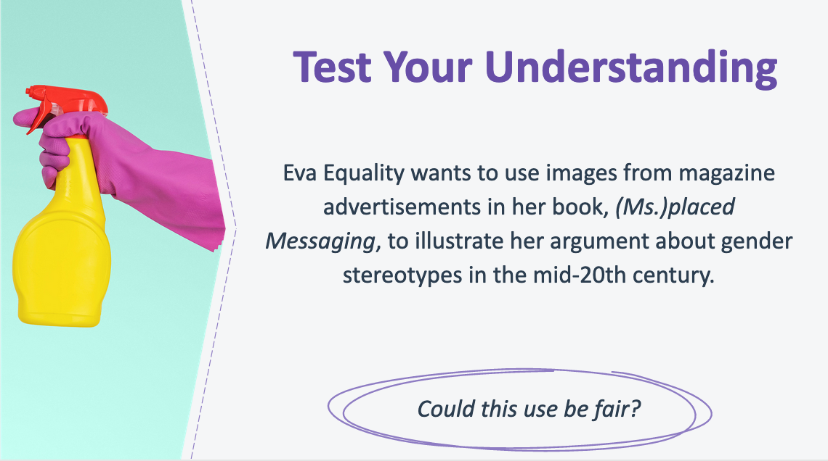
17. Test Your Understanding
Let’s try applying this principle. Here’s the scenario: Eva Equality wants to use images from magazine advertisements in her book, (Ms.)placed Messaging, to illustrate her argument about gender stereotypes in the mid-20th century. Does fair use apply?

Eva’s use is fair-use eligible because she wants to use the copyrighted advertisements to illustrate her argument. But, she will need to review the limitations to this principle to make sure her use does not exceed the limits of fair use. Eva will find that the limitations suggest that she should only use as much of the advertisements as reasonably appropriate to enable her reader to assess the validity of the point that she is making. In some cases, she may need to copy the entire advertisement to illustrate her point. In other cases, a telling detail from a section of the advertisement or a small-scale version of the image may be enough. She should avoid just showcasing advertisement images without adding additional content that makes it clear how these images support her argument about gender stereotypes. Finally, she should credit the magazine advertisements in a reasonable manner if the original authors are known.

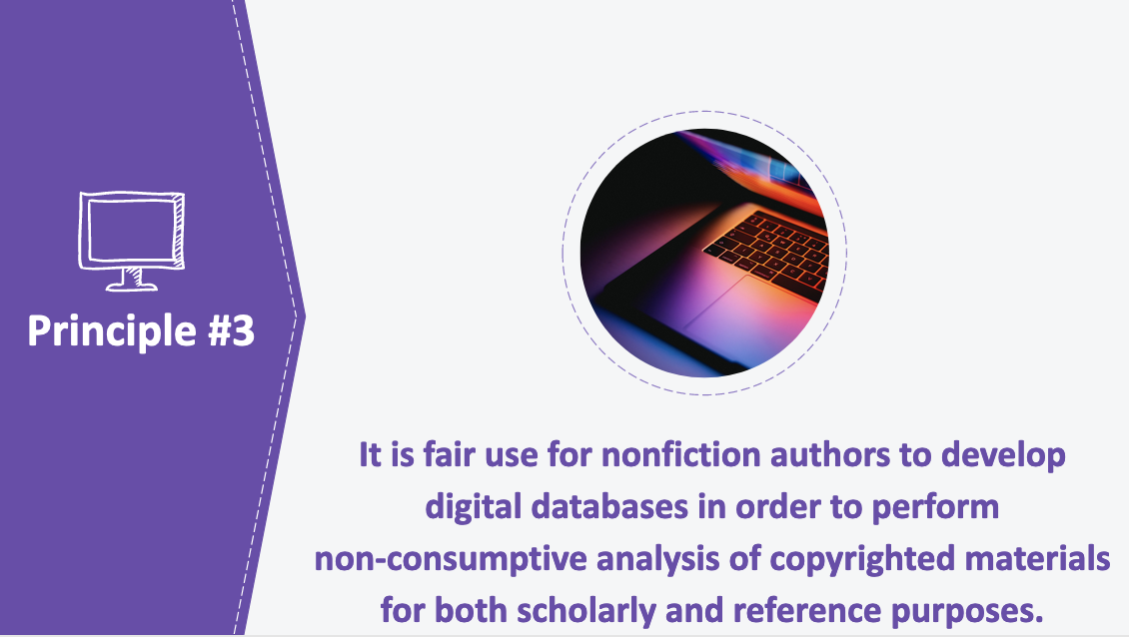

18. Principle #3
New tools are available to nonfiction authors that allow them to copy works into digital databases in order to perform computational analyses across aggregated sets of texts or images. In these cases, the nonfiction author is not reading, displaying, or sharing large portions of the copyrighted material, but is instead using data mining technology to derive factual information about the works and incorporate those findings into her writings. For example, a nonfiction author may import works into a database and then use data mining technology to count the number of times a word appears in a collection of works, or to understand how frequently a particular species of mouse is used as a test subject.

Legal cases and one best practices guide provide strong support for the principle that it is fair use for nonfiction authors to develop digital databases in order to perform non-consumptive analysis of copyrighted materials for both scholarly and reference purposes (subject to the limitation we’ll discuss next).

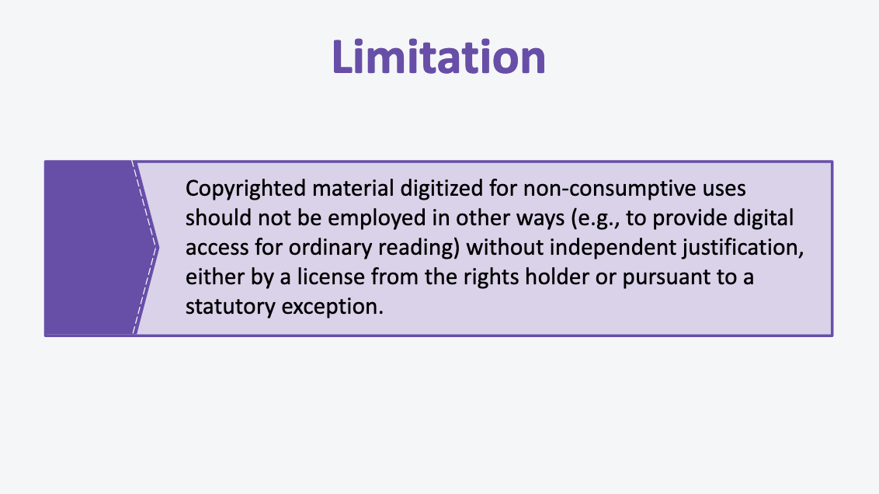

19. Limitation
As with the other principles, there is an important limitation to bear in mind. In this case, the limitation is that copyrighted material digitized for non-consumptive uses should not be employed in other ways (e.g., to provide digital access for ordinary reading) without independent justification, either by a license from the rights holder or pursuant to a statutory exception.

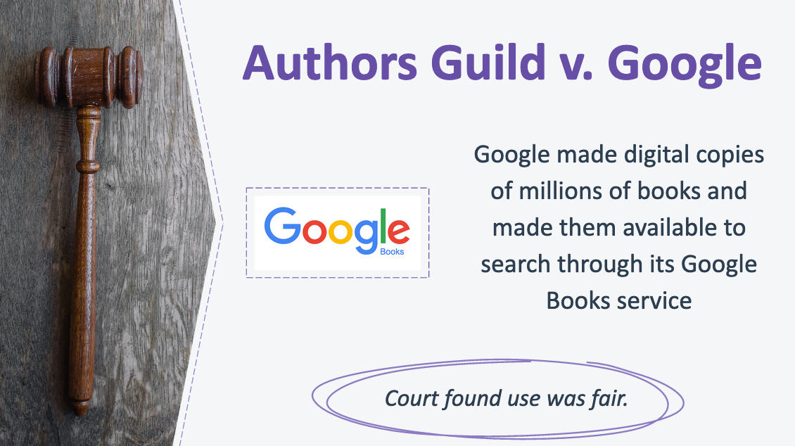

20. Authors Guild v. Google
Non-consumptive use was found to be a fair use in the case of Authors Guild v. Google. Google made digital copies of millions of books and made them available to search through its Google Books service so that users could identify relevant words, terms, or snippets from the scanned text. The service allowed users to, for example, “track the frequency of references to the United States as a single entity (“the United States is”) versus references to the United States in the plural (“the United States are”) and how that usage has changed over time.” The Second Circuit held that Google Books service was a fair use, finding that “the purpose of Google’s copying of the original copyrighted books is to make available significant information about those books,” a different function from that of the original books.

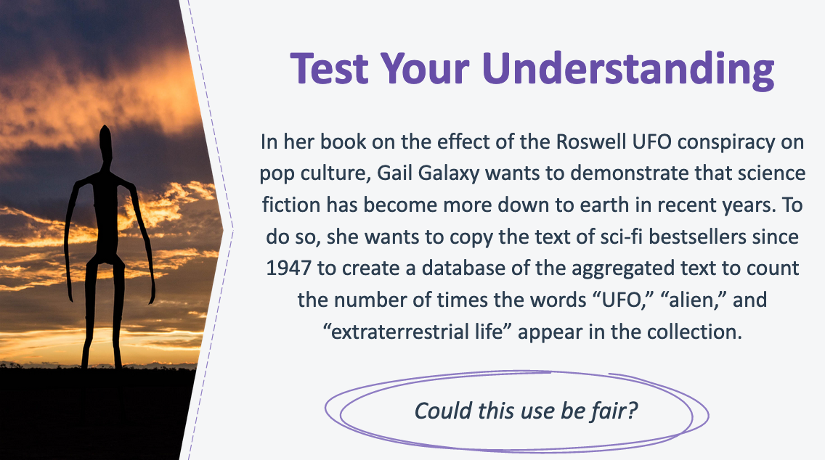
21. Test Your Understanding
Let’s try a hypo based on this principle. Here’s the scenario: In her scholarly book on the effect of the Roswell UFO conspiracy on pop culture, Gail Galaxy wants to demonstrate that science fiction writing has become more down to earth in recent years. To do so, she wants to copy the text of sci-fi bestsellers since 1947 to create a database of the aggregated text to count the number of times the words “UFO,” “alien,” and “extraterrestrial life” appear in the collection. Does fair use apply?

Because Gail wants to create a digital database of copyrighted material for non-consumptive analysis across the collection for scholarly purposes, her use is fair-use eligible under the principle described in this section. However, Gail will need to review the limitations to this principle to ensure that her use stays within the bounds of fair use. Gail will find that the limitations suggest that she should not use the copyrighted material in the sci-fi bestsellers database in other ways (for example, to provide digital access to the entire text of the books), unless she has an independent justification for doing so (such as a license from the rights holder).

22. Fair Use Misconceptions
In this section, we’ll debunk some common myths and misconceptions about fair use.

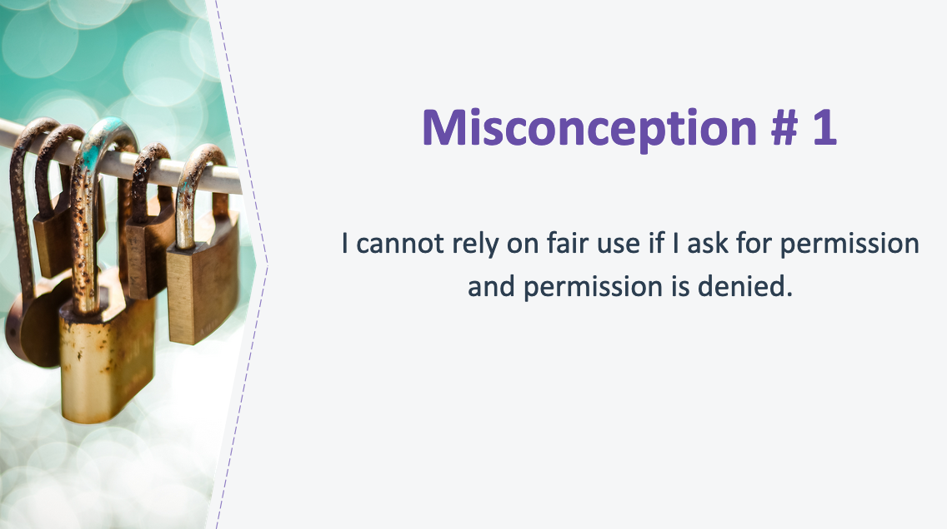
23. Misconception #1
One common misconception is that an author cannot rely on fair use if she asks for permission and that permission is denied.

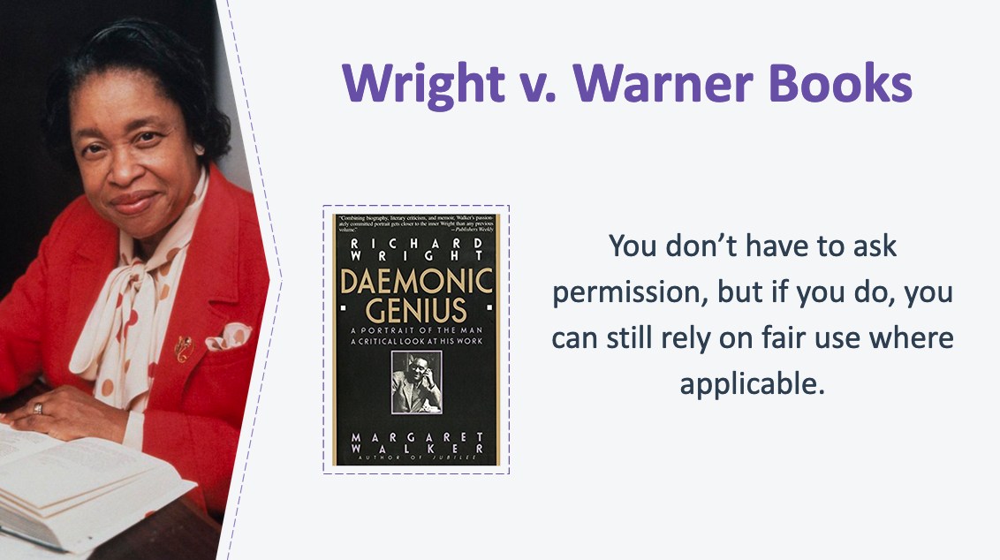
24. Wright v. Warner Books
You do not have to ask permission or alert the copyright holder when a use of materials is protected by fair use. But, if you choose, you may inquire about permissions and still claim fair use if your request is refused or ignored. In some cases, courts have found that asking permission and then being rejected has actually enhanced fair use claims. The Supreme Court has even said that asking for permission may be a good faith effort to avoid litigation.

Here's an example of this in a case involving the biographer Margaret Walker who quoted from Richard Wright’s unpublished letters and journal entries to illustrate factual points in the biography. The plaintiff in this case had refused to give permission to use Wright’s copyrighted works in the biography. The fact that permission was denied did not affect the outcome of this case; in fact, the use was found to be a fair use.

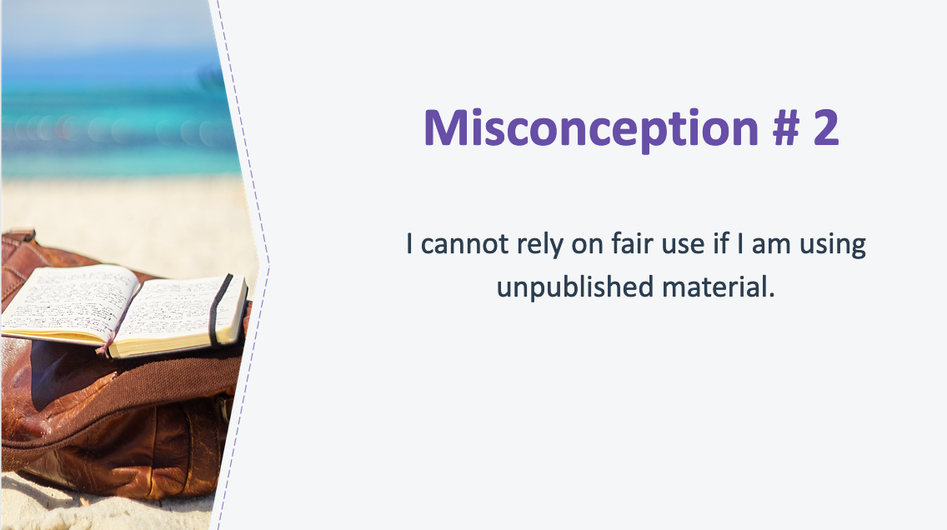

25. Misconception #2
Another misconception is that an author cannot rely on fair use if he is using unpublished material.

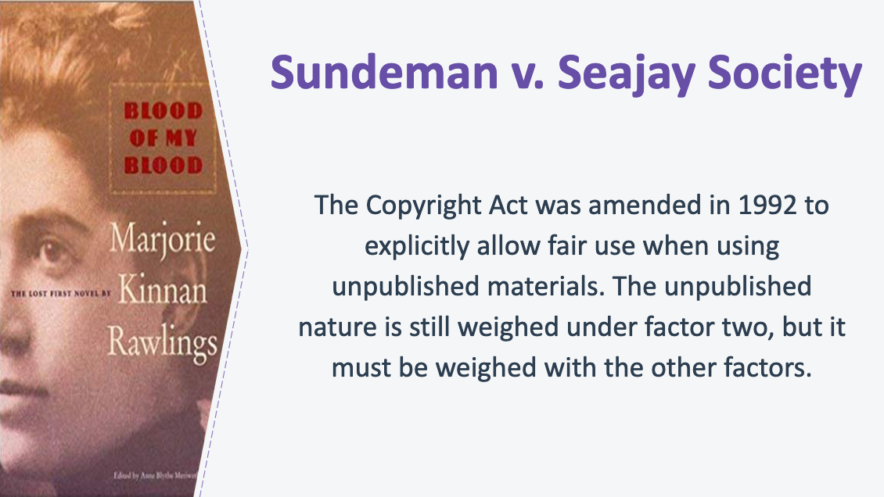

26. Sundeman v. Seajay Society
Congress amended the Copyright Act in 1992 to explicitly allow for fair use when using unpublished works after several court decisions suggested that the use of unpublished materials would rarely be fair use. While a court may still consider a work’s unpublished status to weigh against fair use when evaluating the “nature of the work” under factor two, this factor is rarely decisive on its own and courts still must weigh all of the fair use factors, including the purpose of the use. The purpose of the use may weigh against fair use if the unpublished material is being used in a frivolous or exploitative manner. On the other hand, the purpose of the use may weigh in favor of fair use if the unpublished material transforms the original material (by, for example, using the original material as the object of criticism or commentary) and contributes to the public’s interest in advancing knowledge.

An example of this is a case where a scholar wrote a critical review of Blood of My Blood, an unpublished novel by Marjorie Rawlings. The Court found that the critical review was a fair use—even though the novel was unpublished—in part because it was a scholarly appraisal of the work with the purpose of criticizing and commenting on the work.

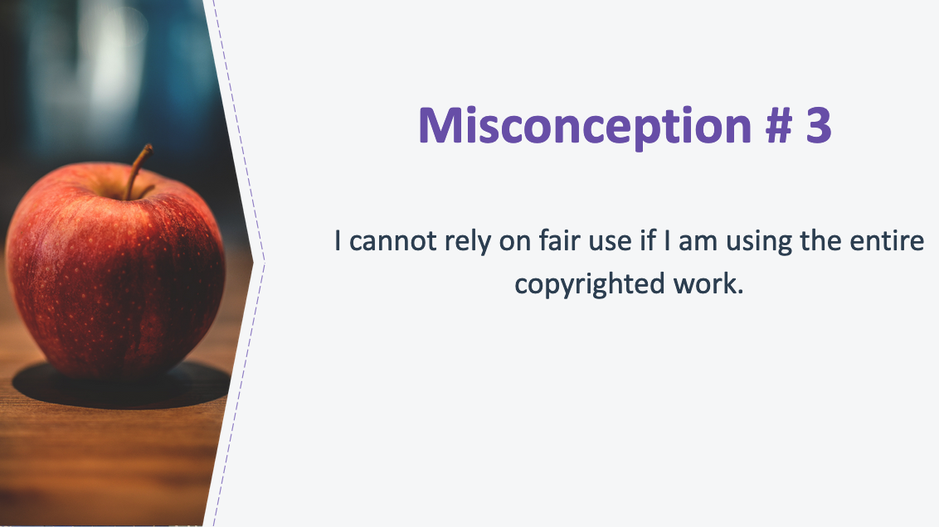
27. Misconception #3
Another common misconception is that an author cannot rely on fair use if she is using the entire copyrighted work.

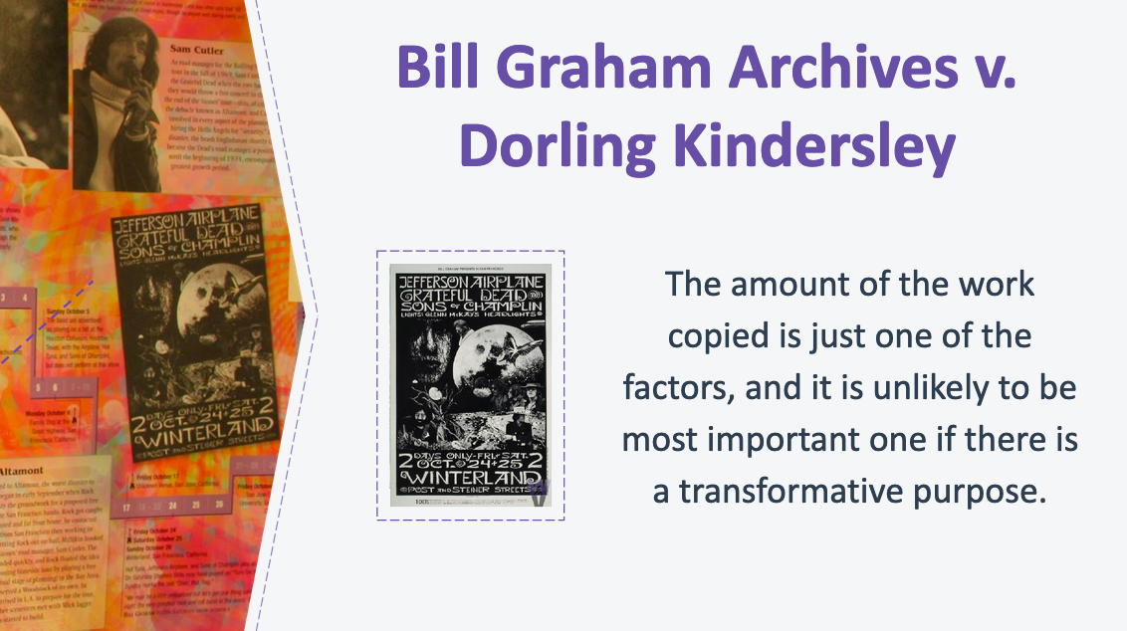
28. Bill Graham Archives v. Dorling Kindersley
In some situations, courts have found use of an entire work to be fair. For example, recall the Google Books case we discussed in terms of non-consumptive uses: Google copied millions of books in order to enable full-text searching of the books.

Here’s another example. DK Guides produced a coffee table book that included information and images related to the Grateful Dead, including copies of seven Grateful Dead event posters reproduced as thumbnails along a timeline together with captions describing the events. The court concluded that copying the entire work did not weigh against fair use because copying the entirety of the work was necessary for the use, especially since the image size and quality was the minimum necessary to ensure the reader’s recognition of the images as historical artifacts of Grateful Dead concert events.
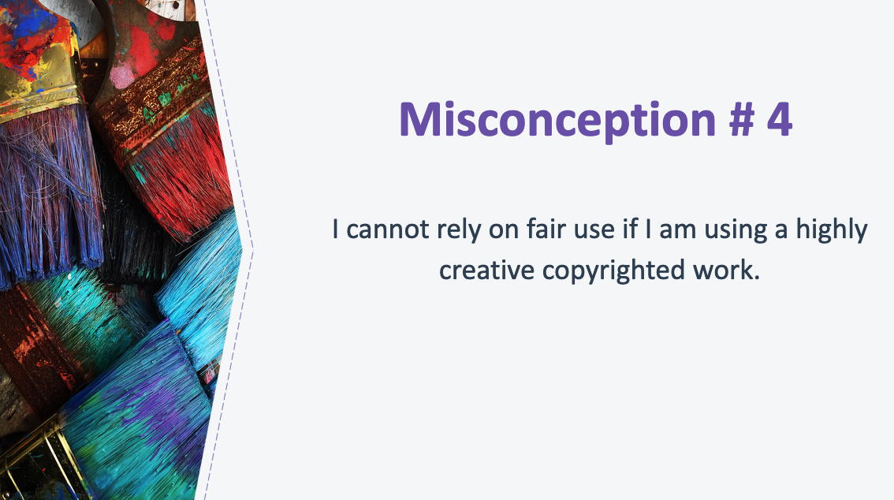

29. Misconception #4
Another misconception is that an author cannot rely on fair use if he is using a highly creative copyrighted work.

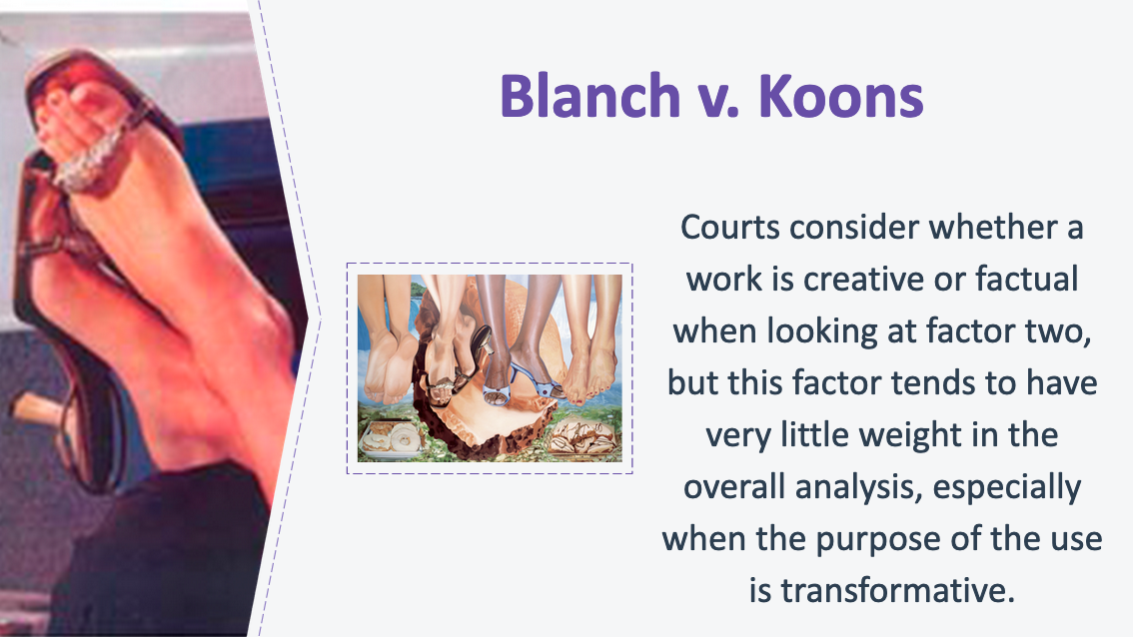
30. Blanch v. Koons
While courts do consider whether the copyrighted material used is primarily factual or creative under the second factor, “the nature of the work,” this factor is rarely decisive on its own. Courts still must weigh all four factors, including the “purpose of the use.” Where the purpose of the use is transformative, such as when a nonfiction author comments on copyrighted material or uses copyrighted material to support a point, and the amount used is reasonable, the second factor rarely affects the final outcome of fair use cases.

This slide shows an example of this. Artist Jeff Koons incorporated “Silk Sandals,” a photograph by Andrea Blanch that was used in an advertisement, into a commissioned collage painting. Although the photograph was creative in nature, the second factor had little weight given Koons’ transformative purpose (using the image “to satirize life as it appears when seen through the prism of slick fashion photography”).

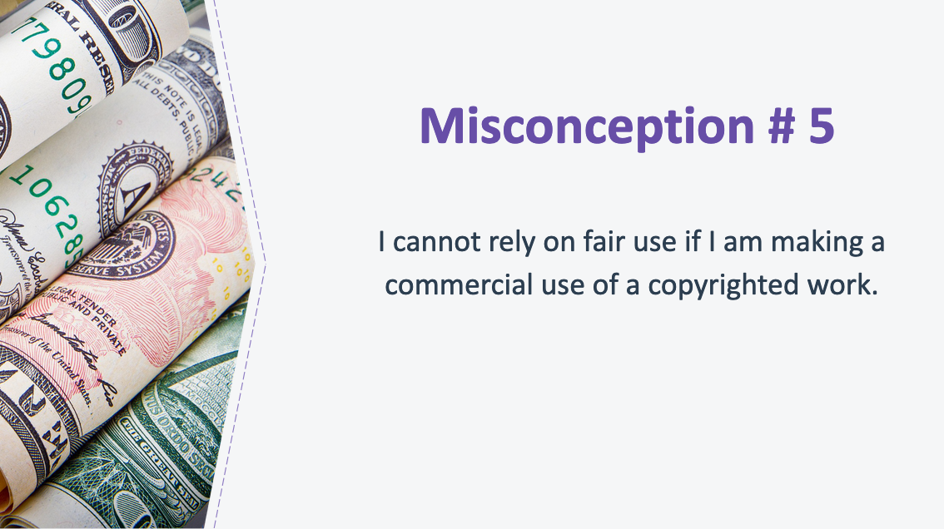

31. Misconception #5
And the final misconception we’ll debunk is that an author cannot rely on fair use if she is making a commercial use of a copyrighted work.

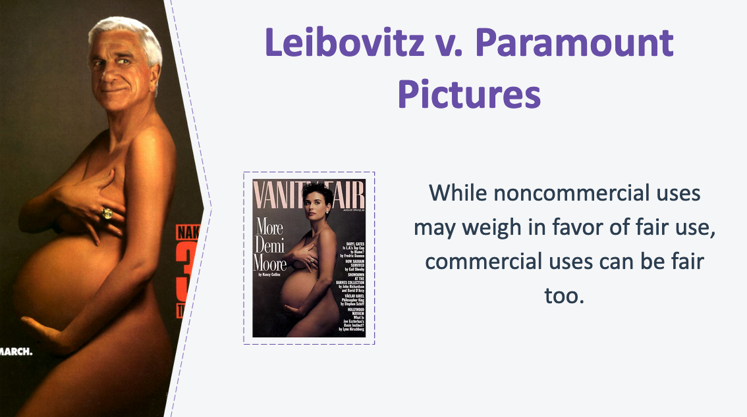

32. Leibovitz v. Paramount Pictures
While “noncommercial” uses may be a plus in a fair use analysis, there are no categorical rules: Commercial uses can be fair use, and not all noncommercial uses will be fair use. In fact, some of the important court victories for fair use over the past two decades have been won by defendants whose activities were commercial, including musicians, publishers, and artists who sell their work (sometimes at substantial prices).

A court found that a Paramount ad for the film Naked Gun 33¹⁄₃ that parodied Annie Leibovitz’s photograph of a pregnant Demi Moore was fair use. While the court did discount the strength of the fair use argument because the ad promoted a commercial product, overall the court held that the use was fair, in large part because it commented, through ridicule, on what a viewer might reasonably think is the undue self-importance conveyed by the subject of the Leibovitz photograph.

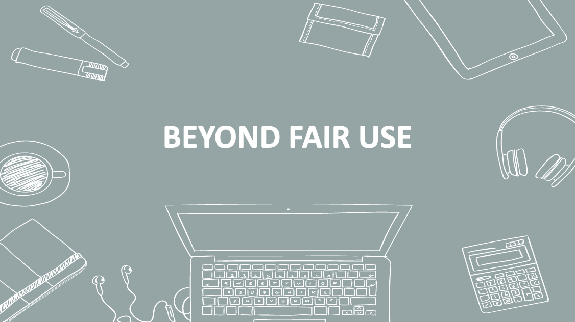
33. Beyond Fair Use
Before I open up to questions, let’s take a moment to look at a few topics beyond fair use: 1) how to proceed if your intended use is not likely to be fair, and 2) considerations outside of copyright law.

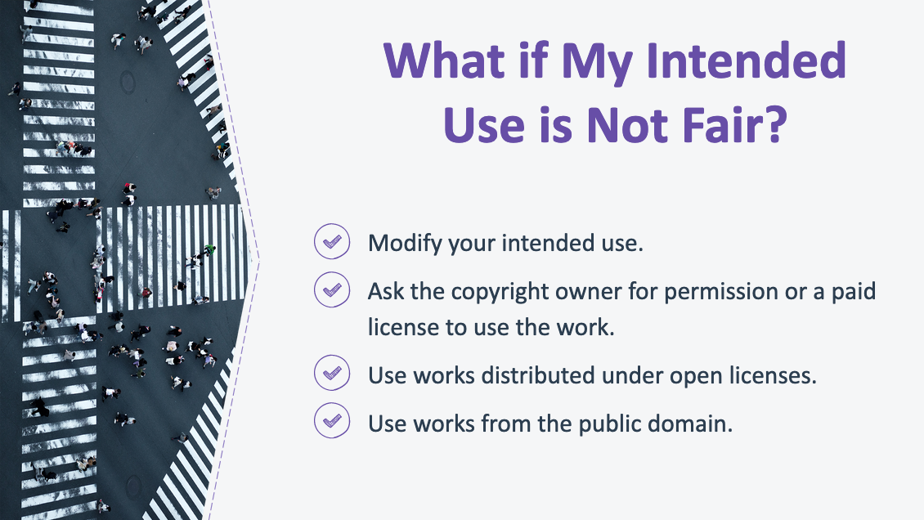
34. What if My Intended Use is Not Fair Use?
Even if your intended use of a copyrighted work doesn’t qualify as a fair use, there are still ways you might be able to use the work (or something similar). If your intended use is unlikely to be a fair use, there are still options you might explore:

- Modify your intended use: If your intended use doesn’t fit within the principles and limitations we reviewed, consider modifying your intended use to bring it within the bounds of fair use. For example, you may find that using less of the copyrighted work, providing additional context for the work, or adding additional commentary to your text might make your fair use case stronger.

- Ask the copyright owner for permission or a paid license to use the work: Some copyright owners may allow others to reproduce and use their works at no cost, others might offer a license for the use of their copyrighted works in exchange for payment. Since the cost and restrictions imposed on licensed works vary widely, it’s important to pay close attention to the terms of the license.

- Use works distributed under open licenses: Some works are available under open licenses (such as Creative Commons licenses) that allow for specific uses without the need to seek additional permission from the owner. You may find that a work licensed in this way is available and suitable for your project. For example, increasingly, museums are distributing photographs of works in their collections under open access licenses. (Again, be aware of the terms of the license to make sure it is compatible with your intended use.)

- Use works from the public domain: Works that are not protected by copyright are in the “public domain” and may be freely copied (unless other restrictions apply, such as those imposed by contractual restrictions we’ll discuss in a minute). Works may enter the public domain because their copyright protection expired, because they are not eligible for copyright protection, or because the copyright owner dedicated the work to the public domain. You may find that a public domain work is available and suitable for your needs.

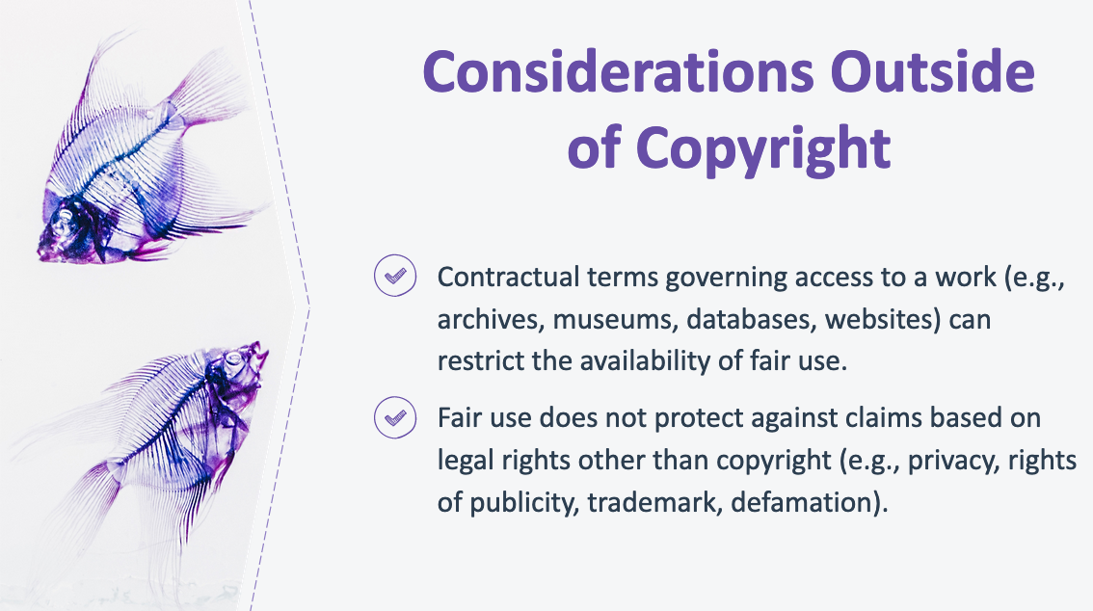
35. Considerations Outside of Copyright
It is important for authors to be aware that contractual terms governing access to a work can restrict the availability of fair use. Some archives, museums, and commercial collections (including on websites) place contractual restrictions on the use of those works, even when use of the work would otherwise be permitted by fair use (and, in some cases, even when the work itself is in the public domain!).

This is beginning to change, and some archives and museums have already abandoned these practices. However, if you are a party to such a contract, your ability to use materials you’ve accessed may be limited by the terms of the contract. For example, a biographer who accesses her subject’s personal papers through an archive may find that, as a condition of accessing those materials, the subject’s estate forbids quoting from the materials without the express permission of the estate. Similarly, an art critic may find that he has agreed to terms governing the use of photographs he accessed through an online archive.

At least some courts have held that such contracts may be enforced, even if the restricted use would be fair use as a matter of copyright law. In these cases, nonfiction authors cannot rely on fair use since demands for permission in this context are based on contractual claims, not copyright. As such, nonfiction authors should pay careful attention to the conditions of access to source materials and may want to consider negotiating for better terms that do not restrict their research and writing goals.

It is important for authors to be aware that fair use is a limitation on exclusive rights under copyright and does not apply to other legal claims. When using third party materials, authors should consider legal issues beyond copyright, such as potential contractual restrictions we just discussed, privacy rights, trademark law, right of publicity, defamation, and community norms, like rules against academic plagiarism.

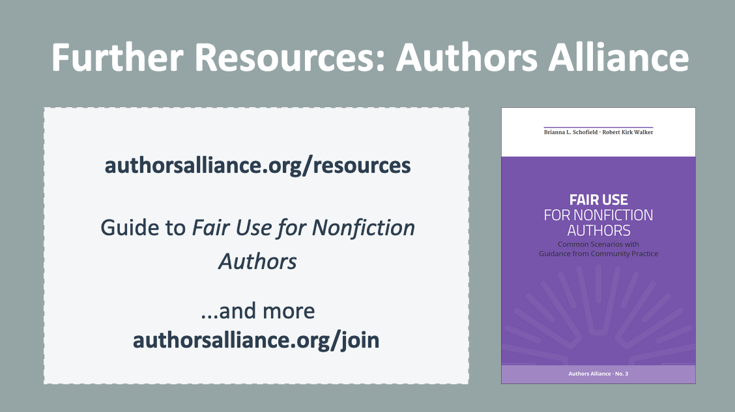
36. Further Resources
I hope today’s presentation helped you to understand when you can rely on fair use to incorporate copyrighted works into your writing. I encourage you to check out additional resources created by Authors Alliance, a nonprofit organization that helps authors understand and manage their rights. This presentation is based on the Authors Alliance guide to Fair Use For Nonfiction Authors, which is freely available online. Authors Alliance membership is free; please consider joining as an individual member to receive updates about their new resources and to learn more about leveraging your rights as an author.
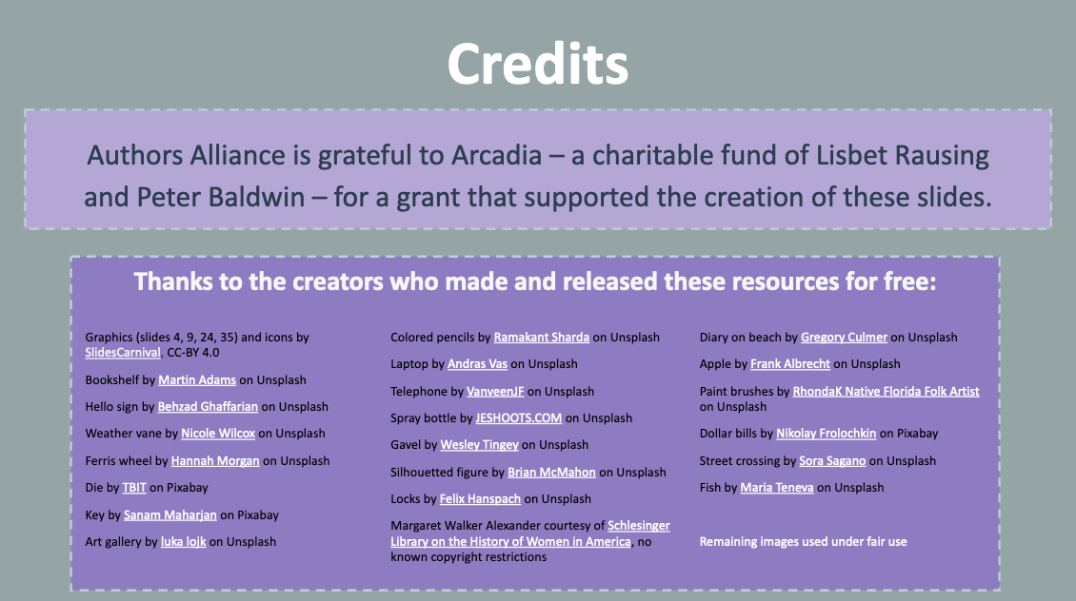

37. Credits

Authors Alliance is grateful to Arcadia—a charitable fund of Lisbet Rausing and Peter Baldwin—for a grant that supported the creation of these materials.

