Fair Use For Nonfiction Authors
  - Overview

What is fair use?

Fair use is a feature of copyright law that, under certain conditions, permits the use of copyrighted works without permission or payment.

Four fair use factors

To decide whether a use is fair, courts must consider at least four factors that are specifically mentioned in the Copyright Act. The four factors are not mechanically applied or weighed equally. By design, fair use is flexible and courts take into account all the facts and circumstances of a specific case to decide if an unlicensed use of copyrighted material is fair. The four factors are:

Factor One: The purpose and character of the use.
Under this factor, courts often ask whether the material been transformed by adding new meaning or expression. When a work is used for a different purpose than the original, the factor will likely weigh in favor of fair use. If it simply acts as a substitute for the original work, the less likely it is to be fair. Courts may also look at whether the use of the material was for commercial or noncommercial purposes under this factor (and favor noncommercial uses), but this is rarely a determinative consideration.

Factor Two: The nature of the copyrighted work.
Under this factor, courts look at whether the copyrighted work that was used is creative or factual in nature. The more factual the work, the more likely this factor is to weigh in favor of fair use. On the flip side, the more creative the copyrighted work, the more likely this factor is to weigh against fair use. Courts may also consider whether the copyrighted work is published or unpublished. If the work is unpublished, this factor is less likely to weigh in favor or fair use.

Factor Three: The amount and substantiality of the portion taken.
Under this factor, courts look at how much for the work was taken, both quantitatively and qualitatively. The more that is taken, quantitatively and qualitatively, the less likely the use is to be fair. That said, copying of full work can still be fair. And conversely, in some cases, even if a small amount is used if it is the “heart” of the work this can weigh against fair use.

Factor Four: The effect of the use on the potential market.
The essential question courts ask under this factor is whether this use will harm the market, or potential market, for the work that was copied (for example, by displacing sales of the original) or whether the use could cause substantial harm if it were to become widespread.

Principles and limitations of fair use for common situations nonfiction authors face

Situation | Principle | Limitations
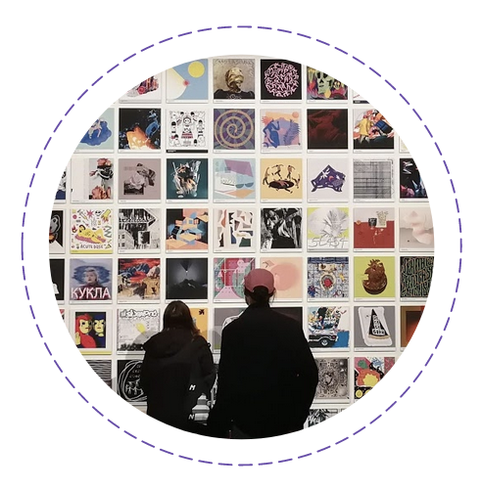  Criticizing, commenting on, or discussing copyrighted material | Fair use applies when the copyrighted material is being used for the purposes of criticism, commentary, or discussion of the work itself. | The amount copied should be reasonably appropriate in light of the analytical purpose.  The use of copyrightable material should be justified by the analytical purpose.  Reasonable attribution should be given to the author of the copyrighted material.
Using copyrighted material to illustrate, support, or prove an argument or point | Fair use applies when the copyrighted material is being used to illustrate, support, or prove an argument or a point. | The amount copied should be reasonable in light of the illustrative purpose.  The copyrighted material should not be reproduced for its intrinsic, expressive purpose. Uses that are solely decorative or entertaining should be avoided.  Reasonable attribution should be given to the author of the copyrighted material.
Using copyrighted material for non-consumptive research | It is fair use for nonfiction authors to develop digital databases in order to perform non-consumptive analysis of copyrighted materials for both scholarly and reference purposes. | Copyrighted material digitized for non-consumptive uses should not be employed in other ways (e.g., to provide digital access for ordinary reading) without independent justification, either by a license from the rights holder or pursuant to a statutory exception.

What if my intended use is not fair use?

Even if your intended use of a copyrighted work doesn’t qualify as a fair use, there are still ways you might be able to use the work (or something similar). If your intended use is unlikely to be a fair use, there are still options you might explore:

- Modify your intended use: If your intended use doesn’t fit within the principles and limitations we reviewed, consider modifying your intended use to bring it within the bounds of fair use. For example, you may find that using less of the copyrighted work, providing additional context for the work, or adding additional commentary to your text might make your fair use case stronger.

- Ask the copyright owner for permission or a paid license to use the work: Some copyright owners may allow others to reproduce and use their works at no cost, while others might offer a license for the use of their copyrighted works in exchange for payment.

- Use works distributed under open licenses: Some works are available under open licenses (such as Creative Commons licenses) that allow for specific uses without the need to seek additional permission from the owner. For example, increasingly, museums are distributing photographs of works in their collections under open access licenses.

- Use works from the public domain: Works that are not protected by copyright are in the “public domain” and may be freely copied (unless other restrictions apply, such as those imposed by contractual restrictions). Works may enter the public domain because their copyright protection expired, because they are not eligible for copyright protection, or because the copyright owner dedicated the work to the public domain.

Considerations beyond fair use

It is important for authors to be aware that fair use is a limitation on exclusive rights under copyright and does not apply to other legal claims. When using third party materials, authors should consider legal issues beyond copyright, such as contractual terms governing access to a work that restrict the availability of fair use, privacy rights, trademark law, right of publicity, and defamation; and community norms, like rules against academic plagiarism.

Authors Alliance is grateful to Arcadia—a charitable fund of Lisbet Rausing and Peter Baldwin—for a grant that supported the creation of these materials.

