Fair Use For Nonfiction Authors
  - Presentation Notes

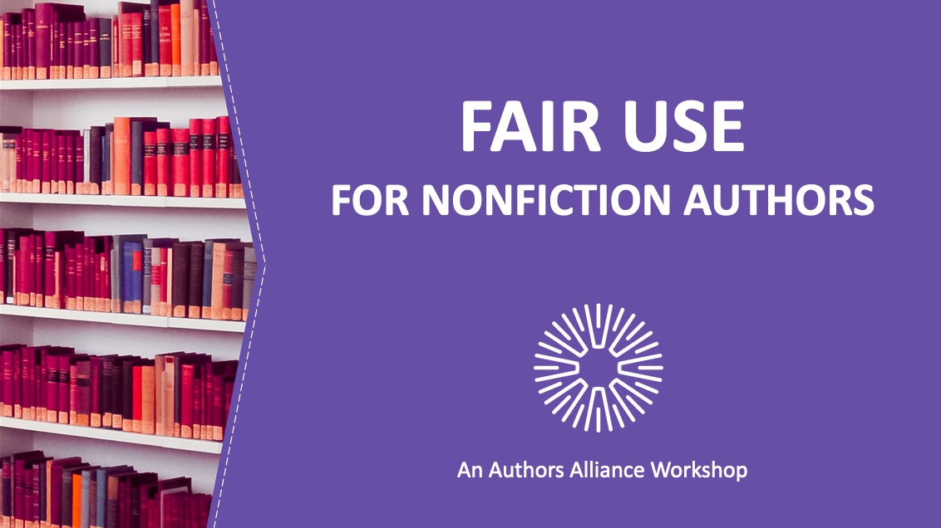

1. Fair Use for Nonfiction Authors
__________________________________________________

__________________________________________________
__________________________________________________

__________________________________________________

__________________________________________________________________________________________

__________________________________________________________________________________________

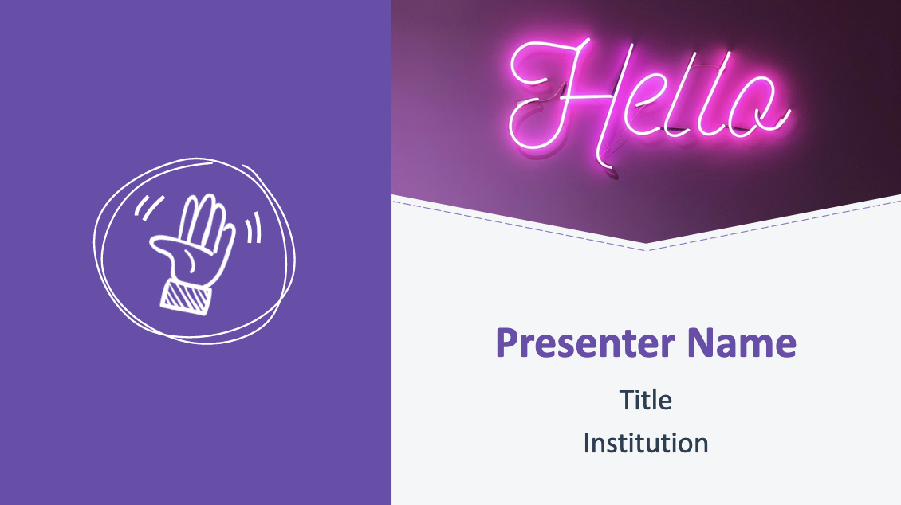

2. Hello!

__________________________________________________

__________________________________________________
__________________________________________________

__________________________________________________

__________________________________________________________________________________________

__________________________________________________________________________________________

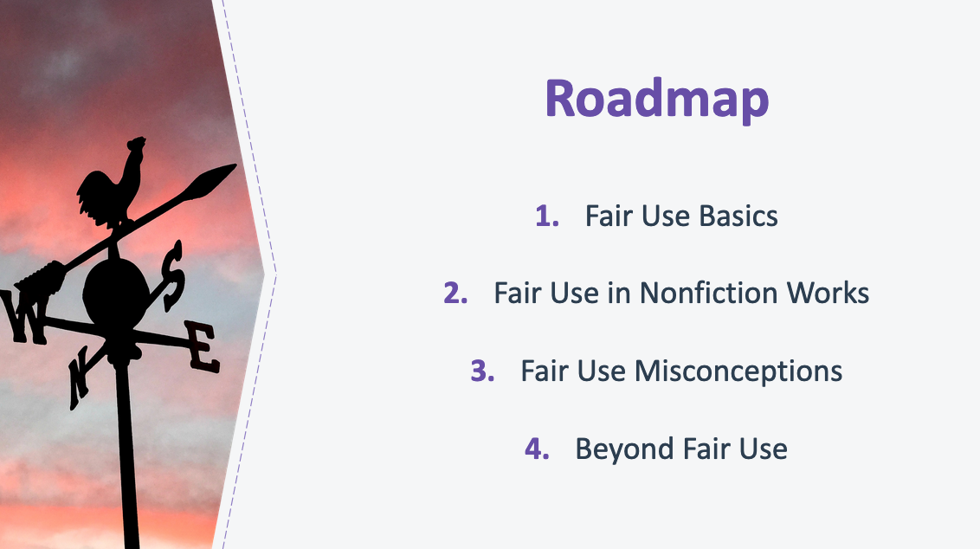

3. Roadmap
__________________________________________________

__________________________________________________
__________________________________________________

__________________________________________________

__________________________________________________________________________________________

__________________________________________________________________________________________
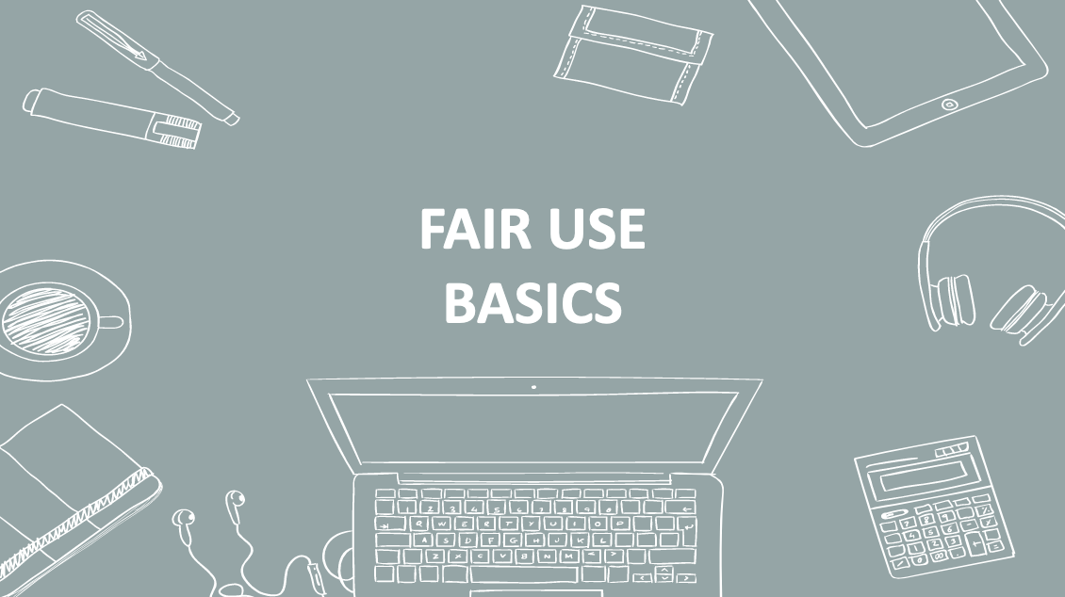

4. Fair Use Basics
__________________________________________________

__________________________________________________
__________________________________________________

__________________________________________________

__________________________________________________________________________________________

__________________________________________________________________________________________

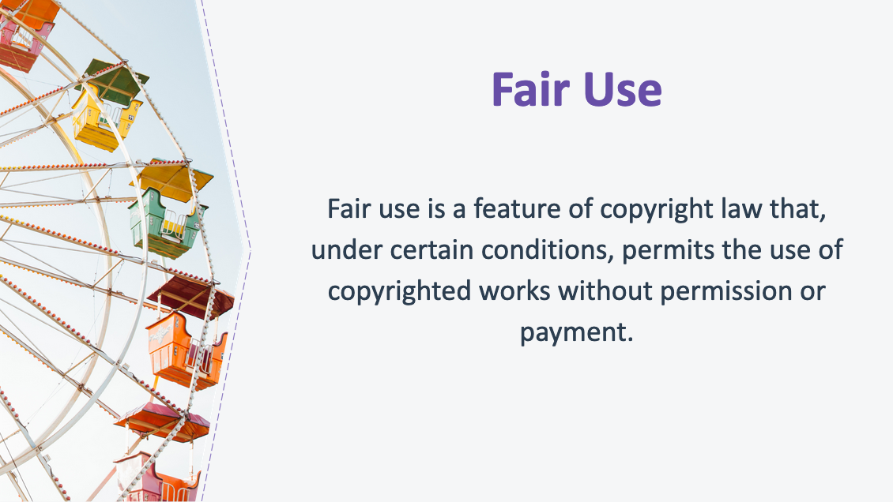
5. Fair Use
__________________________________________________

__________________________________________________
__________________________________________________

__________________________________________________

__________________________________________________________________________________________

__________________________________________________________________________________________

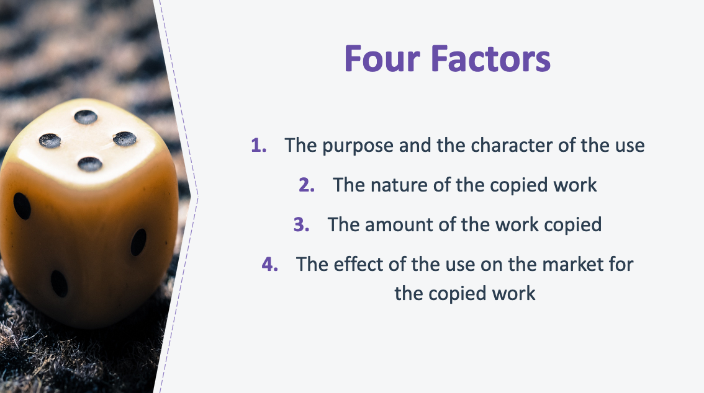

6. Four Factors
_________________________________________________

_________________________________________________
_________________________________________________

_________________________________________________

__________________________________________________________________________________________

__________________________________________________________________________________________
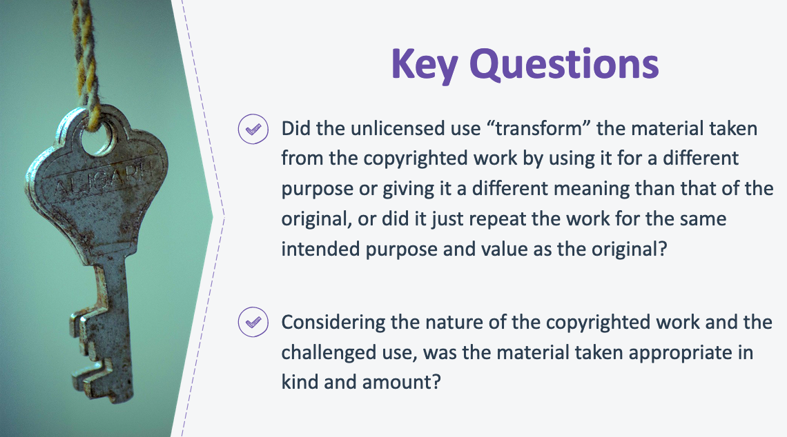

7. Key Questions
_________________________________________________

_________________________________________________
_________________________________________________

_________________________________________________

__________________________________________________________________________________________

__________________________________________________________________________________________

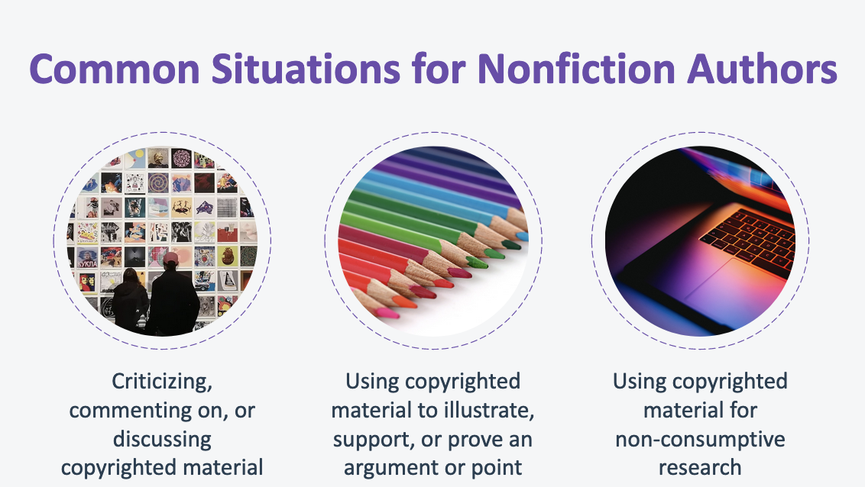

8. Common Situations for Nonfiction Authors
_________________________________________________

_________________________________________________
_________________________________________________

_________________________________________________

__________________________________________________________________________________________

__________________________________________________________________________________________

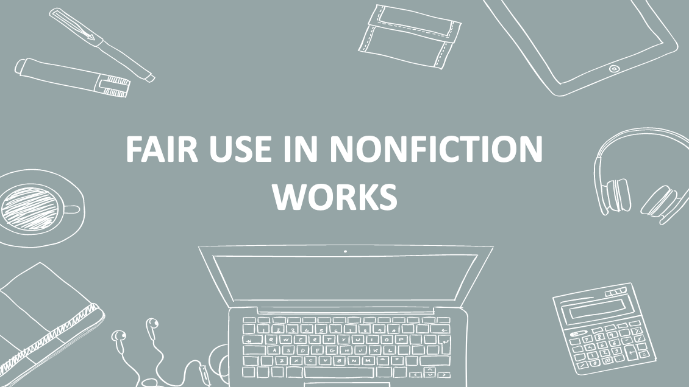
9. Fair Use in Nonfiction Works
_________________________________________________

_________________________________________________
_________________________________________________

_________________________________________________

__________________________________________________________________________________________

__________________________________________________________________________________________

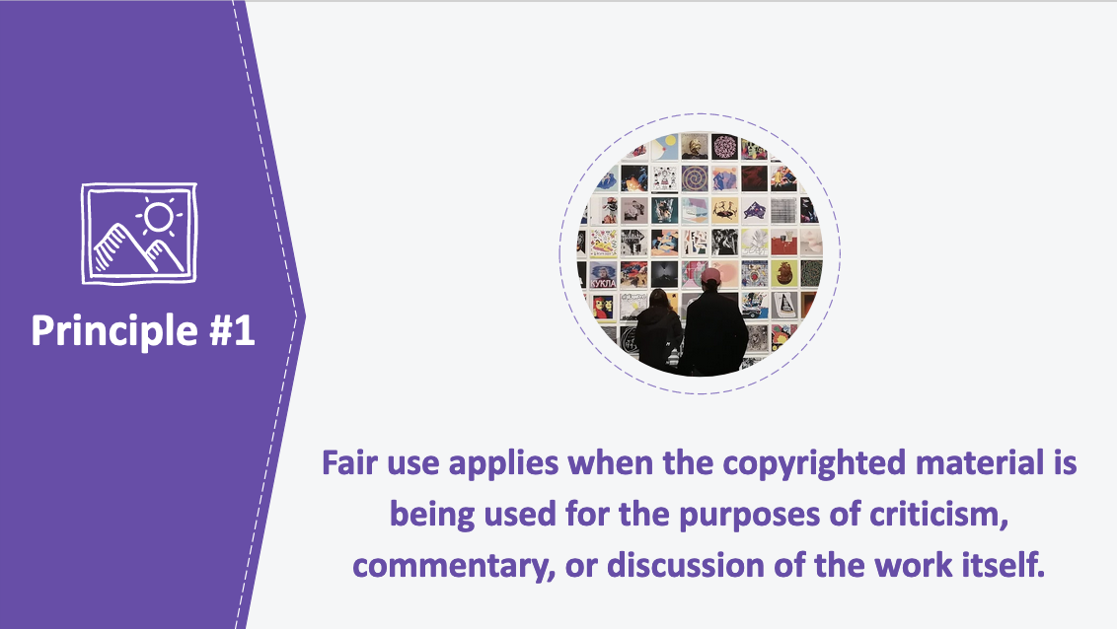

10. Principle #1
_________________________________________________

_________________________________________________
_________________________________________________

_________________________________________________

__________________________________________________________________________________________

__________________________________________________________________________________________

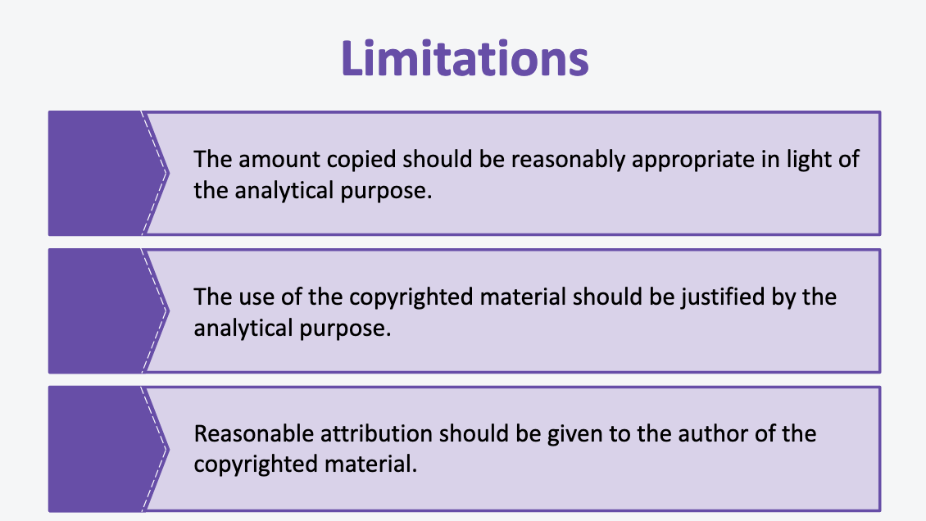

11. Limitations
_________________________________________________

_________________________________________________
_________________________________________________

_________________________________________________

__________________________________________________________________________________________

__________________________________________________________________________________________

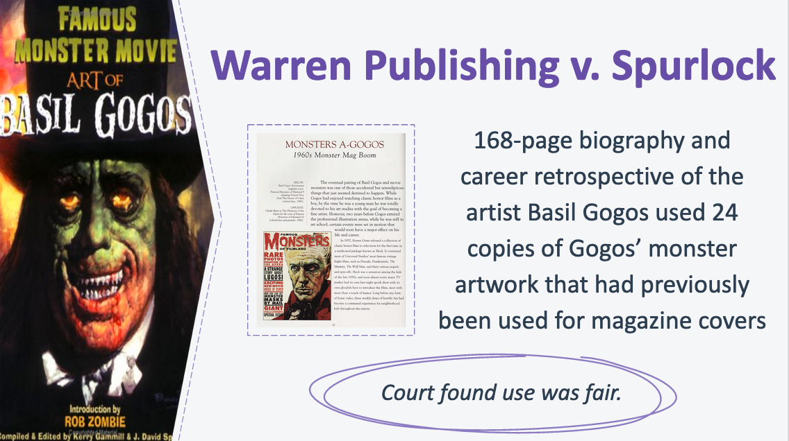

12. Warren Publishing v. Spurlock
_________________________________________________

_________________________________________________
_________________________________________________

_________________________________________________

__________________________________________________________________________________________

__________________________________________________________________________________________

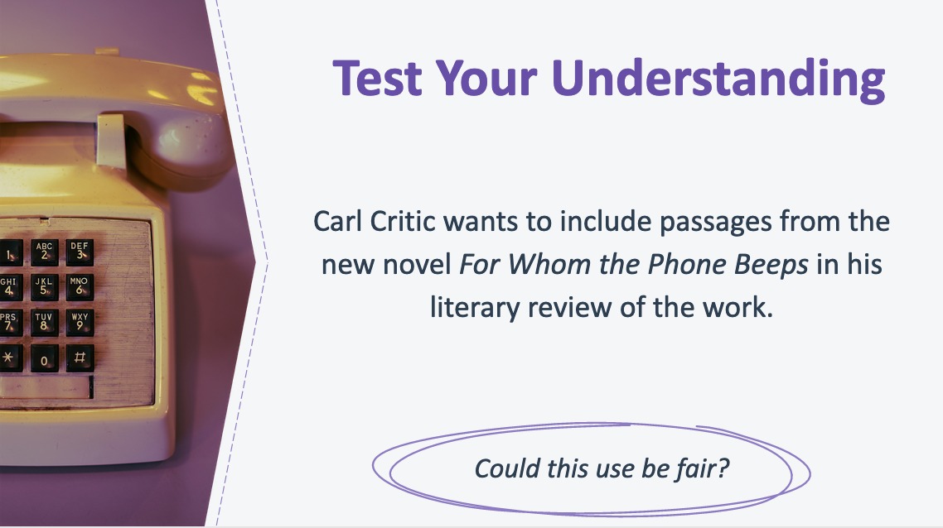

13. Test Your Understanding
_________________________________________________

_________________________________________________
_________________________________________________

_________________________________________________

__________________________________________________________________________________________

__________________________________________________________________________________________

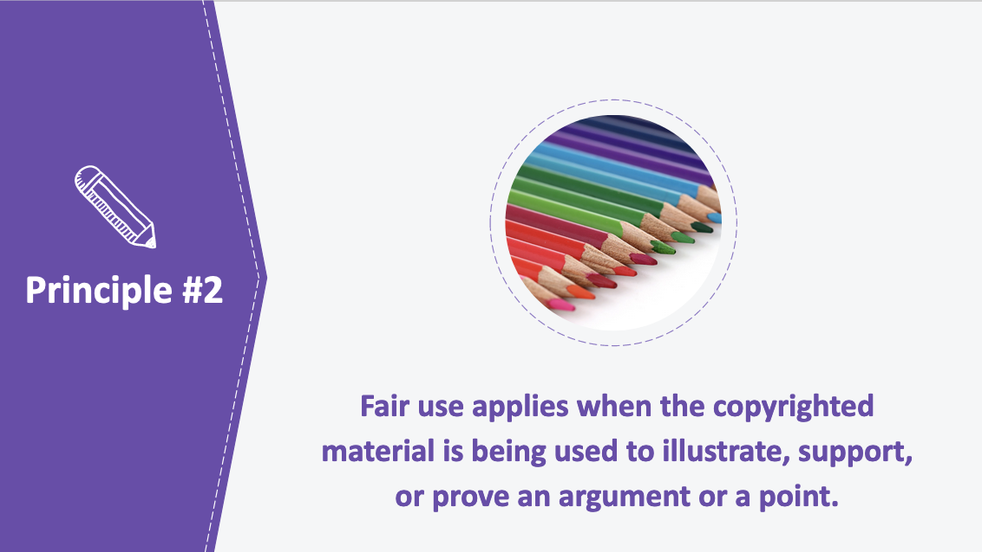
14. Principle #2
_________________________________________________

_________________________________________________
_________________________________________________

_________________________________________________

__________________________________________________________________________________________

__________________________________________________________________________________________

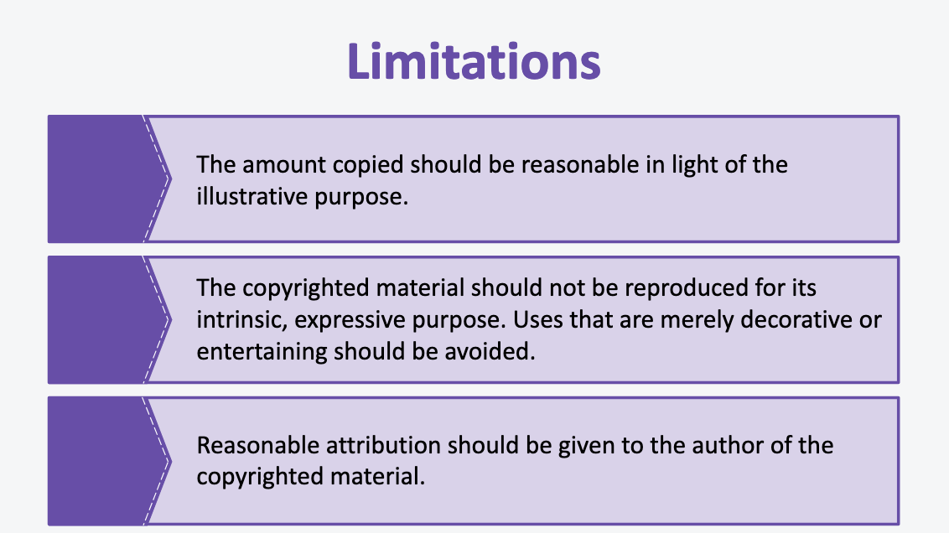

15. Limitations
_________________________________________________

_________________________________________________
_________________________________________________

_________________________________________________

__________________________________________________________________________________________

__________________________________________________________________________________________

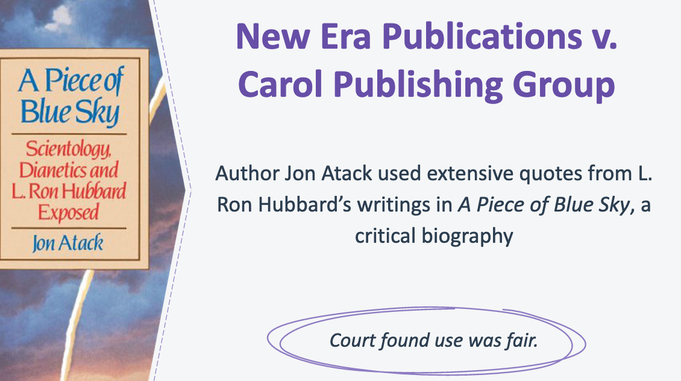
16. New Era Publications v. Carol Publishing Group
_________________________________________________

_________________________________________________
_________________________________________________

_________________________________________________

__________________________________________________________________________________________

__________________________________________________________________________________________

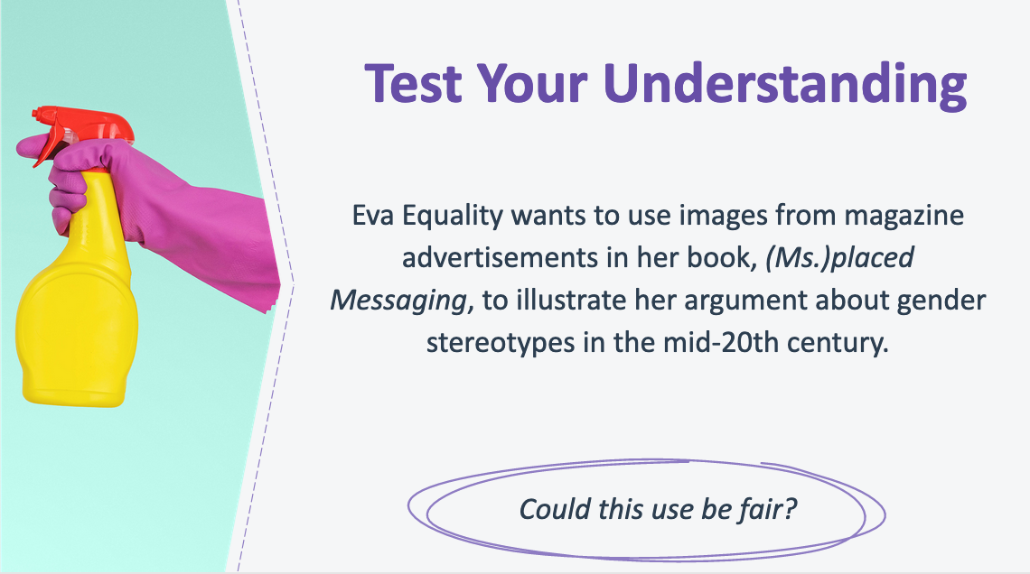
17. Test Your Understanding
_________________________________________________

_________________________________________________
_________________________________________________

_________________________________________________

__________________________________________________________________________________________

__________________________________________________________________________________________

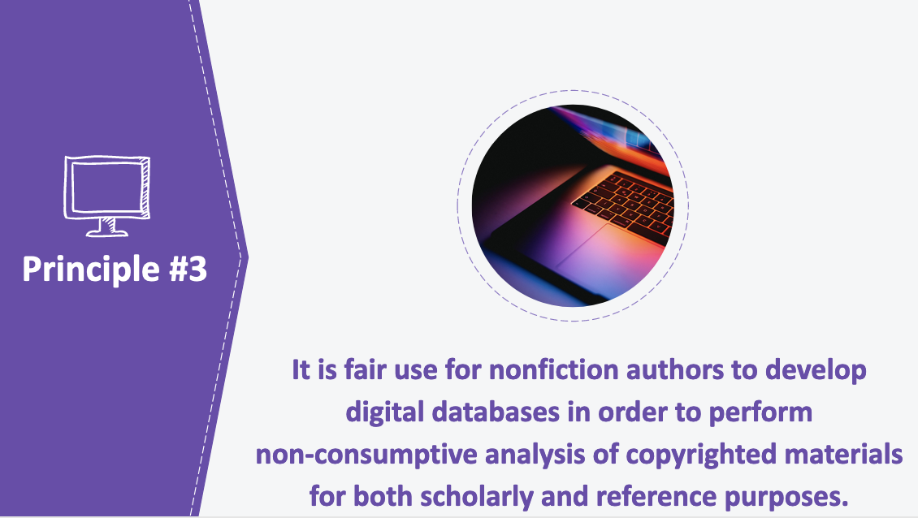

18. Principle #3
_________________________________________________

_________________________________________________
_________________________________________________

_________________________________________________

__________________________________________________________________________________________

__________________________________________________________________________________________

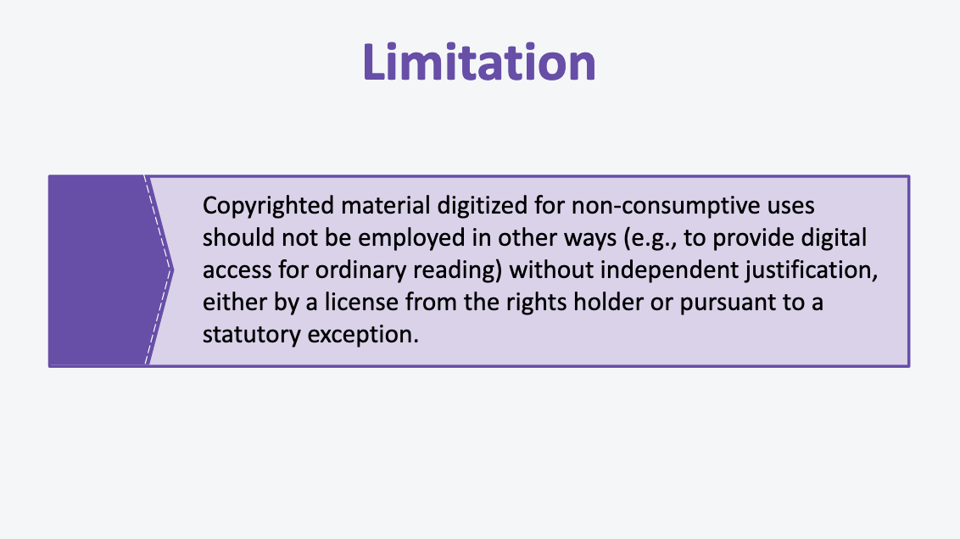

19. Limitation
_________________________________________________

_________________________________________________
_________________________________________________

_________________________________________________

__________________________________________________________________________________________

__________________________________________________________________________________________

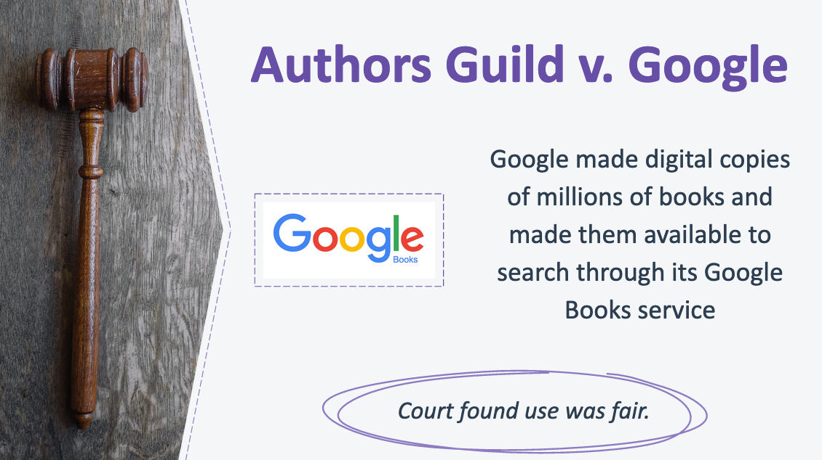

20. Authors Guild v. Google
_________________________________________________

_________________________________________________
_________________________________________________

_________________________________________________

__________________________________________________________________________________________

__________________________________________________________________________________________

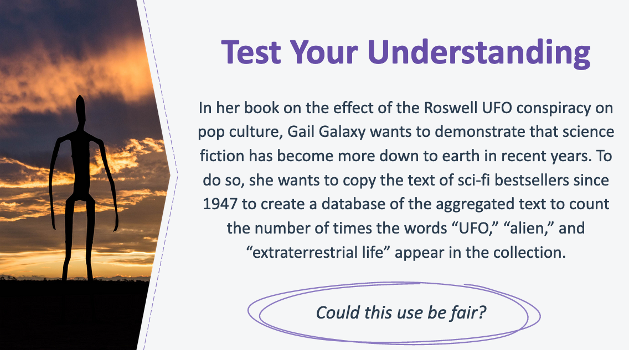
21. Test Your Understanding
_________________________________________________

_________________________________________________
_________________________________________________

_________________________________________________

__________________________________________________________________________________________

__________________________________________________________________________________________

22. Fair Use Misconceptions
_________________________________________________

_________________________________________________
_________________________________________________

_________________________________________________

__________________________________________________________________________________________

__________________________________________________________________________________________

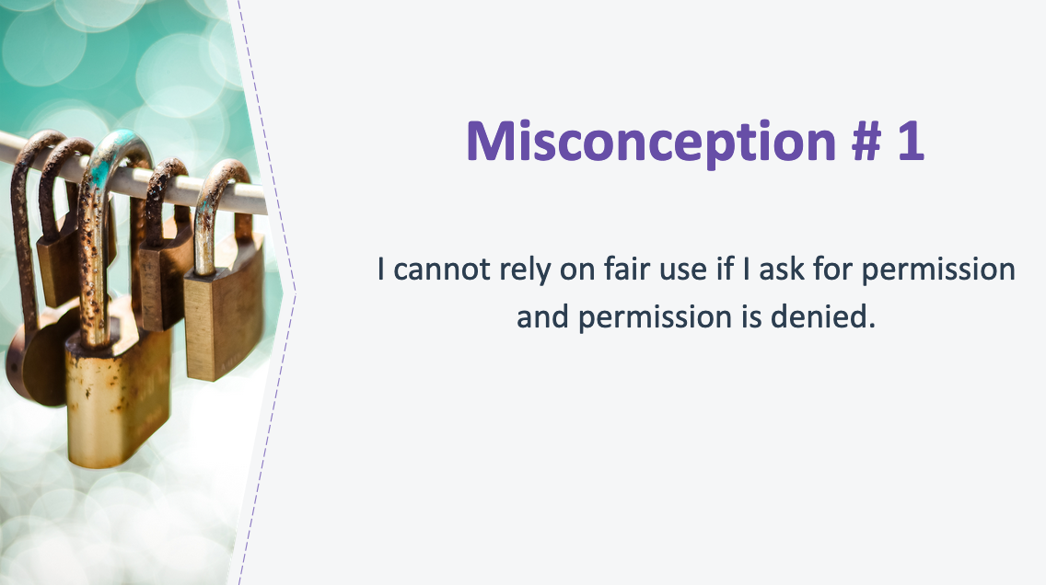
23. Misconception #1
_________________________________________________

_________________________________________________
_________________________________________________

_________________________________________________

__________________________________________________________________________________________

__________________________________________________________________________________________

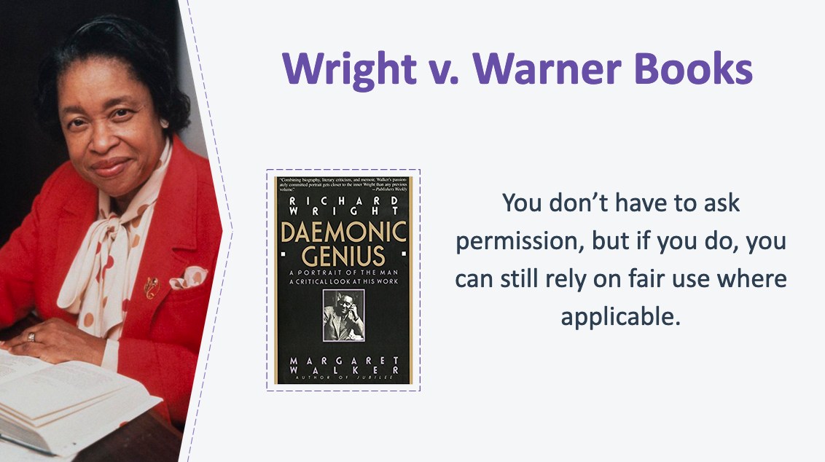
24. Wright v. Warner Books
_________________________________________________

_________________________________________________
_________________________________________________

_________________________________________________

__________________________________________________________________________________________

__________________________________________________________________________________________

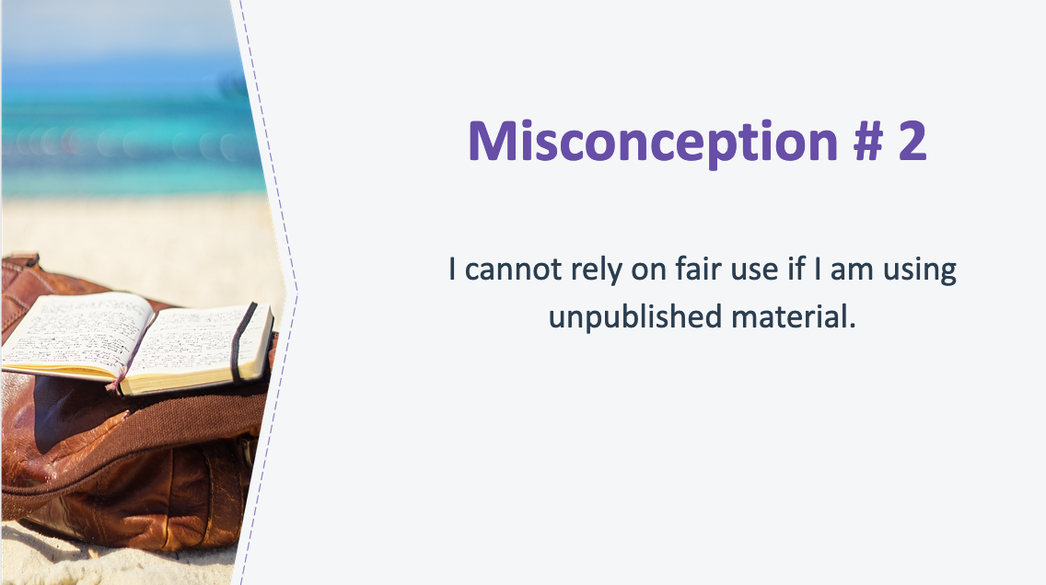

25. Misconception #2
_________________________________________________

_________________________________________________
_________________________________________________

_________________________________________________

__________________________________________________________________________________________

__________________________________________________________________________________________
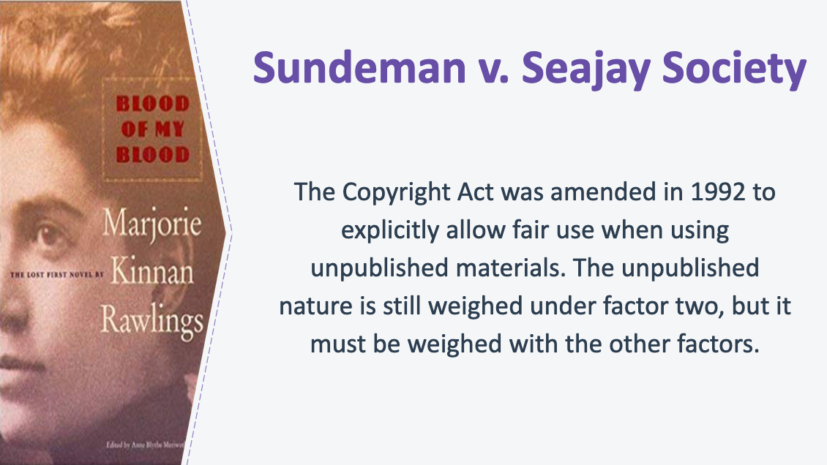

26. Sundeman v. Seajay Society
_________________________________________________

_________________________________________________
_________________________________________________

_________________________________________________

__________________________________________________________________________________________

__________________________________________________________________________________________

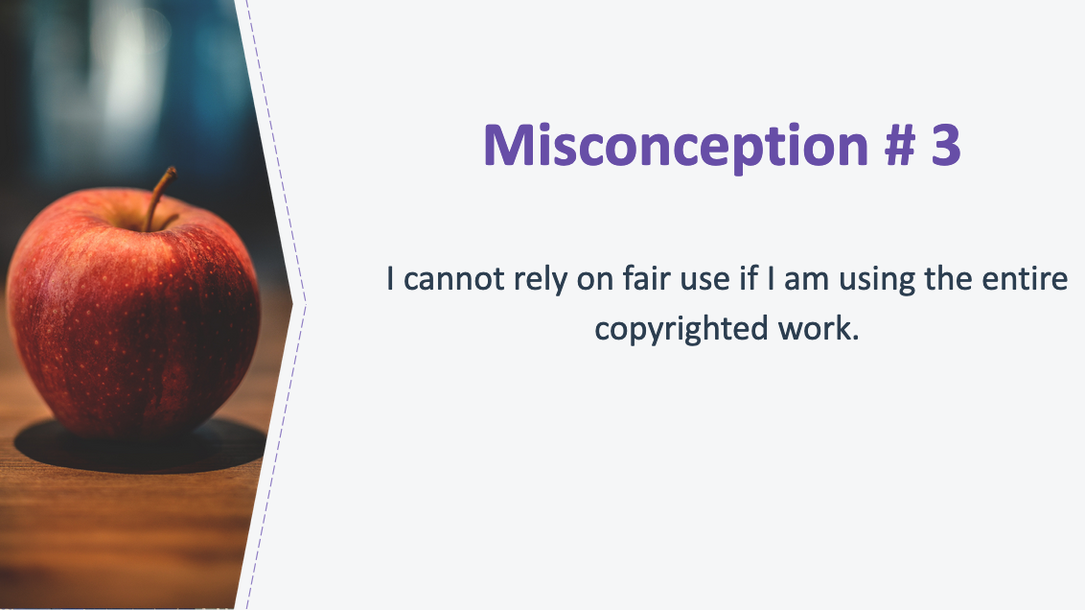
27. Misconception #3
_________________________________________________

_________________________________________________
_________________________________________________

_________________________________________________

__________________________________________________________________________________________

__________________________________________________________________________________________

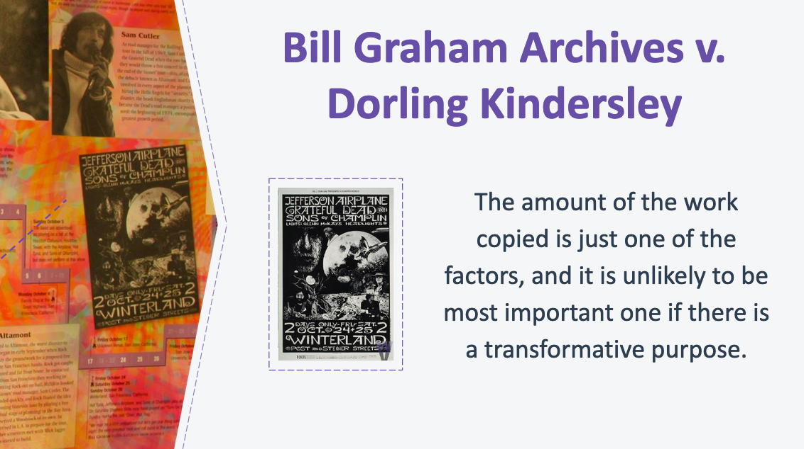
28. Bill Graham Archives v. Dorling Kindersley
_________________________________________________

_________________________________________________
_________________________________________________

_________________________________________________

__________________________________________________________________________________________

__________________________________________________________________________________________
.
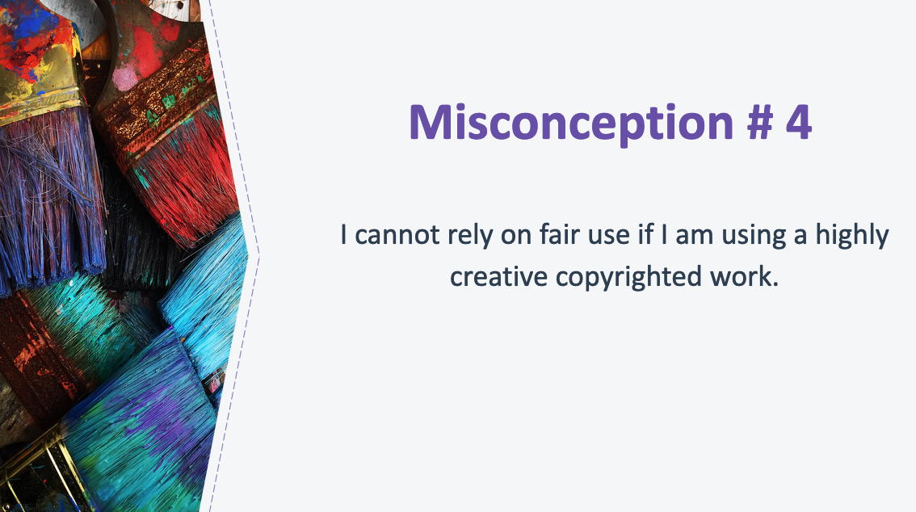

29. Misconception #4
_________________________________________________

_________________________________________________
_________________________________________________

_________________________________________________

__________________________________________________________________________________________

__________________________________________________________________________________________

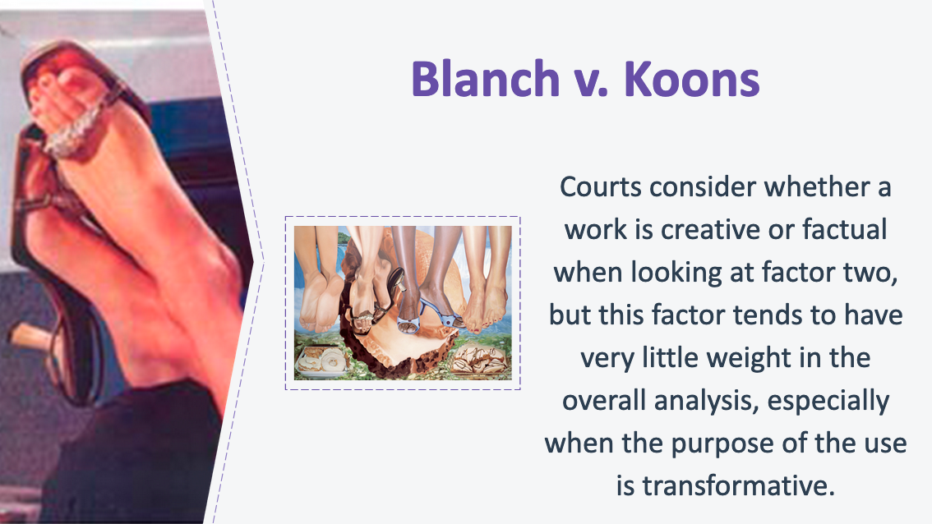
30. Blanch v. Koons
_________________________________________________

_________________________________________________
_________________________________________________

_________________________________________________

__________________________________________________________________________________________

__________________________________________________________________________________________

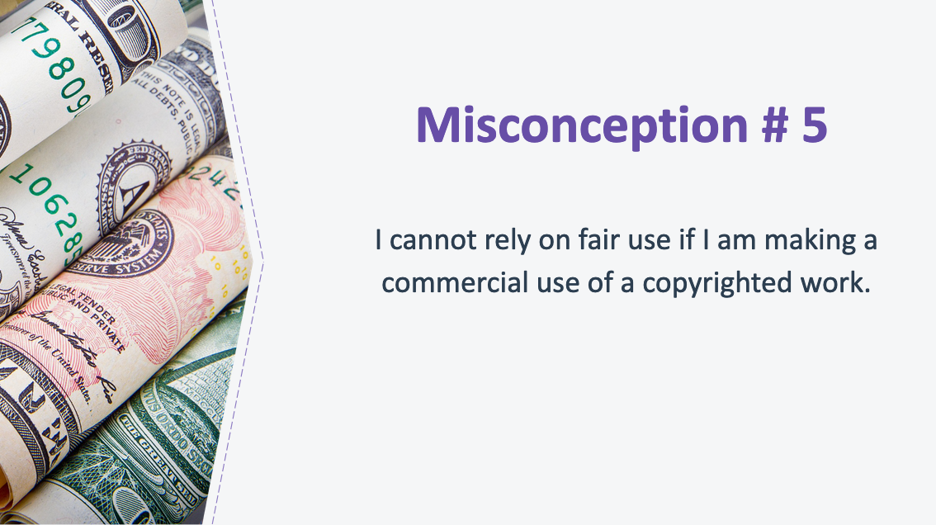
31. Misconception #5
_________________________________________________

_________________________________________________
_________________________________________________

_________________________________________________

__________________________________________________________________________________________

__________________________________________________________________________________________

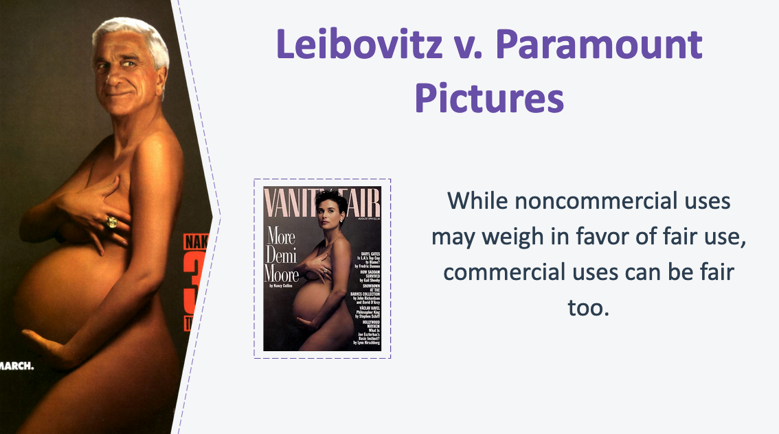

32. Leibovitz v. Paramount Pictures
_________________________________________________

_________________________________________________
_________________________________________________

_________________________________________________

__________________________________________________________________________________________

__________________________________________________________________________________________

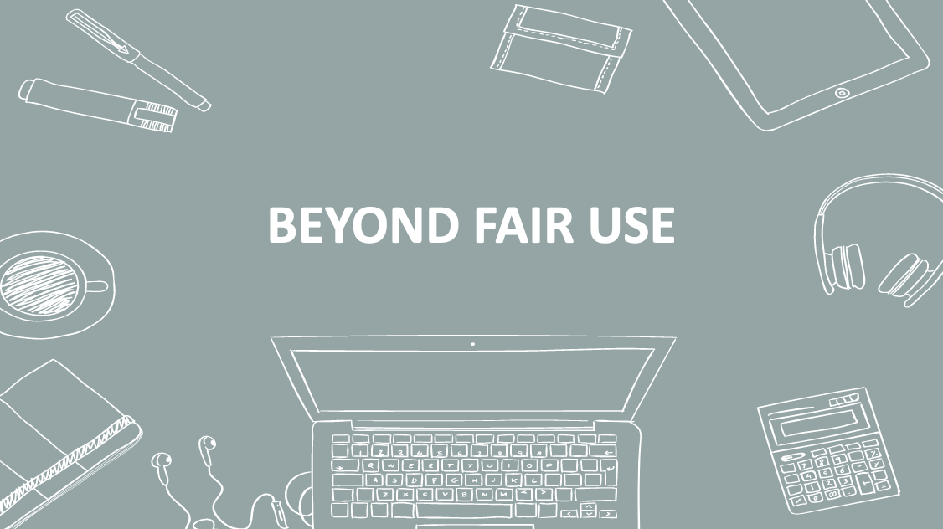
33. Beyond Fair Use
_________________________________________________

_________________________________________________
_________________________________________________

_________________________________________________

__________________________________________________________________________________________

__________________________________________________________________________________________

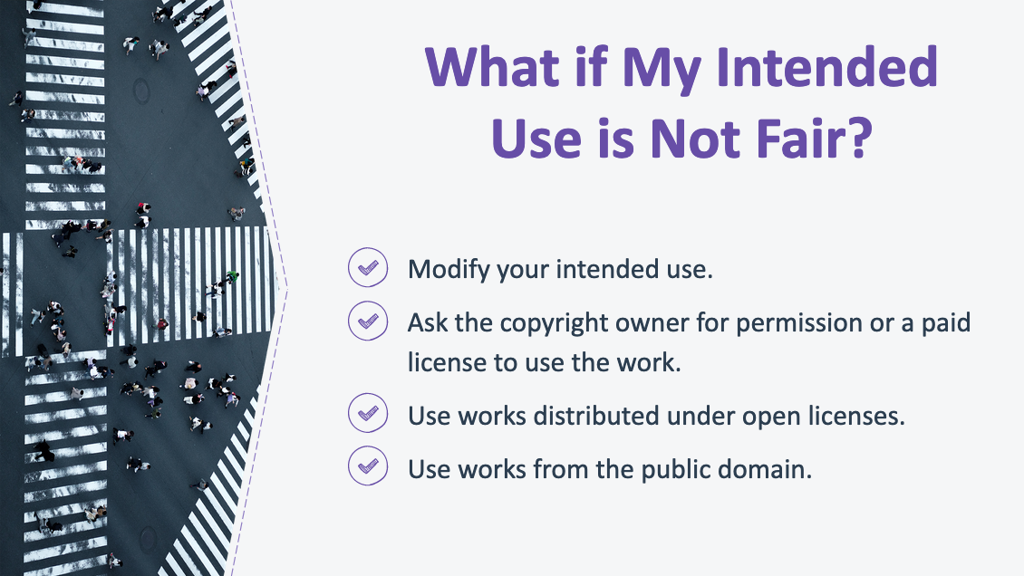
34. What if My Intended Use is Not Fair Use?
_________________________________________________

_________________________________________________
_________________________________________________

_________________________________________________

__________________________________________________________________________________________

__________________________________________________________________________________________

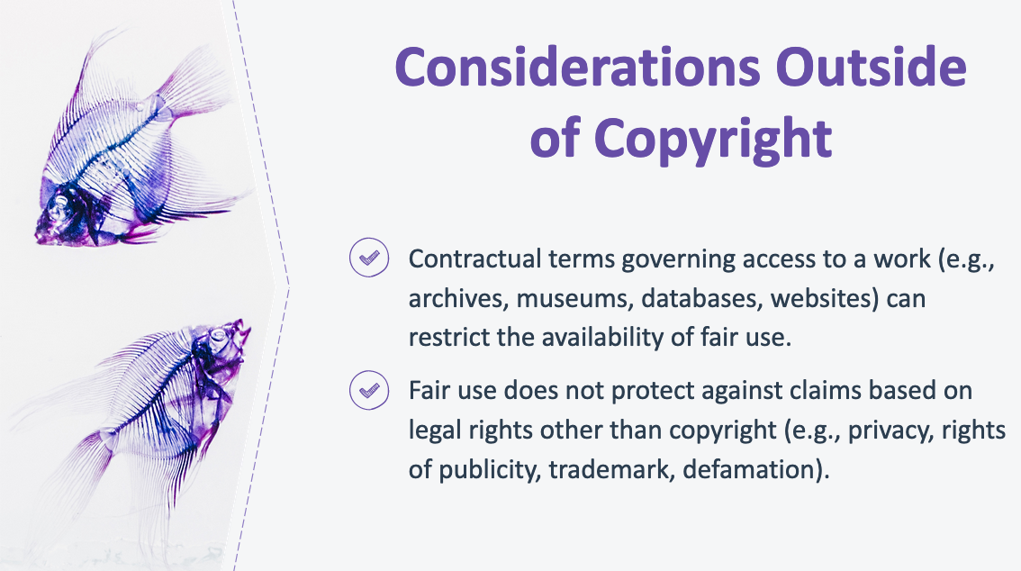
35. Considerations Outside of Copyright
_________________________________________________

_________________________________________________
_________________________________________________

_________________________________________________

__________________________________________________________________________________________

__________________________________________________________________________________________

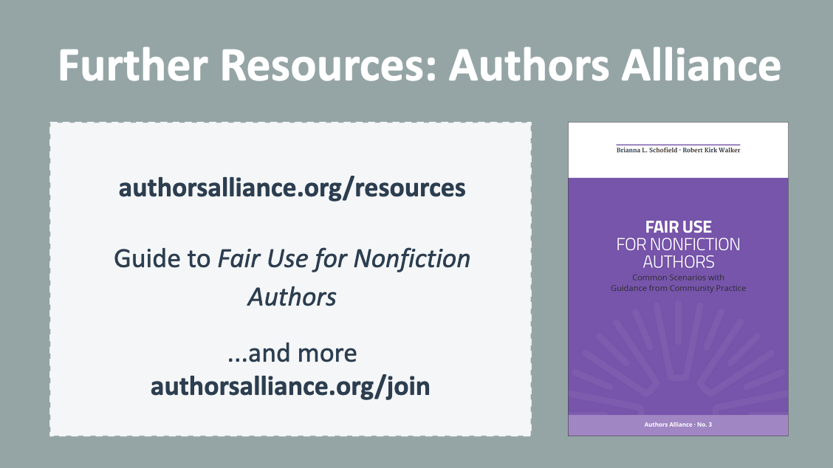
36. Further Resources
_________________________________________________

_________________________________________________
_________________________________________________

_________________________________________________

__________________________________________________________________________________________

__________________________________________________________________________________________

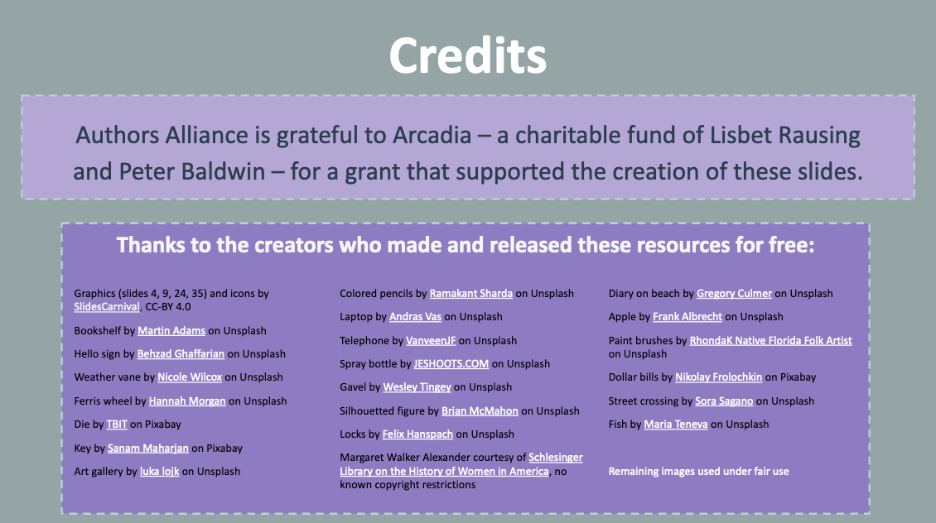

37. Credits

Authors Alliance is grateful to Arcadia—a charitable fund of Lisbet Rausing and Peter Baldwin—for a grant that supported the creation of these materials.

