Understanding Open Access
  - Presenter Notes

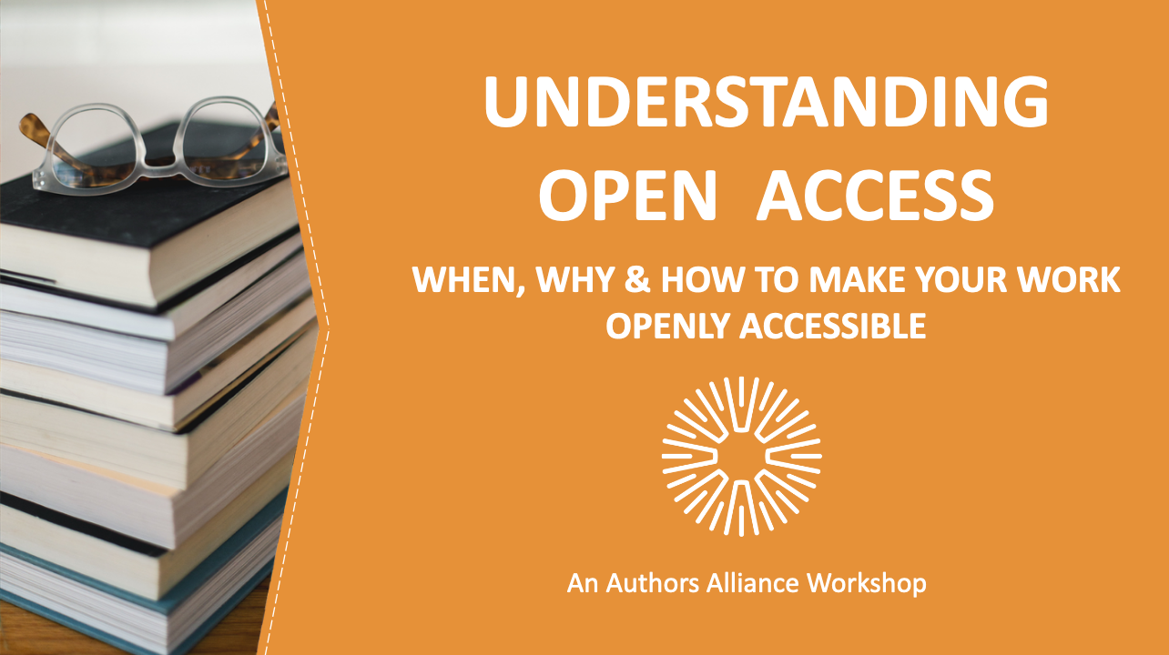
1. Understanding Open Access
This presentation is for authors who are considering making their works openly accessible, for those who are required to make their works openly accessible by an institutional or funding mandate, and for those who are just interested in learning more about open access. We’ll cover what “open access” means and provide you with practical steps you can take if you wish to make your work openly accessible.

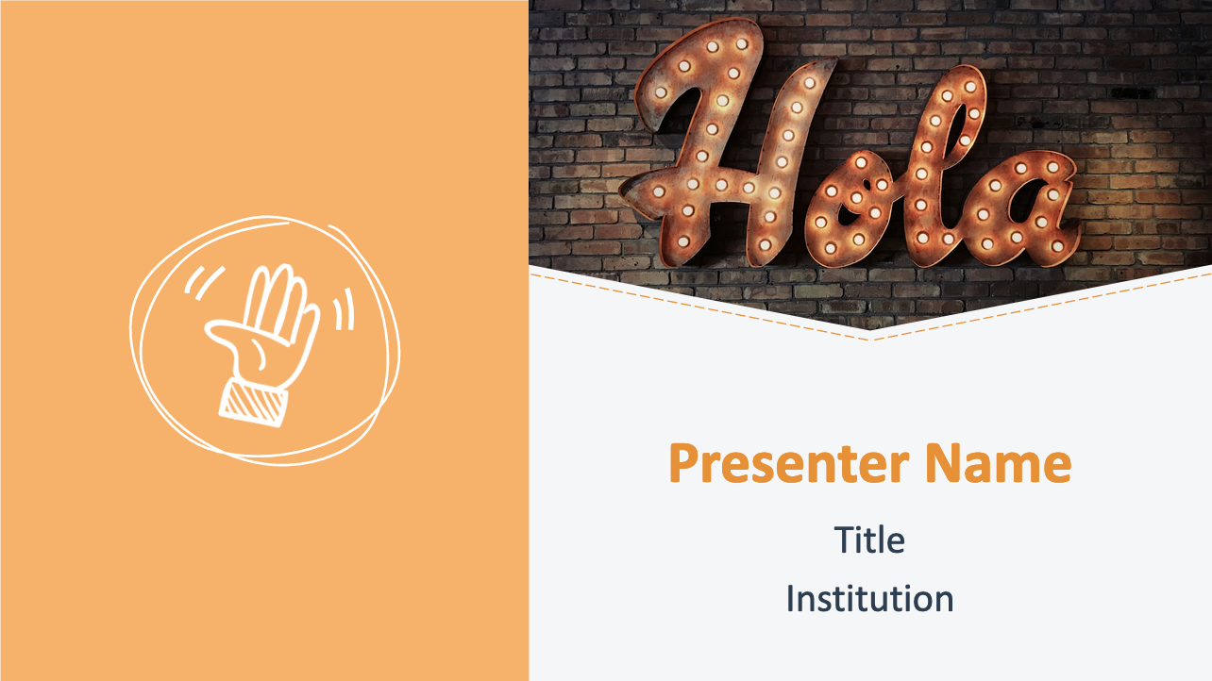
2. Welcome
Introduce presenter(s).

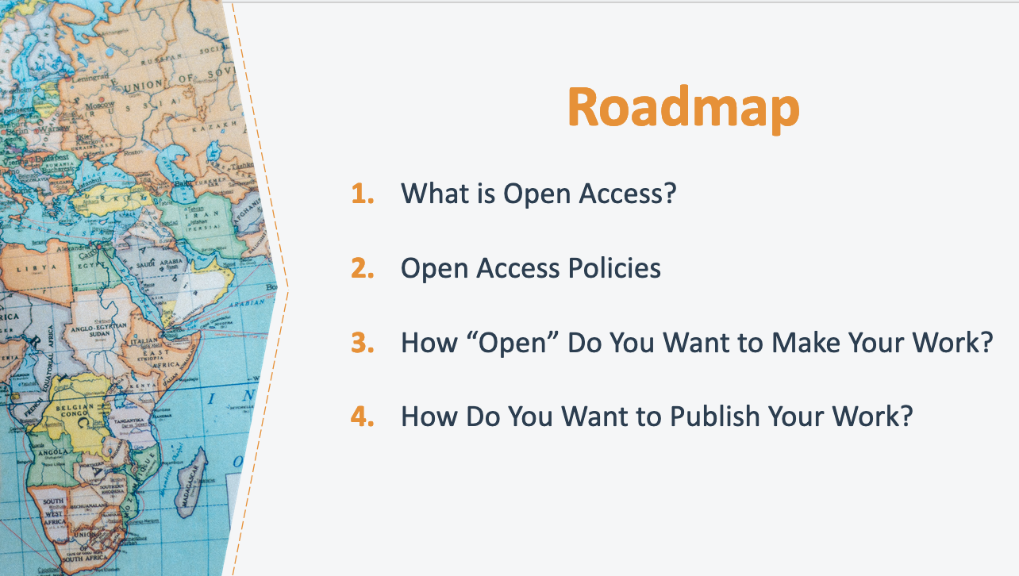
3. Roadmap
Today’s presentation has four parts. We’ll start by covering the basics: explaining what open access is and the benefits of making a work openly accessible. We’ll then turn to a discussion about policies that funders or institutions might have in place that require you to make certain works openly accessible. Next, we’ll talk about decisions that you can make to shape how “open” you make a work, including what rights you want to share and what conditions you might want to put on that sharing. Finally, we’ll take a look at options for where and how to publish a work openly. Throughout, I’ll share success stories from authors who’ve seen positive results from sharing their works openly. By the end of the presentation, you will have a better understanding as to whether open access is right for you and your work and, if so, how to make your work openly accessible.

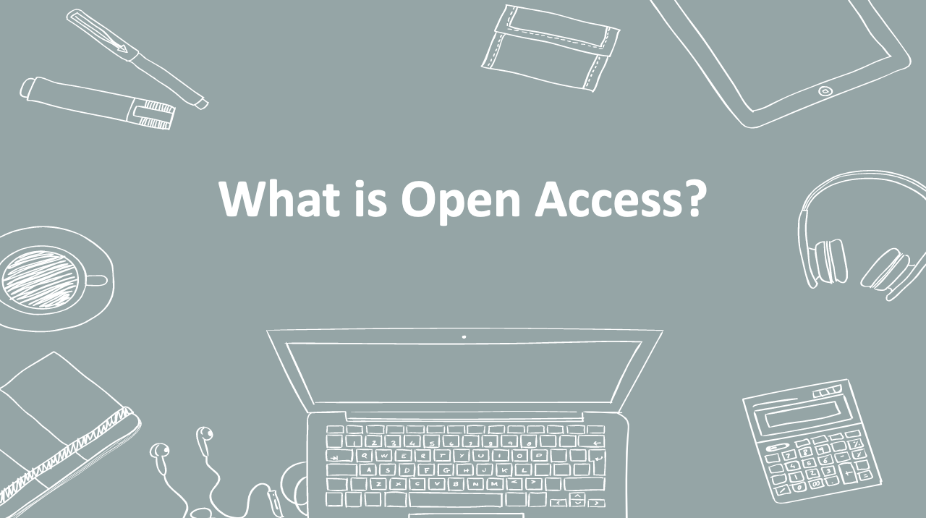
4. What is Open Access?
Let’s get started with an overview of what open access is and its benefits.

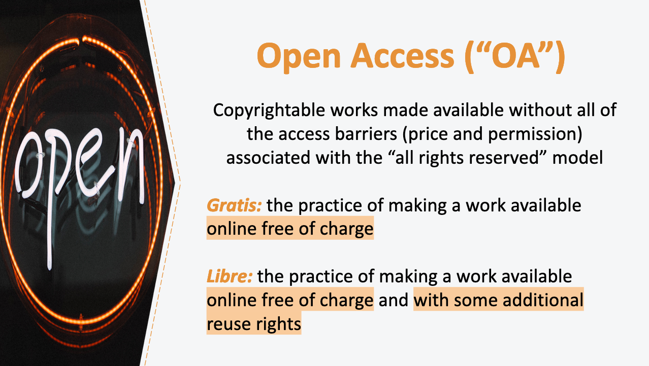
5. Open Access (“OA”)
The basic idea of open access is that it makes copyrightable works available without all of the access barriers associated with the “all rights reserved” model. These barriers can take the form of price barriers (the financial cost to access a work) and permission barriers (the permission needed to further copy, redistribute, and/or adapt a work).

Open access typically comes in two forms. What has come to be known as gratis open access is the practice of making a work available online free of charge (also called public access). The term libre open access (also called full open access) refers to the practice of making a work available online free of charge and with some additional reuse rights, typically granted through a Creative Commons license. (We’ll discuss Creative Commons licenses and these reuse rights later in the presentation.)

So, gratis open access removes price barriers, whereas libre open access additionally removes at least some permission barriers, allowing users to copy, redistribute, and/or adapt a work. Both of these forms of open access contrast with more traditional models of restricted-access publishing in which copies of works are made directly available only to paying customers.

It is worth noting that many open access proponents and research funders do not consider a work truly openly accessible if it only meets gratis open access requirements, and only libre open access is typically compliant with most major international statements on open access.

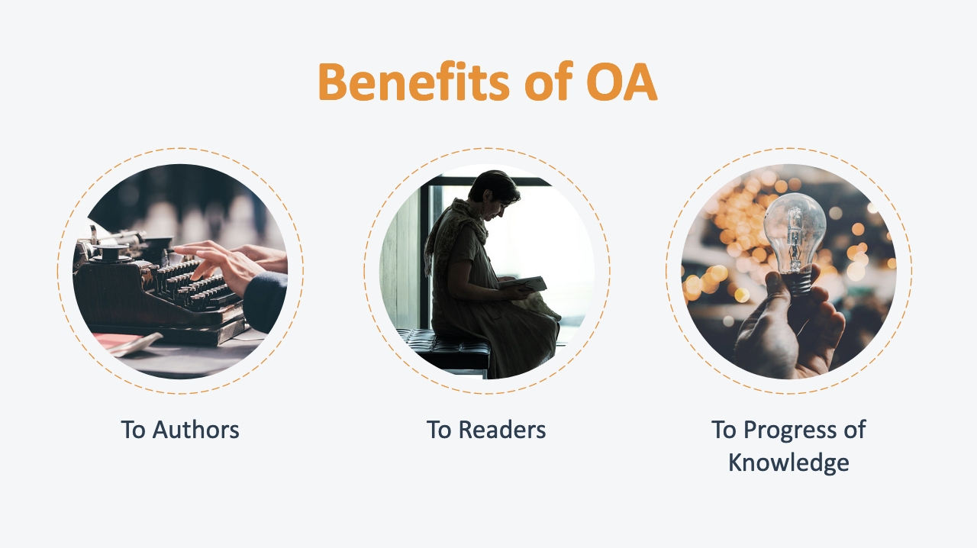
6. Benefits of OA
You may be wondering why authors might want to make their works openly accessible. We’re going to take a look at the benefits of open access in three categories: benefits to authors, to readers, and to the ongoing progress of knowledge.

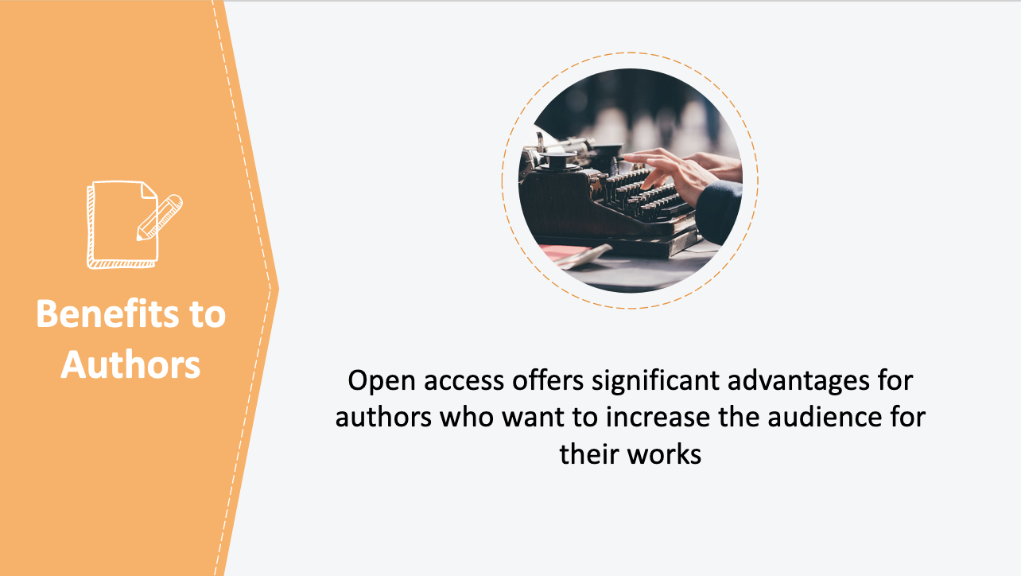
7. Benefits to Authors
Open access offers significant advantages for authors who want to increase the audience for their works by making them freely available to the public. For one, openly accessible works are often full-text indexed, helping potential readers to easily locate a work using search engines, and, importantly, to access the work without being turned away by paywalls. As a result of this increased discoverability and access, some authors find that open access increases their readership. The majority of studies find that open access leads to a greater number of citations.

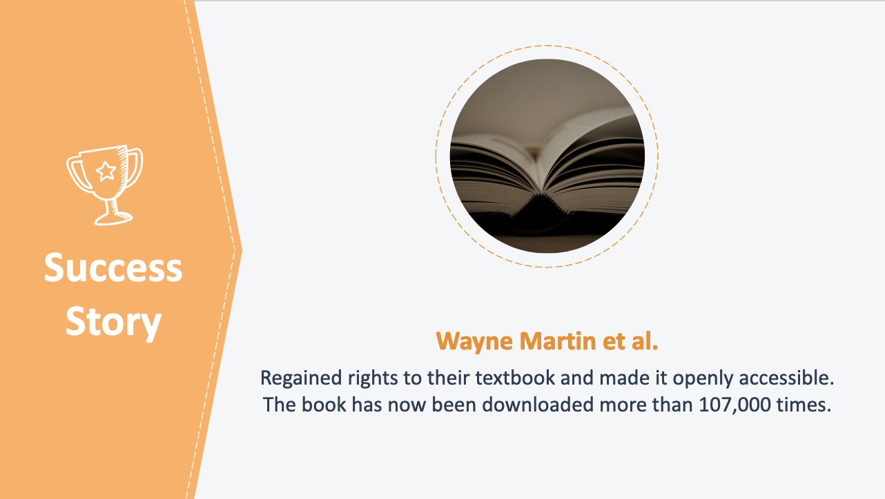
8. Success Story: Wayne Martin et al.
Let’s take a look at how open access has increased readership for the authors of the book Veterinary Epidemiology. After getting the rights back to their 1987 textbook, Wayne Martin and his co-authors released the book on open access terms so that it would be available to learners across the globe. Since the book was digitized and made openly available online three years ago, the book has been downloaded more than 107,000 times.

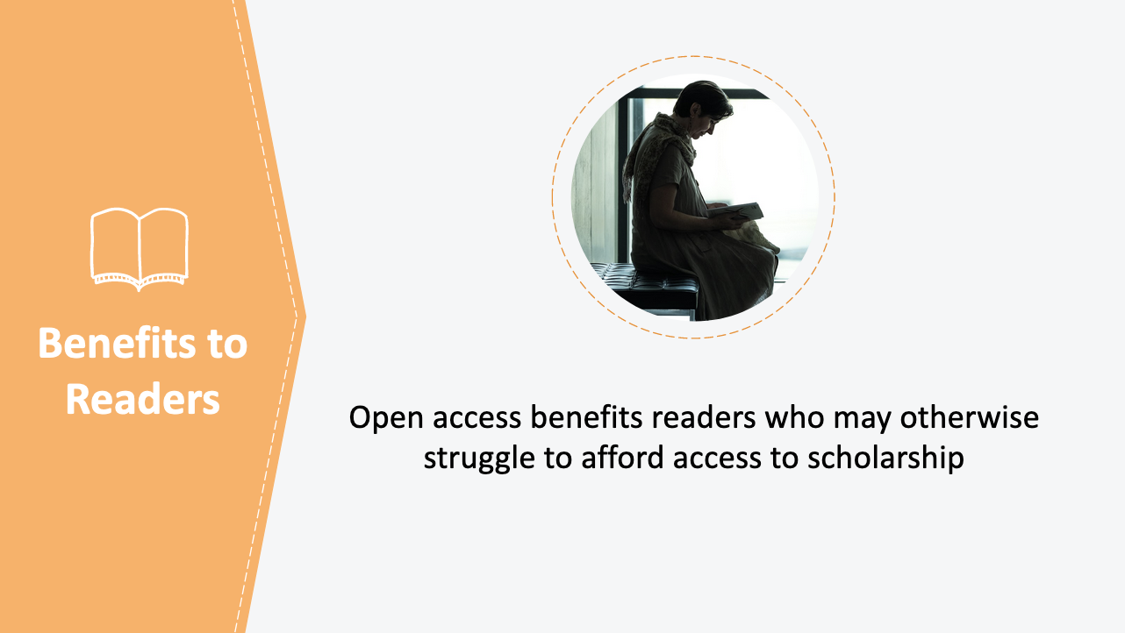
9. Benefits to Readers
Open access also benefits readers who may otherwise struggle to afford access to scholarship. Many students, teachers, researchers, and other professionals from low- and middle-income countries struggle to get access to prohibitively expensive subscription-based journals and other restricted-access scholarship. Even individuals at U.S-based institutions may find that their libraries do not have the resources to subscribe to relevant journals in their fields. By removing price barriers, open access makes it easier for students, teachers, researchers, and practitioners to access the information they need to learn, teach, research, and practice in their fields.

Making research openly accessible also allows individuals to connect with issues of public interest. For example, journalists play an important role in closing the gap between scholarship and the public by reporting on important research results. If the research is openly accessible, journalists can close this gap even further by providing interested readers with direct links to the relevant articles, which the public can access without encountering prohibitive price barriers.

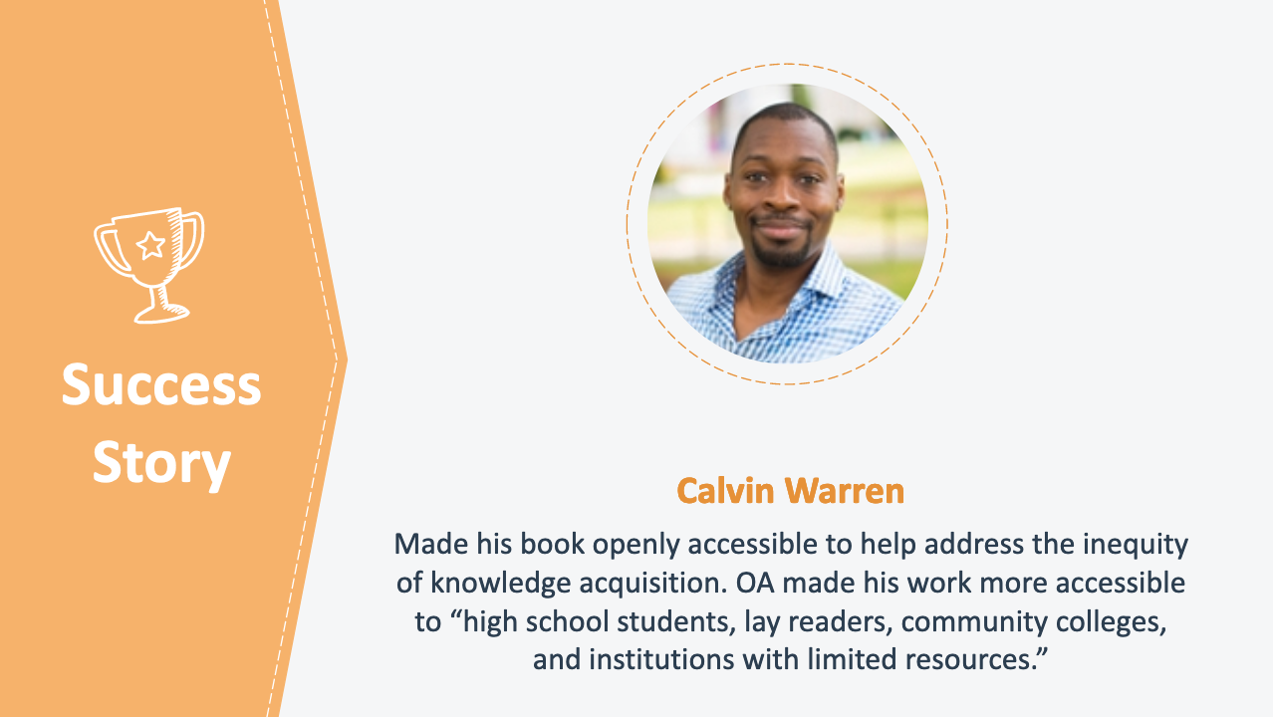
10. Success Story: Calvin Warren
Let’s take a look at how benefits to readers swayed one author to make his book openly accessible. Professor Calvin Warren decided to make his book Ontological Terror: Blackness, Nihilism, and Emancipation openly accessible to address the inequity of knowledge acquisition. In his words:

“Unfortunately, academic knowledge is becoming increasingly inaccessible, and this “epistemological exclusivity” is resulting in disturbing patterns of asymmetry. Journals require membership to read current scholarship, and this financial barrier prevents students and scholars from resource poor institutions from acquiring information. The cost of academic books is equally exorbitant, reinforcing the dynamic that knowledge acquisition requires money. I’ve grown uncomfortable with this dynamic and had been searching for a mechanism to make my work more accessible to high school students, lay readers, community colleges, and institutions with limited resources. Open access provided such a mechanism and addressed the inequity of knowledge acquisition. Accessing my book for free has increased my readership and made it possible for black nihilism, as an idea, to expand its horizon.”

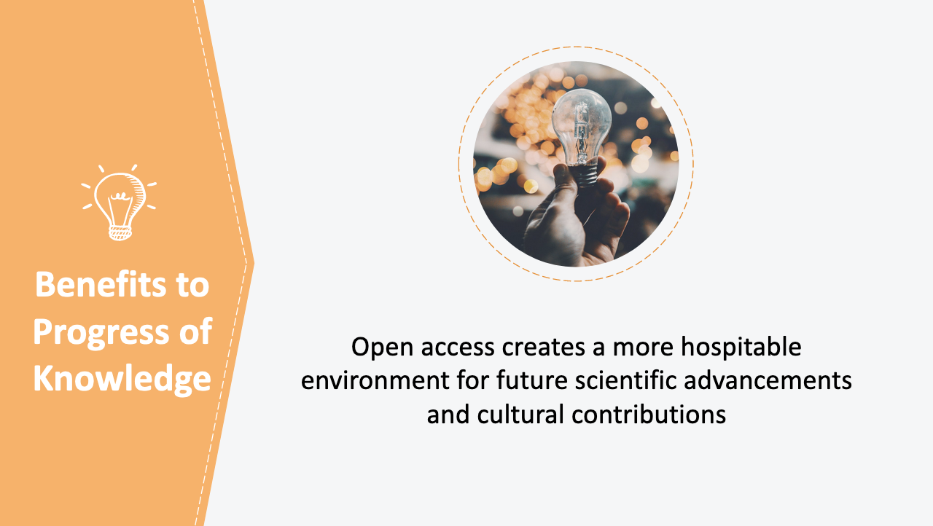
11. Benefits to Progress of Knowledge
Finally, open access also leads to benefits to the ongoing progress of knowledge. New scientific and cultural contributions necessarily build on the works of authors who came before. By removing barriers to access and reuse, open access creates a more hospitable environment for future scientific advancements and cultural contributions. The easier it is to find, access, read, and reuse a work, the more opportunities there are for others to build upon the work, accelerating the pace of innovation and discovery.

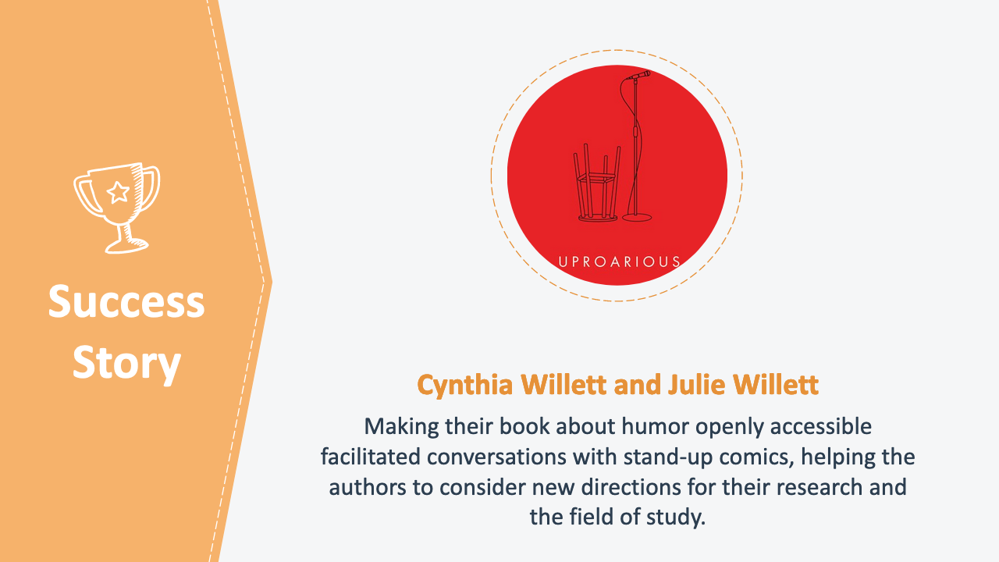
12. Success Story: Cynthia Willett and Julie Willett
Cynthia and Julie Willett’s book, Uproarious: How Feminists and Other Subversive Comics Speak Truth examines theories of humor through the lens of feminist comics. They decided to make the book openly accessible to make their research more accessible not only to students at elite institutions but also to those who lack resources yet often drive conversations in trending fields like humor. They describe the most unexpected result of the decision to open up access as facilitating conversations with stand-up comedians which have helped them to think about new directions for their research and for the field of study.

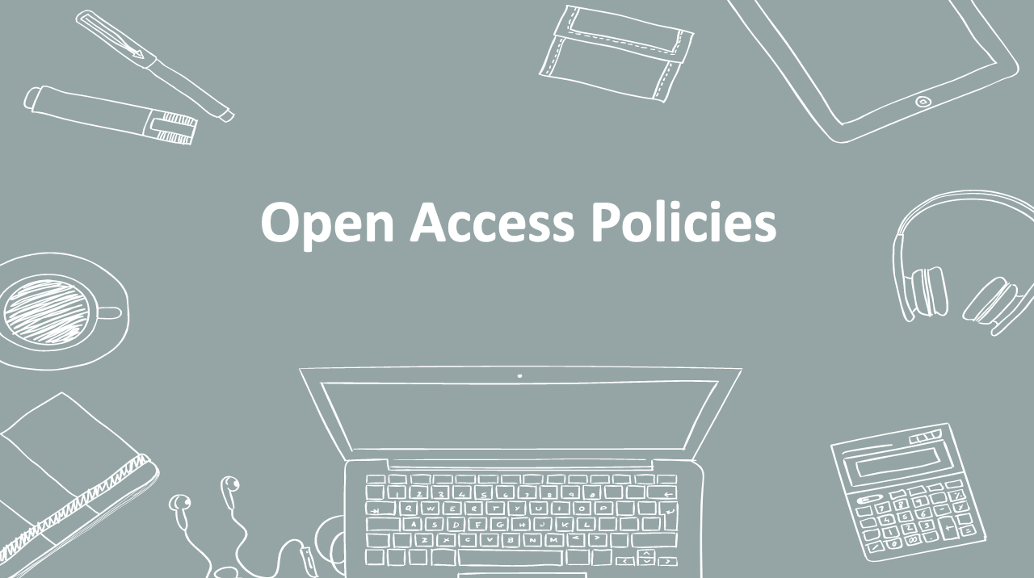
13. Open Access Policies
Now that we’ve examined what open access is and its benefits, let’s turn to open access policies.

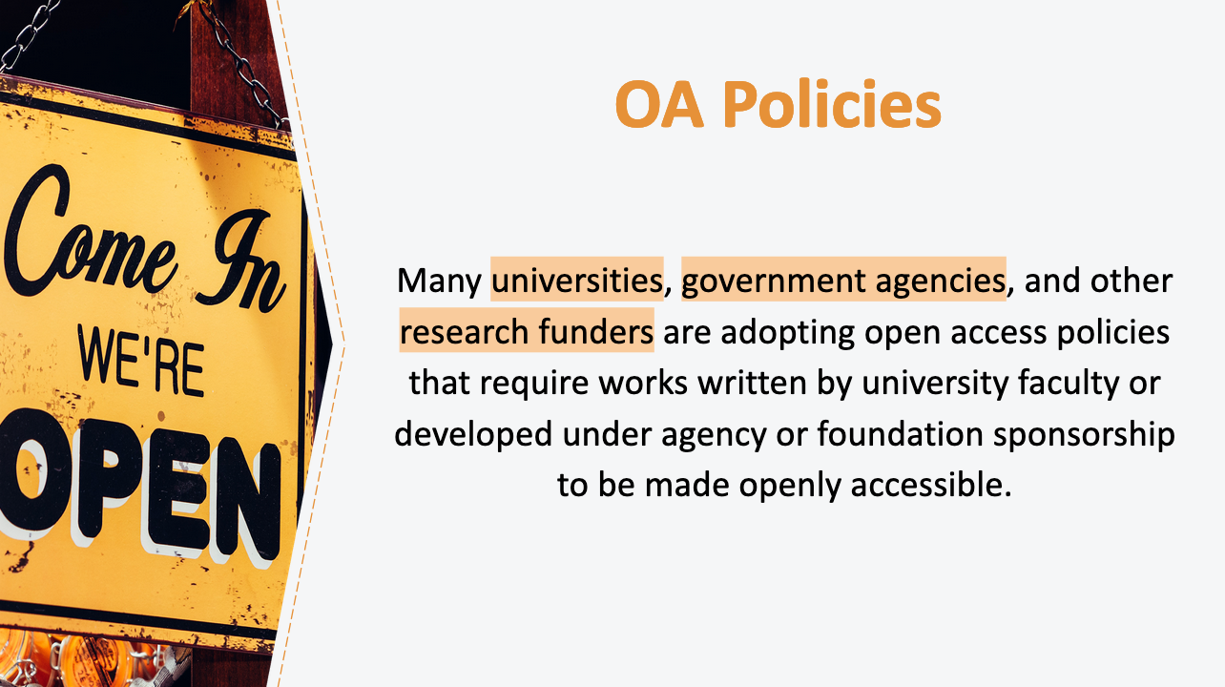
14. OA Policies
Many universities, government agencies, and other research funders are adopting open access policies that require works written by university faculty or developed under agency or foundation sponsorship to be made openly accessible.

For example, faculty at universities around the country have voted to pass open access policies at their institutions. Under these policies, faculty members typically grant to their universities the right to deposit faculty-authored works in institutional repositories. [Presenter to insert details about your institution’s OA policy, if any.]

Under similar policies, many government agencies require grant recipients to deposit their research findings in open access repositories where they are available for free public access. And foundations that sponsor research, for example the Bill and Melinda Gates Foundation, are also increasingly adopting OA policies that require research resulting from grant funding be made openly accessible.

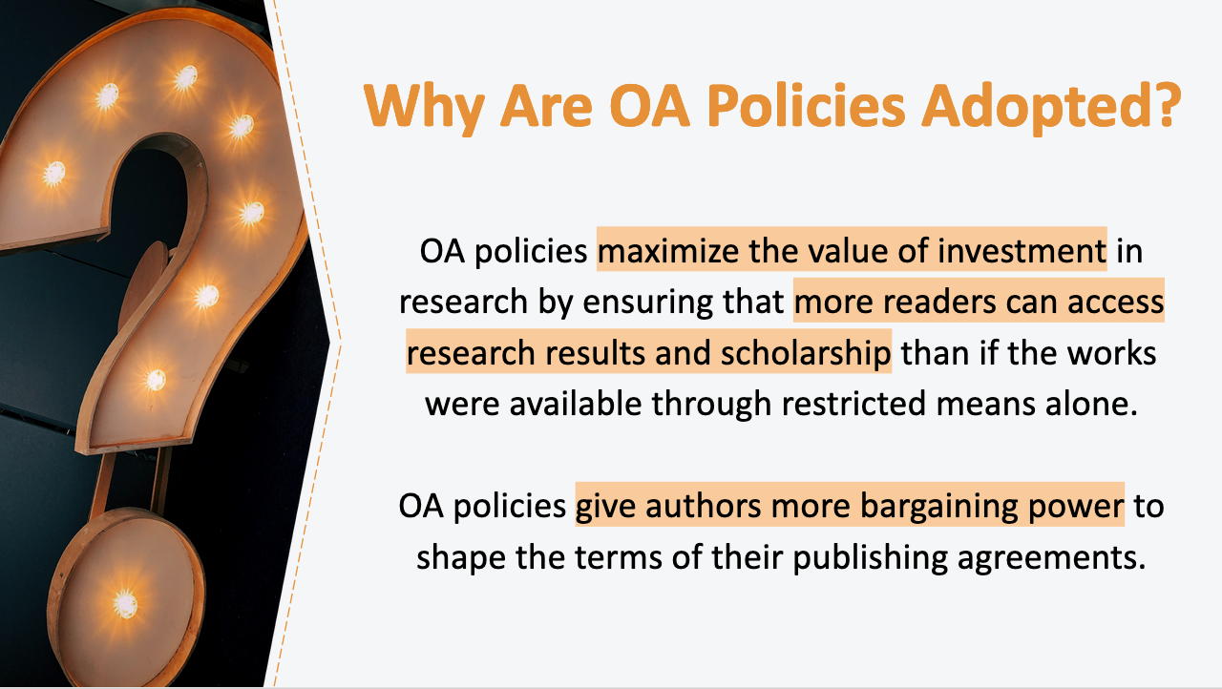
15. Why Are OA Policies Adopted?
You might wonder why institutions and funders adopt open access policies. Typically, OA policies are adopted by entities that view the communication and dissemination of funded works as an integral part of their mission. Universities, for example, further their educational missions by implementing open access policies that make scholarly works more widely available. Open access policies maximize the value of investment in research by ensuring that more readers can access research results and scholarship than if the works were available through restricted means alone.

Importantly, authors subject to open access policies benefit from the power of collective action. The unified action of a body of authors—for example, the faculty of a university—gives these authors more bargaining power and helps them collectively reserve rights that might otherwise be signed away by individual authors in publishing agreements. Whereas conventional publishers previously may have denied the requests of an individual author to make her work openly accessible, many now accommodate open access policies.

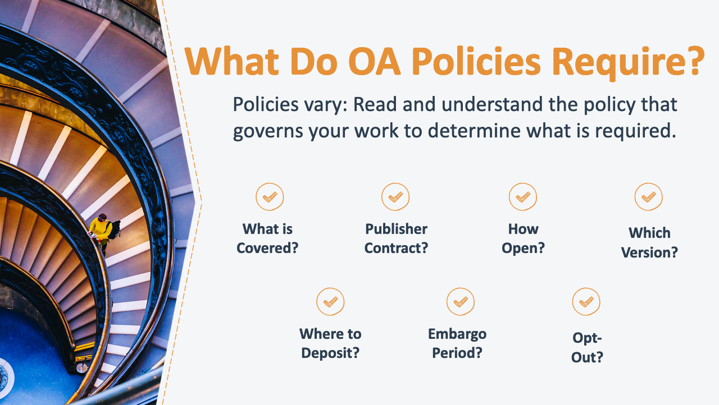
16. What Do OA Policies Require?
If you’re subject to an open access policy, it is important to understand what is specifically required of you under the policy. Let’s take a look at some things you need to consider.

Who and what is covered by the policy? Some policies cover only certain employees (for example, faculty, but not staff) or only certain types of works (for example, scholarly articles, but not books).

How does the policy interact with your agreement with your publisher? Some open access policies require authors to retain certain non-exclusive rights when they publish their works. In order to comply with such policies, authors need to be careful not to transfer all of the rights that they have as copyright owners to their publishers. Instead, these authors need to retain the rights they need to make their works openly accessible in accordance with the terms of the open access policy.

Other open access policies grant the author’s institution a non-exclusive license to their works, which allows these institutions to make works openly accessible (this type of policy is sometimes referred to as a “Harvard-style” policy). These authors can then transfer some rights to publishers; they should make sure that they are not purporting to grant rights to the publisher that they have already granted to their institution.

What degree of openness is required by the policy? Some policies follow the gratis open access model and merely require that the work be publicly accessible in an open access repository, free from pay walls. Other open access policies follow the libre open access model and require authors to provide additional permissions.

Which version of your work is covered by the policy? Some policies specify which version of a publication must be made openly available. Often the policy applies to the final peer-reviewed version, prior to publisher formatting.

Where should your work be deposited? Some policies specify the repository in which a work should be deposited, while others only require that the work be made openly accessible, regardless of the particular place it is available.

Does the policy provide for—or limit the length of—an embargo period? Some policies accommodate publishers’ requests to delay open access to an article until a set embargo period has passed, though some policies specifically limit the length of such an embargo.

Does the policy allow you to opt out? Some policies permit authors to request a waiver that would allow them to opt out of the grant of a non-exclusive license to their institution for a particular work. Other policies additionally allow authors to request blanket waivers for all of their works. There is typically no opt-out available for government or foundation-sponsored research subject to an open access policy.

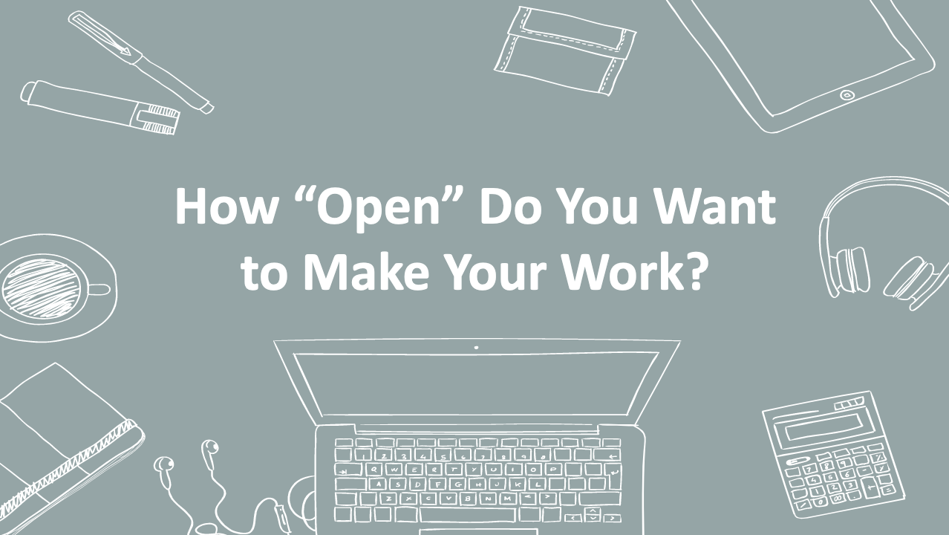
17. How “Open” Do You Want to Make Your Work?
Now we’ll take a look at what rights you might want to give to the public to allow them to share and adapt your work, as well as conditions and restrictions you might want to place on the use of your work. In this section of the presentation, we’ll also examine how to signal to the public that a work is openly accessible.

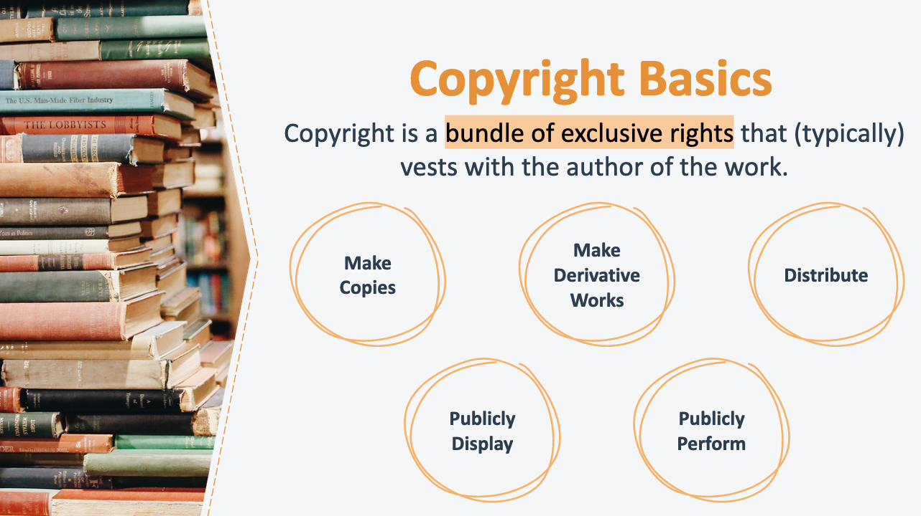
18. Copyright Basics
Under current U.S. copyright law, copyright attaches to an original work of authorship automatically from the moment the work is first created. This means that authors have the exclusive right to make copies of their works; sell or otherwise distribute their works; prepare adaptations (e.g., audio editions, movie adaptations, and translations); and perform or display their works publicly.

Though these rights are subject to a number of limitations, an author generally has the choice whether to license or transfer any, or all, of these rights and, if so, to whom and to what extent. If you wish to grant the public the rights to reuse your work, you need to affirmatively indicate which of these rights you are granting. You also need to indicate what conditions or restrictions, if any, you are placing on the public’s reuse of your work. We’ll cover each of these in turn.

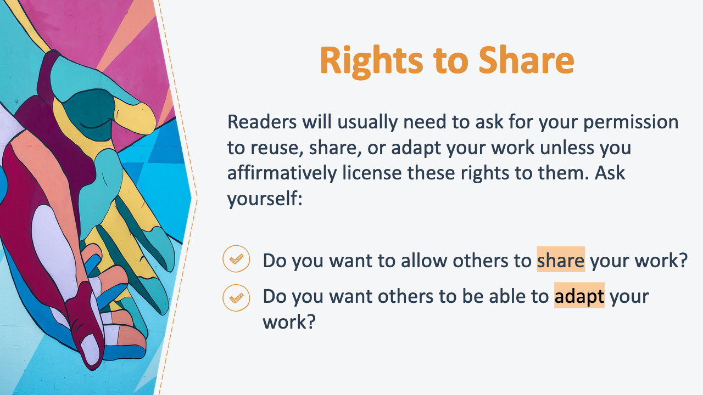
19. Rights to Share
While you can help readers access your works by removing price barriers alone (for example, by putting it on the internet), readers will usually still need to ask for your permission to reuse, share, or adapt your work unless you affirmatively license these rights to them (or unless their use falls within a copyright limitation or exception). When you consider how you would like to allow others to access and use your work, consider the following two questions.

Do you want to allow others to share your work? When you allow others to share your work, readers can distribute, copy, or perform your work without first having to get your permission or rely on a copyright exception (such as fair use).

Do you want others to be able to adapt your work? When you allow others to adapt your work, readers can build upon or create new works based on your work without first needing to get your permission or rely on a copyright exception. This is sometimes referred to as allowing others the right to prepare “derivative works.” A translation of an article written in English into another language is an example of a derivative work.

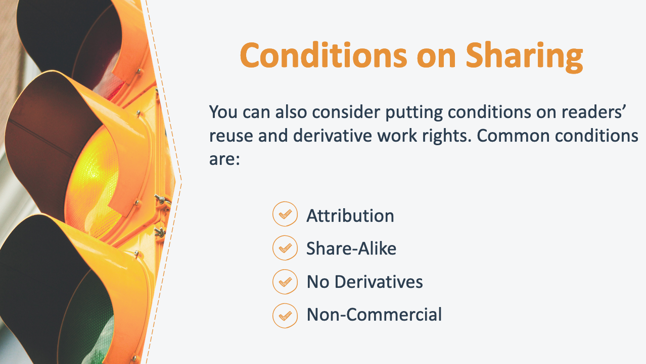
20. Conditions on Sharing
Once you consider what rights you would like to share with the public, you can consider how you would like to fine-tune your work’s degree of “openness” by putting conditions on readers’ reuse and derivative work rights. Some common conditions to consider are:

Attribution: Those who reuse a work or create a derivative work must give credit to the author for the creation of the original work.

Share-Alike: When readers create a new work based on the originally licensed material, they must distribute that new work under license terms identical to those the author imposed on the original work. For example, if an author grants full reuse rights and requires share-alike from subsequent users, subsequent users cannot impose more restrictive conditions on reuse than those imposed by the author on the original work.

No Derivatives: Readers are prohibited from adapting a work to create a new work. The right to create derivative works is reserved to the author, meaning that readers will be allowed only to distribute, reproduce, or perform a work as long as it is passed along unchanged and in whole.

Non-Commercial Use: Readers are prohibited from making any reuse or derivative work available commercially.

If you are subject to an open access policy, you should check whether you are required to grant particular user rights or if you are limited as to what restrictions you can place on user rights.

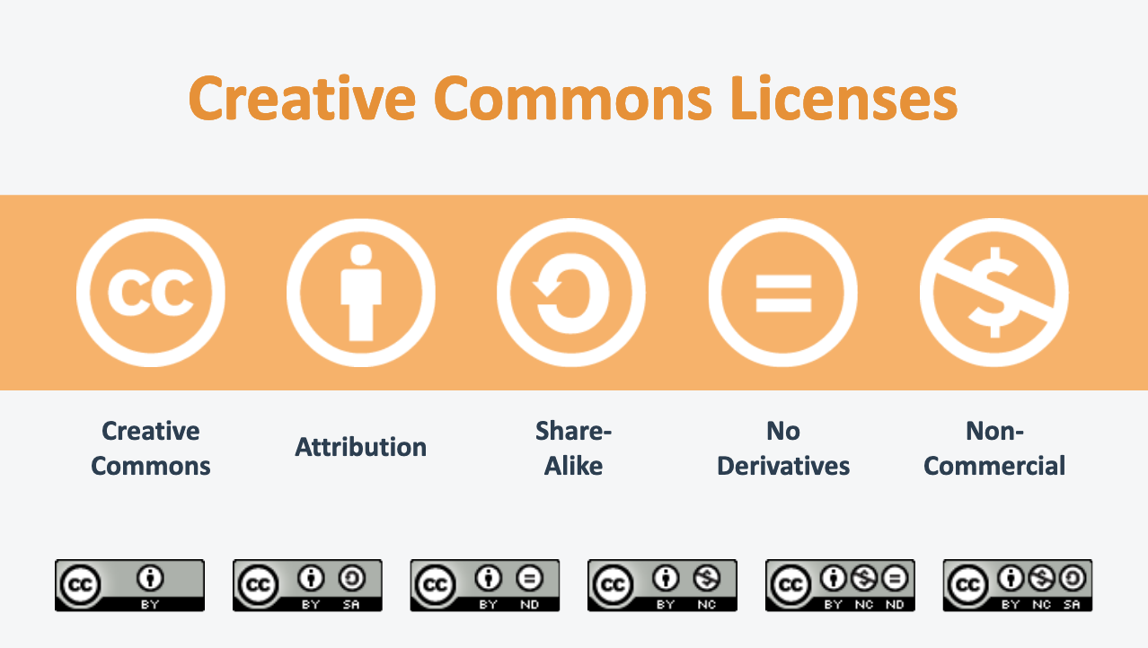
21. Creative Commons Licenses
To indicate how they want their work to be shared and what restrictions they are placing on the use of their work, many authors use a pre-drafted open access license from Creative Commons. Creative Commons allows authors to choose from among a menu of pre-drafted licenses depending on the rights they want to grant and the conditions they want to place on use of their works. As you can see, options for these pre-drafted conditions match the ones we’ve just discussed, including requiring attribution, requiring onward users to share alike, restricting derivative works, or restricting commercial uses. Creative Commons’ pre-drafted licenses include six combinations of these conditions, but all of them require attribution.

The conditions you place on the use of your copyrighted work through open access licenses are legally enforceable. If a downstream user fails to comply with the terms of the license you select, you can bring a copyright infringement claim (or in some cases a breach of contract claim) against that user. For example, if someone makes a commercial reproduction of a copyrighted work that you have licensed for non-commercial use only (and their use is not otherwise permissible under an exception to copyright law), that user is infringing on your copyright because he is exceeding the scope of the license.

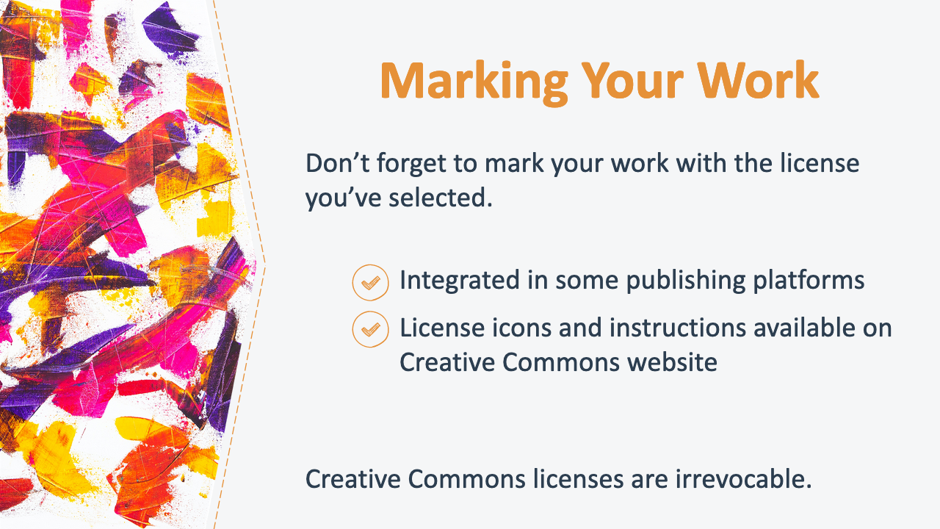
22. Marking Your Work
To apply an open access license to your work, you need to mark your work with the appropriate license. For some open access repositories or journals, the marking process is integrated into the distribution platform. So, if you are making works available through an open access repository or journal, you should check with your specific open access platform for more details on how to mark your work with a public license. If the marking process is not already integrated, you can follow instructions on the Creative Commons website for how to download icons and mark your work.

For Creative Commons licenses, it is important to note that once you apply the license to a work, that license may not be revoked. Even if you later stop making your work available to the public, anyone may rely on the terms of the license that had been attached to your work to reuse it.

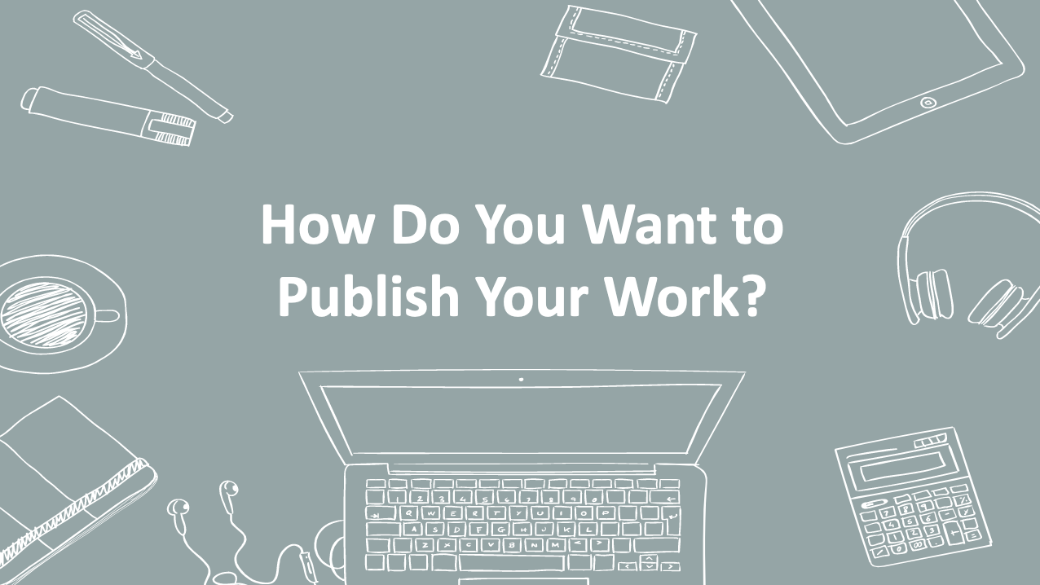
23. How Do You Want to Publish Your Work?
In addition to deciding how “open” you want to make your work, you will also need to decide where you will make your work openly accessible. This involves deciding which open access model (or models) you will use to disseminate your work.

Open access models are generally divided into two categories: “Gold Open Access” and “Green Open Access.” Gold Open Access describes the model by which an open access publisher makes your work openly accessible. In contrast, Green Open Access (also called “self-archiving”) describes the model by which you as an author make your work openly accessible. It is also possible to collaborate with a conventional publisher to make your work openly accessible. We’ll discuss each of these in turn.

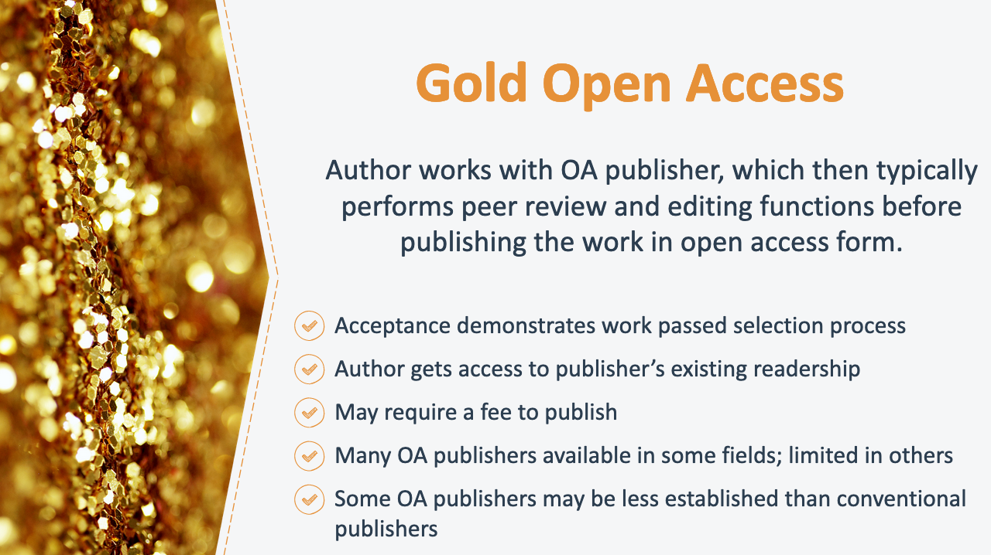
24. Gold Open Access
Under the Gold Open Access model, an author works with an open access publisher, which then typically performs peer review and editing functions before publishing the work in open access form. Key advantages and limitations of Gold Open Access include:

Gold Open Access demonstrates to readers that the work has passed the publisher’s editorial selection process. Acceptance by an open access publisher signals to readers that the publisher’s editors have carefully reviewed the work and determined it is a worthwhile addition to scholarly discourse that meets the publisher’s standards of quality and accuracy.

Authors who publish in an open access journal benefit from the journal’s existing readership and presence in a particular field. Articles published in an open access journal derive visibility from the journal’s pre-existing, regular audience.

Some open access publishers may require a fee to publish an author’s work. Some, but not all, open access publishers charge authors “publication fees” or “article-processing charges” (“APCs”) to publish their works. These charges typically cover the publisher’s cost of preparing manuscripts for publication and administering the publication.

There are many open access publishers available for some fields or types of works, but few or none for others. There are many well-established open access journal options for scholarly articles, particularly scientific articles. However, there are currently fewer options in the humanities and social sciences and for authors of book-length works. That said, the landscape is changing rapidly and open access options are increasingly available. (Authors can also consider working with a conventional publisher to make a work openly accessible in conjunction with print publishing, which we’ll discuss later in this presentation.)

Open access publishers are generally newer and not yet as established as conventional publishers. Many open access publishers have not been around as long as the most prominent conventional publishers and, as such, do not necessarily command the same recognition as well-established publisher. However, authors should not assume just because a publisher is open access, it is not prestigious.

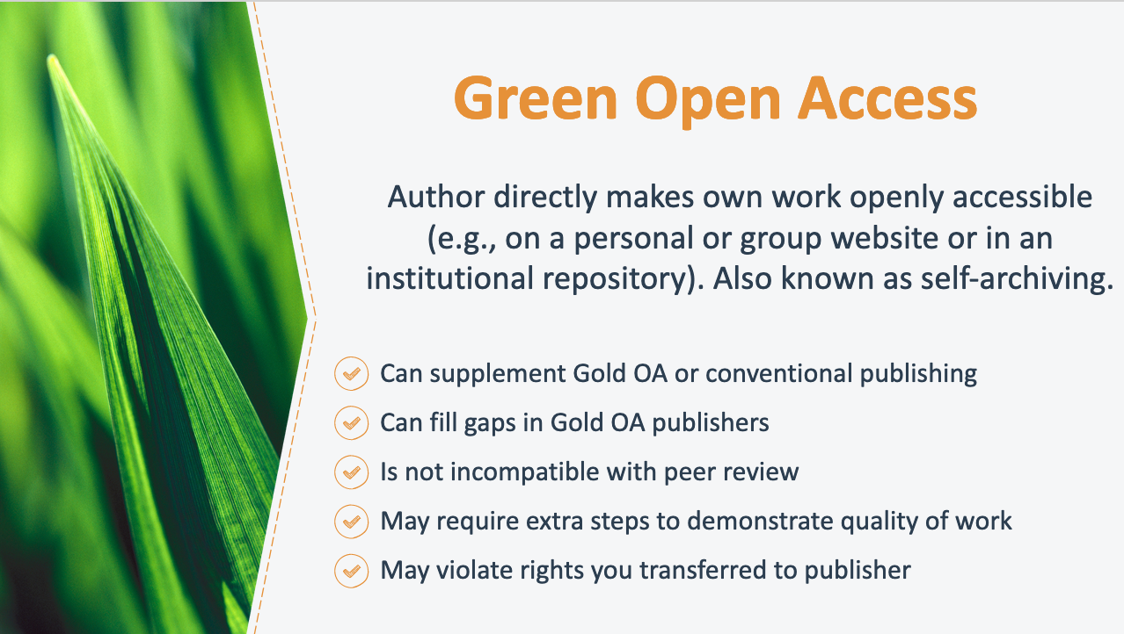
25. Green Open Access
Another open access model is “Green Open Access.” Green Open Access refers to an author directly making her own work openly accessible on for example, an institutional repository or a personal or group website (also known as “self-archiving”). Key advantages and limitations of Green Open Access include:

Green OA can supplement Gold OA or conventional publishing: Whether you plan to publish your work with an open access or conventional publisher, you may still be able to self-archive your work (more on working with conventional publishers next). This can increase access to your work even if it is otherwise published by an OA or conventional publisher.

Green OA can fill gaps in Gold OA: Green OA is an excellent option if you would like to make your work openly available, but a suitable open access publisher does not yet exist in your field or for your type of work.

Green OA is not incompatible with—and may encourage additional—peer review: While peer review is not required to self-archive a work, many authors self-archive works that have already been peer reviewed prior to publication with an open access or conventional publisher. Making a work available through Green OA can even encourage additional feedback that enables you to further develop your work.

Green OA may require extra steps to demonstrate the quality of a work: Because there are low barriers to putting something online, the digital online existence of a work is not alone evidence of its quality. Therefore, you may want to take steps to signal to readers the quality of your work. For example, if your work has been peer-reviewed, published, or accepted for publication, you should indicate that information on the self-archived copy of your work.

Green OA may violate rights you have transferred to your publisher: If you have already signed a publishing contract, be sure to check the terms of your agreement before self-archiving your work. If you transferred all of your rights to your publisher, for example, your publisher can object to you distributing your work to the public.

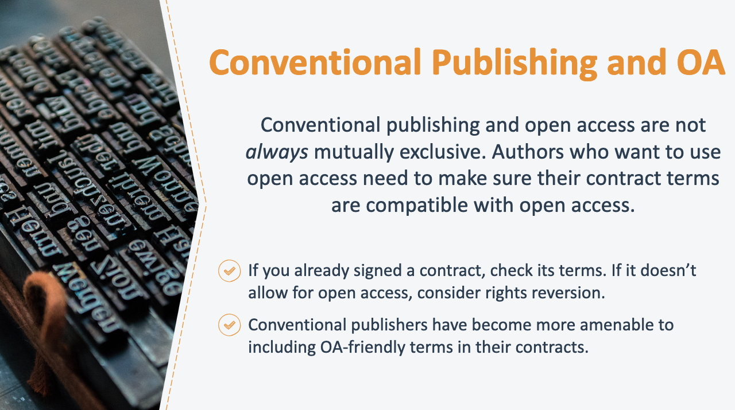
26. Conventional Publishing and OA
If you assign your copyrights to a publisher or grant your publisher an exclusive copyright license, you may not be able to make your work openly available unless you’ve made another arrangement with your publisher. That said, conventional publishing and open access are not always mutually exclusive. Authors who want to make their works openly accessible need to make sure their contract terms are compatible with open access.

If you have already signed a publishing contract with a conventional publisher, you should first evaluate the terms of your contract to determine if it allows you to make your work openly accessible and, if so, under what terms. If it does not, you will need to work with your publisher to secure permission or regain the right to make your work openly accessible. Publishers are often open to working with authors to make their works available in the ways the authors want, particularly when a work is no longer profitable to the publisher. (Check out Authors Alliance’s guide to rights reversion for more information on this process.)

As open access mandates have become more common, conventional publishers have become more amenable to including open-access-friendly terms in their contracts, either by default or upon negotiation with the author. Let’s take a look at a few examples of how authors have successfully negotiated for open access terms with conventional publishers.

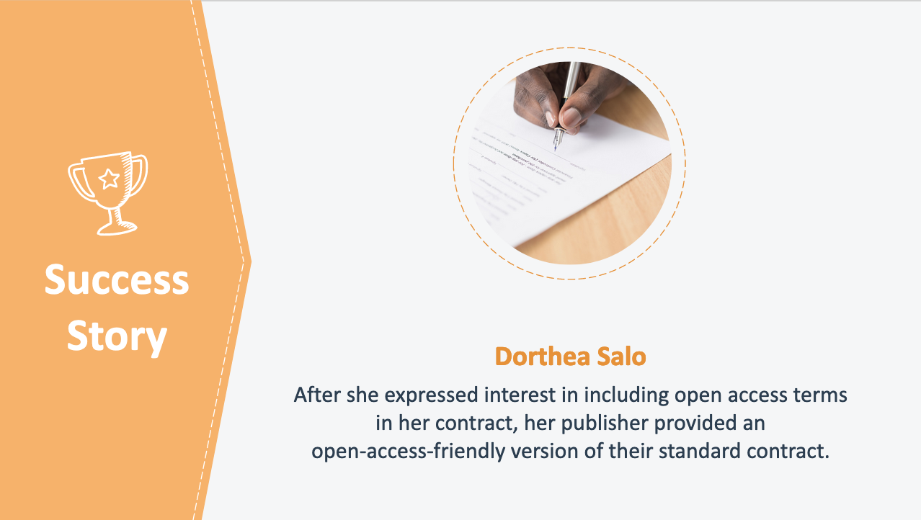
27. Success Story: Dorthea Salo
After one of her articles was accepted for publication, a representative of the publisher initially expressed that he understood that open access was important to Ms. Salo. When she received the publication contract for this work, however, it did not contain a provision allowing Ms. Salo to retain the right to make her work openly accessible. When she asked the publisher if such a clause could be included, the publisher responded, “Oh, you want the other contract,” and proceeded to provide Ms. Salo with an open-access-friendly version of the contract.

The lesson from this story is that some authors find it is sufficient to simply tell a publisher that they want to make their work openly accessible and request terms that are compatible with that goal. (If you are subject to an open access policy, it may be helpful if you provide the publisher with a copy of the open access policy.) Some publishers already have an alternate publishing contract available where authors retain the rights to make their works openly available and will provide this contract upon request. As with any contract the publisher provides, be sure to check that the terms of this alternative contract are in line with your desired outcome, including how open you want to make your work.

Another common approach for securing open-access-friendly contract terms is to attach an addendum to your publishing contract that modifies the original publishing contract and permits the author to make the work openly accessible. If your institution or research is governed by an open access policy, check to see whether they have a model addendum that you can use to comply with the terms of the policy. SPARC also has a sample addendum that you can consult.

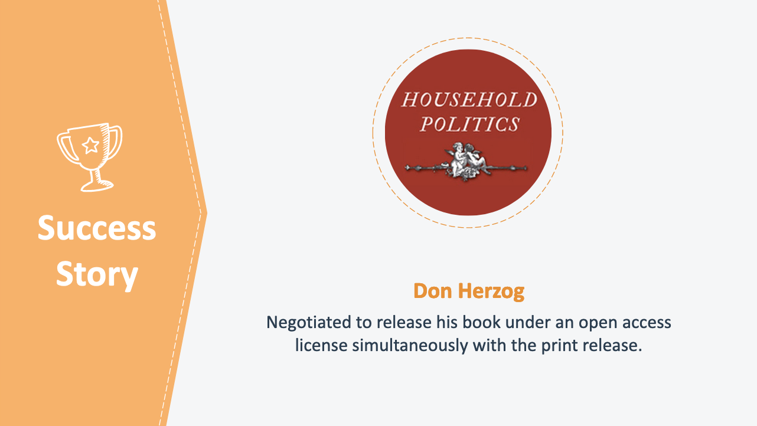
28. Success Story: Don Herzog
Here’s another example where a publisher agreed to an author’s request to make a work openly accessible, this time a scholarly book.

Professor Don Herzog wrote an academic book titled Household Politics and decided to upload the book to his university’s institutional repository because he felt that the high prices charged for scholarly monographs by a traditional academic press would limit its availability. Shortly before he deposited Household Politics in the repository, Yale University Press contacted Professor Herzog about publishing a print version of his book. Professor Herzog agreed, on the condition that he could still upload his book to the repository.

Ultimately, Yale University Press allowed Professor Herzog to make not only the original manuscript but also the final peer-reviewed, copy-edited, typeset, and designed version available under an open access license. Professor Herzog believes that open access to his book has increased his reader base: he states that although a university press typically sells well under 1,000 copies of a given book, his book has been downloaded over 3,500 times in just three years.

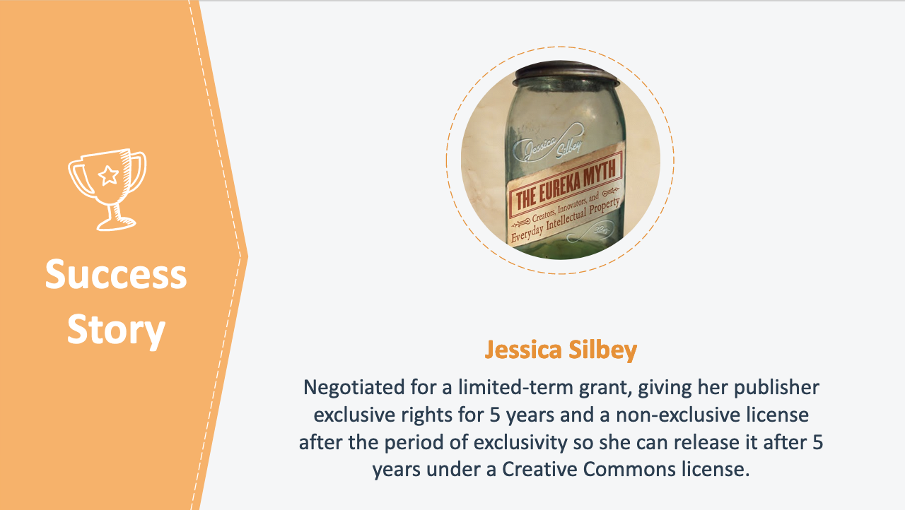
29. Success Story: Jessica Silbey
Finally, consider ways that you can compromise in order to meet your open access goals. For example, publishers may ask that you contribute financially to publishing the work to cover their costs and anticipated loss of sales. Another compromise that some authors make is to agree to an embargo period. This gives their publisher a chance to recoup their investment in the work, but still allows the author to reap some of the benefits of open access. Here’s an example of where this strategy worked.

When she published her book The Eureka Myth: Creators, Innovators and Everyday Intellectual Property, law professor Jessica Silbey negotiated for an innovative grant of rights to her publisher. Under the terms, her publisher obtained the exclusive right to publish the book for five years. After five years, Professor Silbey will automatically regain her copyrights and her publisher will keep a non-exclusive right to continue selling the book (under the same royalty terms). This arrangement enabled her publisher to fulfill its sales objectives, while also allowing Silbey to realize her goal of making The Eureka Myth widely available to readers in a Creative Commons-licensed online version after five years.

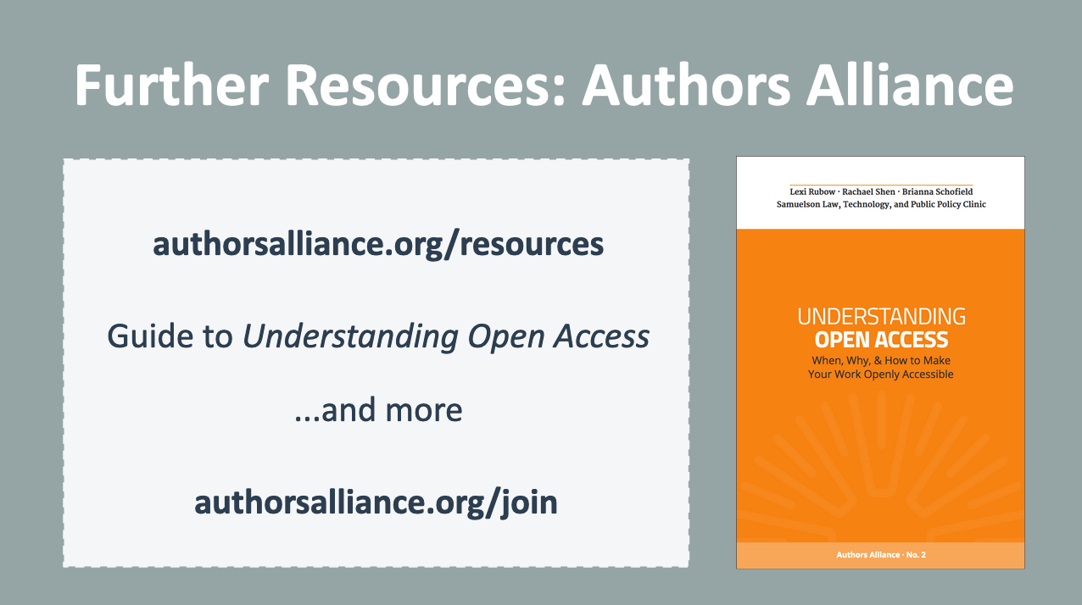
30. Further Resources: Authors Alliance
I hope today’s presentation helped you to understand what “open access” means and the practical steps to take if you wish to make your work openly accessible. I encourage you to check out additional resources created by Authors Alliance, a nonprofit organization that helps authors understand and manage their rights. This presentation is based on the Authors Alliance guide to Understanding Open Access, which is freely available online. Authors Alliance membership is free; please consider joining as an individual member to receive updates about their new resources and to learn more about leveraging your rights as an author.

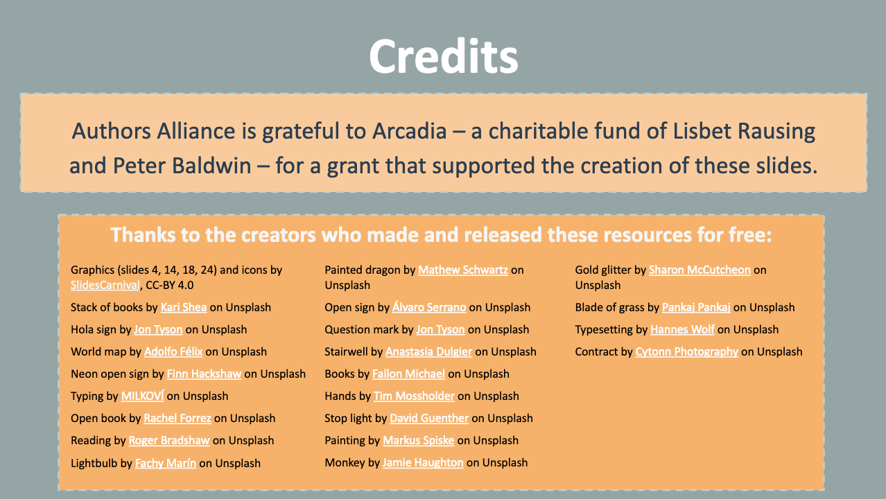
31. Credits

Authors Alliance is grateful to Arcadia—a charitable fund of Lisbet Rausing and Peter Baldwin—for a grant that supported the creation of these materials.

