Understanding Open Access
  - Presentation Notes

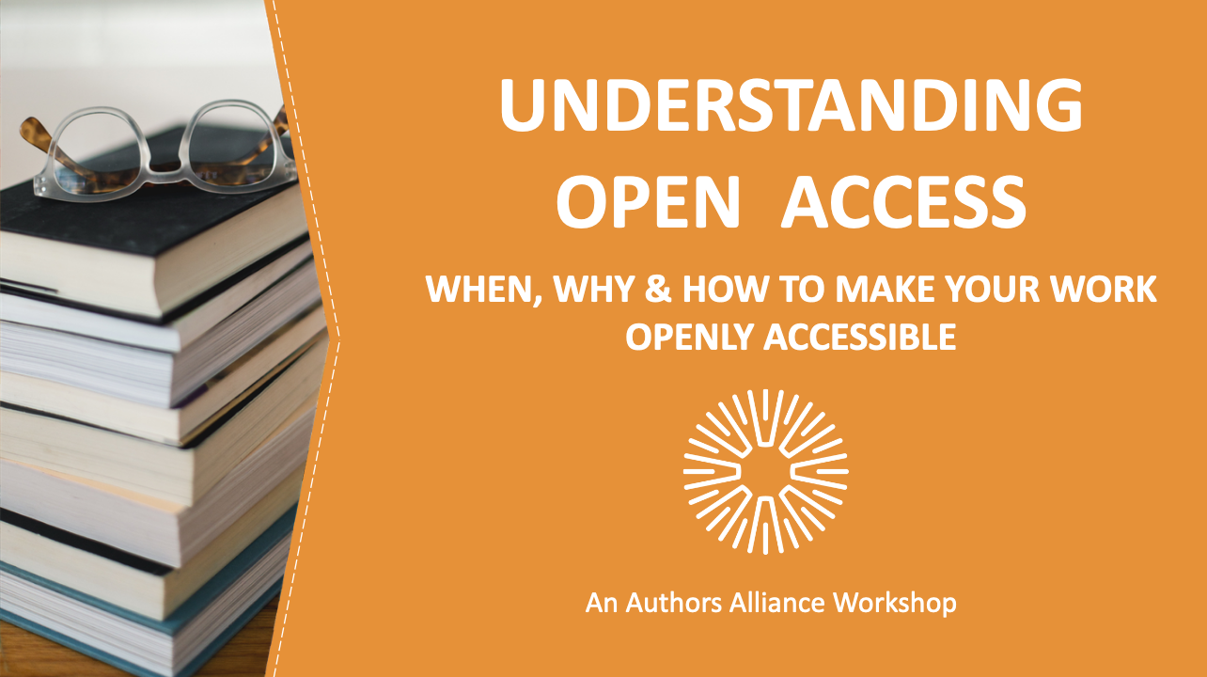
1. Understanding Open Access
__________________________________________________

__________________________________________________
__________________________________________________

__________________________________________________

__________________________________________________________________________________________

__________________________________________________________________________________________

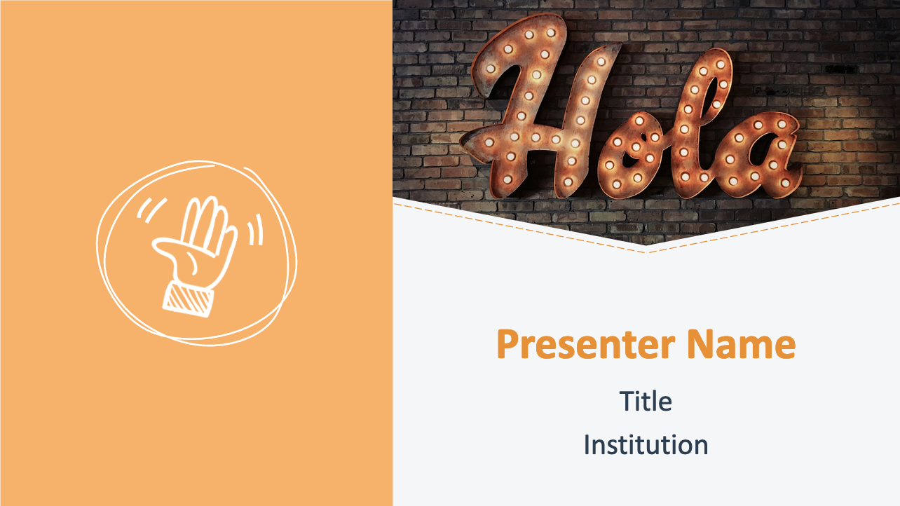
2. Welcome
__________________________________________________

__________________________________________________
__________________________________________________

__________________________________________________

__________________________________________________________________________________________

__________________________________________________________________________________________

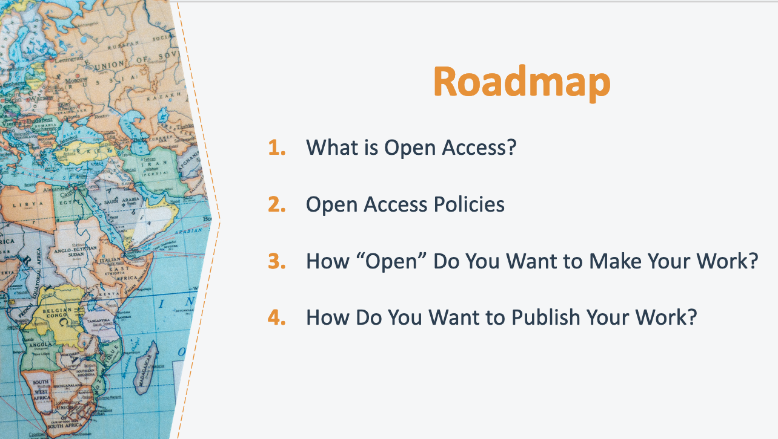

3. Roadmap
__________________________________________________

__________________________________________________
__________________________________________________

__________________________________________________

__________________________________________________________________________________________

__________________________________________________________________________________________
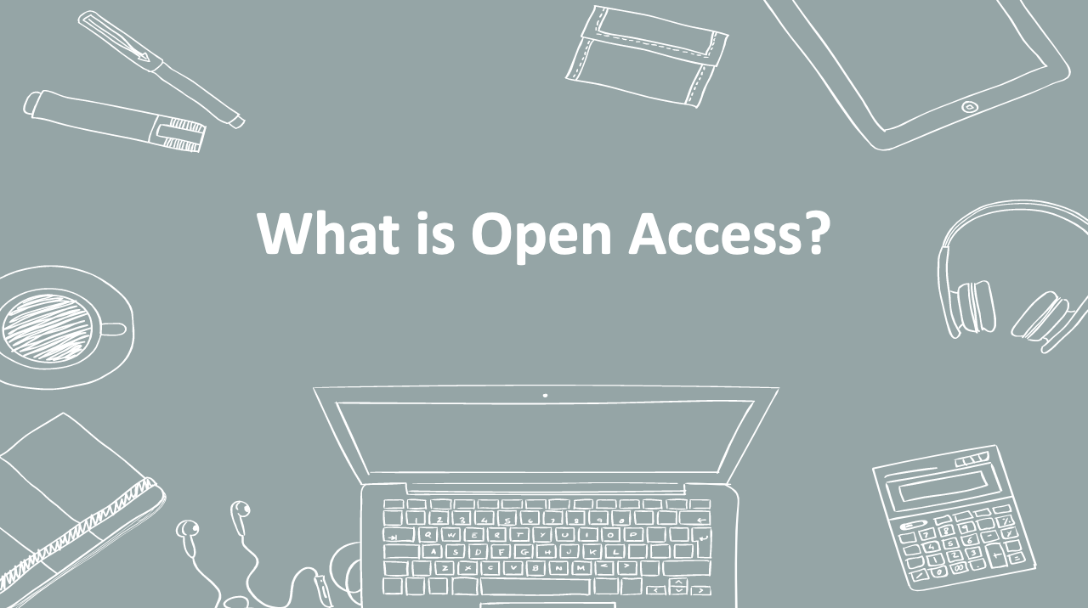

4. What is Open Access?
__________________________________________________

__________________________________________________
__________________________________________________

__________________________________________________

__________________________________________________________________________________________

__________________________________________________________________________________________

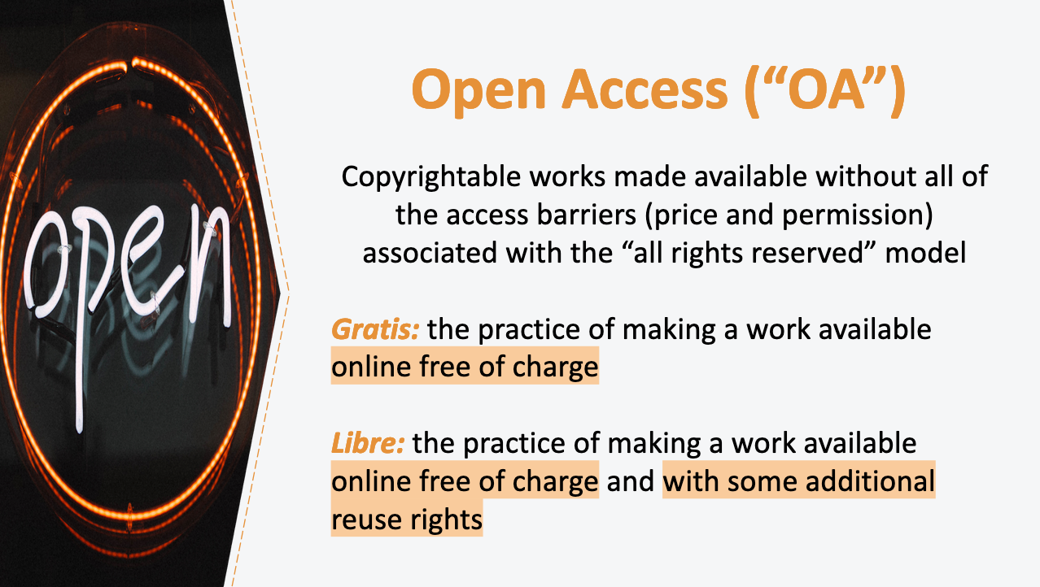

5. Open Access (“OA”)
__________________________________________________

__________________________________________________
__________________________________________________

__________________________________________________

__________________________________________________________________________________________

__________________________________________________________________________________________

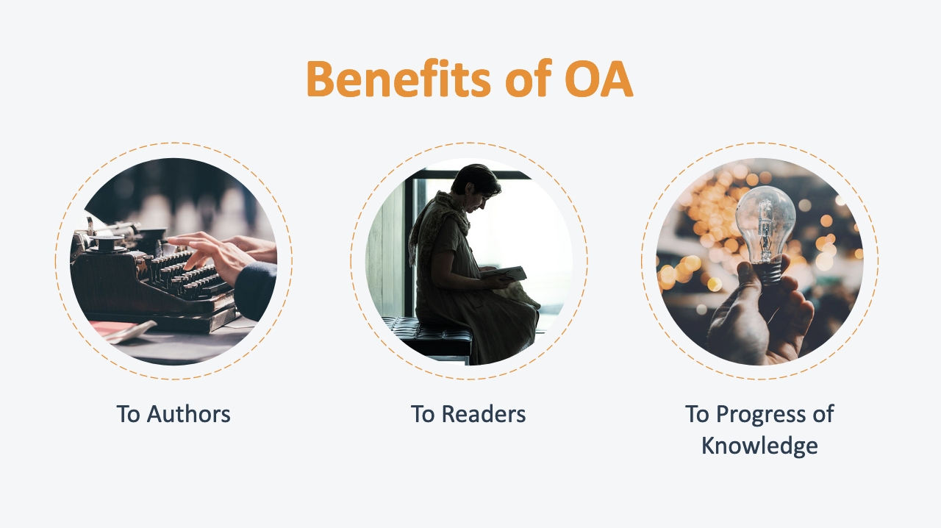

6. Benefits of OA
_________________________________________________

_________________________________________________
_________________________________________________

_________________________________________________

__________________________________________________________________________________________

__________________________________________________________________________________________
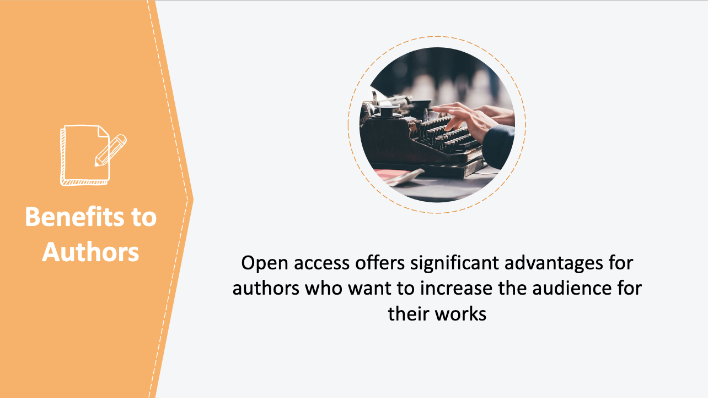

7. Benefits to Authors
_________________________________________________

_________________________________________________
_________________________________________________

_________________________________________________

__________________________________________________________________________________________

__________________________________________________________________________________________

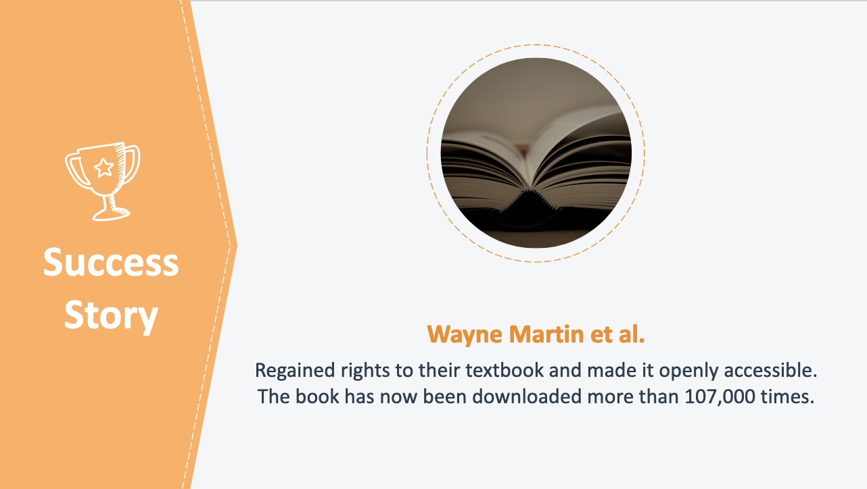

8. Success Story: Wayne Martin et al.
_________________________________________________

_________________________________________________
_________________________________________________

_________________________________________________

__________________________________________________________________________________________

__________________________________________________________________________________________
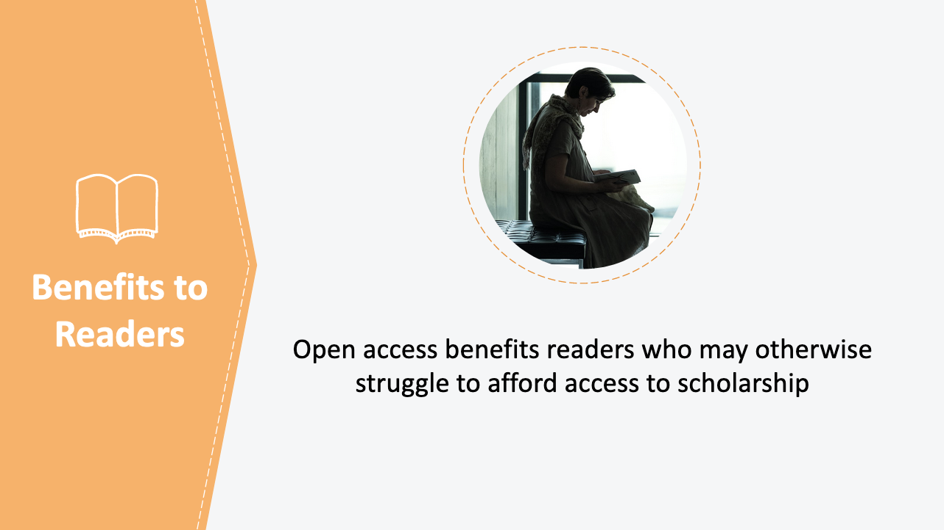

9. Benefits to Readers
_________________________________________________

_________________________________________________
_________________________________________________

_________________________________________________

__________________________________________________________________________________________

__________________________________________________________________________________________

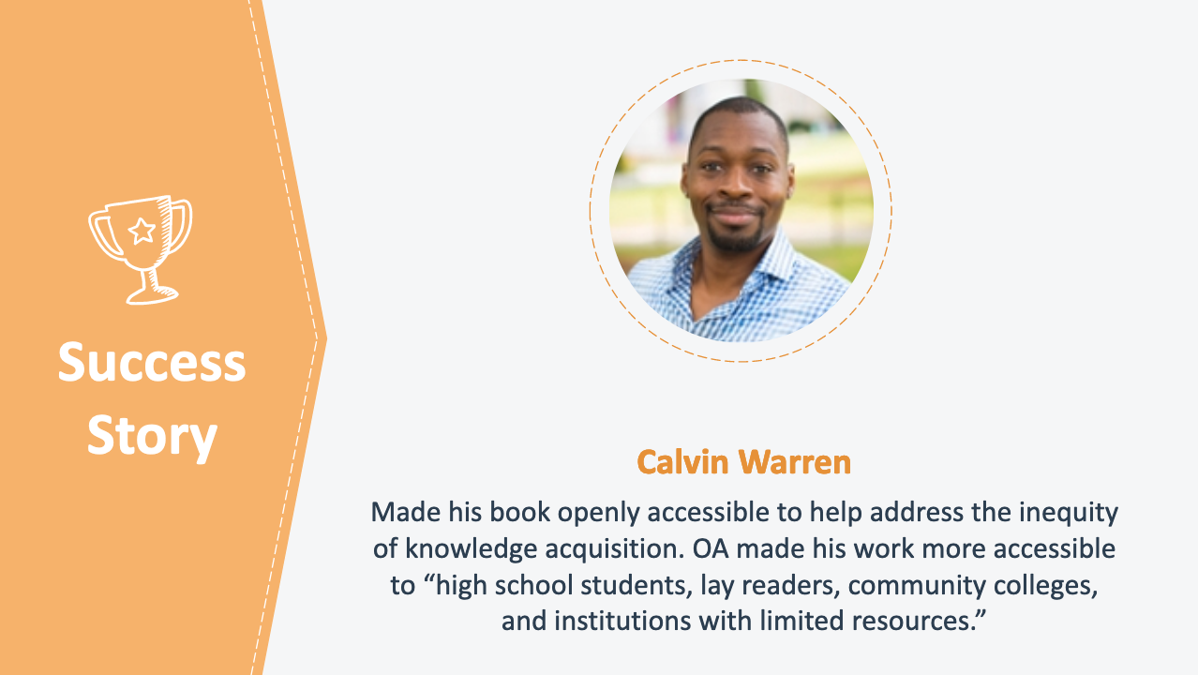

10. Success Story: Calvin Warren
_________________________________________________

_________________________________________________
_________________________________________________

_________________________________________________

__________________________________________________________________________________________

__________________________________________________________________________________________

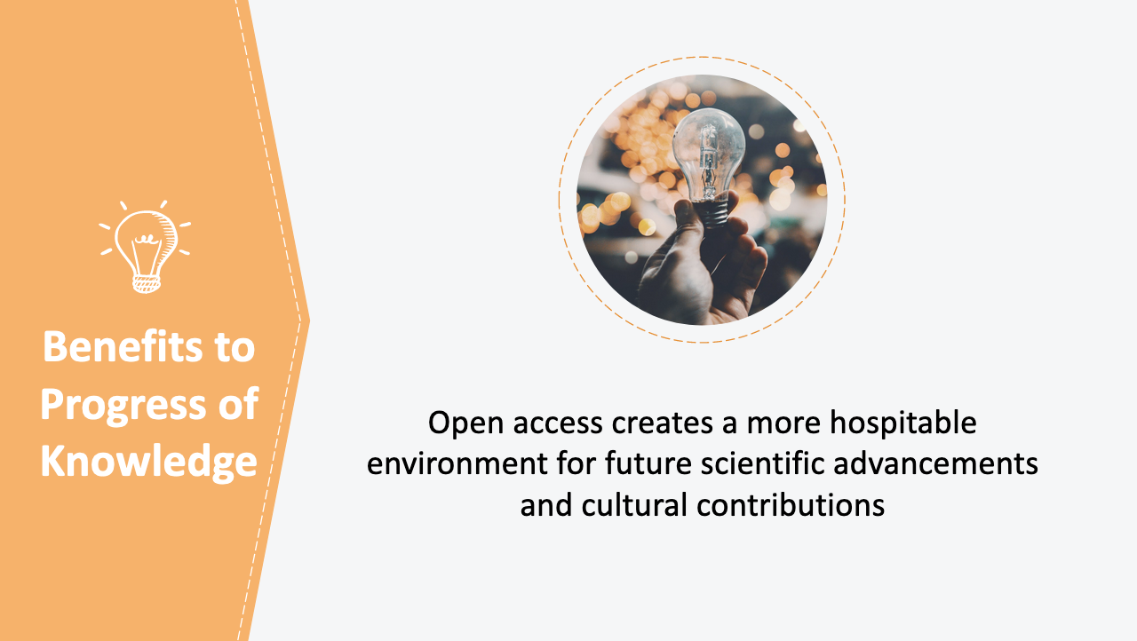

11. Benefits to Progress of Knowledge
_________________________________________________

_________________________________________________
_________________________________________________

_________________________________________________

__________________________________________________________________________________________

__________________________________________________________________________________________

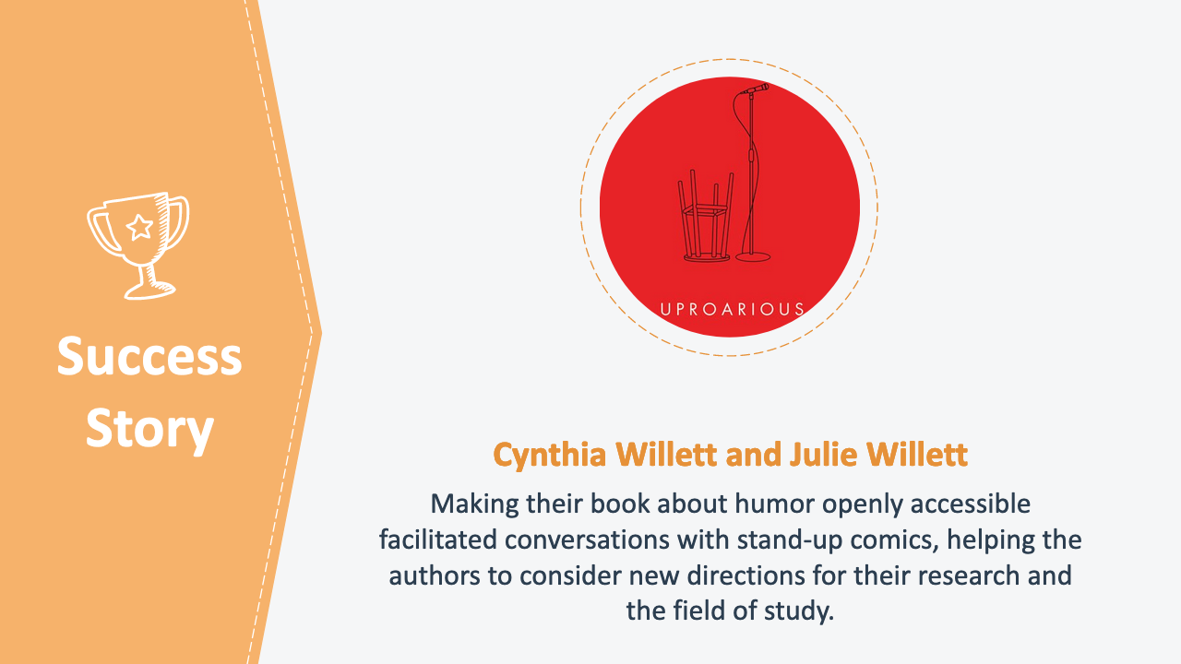

12. Success Story: Cynthia Willett and Julie Willett
_________________________________________________

_________________________________________________
_________________________________________________

_________________________________________________

__________________________________________________________________________________________

__________________________________________________________________________________________

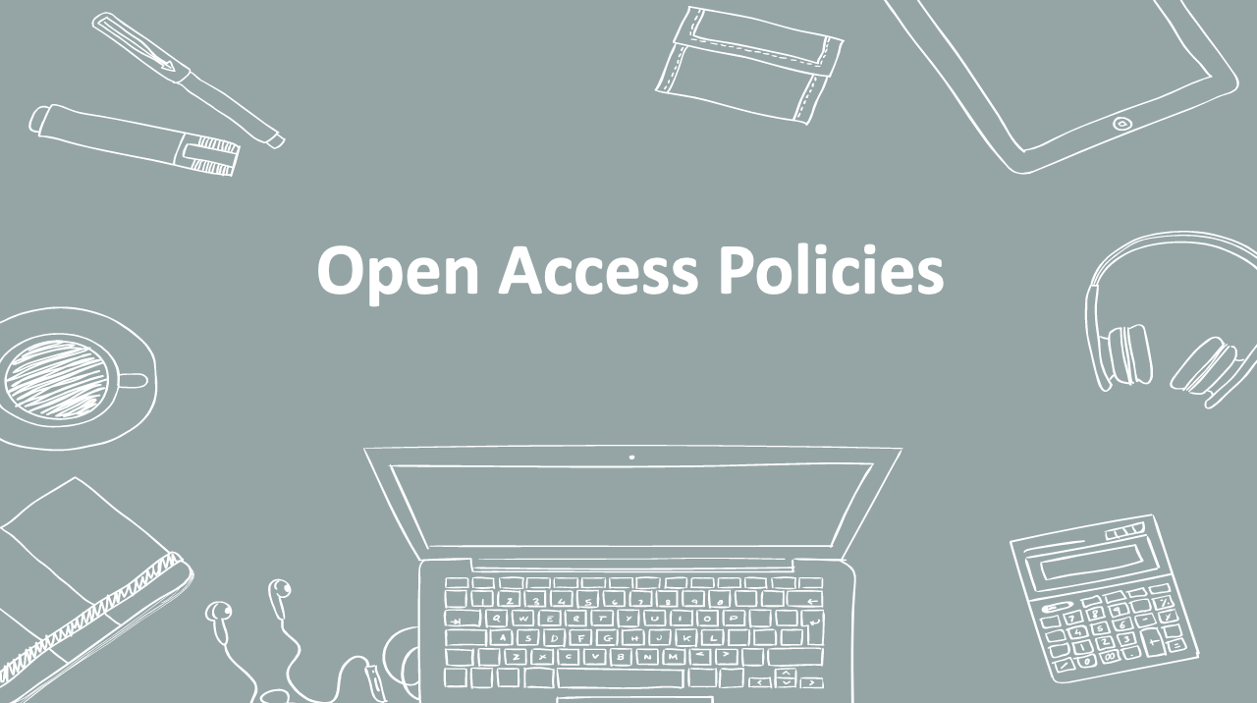

13. Open Access Policies
_________________________________________________

_________________________________________________
_________________________________________________

_________________________________________________

__________________________________________________________________________________________

__________________________________________________________________________________________

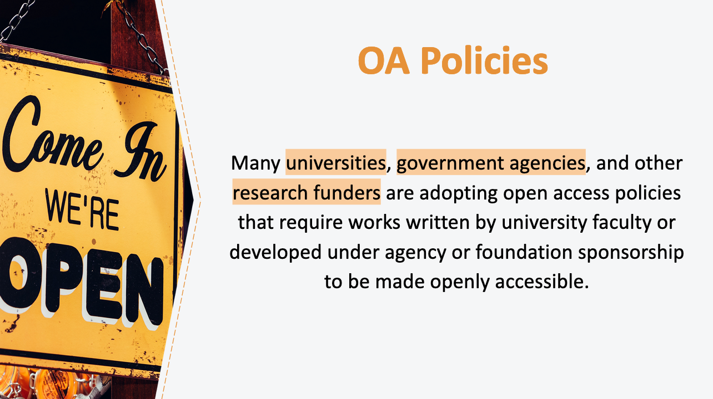
14. OA Policies
_________________________________________________

_________________________________________________
_________________________________________________

_________________________________________________

__________________________________________________________________________________________

__________________________________________________________________________________________

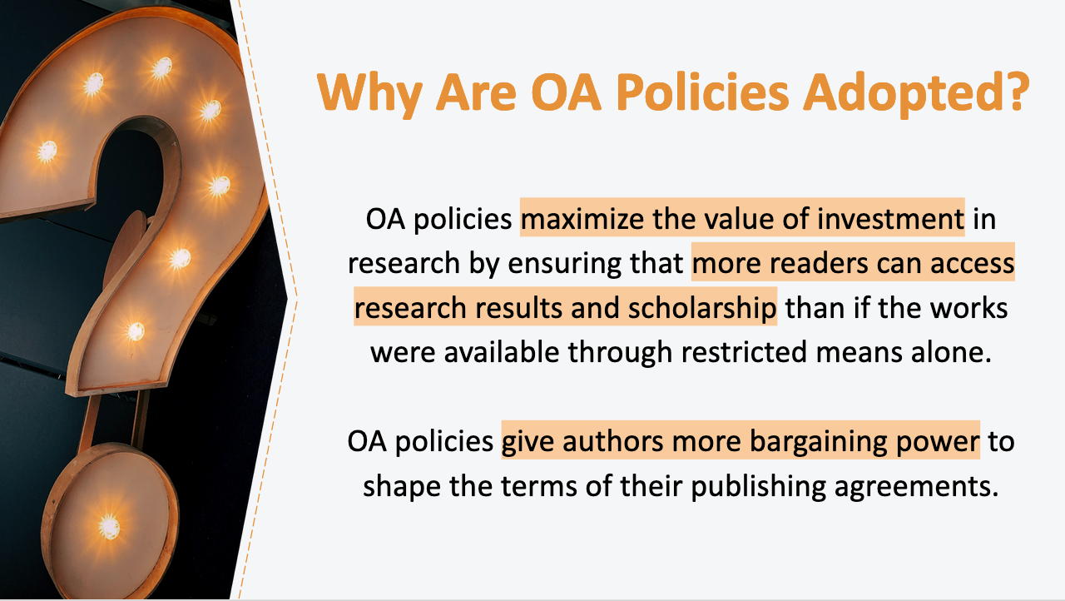

15. Why Are OA Policies Adopted?
_________________________________________________

_________________________________________________
_________________________________________________

_________________________________________________

__________________________________________________________________________________________

__________________________________________________________________________________________

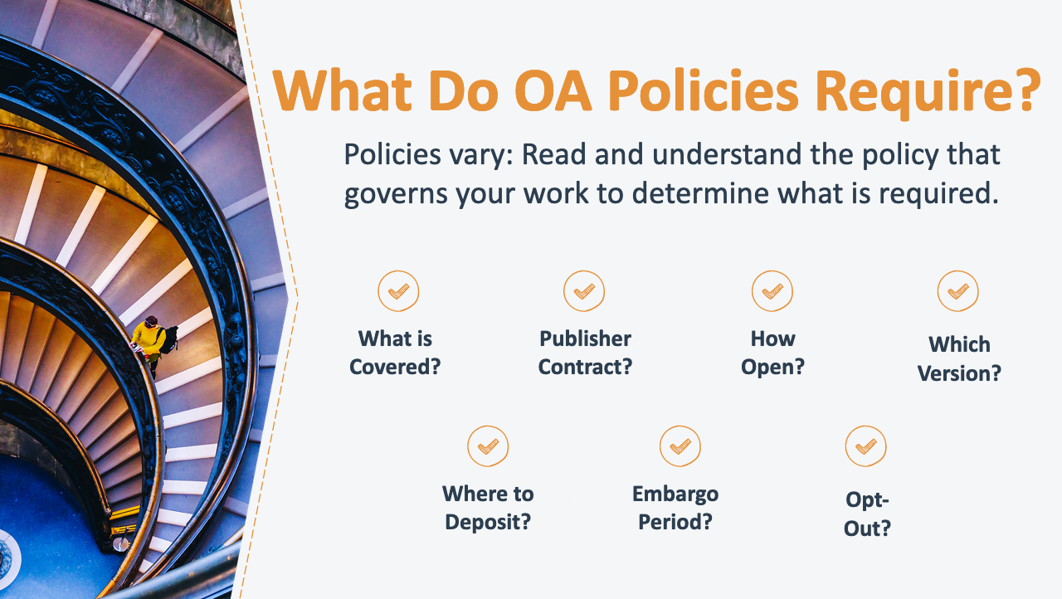
16. What Do OA Policies Require?
_________________________________________________

_________________________________________________
_________________________________________________

_________________________________________________

__________________________________________________________________________________________

__________________________________________________________________________________________

17. How “Open” Do You Want to Make Your Work?
_________________________________________________

_________________________________________________
_________________________________________________

_________________________________________________

__________________________________________________________________________________________

__________________________________________________________________________________________

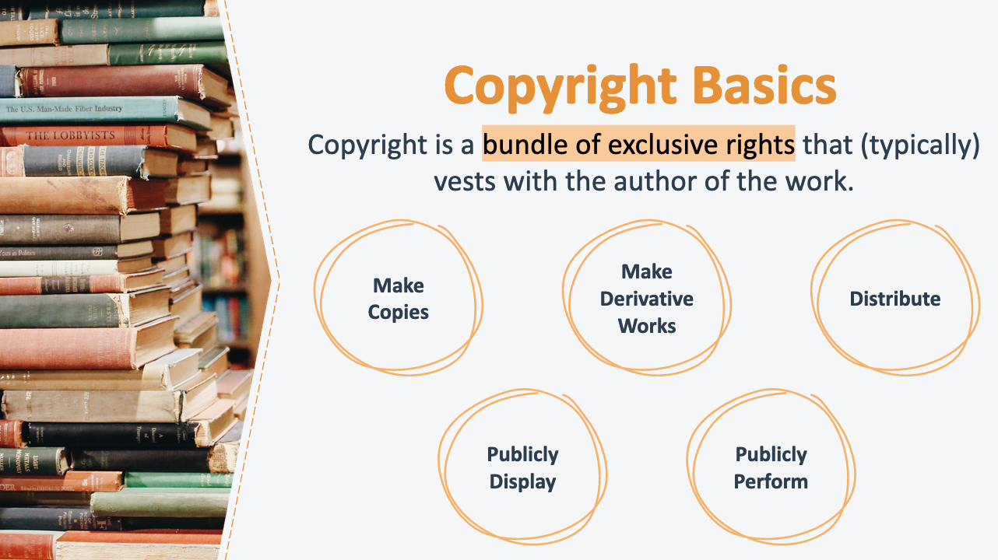

18. Copyright Basics
_________________________________________________

_________________________________________________
_________________________________________________

_________________________________________________

__________________________________________________________________________________________

__________________________________________________________________________________________

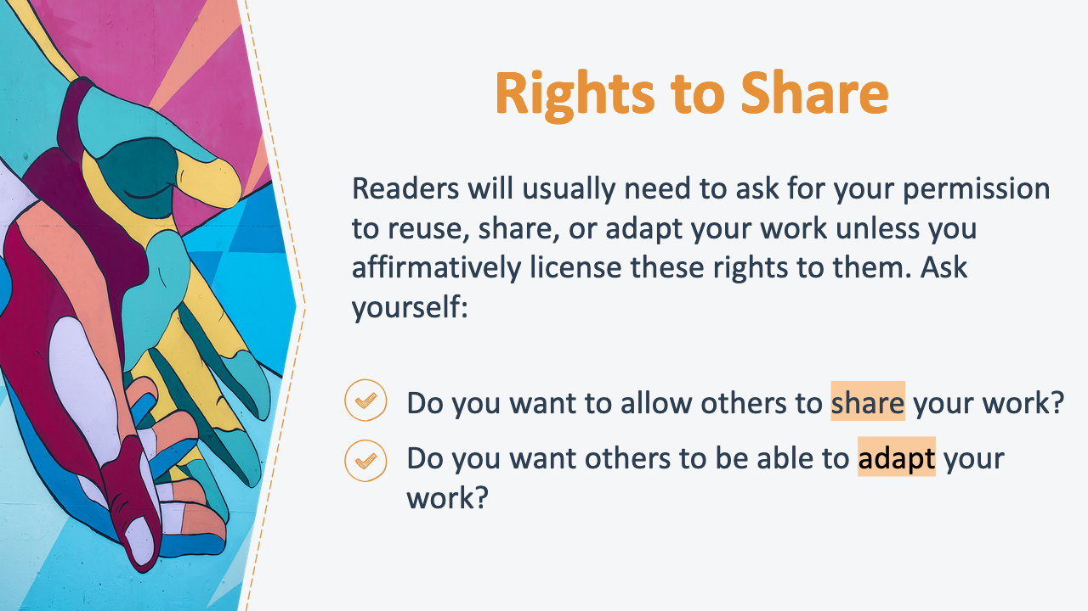

19. Rights to Share
_________________________________________________

_________________________________________________
_________________________________________________

_________________________________________________

__________________________________________________________________________________________

__________________________________________________________________________________________

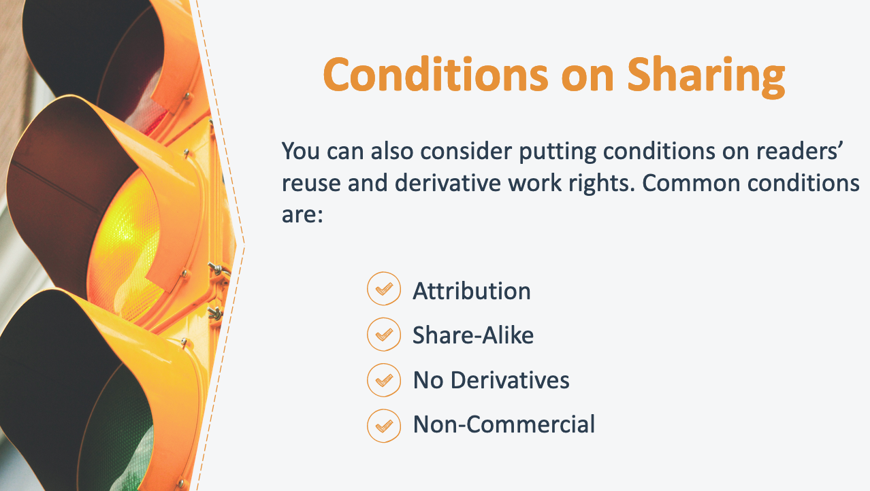

20. Conditions on Sharing
_________________________________________________

_________________________________________________
_________________________________________________

_________________________________________________

__________________________________________________________________________________________

__________________________________________________________________________________________

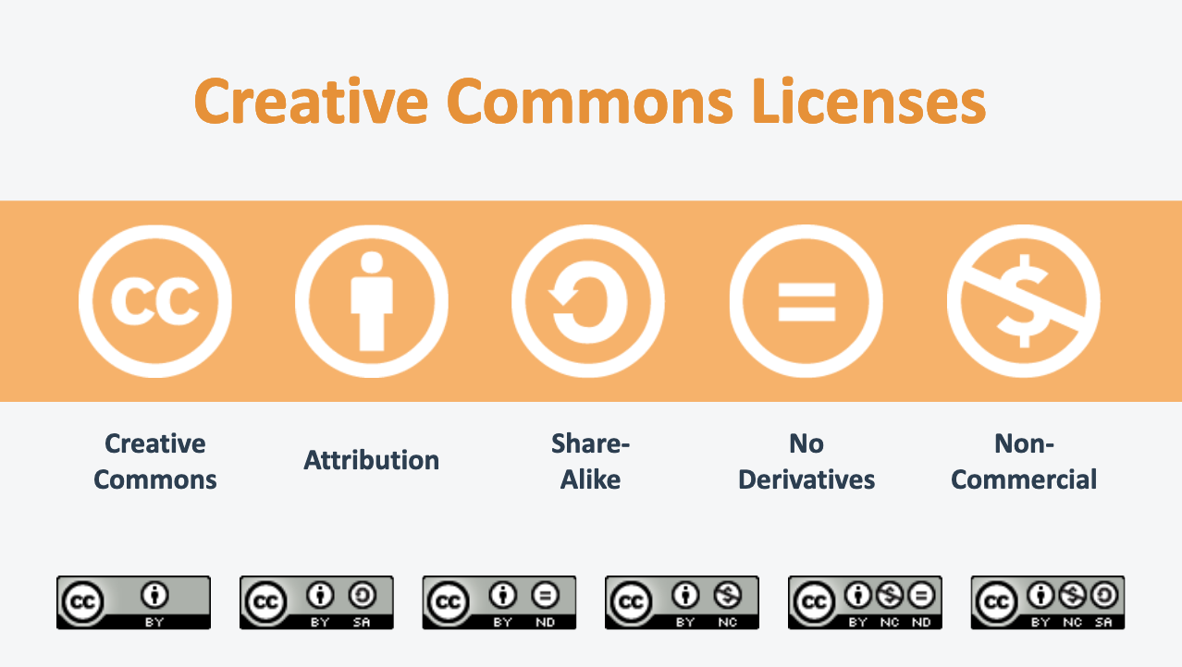
21. Creative Commons Licenses
_________________________________________________

_________________________________________________
_________________________________________________

_________________________________________________

__________________________________________________________________________________________

__________________________________________________________________________________________

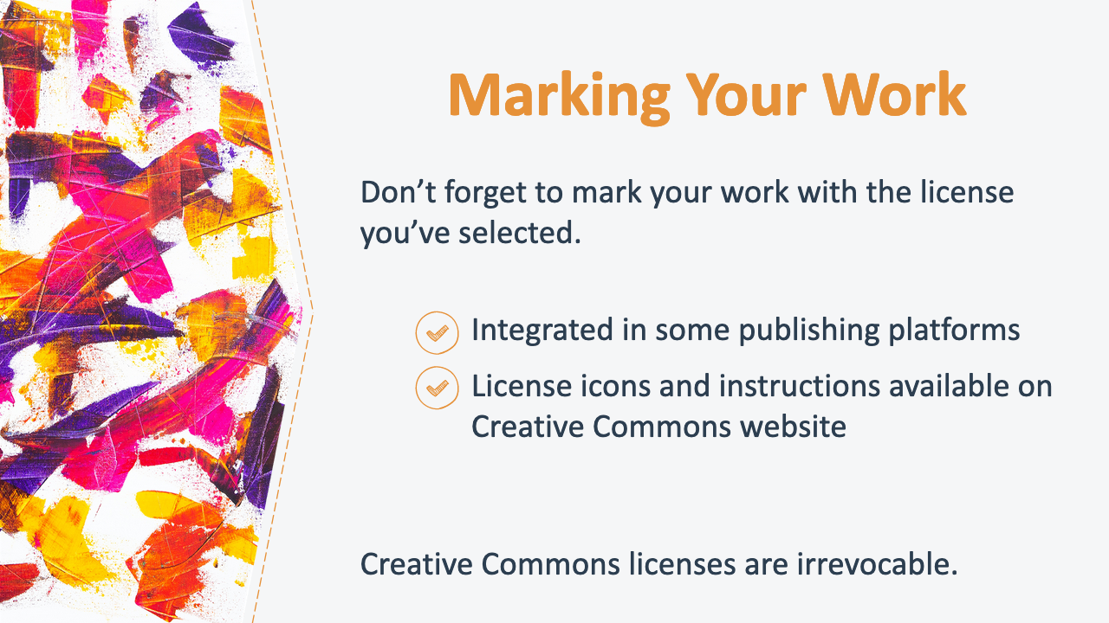
22. Marking Your Work
_________________________________________________

_________________________________________________
_________________________________________________

_________________________________________________

__________________________________________________________________________________________

__________________________________________________________________________________________

23. How Do You Want to Publish Your Work?
_________________________________________________

_________________________________________________
_________________________________________________

_________________________________________________

__________________________________________________________________________________________

__________________________________________________________________________________________

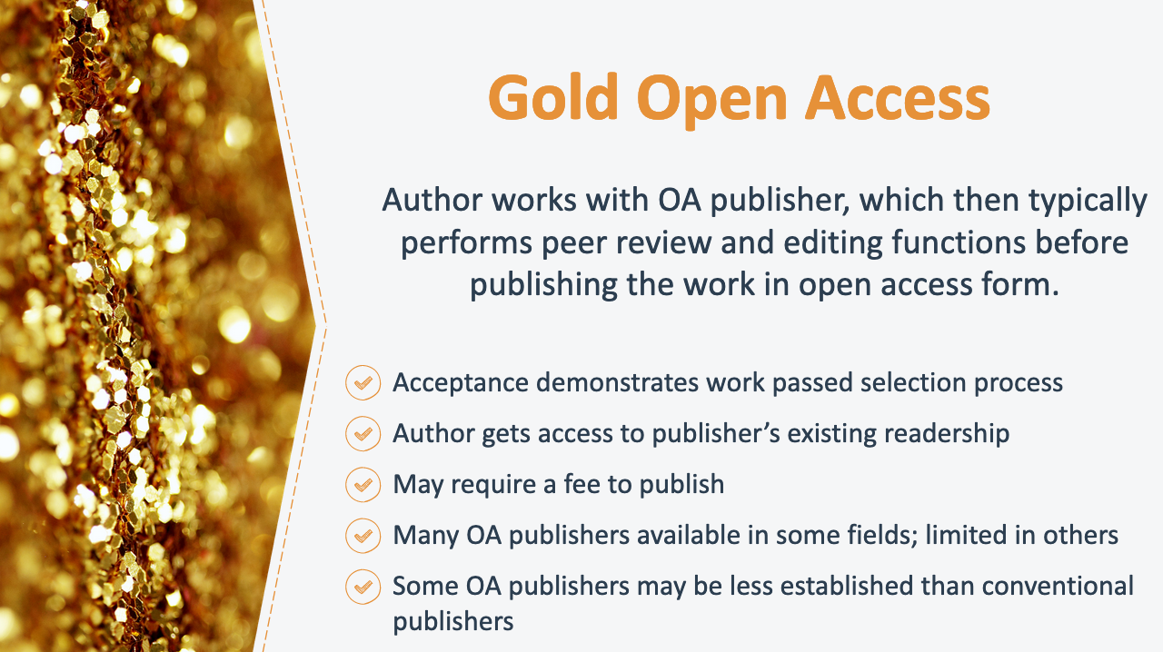
24. Gold Open Access
_________________________________________________

_________________________________________________
_________________________________________________

_________________________________________________

__________________________________________________________________________________________

__________________________________________________________________________________________

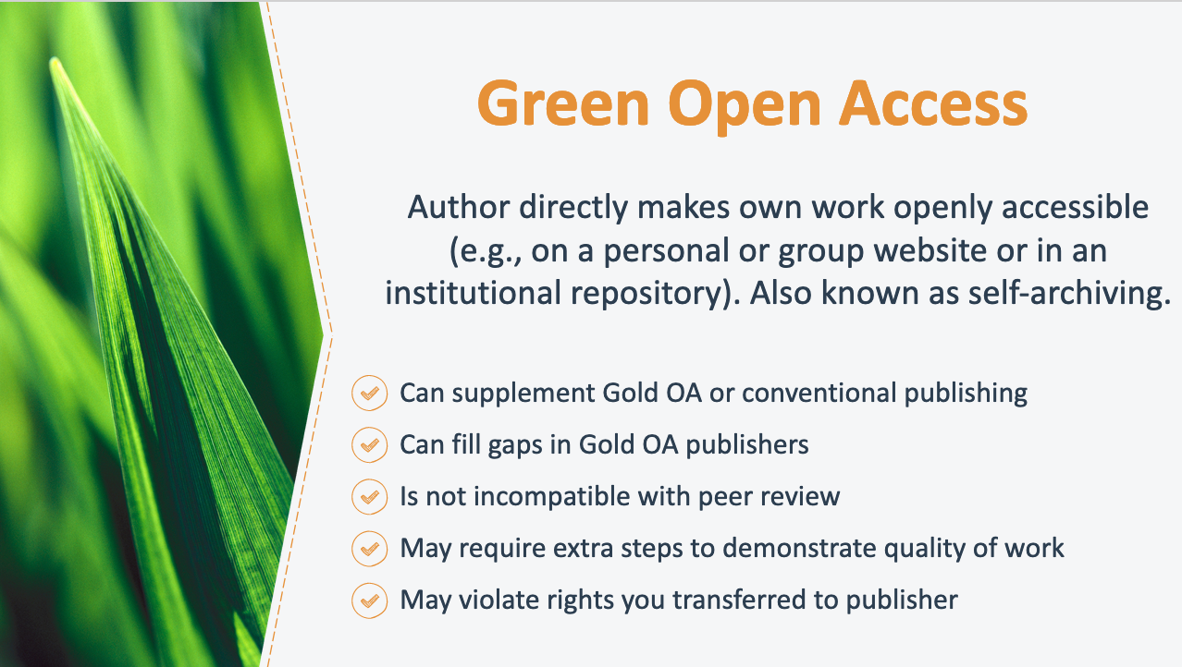

25. Green Open Access
_________________________________________________

_________________________________________________
_________________________________________________

_________________________________________________

__________________________________________________________________________________________

__________________________________________________________________________________________
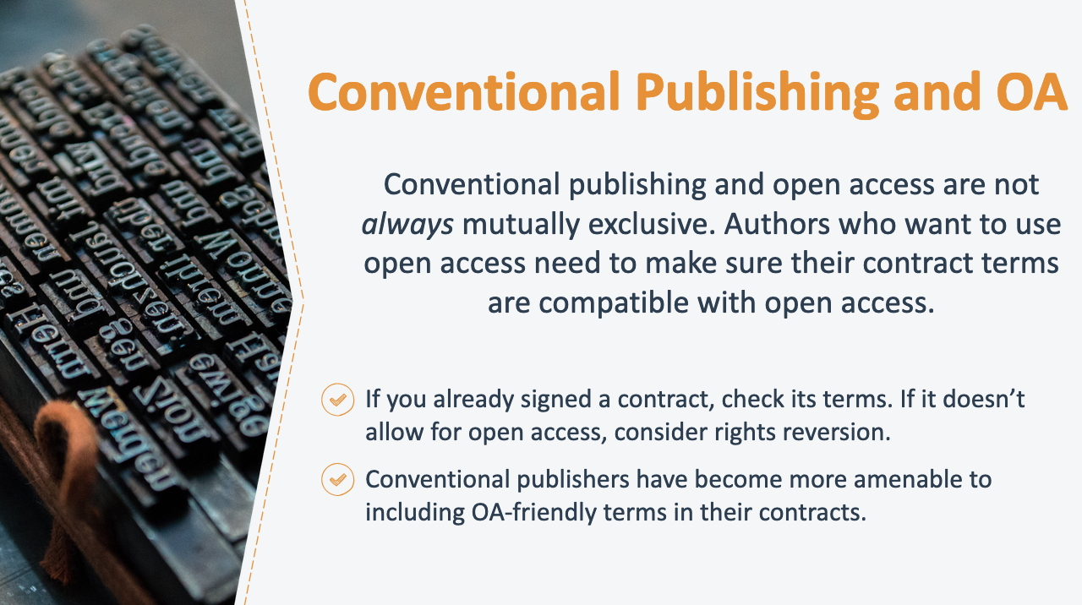

26. Conventional Publishing and OA
_________________________________________________

_________________________________________________
_________________________________________________

_________________________________________________

__________________________________________________________________________________________

__________________________________________________________________________________________

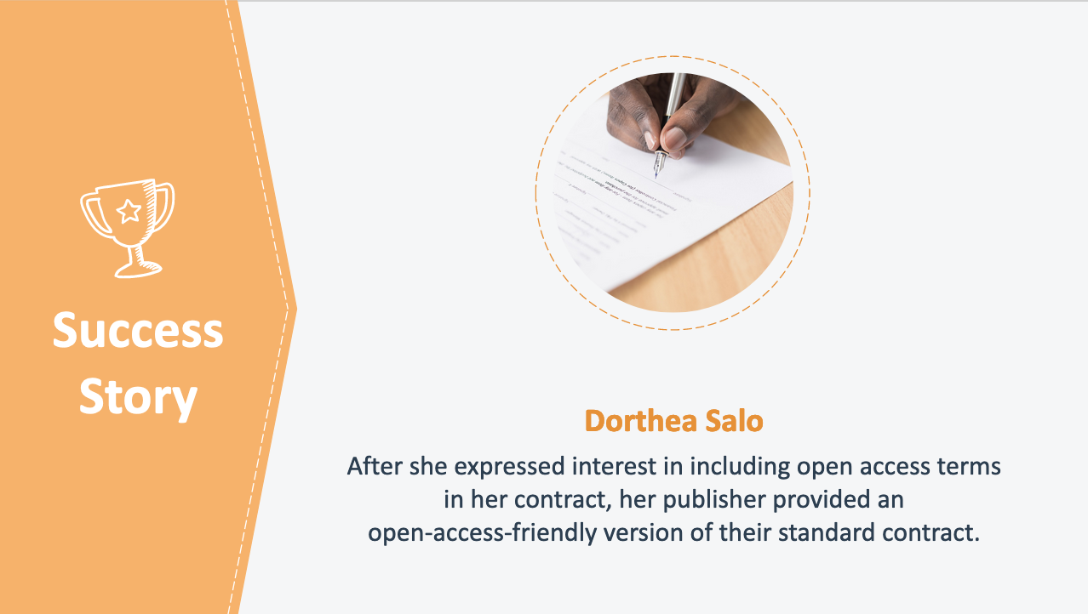
27. Success Story: Dorthea Salo
_________________________________________________

_________________________________________________
_________________________________________________

_________________________________________________

__________________________________________________________________________________________

__________________________________________________________________________________________

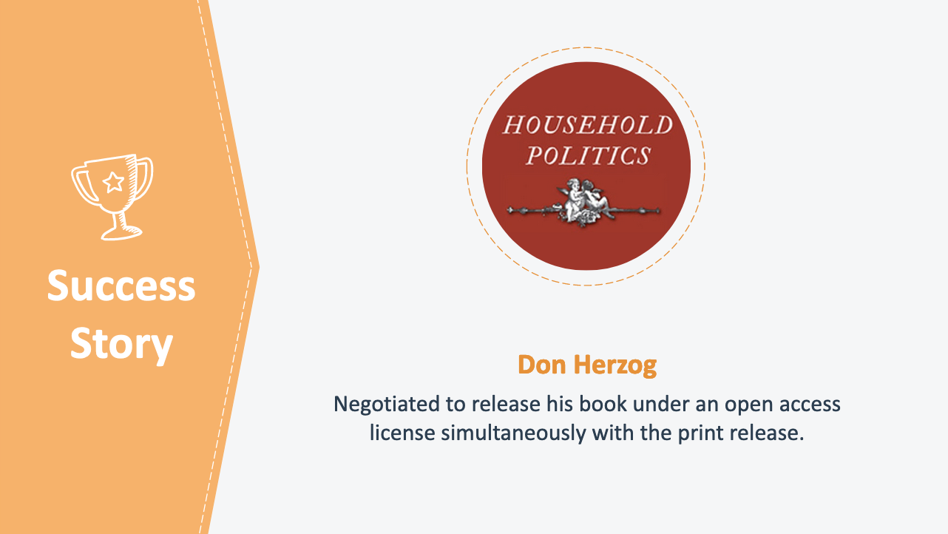

28. Success Story: Don Herzog
_________________________________________________

_________________________________________________
_________________________________________________

_________________________________________________

__________________________________________________________________________________________

__________________________________________________________________________________________
.

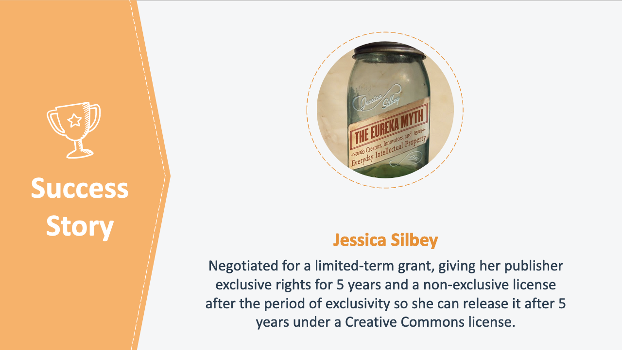
29. Success Story: Jessica Silbey
_________________________________________________

_________________________________________________
_________________________________________________

_________________________________________________

__________________________________________________________________________________________

__________________________________________________________________________________________

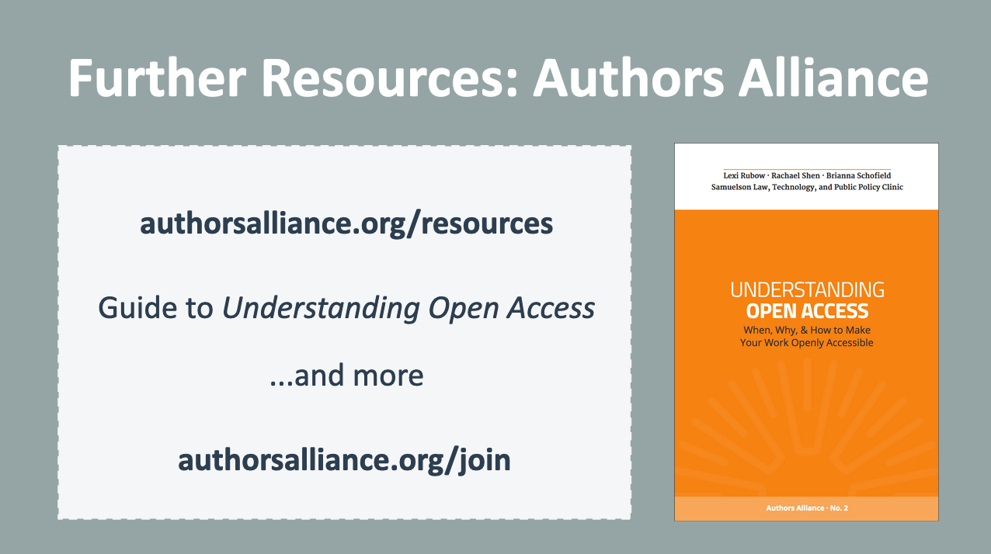
30. Further Resources: Authors Alliance
_________________________________________________

_________________________________________________
_________________________________________________

_________________________________________________

__________________________________________________________________________________________

__________________________________________________________________________________________

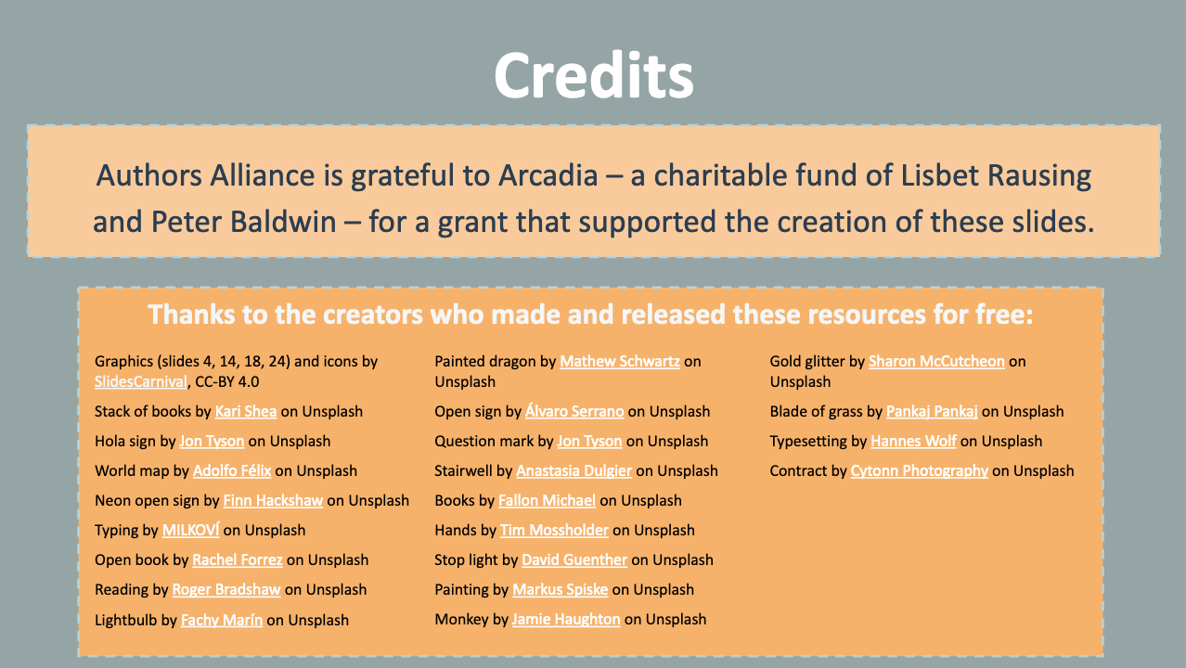
31. Credits
_________________________________________________

_________________________________________________
_________________________________________________

_________________________________________________

__________________________________________________________________________________________

__________________________________________________________________________________________

Authors Alliance is grateful to Arcadia—a charitable fund of Lisbet Rausing and Peter Baldwin—for a grant that supported the creation of these materials.

