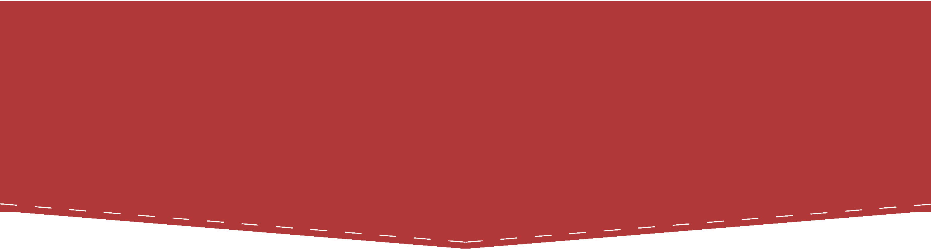
Copyright for Graduate Students
  - Presenter Notes

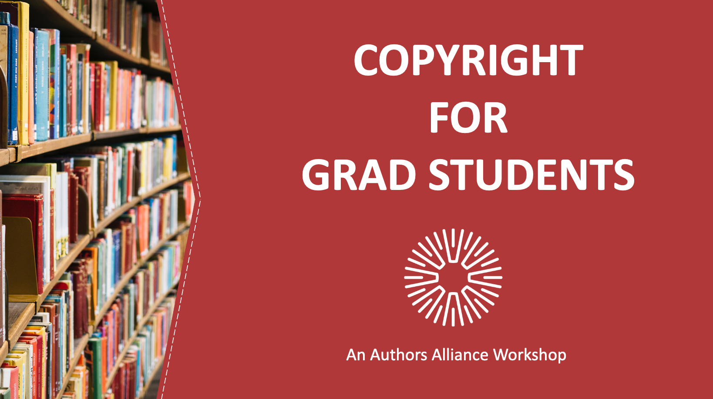
1. Copyright for Graduate Students
Welcome, everyone! This presentation is for graduate students who are interested in learning more about copyright issues that may arise as you navigate your scholarship.

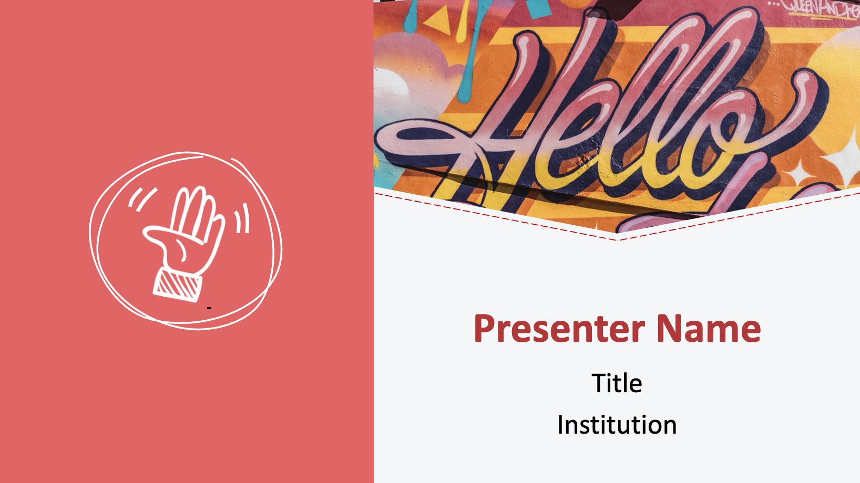
2. Hello
Introduce presenter(s).

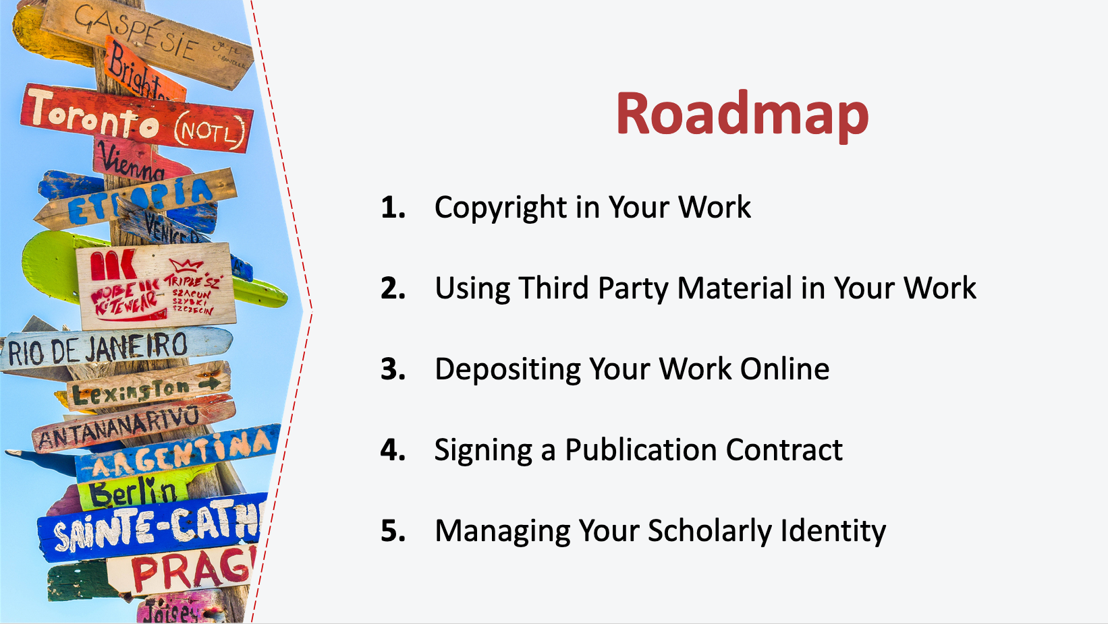
3. Roadmap
Today’s presentation has five parts. We’ll start by covering the basics of what copyright is and what copyrights you have in your work. We’ll then turn to a discussion about incorporating works by third parties into your writing, including using works in the public domain and openly licensed works, relying on fair use, and securing permissions. Next, we’ll talk about depositing your dissertation online. Then we’ll cover the things to consider when signing a publication contract, including some basic points you may want to negotiate. Finally, we’ll take a look at actions you can take to manage your scholarly identity online.

By the end of the presentation, you will have a better understanding of what copyright is, how to use copyrighted material in your work, and some of the ways that you can manage your own copyrights.

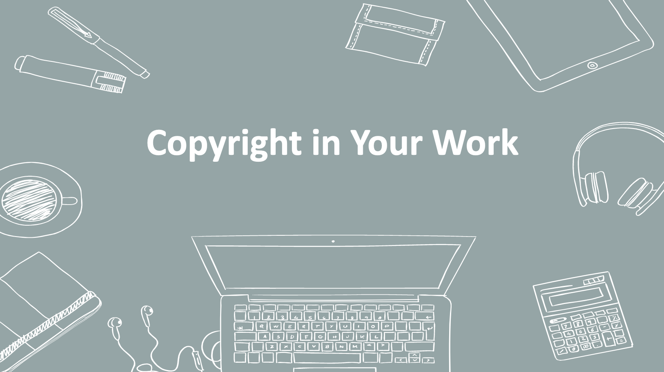
4. Copyright in Your Work
Let’s get started with an overview of what copyright is, what it protects, and how long it lasts.

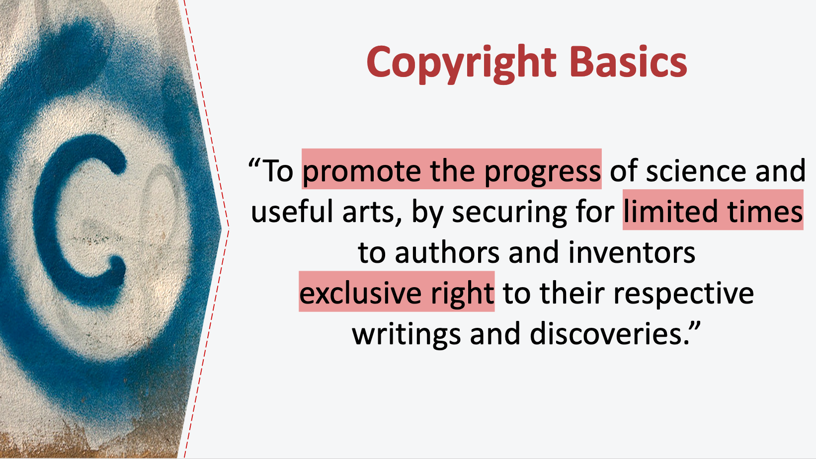
5. Copyright Basics
The source of copyright law in the United States is the U.S. Constitution. Article 1, section 8, clause 8 of the Constitution gives Congress the ability to pass laws to incentivize authors and creators by allowing a period of time during which they can profit from their work—a kind of temporary monopoly. Note the phrase "limited times.” This is a nod to the value of works eventually being free from this temporary monopoly and available for the public to freely use and build upon.

The current copyright law in the U.S. is the Copyright Act of 1976. The Copyright Act protects original, creative works of authorship that are fixed in any tangible medium of expression.

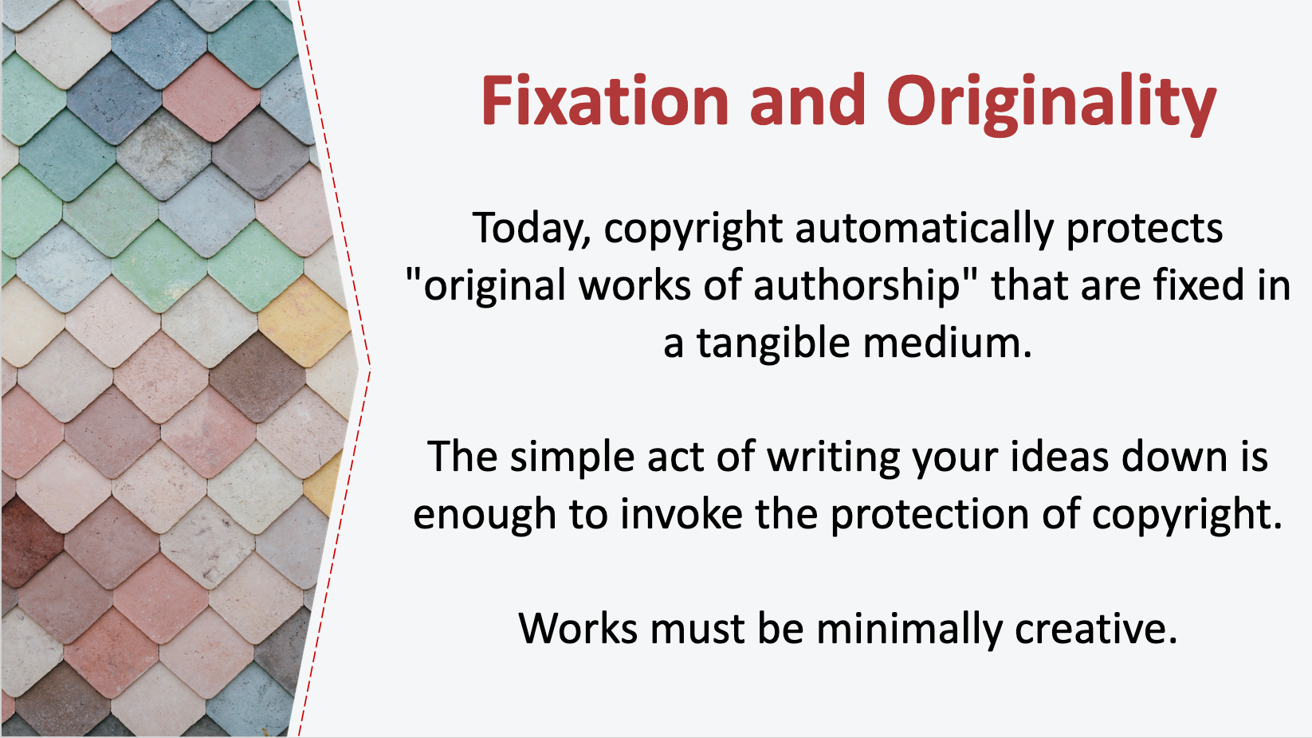
6. Fixation and Originality
Today, copyright protection is automatic. When you write a book, an article, or some other work of original expression, you generally will have a copyright in that work from the moment you commit that expression to paper (or save to your computer, as the case may be). Today, there is no need to register your work with the Copyright Office or place a copyright symbol on your work before it is eligible to receive copyright protection. You just have to “fix” your original, creative work in a tangible medium.

There are a few things to unpack there! “Fixing” a work just means it is written, saved, painted, or otherwise created in a medium that is not ephemeral. Skywriting is not fixed, but writing a poem on a cocktail napkin is, as is saving a document on your computer. Merely typing into word processing software is not fixed until it is saved since a work must be reproducible or retrievable in order to be “fixed.”

What is an original work? “Original” essentially means that it comes from you and not somewhere else. It originates with you. It does have to be minimally creative, but that is a very low bar. Courts have held that almost any spark of creativity beyond the trivial will constitute sufficient originality. Some things are barred from protection by regulation—titles, short phrases, and forms, for example—but, on the whole, most everything you write is protectable by copyright.

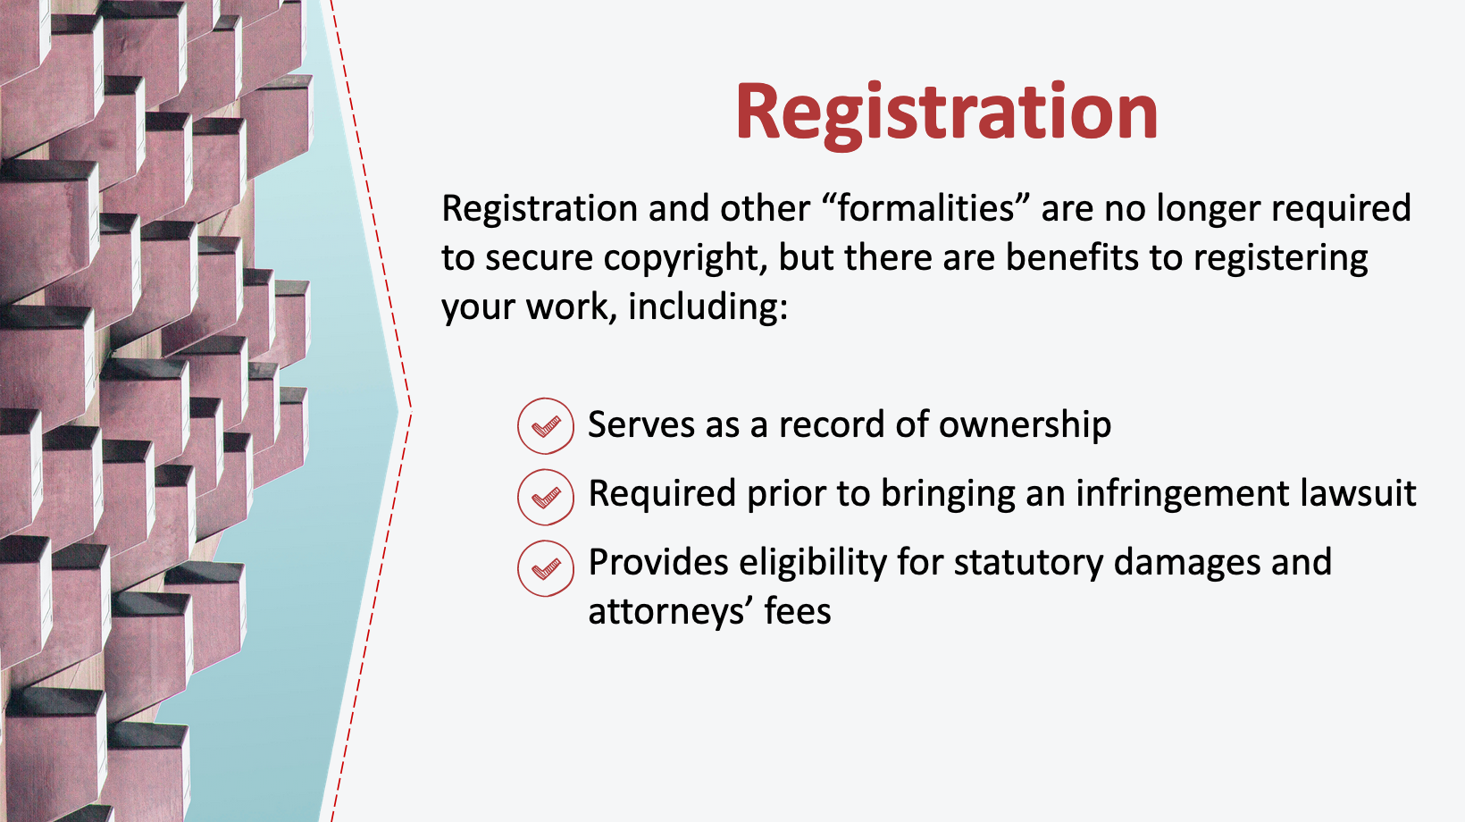
7. Registration
While you are no longer required to register your work with the Copyright Office in order to secure copyright (as we just discussed, under today’s copyright laws your work is automatically protected from the moment it is fixed in a tangible medium), there are benefits to registering your work by paying a small fee and submitting a record to the U.S. Copyright Office. First, registration serves as a record of ownership, which can be helpful if someone wants to find out who owns a work in order to ask permission to use it. Registration is also required prior to bringing an infringement lawsuit, and if you register in a timely manner you are then eligible for additional remedies in the event of a lawsuit, such as statutory damages and attorneys’ fees. If you don’t register your copyright, you can only collect actual damages. Typically, if you are working with a publisher, the publisher will assume responsibility for registering the copyright in a work prior to publication.

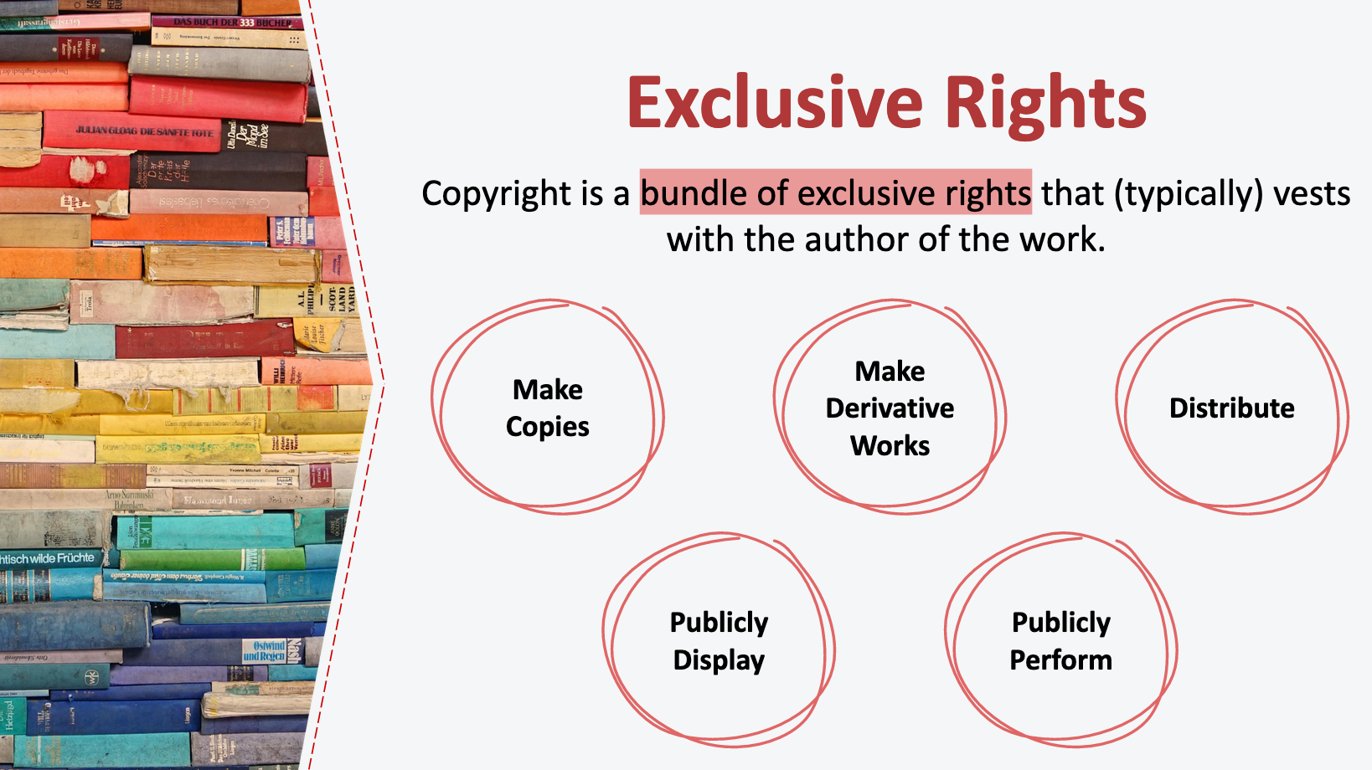
8. Exclusive Rights
With some exceptions (such as writing something at the behest of your employer, in which case your work might be considered a “work for hire” and the employer may be the copyright owner), you will generally hold the copyright to that work simply by being the author of the work. So what does copyright give you?

Copyright is a bundle of exclusive rights that only the copyright holder, or someone authorized by the copyright holder, can exercise—unless their use falls under an exception to copyright law (like fair use). These rights include the right to make copies of that work and the right to make other works derived from that work, such as translations, abridgements, or movie adaptations. These rights also include the rights to distribute, publicly display, and publicly perform the copyrighted work.

By holding the copyright in a work, an author can usually prevent all others from exercising these rights (again, barring an exception or limitation to copyright, like fair use, which we’ll talk about later in today’s presentation). This means the copyright holder of a book can print and sell copies of the book, create new works that incorporate the original book’s content, read the book aloud to public audiences, or publicly display its text.

It’s important to note that the original copyright holder can license these rights to others, and can even hand over these rights to another party entirely. In fact, publishers will sometimes ask the author to transfer these rights in a publication contract: We’ll talk more about considerations when licensing or assigning your copyrights to publishers later in this presentation.

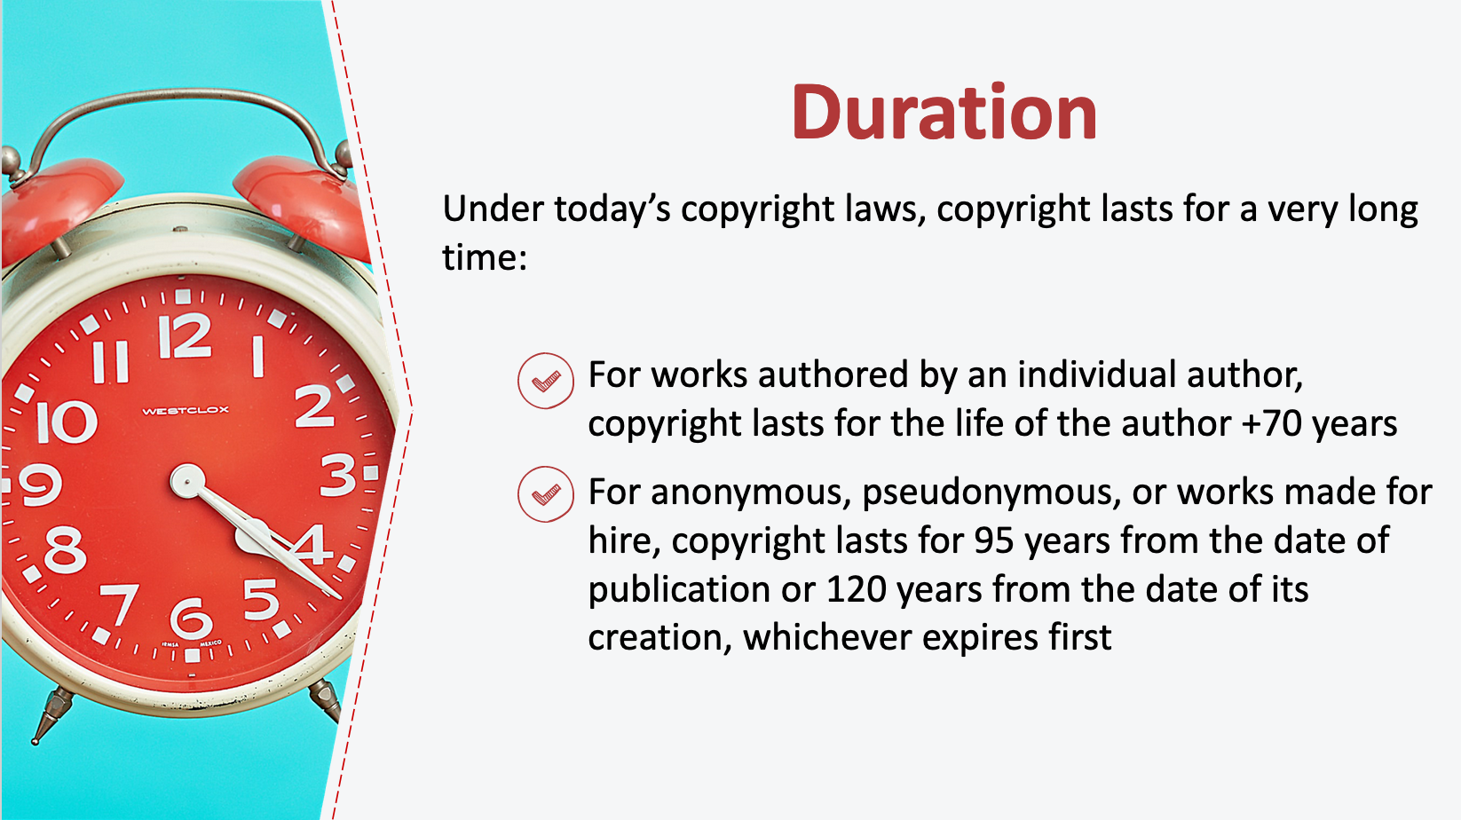
9. Duration
Under today’s copyright laws, copyright protection lasts for a very long time. As a general rule, for works authored by an individual author, copyright lasts for the life of the author plus an additional 70 years. For an anonymous work, a pseudonymous work, or a work made for hire, the copyright lasts for 95 years from the year of its first publication or 120 years from the year of its creation, whichever expires first. Note that this way of calculating copyright duration was adopted in the 1976 Copyright Act which went into effect on January 1, 1978. For works first published or registered prior to that date, the length of copyright differs.

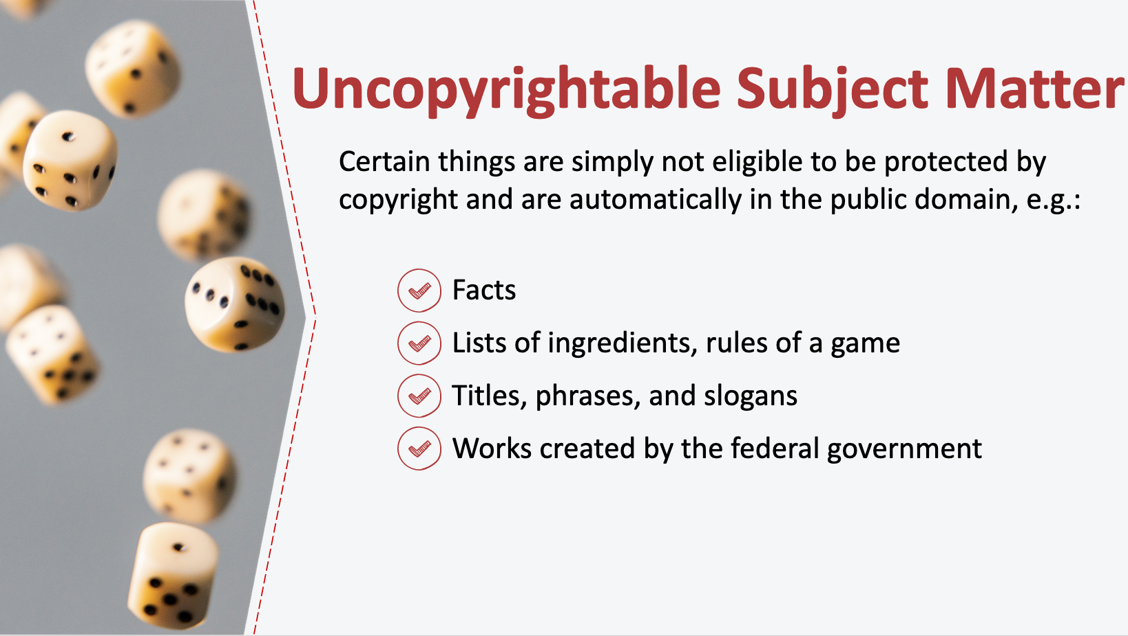
10. Uncopyrightable Subject Matter
Copyright law is not unlimited. In fact, certain kinds of things that are simply not protected by copyright.

An important category of things that are not copyrightable are facts—even if those facts were difficult to collect. For instance, suppose that a historian spent several years reviewing field reports and compiling an exact, day-by-day chronology of military actions during the Vietnam War. Even though the historian expended significant time and resources to create this chronology, the facts themselves would be free for anyone to use. That said, the way that the facts are expressed—such as how they are articulated in an article or a book—is copyrightable.

Things like lists of ingredients for recipes, the rules of a board game, and titles, phrases, and slogans also do not get copyright protection. In addition, works created by the United States federal government are not eligible for copyright protection, though works created by U.S. state governments or foreign governments may be.

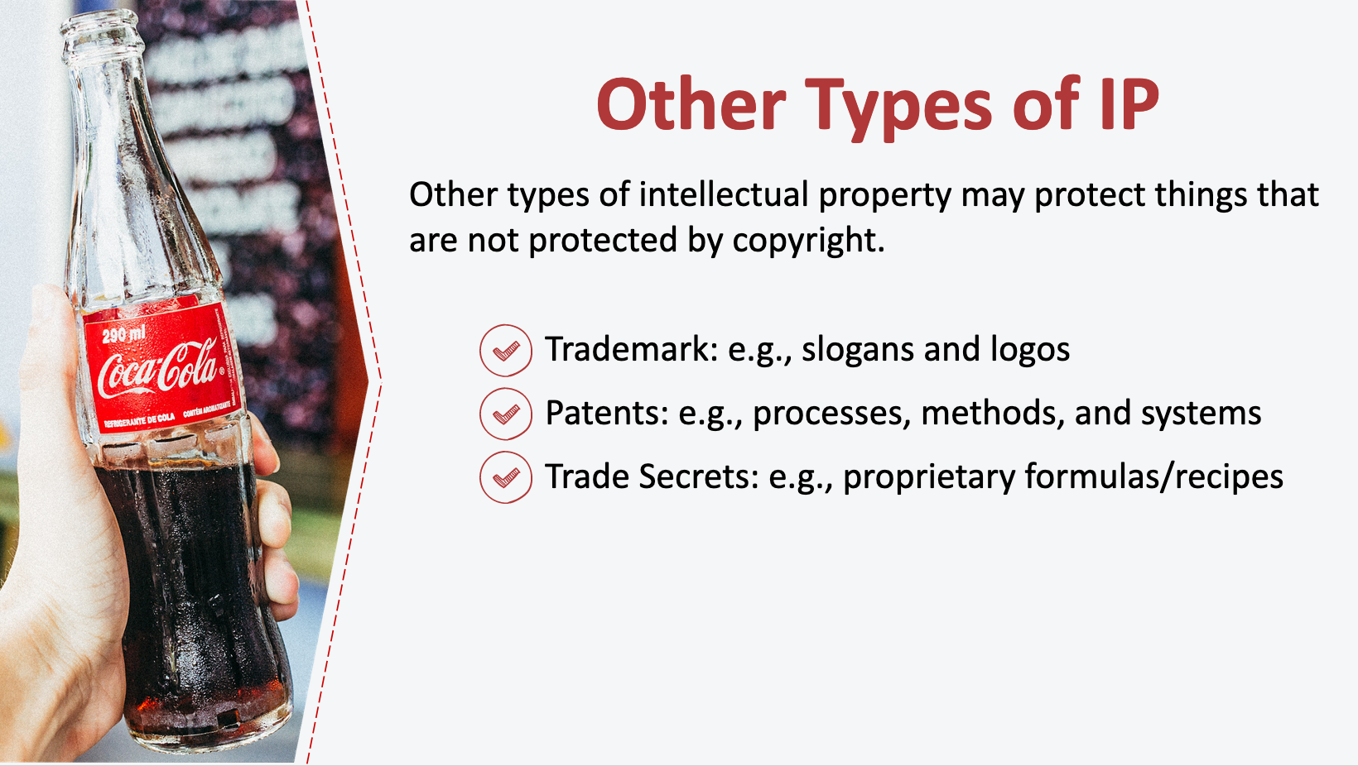
11. Other Types of IP
Copyright is only one part of intellectual property law. Other types of intellectual property may protect things that are not protected by copyright. For example, slogans and logos may be protected by trademark law; processes, methods, and systems may be protected by patent law; and things like secret formulas and recipes that are not disclosed to the public may be protected trade secrets.

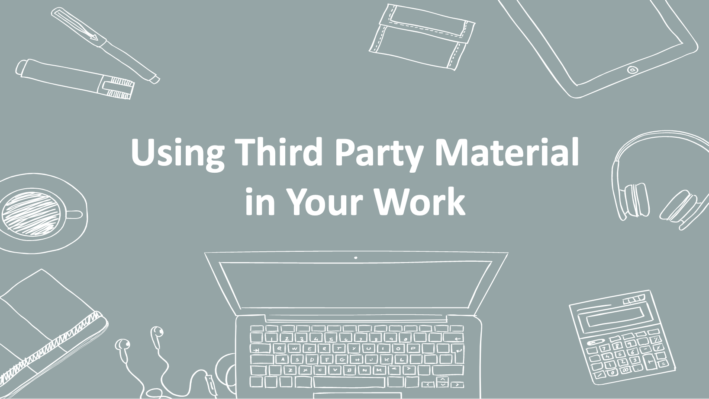
12. Using Third Party Material in Your Work
Let’s turn to what copyright issues might arise when you are using other people’s works in your own work, and what options you have for doing this without running afoul of copyright.

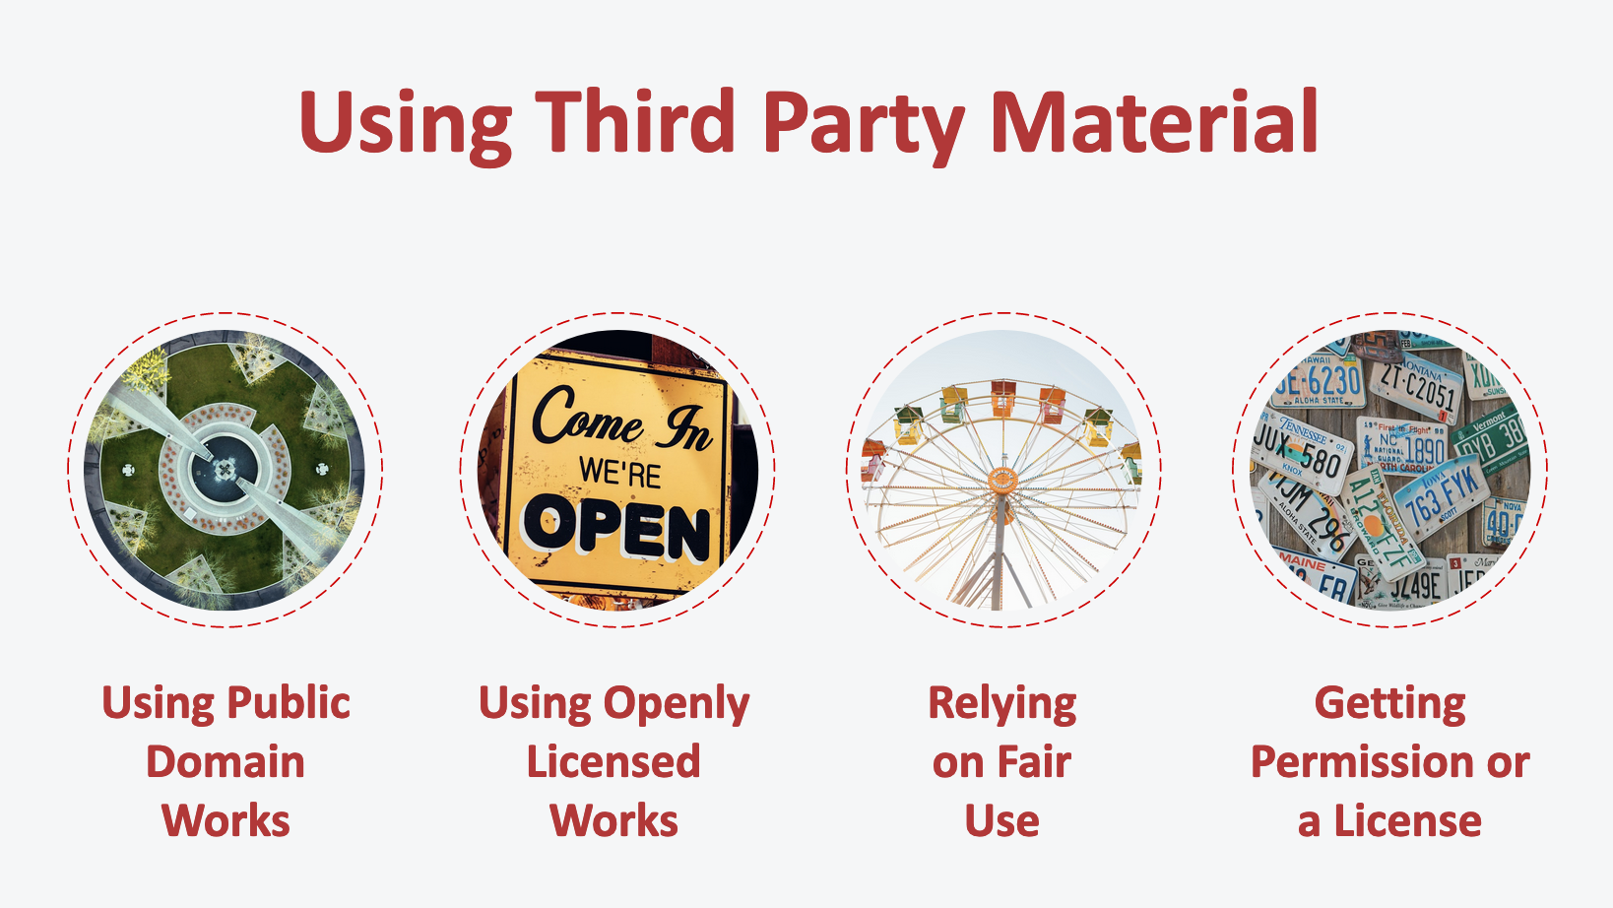
13. Using Third Party Material
In the last section, you learned that, with some limited exceptions, a copyright owner can usually prevent all others from exercising their exclusive rights. This is why you need to consider the copyright implications of incorporating third party works into your own: If you don’t, you may be infringing on someone else’s copyright. So before you incorporate passages, graphs, or images from another work into your own, you need to consider the copyright implications of doing so. Happily, there are some readily available strategies to consider when using third party works in your own work. We’ll take a look at four strategies in this section: using public domain works, using openly licensed works, relying on fair use, and getting a permission or license.

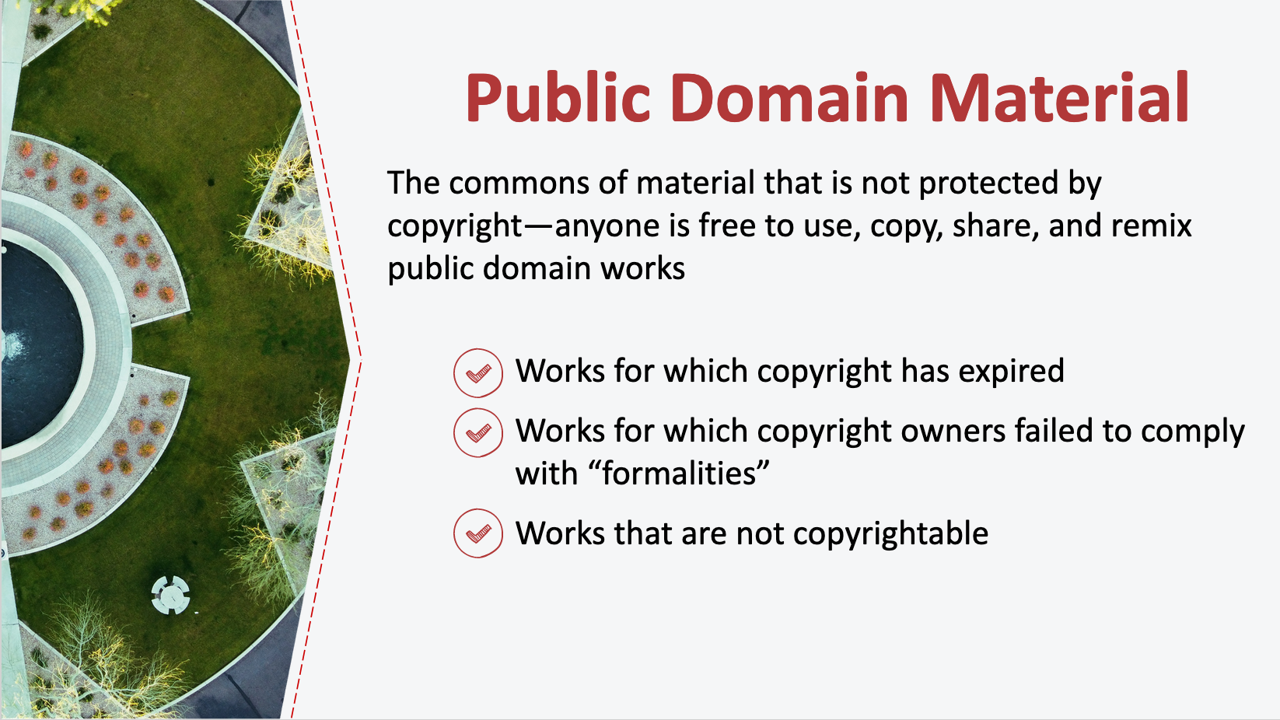
14. Public Domain Material
In copyright, the public domain is the commons of material that is not protected by copyright. Anyone is free to use, copy, share, and remix material that is in the public domain. Some people mistakenly think that the “public domain” means anything that is publicly available. This is wrong: the public domain has nothing to do with what is readily available for public consumption. This means that just because something is on the internet, for example, doesn’t put it in the public domain. Remember that under today’s copyright laws, a work of creative, original expression simply needs to be “fixed in a tangible medium” to be eligible for copyright protection. If I take a photograph today and put it online on my blog, for example, it doesn’t mean that I am also granting you permission to reuse it -- the default is that it is protected by copyright and not in the public domain.

The public domain includes works for which the copyright has expired, works for which copyright owners failed to comply with “formalities,” and other creative expression that is not entitled to copyright protection.

When we talked about duration of copyright, we learned that copyright protects works for a limited time. After that, copyright expires and works fall into the public domain and are free for all to use. Under U.S. copyright law, today, in the year 2020, all works first published in the US in 1924 or earlier are now in the public domain due to copyright expiration. That said, note that unpublished works created before 1924 could still be protected by copyright. Under today’s copyright laws, works created by an individual author today won’t enter the public domain until 70 years after the author’s death.

But when copyright does expire, the work is in the public domain and there are no copyright restrictions. For example, the book Alice in Wonderland is in the public domain, as are New York Times articles from the 1910s, because their term has expired. That means anyone may do anything they want with the works, including activities that were formerly the “exclusive right” of the copyright holder, like making copies and selling them.

Another way a work may enter the public domain is through a failure to comply with certain formalities. As we discussed, formalities are no longer required to secure copyright protection, but copyright law used to require copyright owners to comply with these requirements in order to secure copyright protection. These formalities included a requirement that the copyright owner register her work with the Copyright Office or mark the work with a copyright notice. These requirements existed in some form through March 1989. Because many authors failed to comply, many works from between 1925-March 1989 may be in the public domain. The public domain analysis needs to be done on a case-by-case basis based on the facts surrounding a particular work. (In some cases, a fair use analysis may be easier than making a conclusion about the copyright status of a work – we’ll turn to fair use soon.) If a work is in the public domain because of a failure to comply with formalities, as with copyright expiration, there are no copyright restrictions on its use by others.

In addition to copyright expiration and failure to comply with formalities, copyright law also sets out certain categories of fixed expression that are simply not protected by copyright, and those things are also in the public domain. We talked about some of these earlier: facts; lists of ingredients for recipes; the rules of a board game; titles, phrases, and slogans; and works created by the United States federal government.

So, if a third-party work you’d like to use in your writing is in the public domain, either through copyright expiration, failure to comply with the formerly required formalities, or because it is simply not eligible for copyright protection, there are no copyright restrictions and you’re free to use the work without fear of copyright liability.
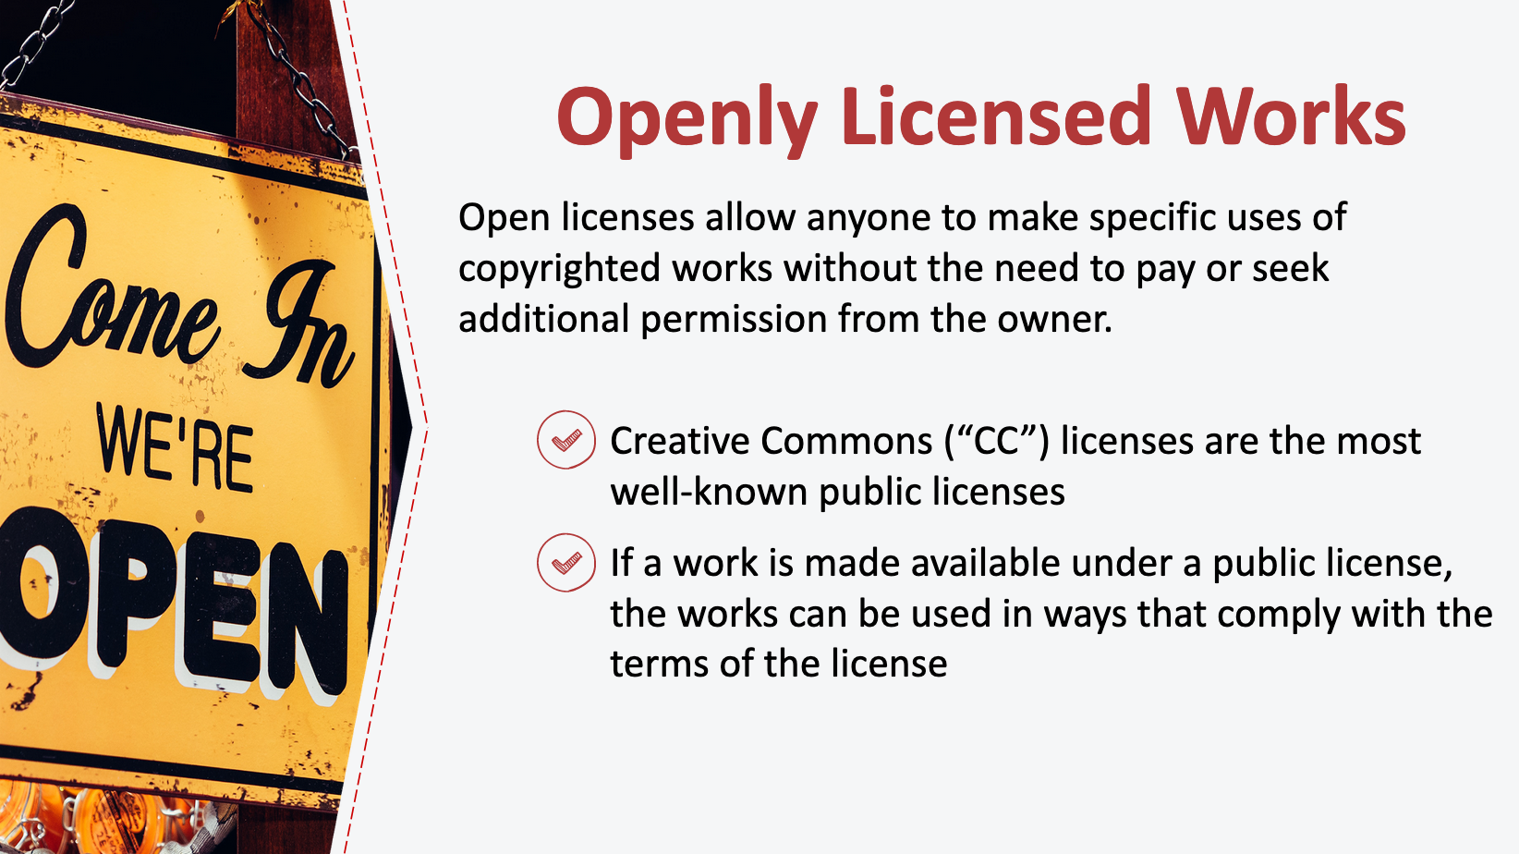
15. Openly Licensed Works
Some copyrighted works are available under public licenses that allow anyone to make specific uses of the works without the need to pay or seek additional permission from the owner. Creative Commons (“CC”) licenses are the most well-known public licenses. Creative Commons is a nonprofit organization that offers a simple, standard way to grant copyright permissions for creative works, and a suite of license options that lets authors impose some commonly-sought limitations on would-be users. Instead of the “all rights reserved” default, copyright owners can apply a CC license that allows others to use and share their works without seeking permission.

CC licenses are especially common in the academic world, especially as research funders increasingly require their grantees to use them and as faculty adopt open access policies. But even non-academic works may be made available under CC licenses. For example, some museums distribute photographs of works in their collections under open licenses.

It is important to pay attention to the specific terms of the license: almost all of the CC licenses require attribution, some can require you to “share alike” (to attach the same license to any work you create using the licensed work), and some restrict commercial uses or the creation of derivative works (like translations).

We’ll talk more about the specific CC license options in a later section. But for now, know that if a work is made available under a public license, the works can be used in ways that comply with the terms of the license.

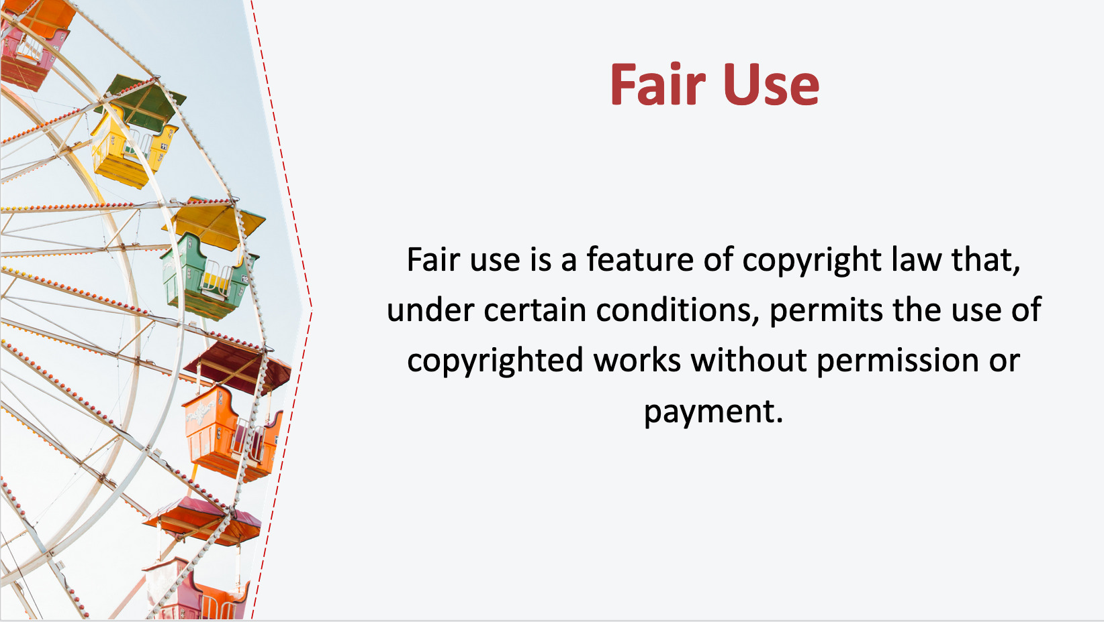
16. Fair Use
If a work you want to incorporate in your own writing is protected by copyright, you can also evaluate whether your use may be allowable under the doctrine of fair use.

Fair use is a feature of copyright law that, under certain conditions, permits the use of copyrighted works without permission or payment. Congress has said that the “fair use of a copyrighted work… for purposes such as criticism, comment, news reporting, teaching…, scholarship, or research… is not an infringement of copyright.”

Why is this? Although copyright law’s best-known feature is protection of owners’ rights, copying, quoting, and generally reusing existing cultural material is critically important to generating new culture. The cultural value of copying is so important that it is written into the social bargain at the heart of copyright law. The bargain is this: We as society give limited rights to creators to encourage them to produce culture; at the same time, we give other creators the chance to use that same copyrighted material, without permission or payment, in some circumstances. Fair use can be seen as a safety valve that is built into copyright law to prevent copyright from stifling onward creativity. Some classic examples of fair use include quoting a copyrighted text in commentary on that text, such as a book review; using an excerpt from a copyrighted text in noncommercial, academic instruction; and creating a parody of a work under copyright.

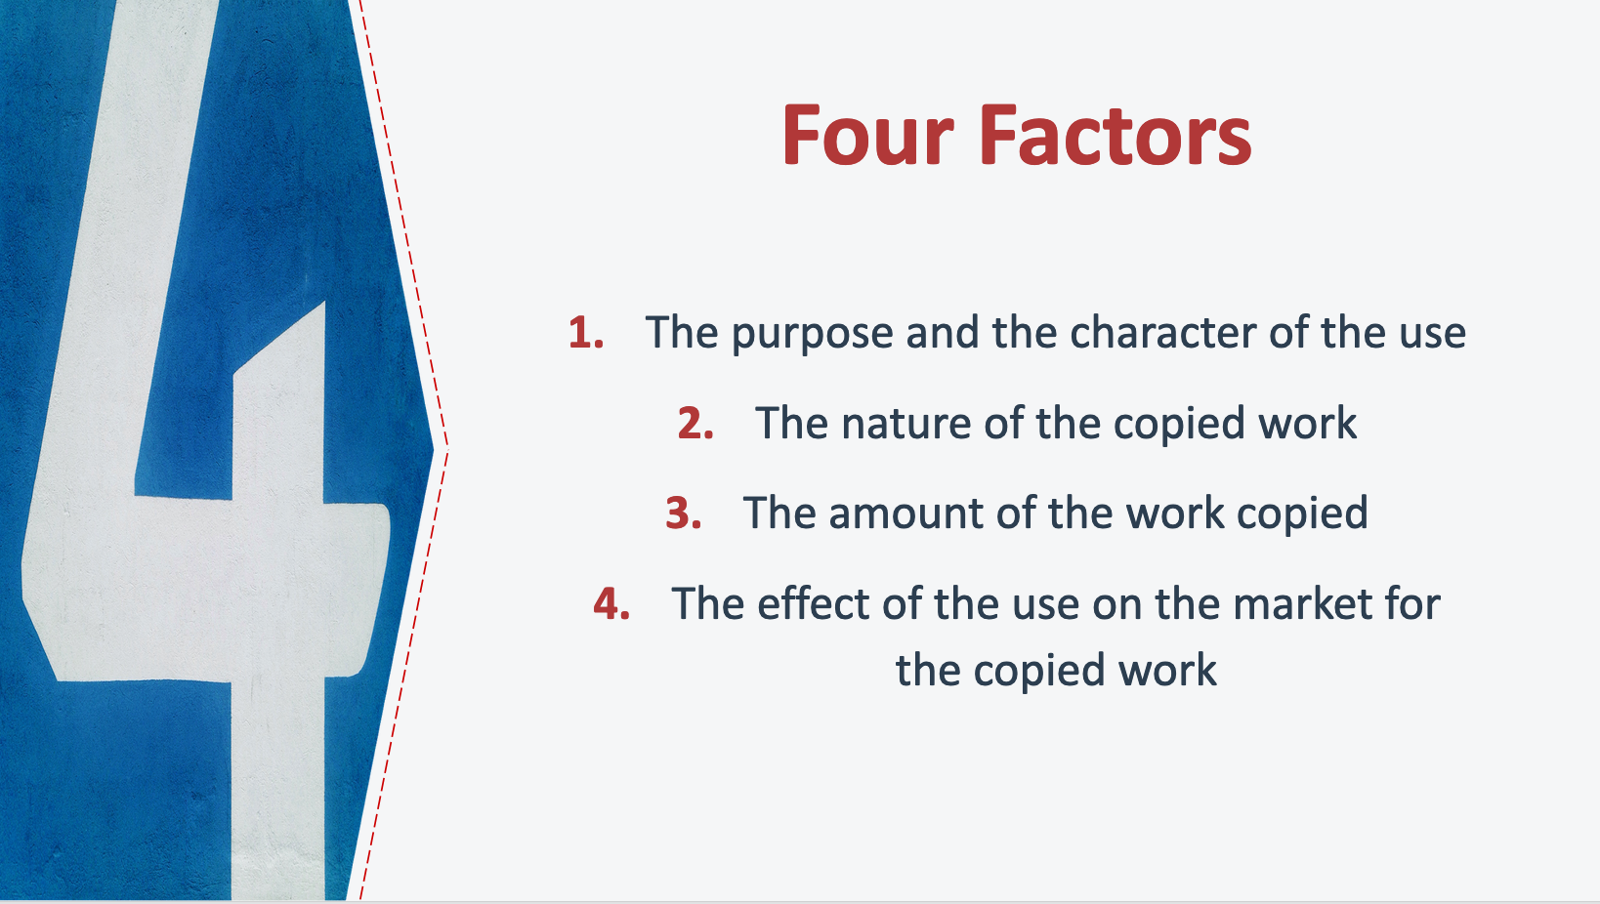
17. Four Factors
To decide whether a use is fair, courts must consider at least four factors that are specifically laid out in the 1976 Copyright Act.

The first factor is the purpose and character of the use. Here, courts ask whether the material has been transformed by adding new meaning or expression, or whether value was added by creating new information, meaning, or understanding. A court will often ask if the work is “transformative,” though transformativeness is not necessarily required. When a work is used for a different purpose than the original, the factor will likely weigh in favor of fair use. If it simply acts as a substitute for the original work, the use is less likely to be fair. Courts may also look at whether the use of the material was for commercial or noncommercial purposes under this factor, but this is rarely a determinative consideration.

The second factor looks to the nature of the copyrighted work. Here, courts consider whether the copyrighted work that was used is creative or factual in nature (a song or a novel vs. a technical article or news item). The more factual the work is in nature, the more likely this factor is to weigh in favor of fair use. On the flip side, the more creative the copyrighted work, the more likely this factor is to weigh against fair use. Courts may also consider whether the copyrighted work is published or unpublished. If the work is unpublished, this factor is less likely to weigh in favor or fair use.

The third factor is the amount and substantiality of the portion of the work that was used. Under this factor, courts look at how much of the work was taken, both quantitatively and qualitatively. Quantitatively, courts look at how much of the original work was used (e.g., all the pages, the entire work of art). Qualitatively, courts look at whether the “heart” of the work was taken (e.g., the essential bit of the work that is why people want to engage with it—the juicy revelations in a tell-all book). The more that is taken, quantitatively and qualitatively, the less likely the use is to be fair. That said, copying a full work can still be fair. And conversely, in some cases, even if a small amount is used, if it is the “heart” of the work this can weigh against fair use.

Finally, the fourth factor is the effect of the use on the market for the copyrighted work. The essential question courts ask here is whether this use will undermine the market, or potential market, for the work that was copied. In assessing this factor, courts consider whether the use would hurt the market for the original work (for example, by displacing sales of the original) and/or whether the use could cause substantial harm if this type of use were to become widespread.

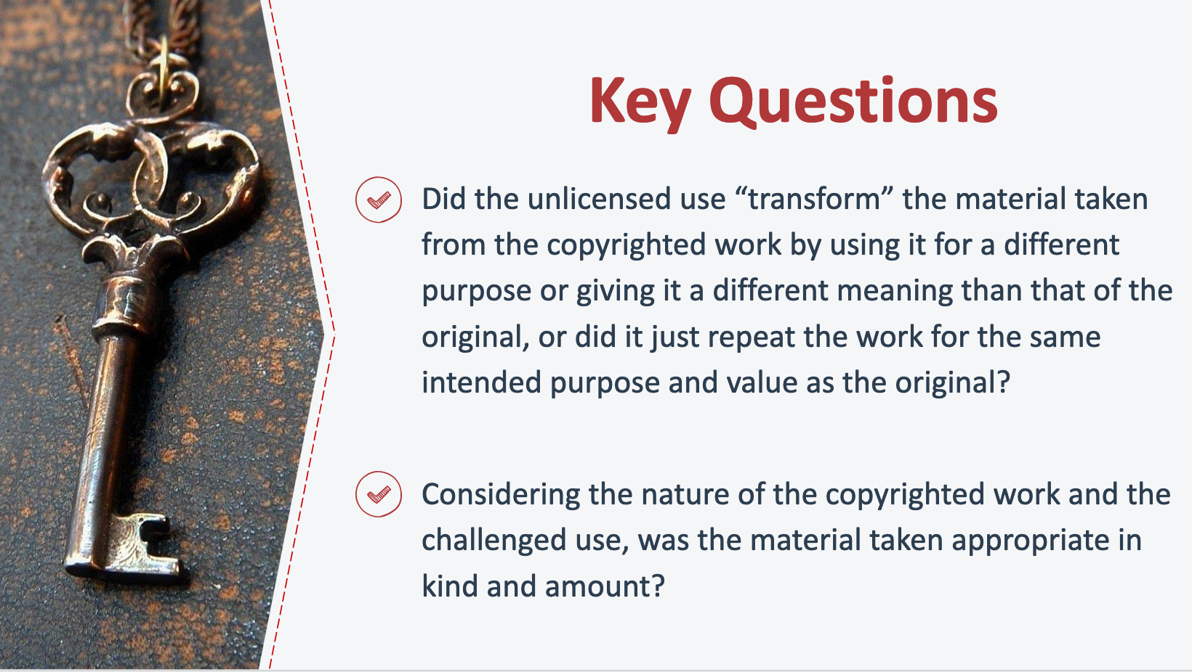
18. Key Questions
The four factors are not mechanically applied or weighed equally. The first factor tends to be most determinative, but the fourth factor has historically been given substantial weight in a court’s analysis. By design, fair use is flexible and courts take into account all the facts and circumstances of a specific case to decide if an unlicensed use of copyrighted material is fair.

Despite its flexibility, however, fair use is not unreliable. In reviewing the history of fair use litigation, scholars have found that judges return again and again to two key questions:

- Did the unlicensed use “transform” the material taken from the copyrighted work by using it for a different purpose or giving it a different meaning than that of the original, or did it just repeat the work for the same intended purpose and value as the original?

- Considering the nature of the copyrighted work and the challenged use, was the material taken appropriate in kind and amount?

If the answers to these two questions are “yes,” a court is more likely to find a use fair.

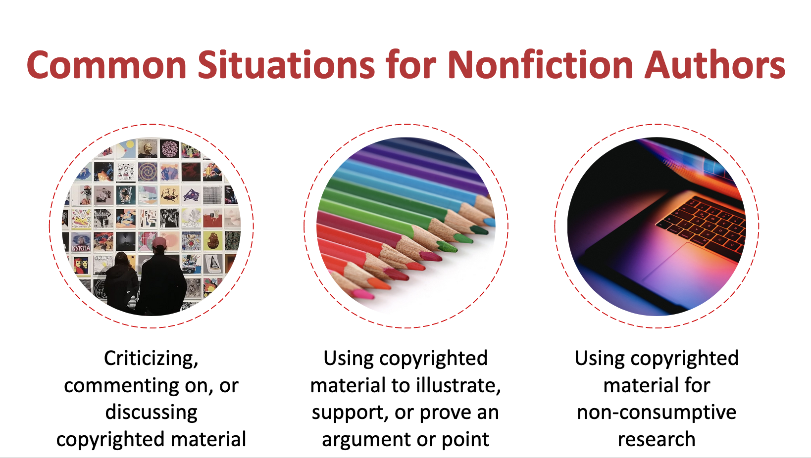
19. Common Situations for Nonfiction Authors
While there are seemingly endless ways that a copyrighted work might be used, the uses nonfiction authors typically want to make of copyrighted works boil down to a few common scenarios.

The first is to criticize, discuss, or comment on copyrighted material. Nonfiction authors often engage in critical analysis of specific copyrighted works and want to use some or all of that material in their new works. In these cases, nonfiction authors are specifically discussing the copyrighted material: the copyrighted work is itself the focus of their social, political, or cultural critique. This type of critical engagement is exactly what fair use is meant to allow. Sometimes copying is essential to an author’s purpose and, without it, a reader wouldn’t be able to understand her critique.

The second common use is to use the copyrighted material to support a point made in the author’s work. Here the material being used is not itself the object of the author’s commentary; instead, the material is being used to support a related point made by the nonfiction author. In other words, nonfiction authors want to use copyrighted material to “show their work” and lend credibility to their theories and arguments. This is another category of use that is fair use eligible.

A third use that is increasingly relevant to nonfiction authors is using copyrighted material for non-consumptive research (for example, copying works into digital databases in order to perform computational analysis across texts and/or images). In these cases, the nonfiction author is not reading, displaying, or sharing large portions of the copyrighted material, but is instead using data mining technology to derive factual information about the works and incorporate those findings into her writings. Again, legal cases provide strong support for the principle that this type of use can be a fair use.

Regardless of whether your use falls into one of these common situations, remember that fair use is fact specific and none of these uses are without limitation: For example, authors shouldn’t use more of the copyrighted work than is reasonably appropriate for the purpose of the use and should pay attention to the potential for market harm. For a deeper dive into fair use in nonfiction writing, check out the Authors Alliance guide to Fair Use for Nonfiction Authors.

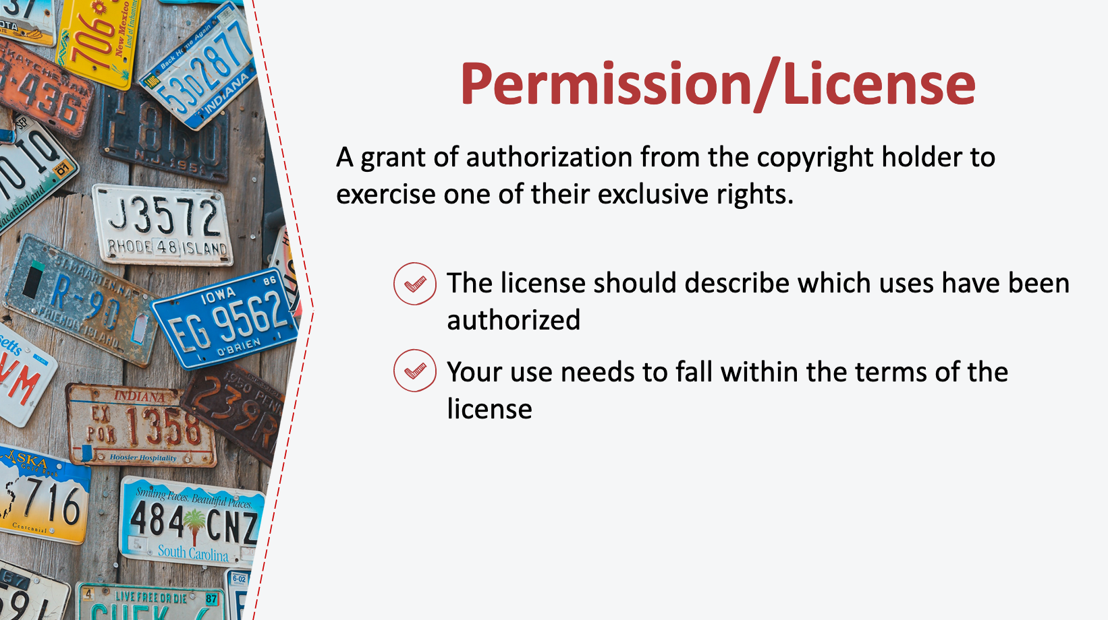
20. Permissions/License
If a work is not in the public domain or openly licensed, and your use is not likely to be a fair use, another option is to seek permission or a license to use the work. A license is a grant of authorization from a copyright holder to exercise one or more of their exclusive rights. For example, you can ask a copyright holder for a license to reproduce a photograph on the cover of your book. The license should describe which uses have been authorized, and of course your use would need fall within the terms of the license.

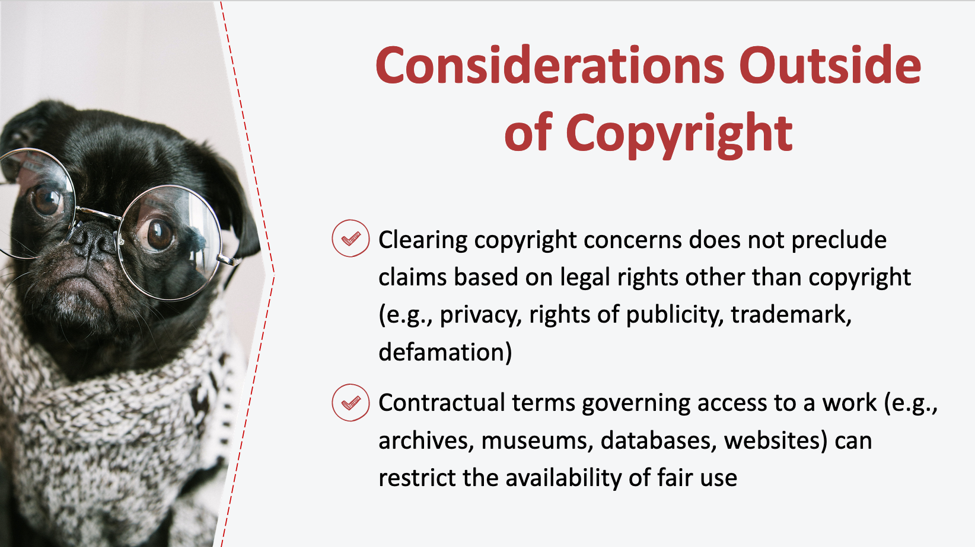
21. Considerations Outside of Copyright
It is important for authors to be aware that clearing copyright concerns does not preclude other legal claims. When using third party materials, authors should consider legal issues beyond copyright, such as potential contractual restrictions, privacy rights, trademark law, the right of publicity, defamation, and community norms, like rules against academic plagiarism.

It is also important for authors to be aware that contractual terms governing access to a work can restrict the availability of fair use. Some archives, museums, and commercial collections (including on websites) place contractual restrictions on the use of those works, even when use of the work would otherwise be permitted by fair use (and, in some cases, even when the work itself is in the public domain!). This is beginning to change, and some archives and museums have already abandoned these practices. However, if you are a party to such a contract, your ability to use materials you’ve accessed may be limited by the terms of the contract. For example, a biographer who accesses her subject’s personal papers through an archive may find that, as a condition of accessing those materials, the subject’s estate forbids quoting from the materials without the express permission of the estate. At least some courts have held that such contracts may be enforced, even if the restricted use would be fair use as a matter of copyright law. In these cases, nonfiction authors cannot rely on fair use since demands for permission in this context are based on contractual claims, not copyright. As such, nonfiction authors should pay careful attention to the conditions of access to source materials and may want to consider negotiating for better terms that do not restrict their research and writing goals.

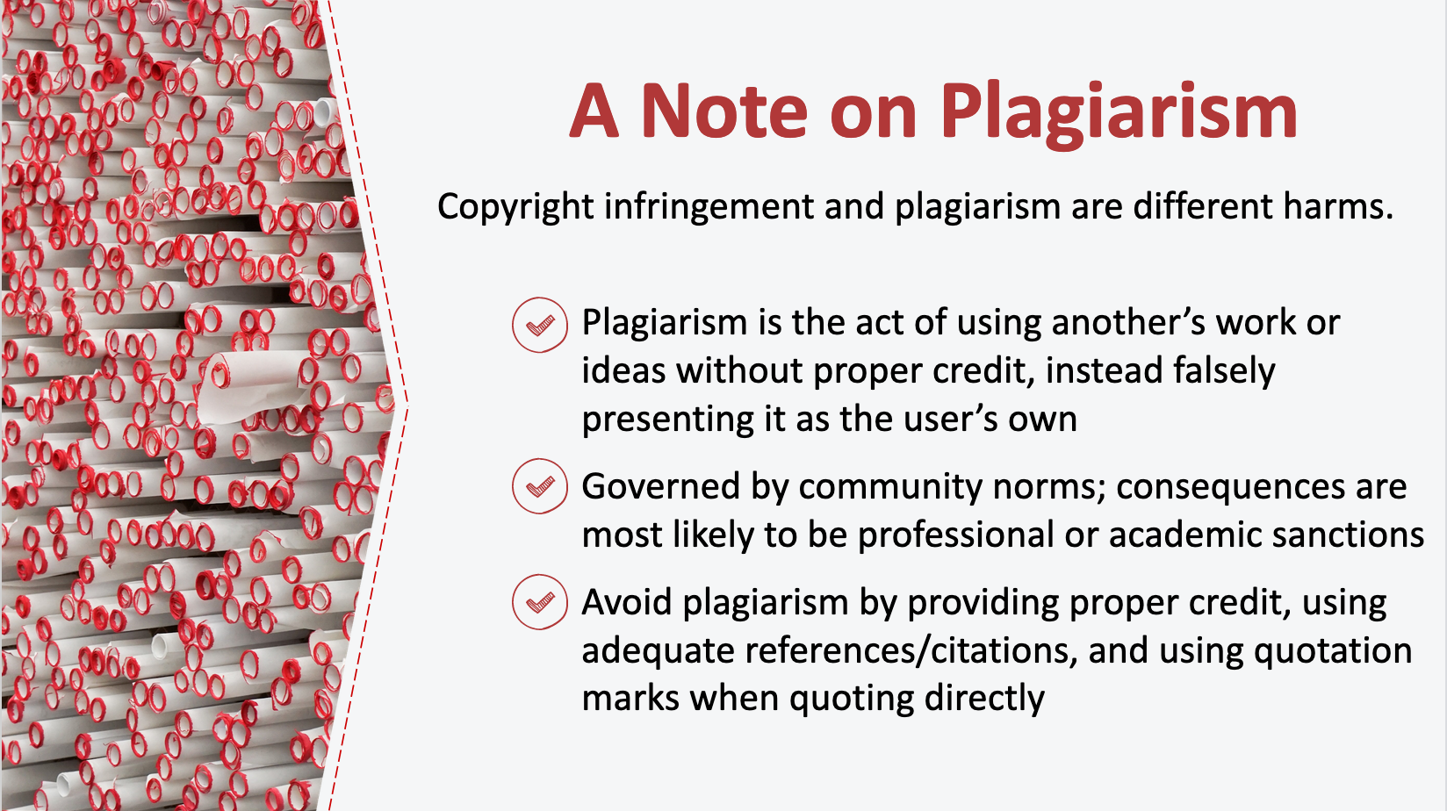
22. A Note on Plagiarism
Before we move on, let’s take a moment to clarify the difference between copyright infringement and plagiarism. Copyright infringement and plagiarism cause different harms. As we discussed, copyright infringement is a harm that is grounded in law. Plagiarism, on the other hand, is a harm that is grounded in ethics. Put simply, plagiarism is the act of using another’s work or ideas and not giving proper credit, instead falsely presenting it as the user’s own. Sometimes plagiarism also rises to the level of copyright infringement, but not always. For example, as we discussed, authors may freely use materials in the public domain without concern for copyright liability. While such uses are not copyright infringement, they may still be plagiarism if the work is used in a manner that presents the work or ideas as the user’s own.

There is no statutory prohibition against plagiarism. Instead, plagiarism is governed by community norms and the consequences of plagiarism are most likely to be professional or academic sanctions. To avoid plagiarizing another’s work or ideas, authors should properly credit the source of the ideas or words used in their text, with adequate references and citations appropriate to their discipline, and use quotation marks where appropriate when quoting directly.

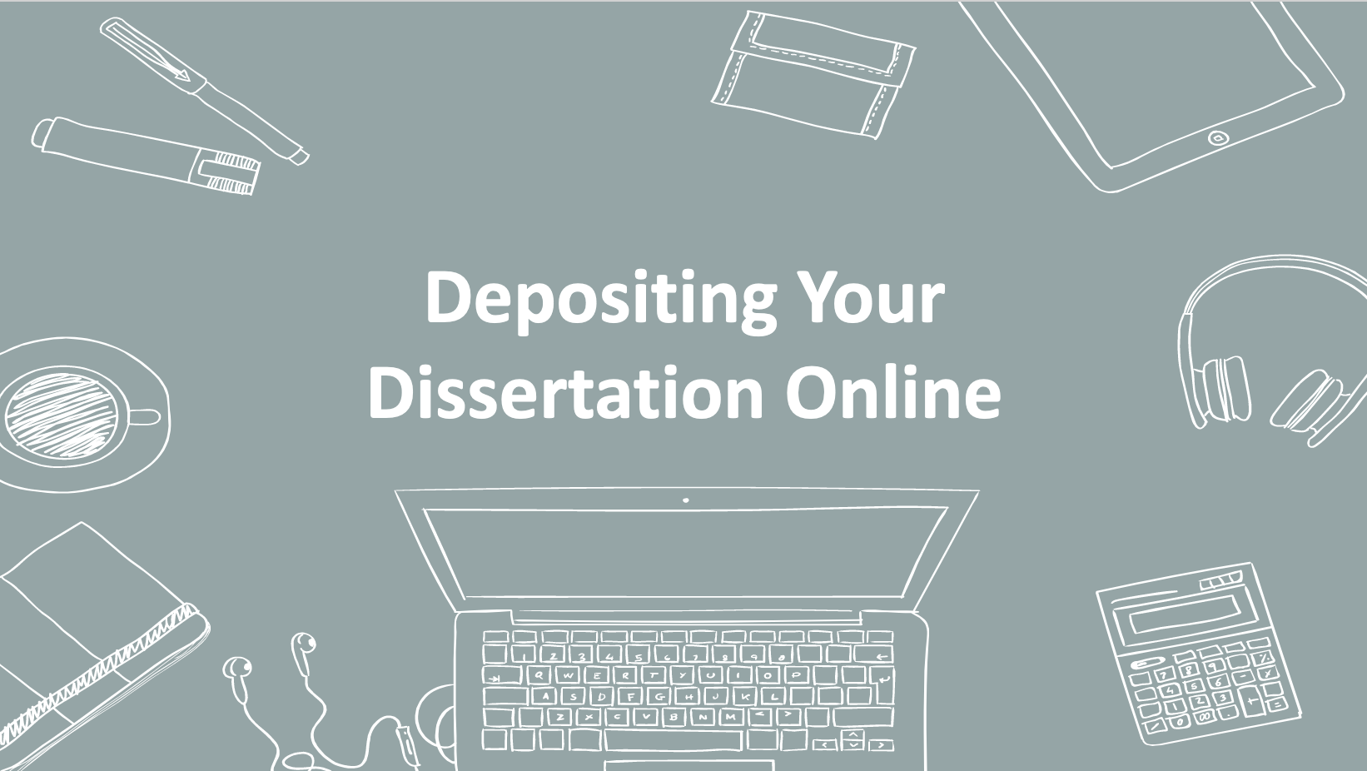
23. Depositing Your Dissertation Online
As you’re looking ahead to the time when your thesis or dissertation is done, one thing to look forward to is how you’re going to make your work available to the world. In this section, we’ll talk about options for making your dissertation available in our institutional repository.

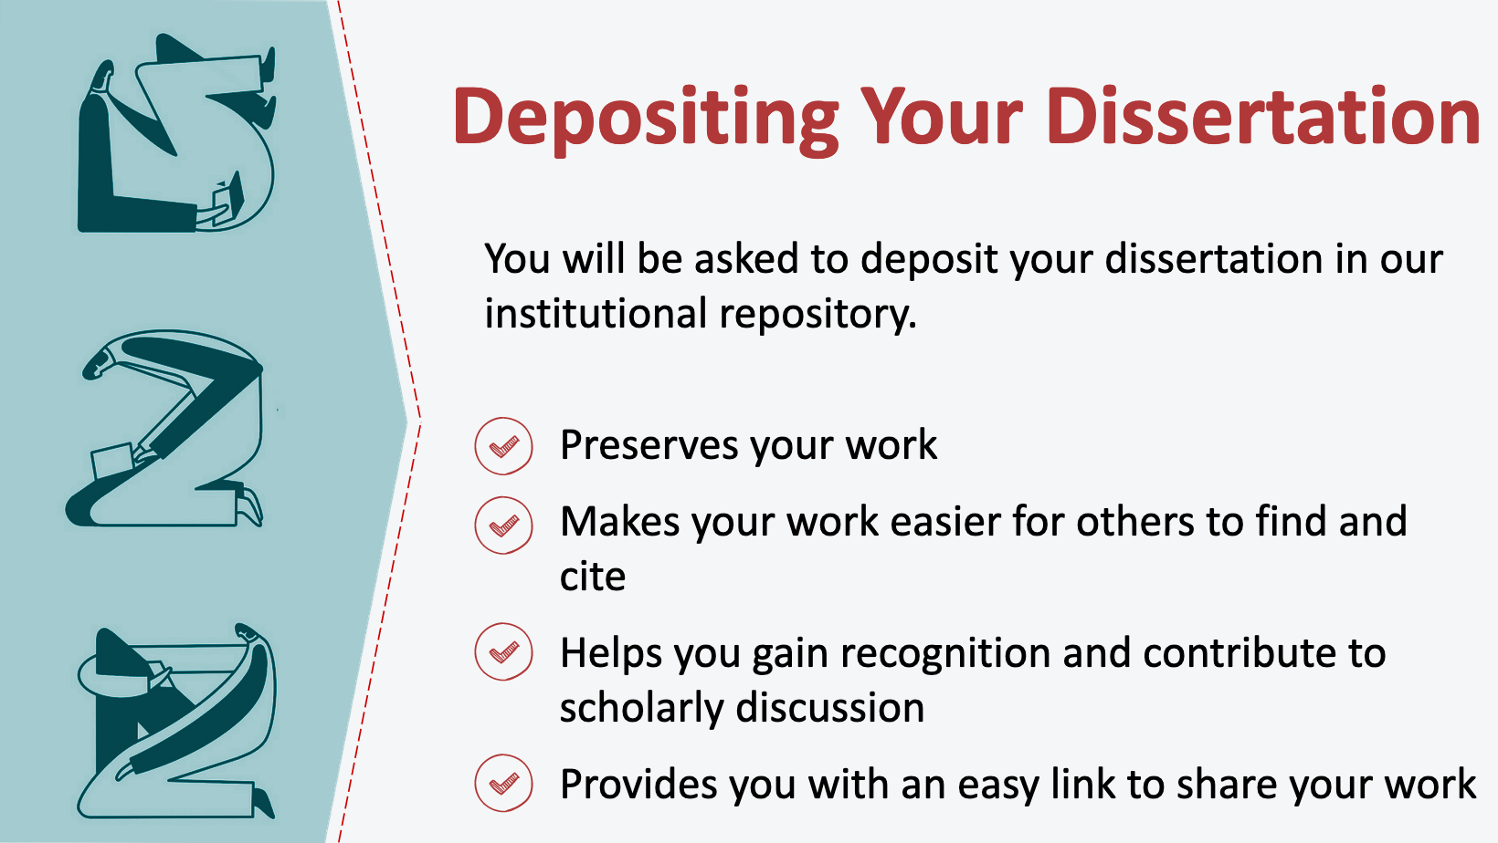
24. Institutional Repository
[Presenter to state institutional policy: e.g., X University requires that all theses and dissertations be made available in our institutional repository where they are made available to readers free of charge.]

Depositing your dissertation in our institutional repository preserves your work and makes it easier for others to find and cite your work. In this way, you can gain recognition and contribute to ongoing scholarly discussions in your field. You will also have an easy link to share your work. You still own the copyright to your work when it is deposited in the repository; you are just giving the university a nonexclusive license to store it in our repository and to make it publicly available.

You will also have options to post your work to ProQuest, which is a database of more than 2.3 million dissertations and theses from around the world. In addition, you have the option to release your work under a Creative Commons license and may have the option to place an embargo on the online release of your work. We’ll discuss each of these options in more detail next.

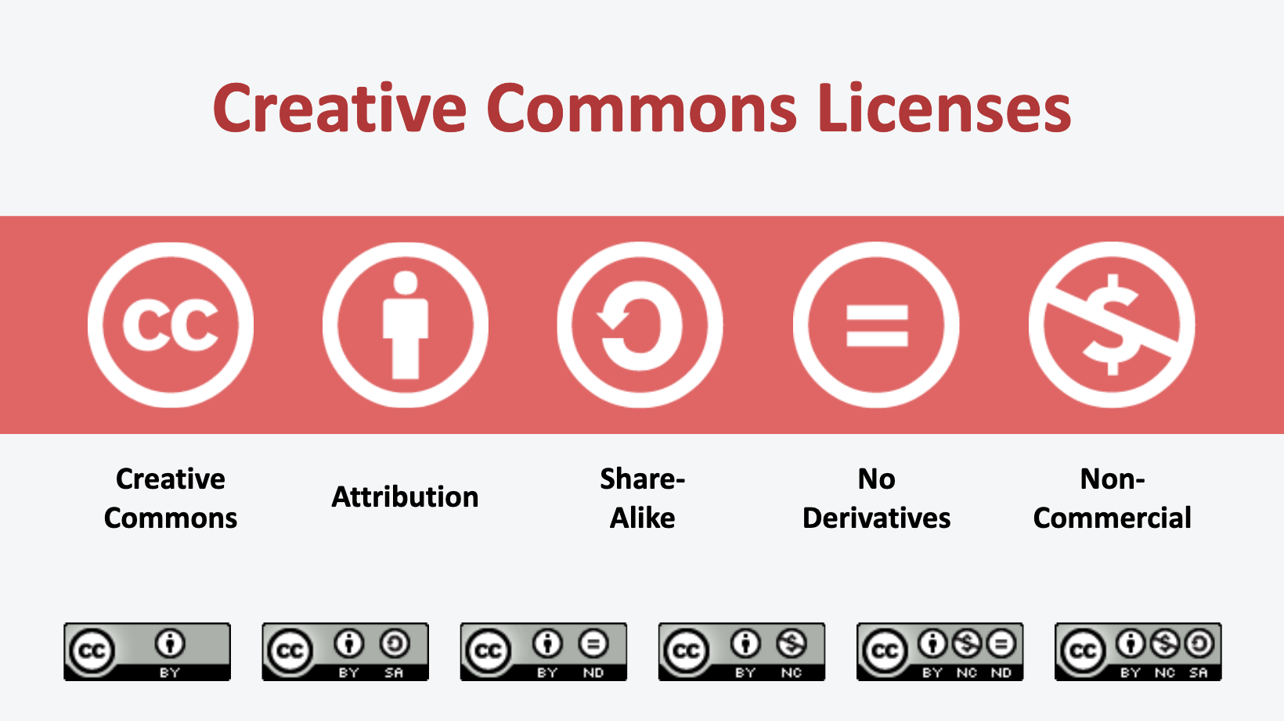
25. Creative Commons Licenses
Let’s start with whether you want to release your work under a Creative Commons license. Placing your work in our institutional repository helps readers access your works by removing price barriers, but without a CC or similar license, readers will usually still need to ask for your permission to reuse, share, or adapt your work unless you affirmatively license these rights to them (or unless their use is subject to a copyright limitation or falls within an exception).

Applying a CC license to your work indicates to readers that they can also copy and distribute your work, without first having to get your permission or rely on a copyright exception like fair use. All CC licenses require attribution, that is, they require those who reuse a work to give credit to the author for the creation of the original work.

CC licenses also allow you to fine-tune your work’s degree of “openness” by putting conditions on readers’ reuse and derivative work rights. Some common conditions are:

- Share-Alike: When readers create a new work based on the originally licensed material, they must distribute that new work under license terms identical to those the author imposed on the original work.

- No Derivatives: Readers are prohibited from adapting a work to create a new work. The right to create derivative works is reserved to the author, meaning that readers will be allowed only to distribute, reproduce, or perform a work as long as it is passed along unchanged and in whole.

- Non-Commercial Use: Readers are prohibited from making any reuse or derivative work available commercially.

Creative Commons allows authors to choose from among a menu of pre-drafted licenses depending on the rights they want to grant and the conditions they want to place on use of their works. As you can see, options for these pre-drafted conditions match the ones we’ve just discussed, including requiring attribution, requiring onward users to share alike, restricting derivative works, or restricting commercial uses. Creative Commons’ pre-drafted licenses include six combinations of these conditions, but all require attribution.

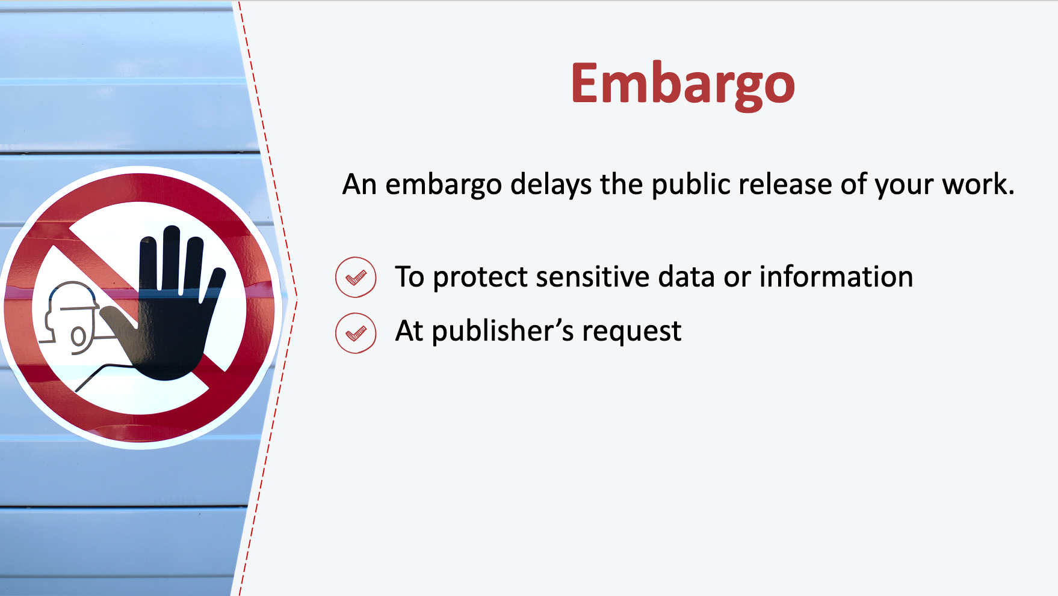
26. Embargo
In addition to deciding whether you want to make your work available under a CC license, you also have the option to place an embargo on the public release of your work. While it is not common to opt for an embargo, when one is requested it is typically because the author has sensitive data or information she wishes to protect (for example, to prevent the release of potentially patentable information or to protect your or other individual’s privacy or safety). Occasionally, a publisher may ask that you place an embargo on your dissertation if you have signed a contract to publish the material in an article or a book. However, since your dissertation will likely need to be significantly reworked prior to subsequent publication, it can be worth asking the publisher to reconsider if you would like to make your dissertation or thesis publicly available in the repository.

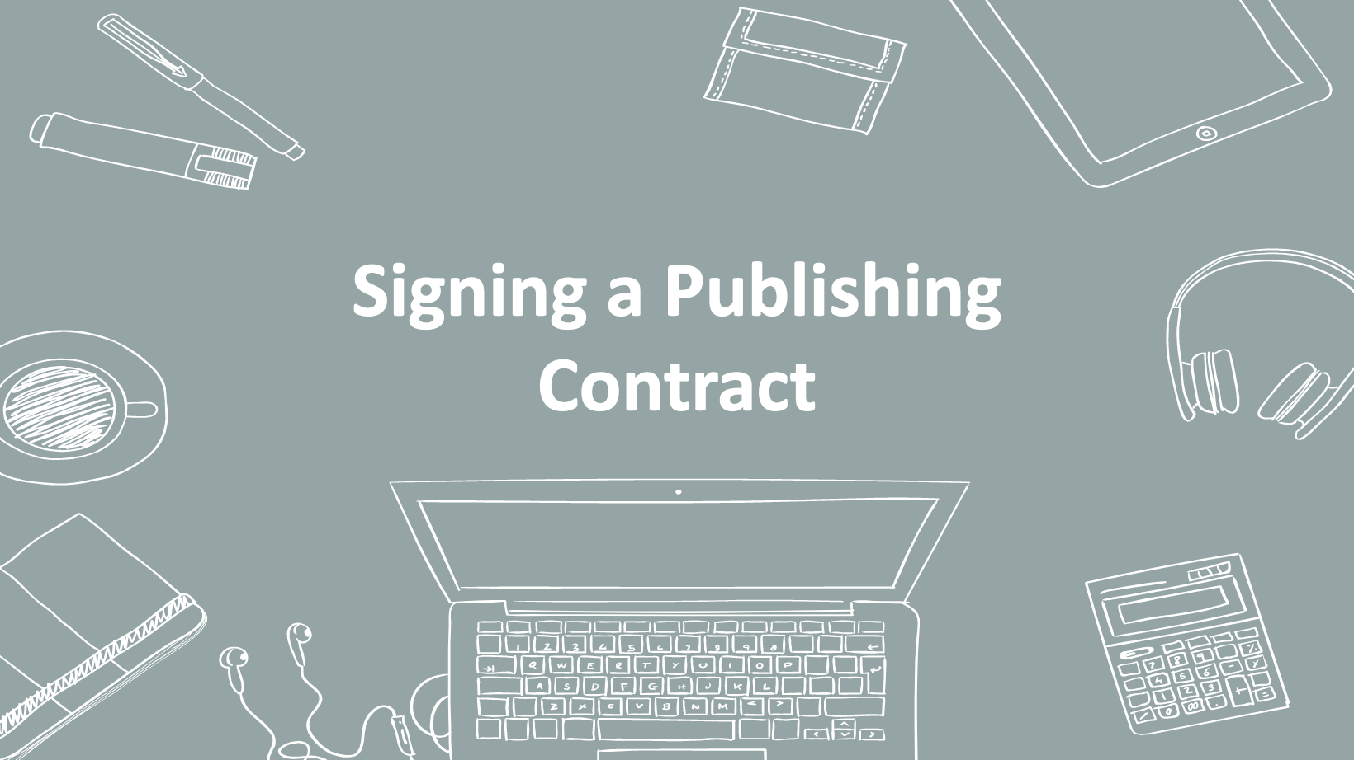
27. Signing a Publication Contract
Let’s move on to publication contracts. At some point in your career, you are likely to be in a position to sign a publication contract with respect to your work. The terms of a publication contract deserve careful attention because they will dictate your rights and obligations related to your work for many years to come. We cannot address everything a contract may cover in this presentation, but in this section we’ll talk about a few high-level considerations you should bear in mind.

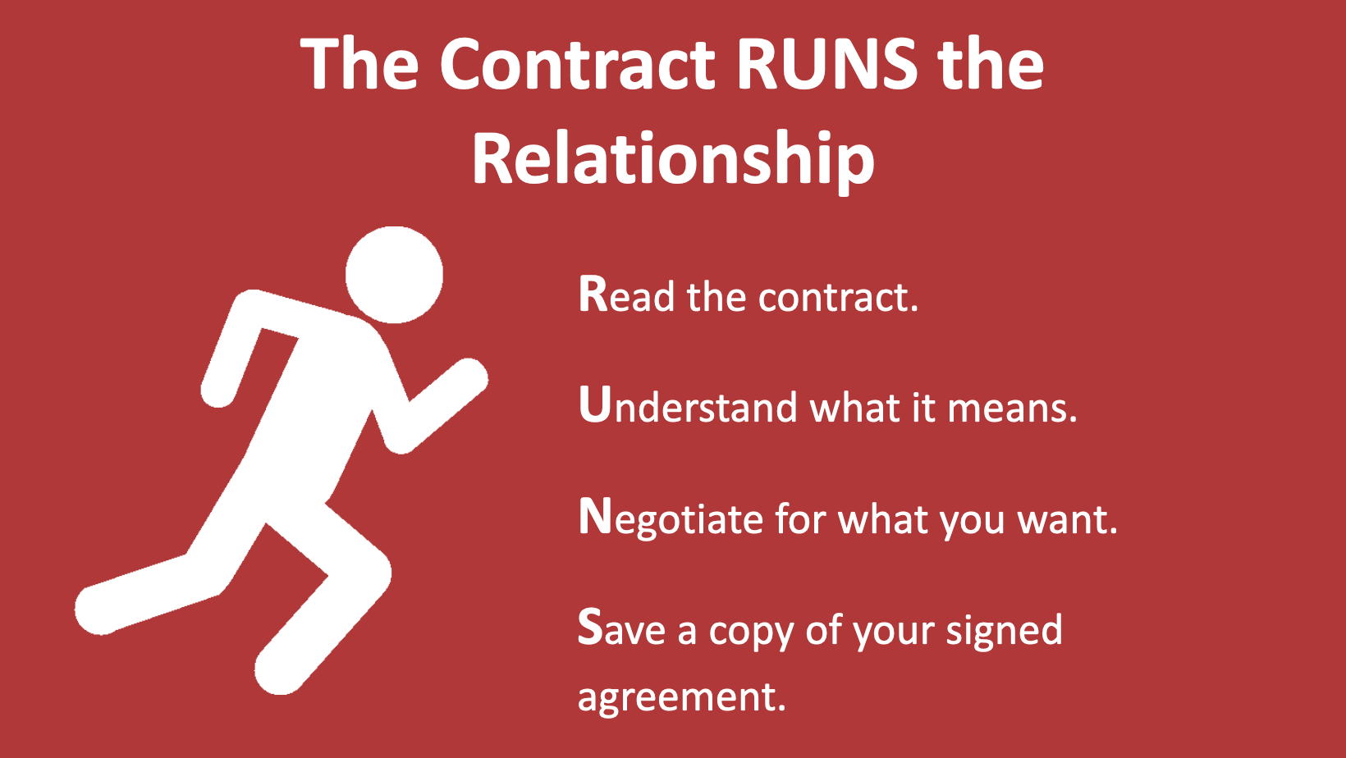
28. The Contract RUNS the Relationship
Let’s start with the very basics: At its core, a contract is simply an agreement between parties to determine the legal rights and obligations they have to each other. Keep in mind this simple mnemonic: The contract RUNS the relationship, so make sure you read everything, understand what it means, negotiate for what you want, and save a copy of your signed agreement. You will likely need to refer to your agreement in the future—for example, to check a deadline for submitting your manuscript, to verify how you’ve divvied up your rights, or to check whether you are eligible to get your copyrights back—so it is important to keep a copy in a safe place.

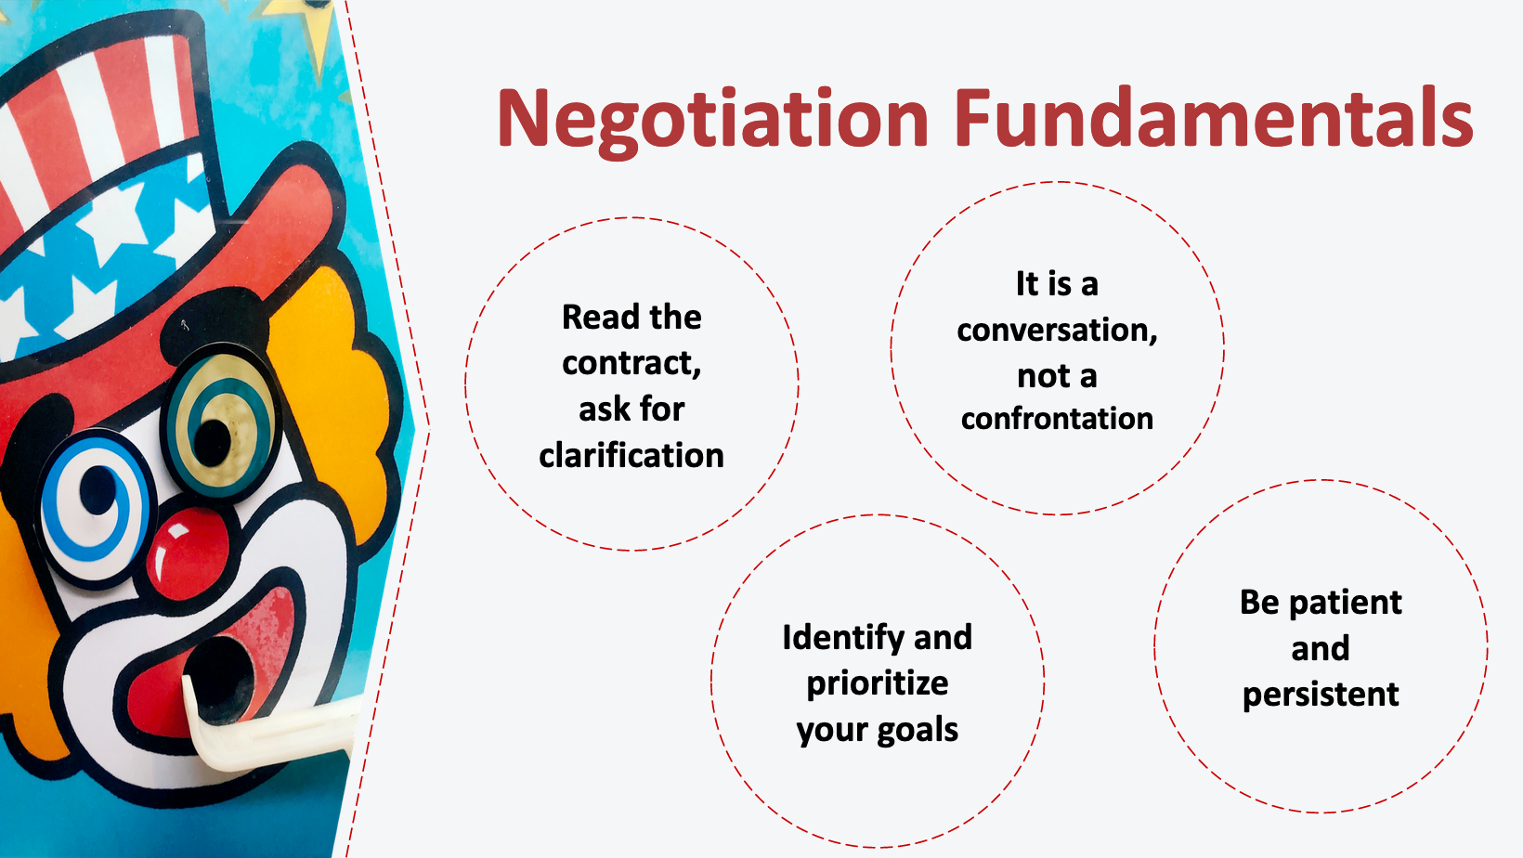
29. Negotiation Fundamentals
There are some basic tips to keep in mind as you evaluate a publication contract.

First, read the contract, ask for clarification. Once you have a draft agreement in front of you, the first step is to read it and to understand its contents. If you don’t understand the terms, you may want to ask for clarification from your scholarly communications office, attorney, or publisher.

Second, identify and prioritize your goals. Before you begin to negotiate, consider what you hope to gain from the relationship with your publisher.

Third, know that negotiation is a conversation, not a confrontation. For many people, the prospect of negotiation is intimidating. But negotiation does not have to be confrontational and tense.

Finally, be patient and persistent. Ask your publisher for any contractual changes you want, and be prepared to prioritize what is most important and persist on those points. Contract negotiations often proceed in fits and starts. Don’t be surprised if it takes longer than you expect.

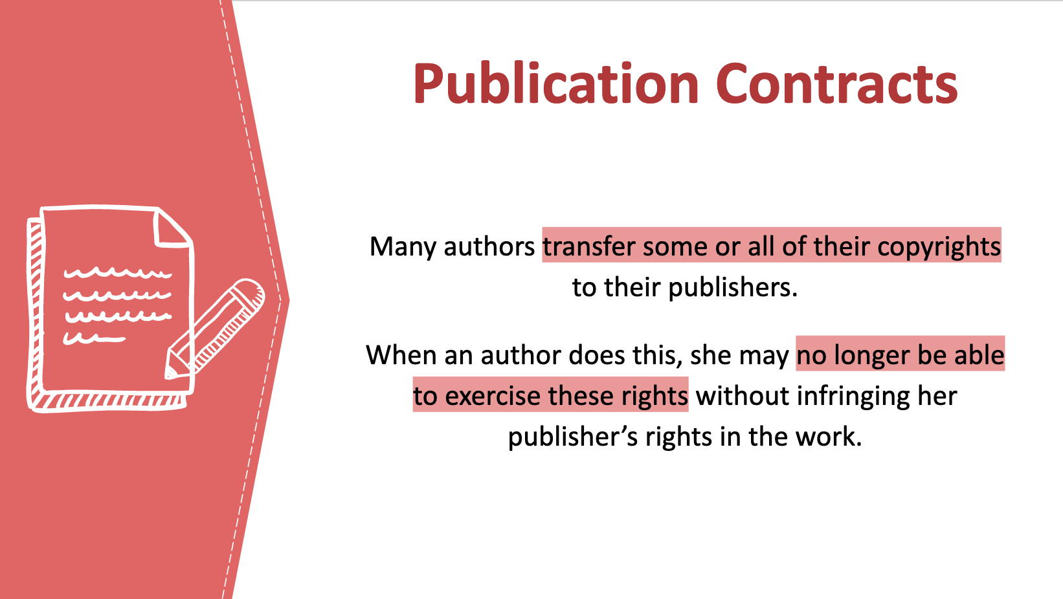
30. Publication Contracts
So why should you care about negotiating the terms of your publication contract? One reason is that it controls the rights to your work, and can even prevent you from exercising those rights.

You already learned that copyright typically vests with the author of a work. When an author signs a publishing agreement, she is frequently asked to transfer some or all of her copyrights to her publisher. And authors are often asked to sign away these rights “for the life of copyright,” which, as we discussed, lasts for a very long time under today’s copyright laws – 70 years after the death of the author. Once an author does sign away her rights, she can no longer exercise those rights herself if they belong exclusively to her publisher, as is often the case. This is one reason it is important to consider the terms of your contract carefully.

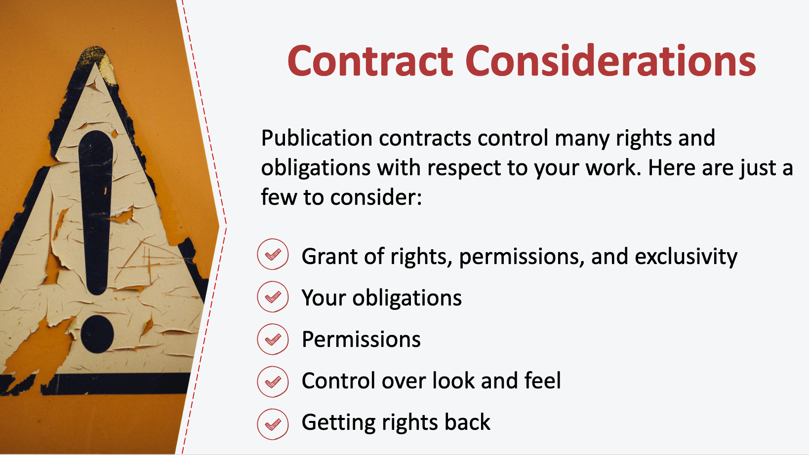
31. Contract Considerations
In addition to the grant of rights, a publication contract controls many other rights and obligations with respect to your work. Here are just a few to consider:

- What permissions are you giving the publisher, and are they exclusive or non-exclusive? Will you be able to make your work available online or under an open license?
- What are your obligations with respect to the work (word count, delivery date, etc.)?
- Who is responsible for permissions? Will you be able to rely on fair use for third-party material used in your work?
- How much control do you want to have over the look and feel of your work?
- Under what circumstances do you want to be able to regain your rights, if you signed them away?

For a deeper dive into contract clauses that control these and other issues, together with ways to make common clauses more author-friendly, check out the Authors Alliance guide to Understanding and Negotiating Book Publication Contracts.

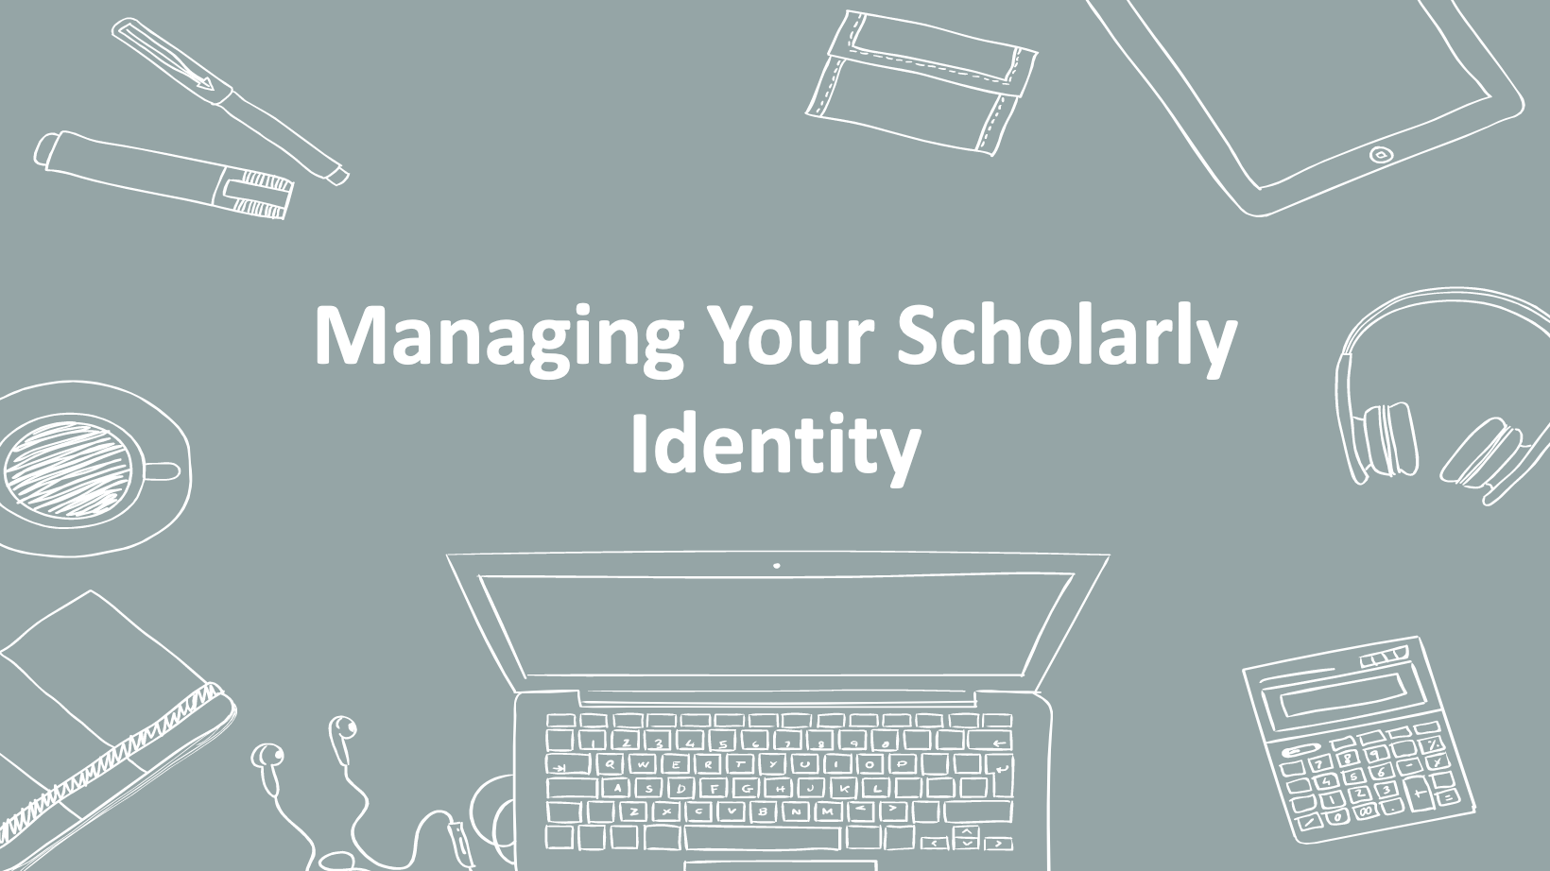
32. Managing Your Scholarly Identity
Before we wrap up, let’s take a moment to discuss what your scholarly identity is and how to manage it online.

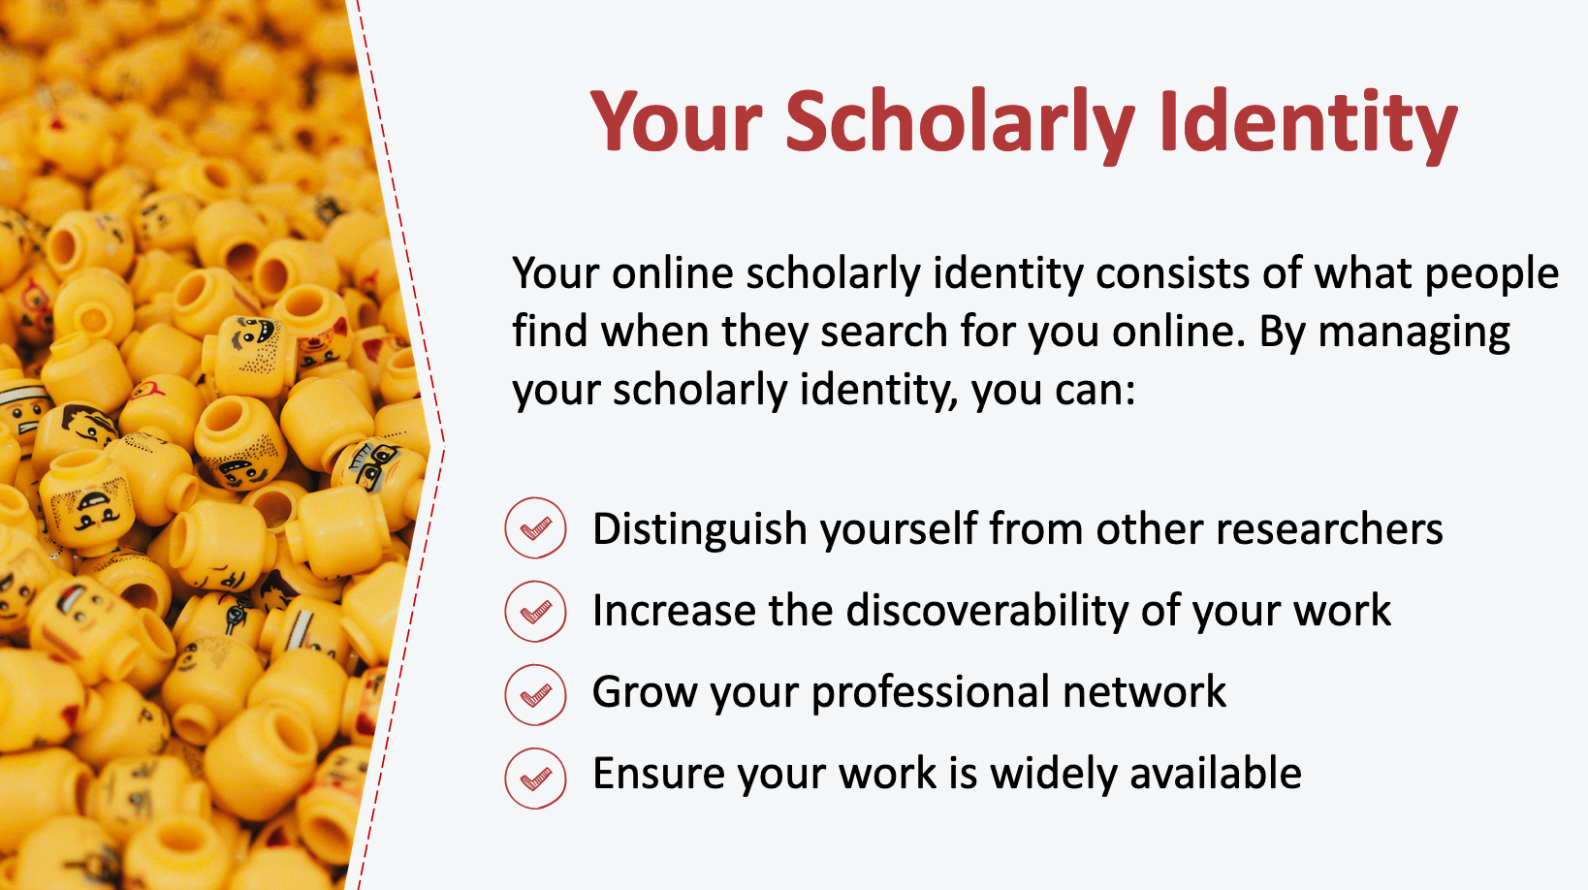
33. Your Scholarly Identity
Your online scholarly identity consists of what people—other researchers, potential employers, funders, and students, for example—find when they search for you online. It includes things like your publications and presentations, fellowships and grants, courses taught, and research interests. It is important to manage your scholarly identity in order to distinguish yourself from other researchers (especially those with the same or similar names), increase the discoverability of your work (and ultimately its impact), and to grow your professional network. Maintaining an accurate, up-to-date online presence is one way of ensuring that your work is widely available to researchers, learners, and others who want access.

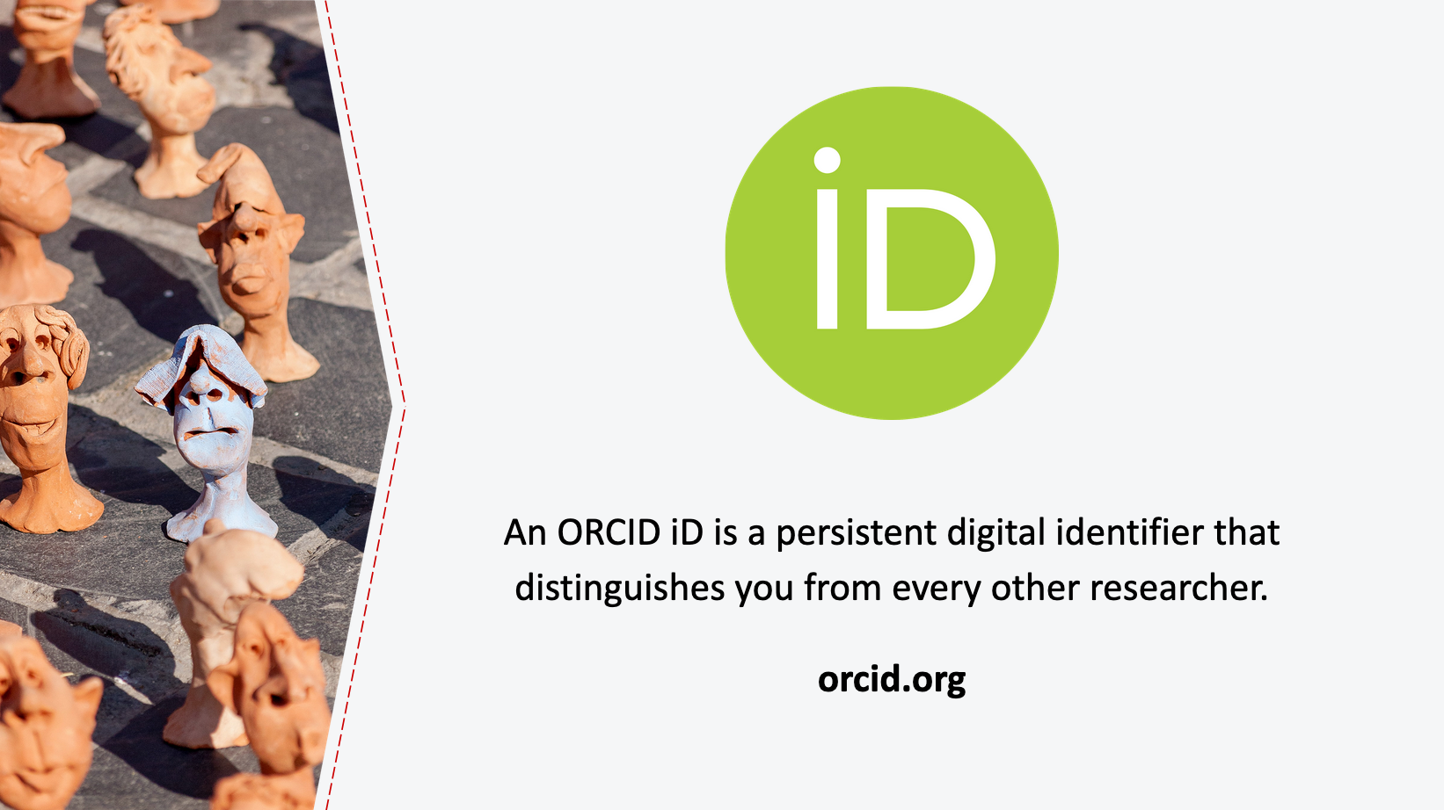
34. ORCID
A good way to start actively managing your scholarly identity is to set up an ORCID identifier. ORCID is a nonprofit organization that assigns each researcher a unique persistent identifier. ORCID helps distinguish researchers with similar or identical names, and allows researchers to associate themselves with their work, notwithstanding differences in spellings or translations of names across languages and changes to their name or affiliations over their career. ORCID identifiers are easy to get from orcid.org. Once you have one, be sure to use it consistently on publications or other research output, websites, and grant applications. This will make it easier for all of your work to be associated with you.

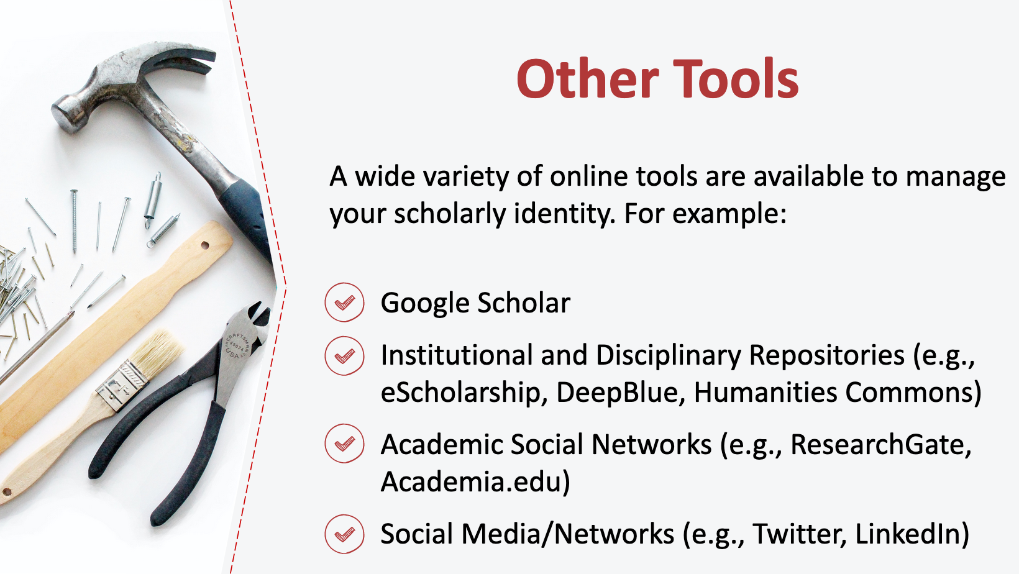
35. Other Tools
There are a number of other online tools that you mind find beneficial to manage your scholarly identity. Here are just a few:

- Google Scholar: Google Scholar allows you to establish a profile and link it to your existing publications. Your profile will be included in Google Scholar searches for your name, and your page shows links to co-authors as well as citation information. Google Scholar will also notify you if it encounters a new publication that may be yours.

- Institutional and Disciplinary Repositories (e.g., eScholarship; DeepBlue; Humanities Commons): Institutional repositories aim to bring the research outputs from one institution in one repository in order to preserve and provide access to that research. [Presenter to address specifics of their institution’s repository and policies.] Discipline-specific repositories are also available, and similarly aim to collect and make available research outputs related to a specific subject area. If you want to share your work with your institutional repository or disciplinary repositories, be sure that you have retained the right to do so under your agreement with your publisher.

- Academic Social Networks (e.g., ResearchGate, Academia.edu): For-profit academic networking sites like ResearchGate and Academia.edu allow you to create a profile and list your publications. These sites may even invite you to upload copies of your publications. Like with institutional and disciplinary repositories, if you’re interested in sharing your work online, be sure that you have retained the right to do so in your agreement with your publisher.

- Social Media (e.g., Twitter, LinkedIn): Don’t forget that your presence on social media and other networking sites like Twitter and LinkedIn also form a part of your scholarly identity online. Use these tools wisely to advance your scholarly reputation.

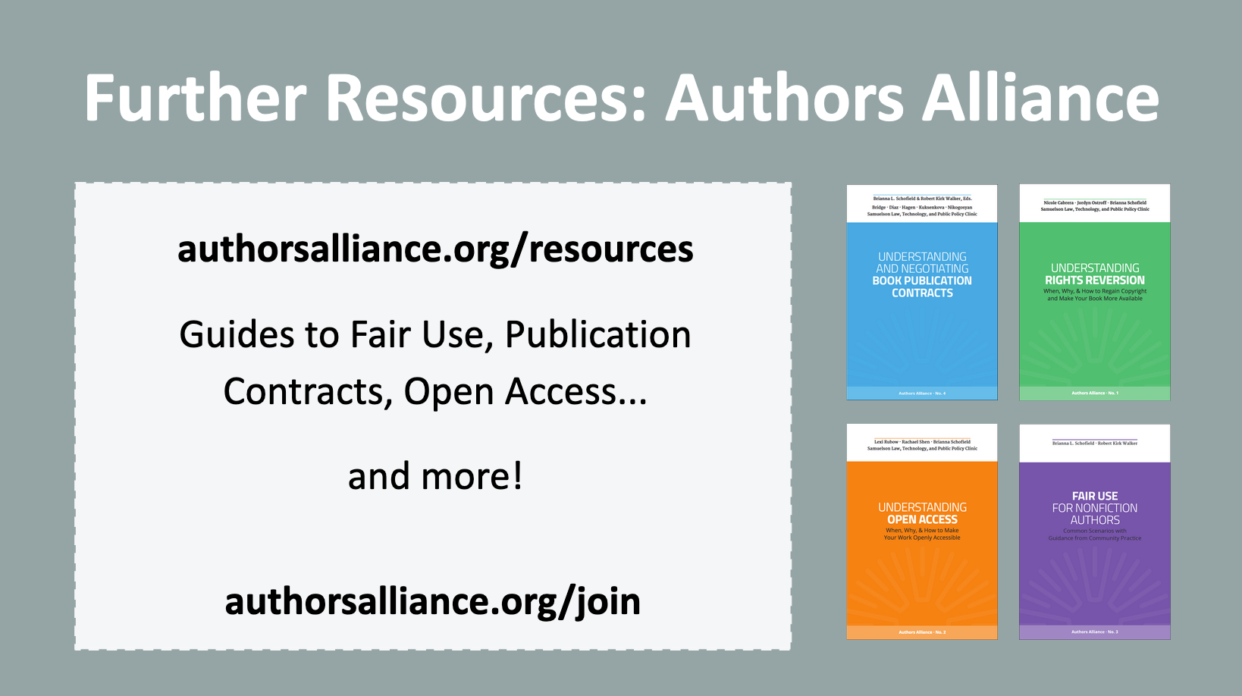
36. Further Resources
I hope today’s presentation helped you to understand what copyright is, how to work with copyrighted material, and ways that you can manage your own copyrights. I encourage you to check out additional resources created by Authors Alliance, a nonprofit organization that helps authors understand and manage their rights. Concepts in this presentation are further explained in the Authors Alliance guides to Fair Use for Nonfiction Authors, Understanding Open Access, and Understanding and Negotiating Book Publication Contracts, all of which are freely available online. Authors Alliance membership is free; please consider joining as an individual member to receive updates about their new resources and to learn more about leveraging your rights as an author.

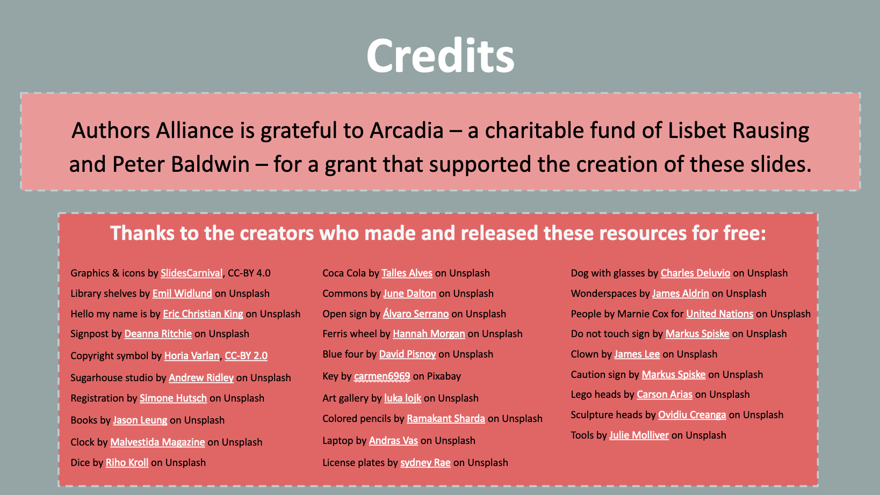
37. Credits

Authors Alliance is grateful to Arcadia—a charitable fund of Lisbet Rausing and Peter Baldwin—for a grant that supported the creation of these materials.

