Copyright for Graduate Students
  - Overview

Copyright

The Copyright Act protects original, creative works of authorship that are fixed in any tangible medium of expression. Today, copyright protection is automatic. When you write a book, an article, or some other work of original expression, you generally will have a copyright in that work from the moment you commit that expression to paper (or save to your computer, as the case may be). Today, there is no need to register your work with the Copyright Office or place a copyright symbol on your work before it receives copyright protection. You just have to “fix” your original, creative work in a tangible medium.
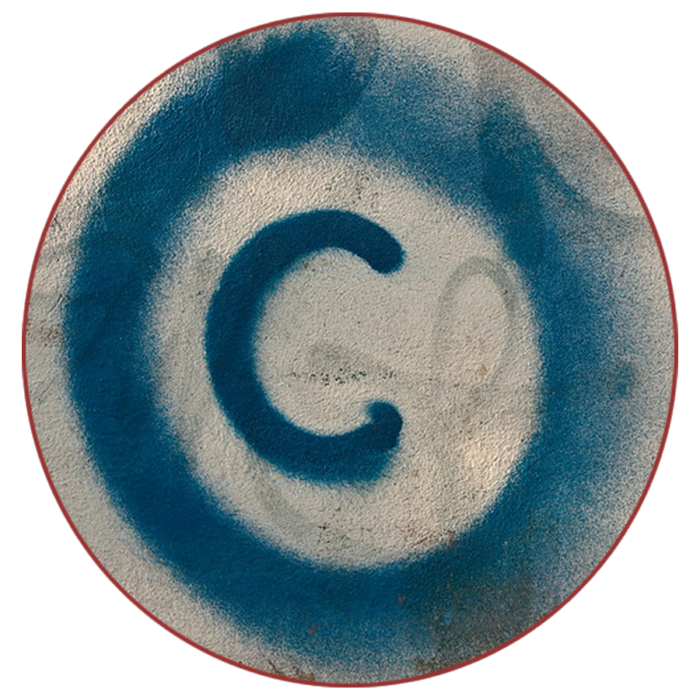
- Registration: While you are no longer required to register your work with the Copyright Office to secure copyright, there are benefits to registering your work by paying a small fee and submitting a record to the U.S. Copyright Office. For example, registration serves as a record of ownership, which can be helpful if someone wants to find out who owns a work in order to ask permission to use it. Registration is also required prior to bringing an infringement lawsuit, and if you register in a timely manner you are then eligible for additional remedies in the event of a lawsuit, such as statutory damages and attorneys’ fees.

- Exclusive Rights: Copyright is a bundle of exclusive rights that only the copyright holder, or someone authorized by the copyright holder, can exercise—unless their use falls under an exception to copyright law (like fair use). These rights include the right to make copies of that work and the right to make other works derived from that work, such as translations, abridgements, or movie adaptations. These rights also include the rights to distribute, publicly display, and publicly perform the copyrighted work.

- Duration: Under today’s copyright laws, copyright protection lasts for a very long time. As a general rule, for works authored by an individual author, copyright lasts for the life of the author plus an additional 70 years. For an anonymous work, a pseudonymous work, or a work made for hire, the copyright lasts for 95 years from the year of its first publication or 120 years from the year of its creation, whichever expires first. Note that this way of calculating copyright duration was adopted in the 1976 Copyright Act which went into effect on January 1, 1978. For works first published prior to that date, the length of copyright differs.

Using Third Party Material in Your Work

With some limited exceptions, a copyright owner can usually prevent all others from exercising their exclusive rights. This is why you need to consider the copyright implications of incorporating third-party works into your own. If you don’t, you may be infringing on someone else’s copyright. Happily, there are some readily available strategies to consider when using third party works in your own work: using public domain works, using openly licensed works, relying on fair use, and getting a permission or license.

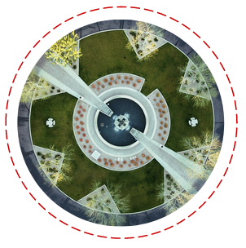 | 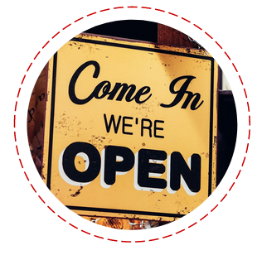 | 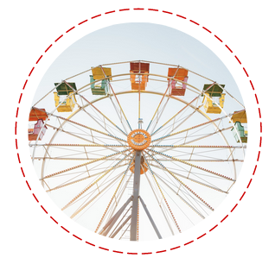 | 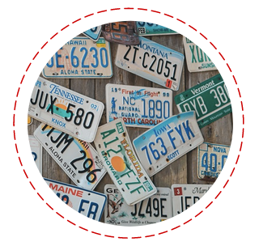
Using Public Domain Works | Using Openly Licensed Works | Relying on Fair Use, if Appropriate | Getting Permission or a License
The public domain is the commons of material that is not protected by copyright. Anyone is free to use, copy, share, and remix material that is in the public domain. The public domain includes works for which the copyright has expired, works for which copyright owners failed to comply with “formalities,” and things that are just not copyrightable at all. | Some works are available under public licenses that allow anyone to make specific uses of copyrighted works without the need to pay or seek additional permission from the owner. Creative Commons (“CC”) licenses are the most well-known public licenses. | Fair use permits the use of copyrighted works without permission or payment, under certain conditions. A fair use analysis involves at least four factors: the purpose and character of the use, the nature of the copyrighted work, the amount and substantiality of the portion taken, and the effect of the use on the potential market for the work. | If a work is not in the public domain or openly licensed, and your use is not likely a fair use, another option is to seek permission or a license to use the work. A license is a grant of authorization from a copyright holder to exercise one of their exclusive rights.

It is important for authors to be aware that clearing copyright concerns does not preclude other legal claims. When using third party materials, authors should consider legal issues beyond copyright, such as potential contractual restrictions, privacy rights, trademark law, right of publicity, defamation, and community norms, like rules against academic plagiarism. Contractual terms governing access to a work can even restrict the availability of fair use.

Depositing Your Dissertation Online

Depositing your dissertation in an institutional repository and/or on ProQuest preserves your work and makes it easier for others to find and cite your work. In this way, you can gain recognition and contribute to ongoing scholarly discussions in your field. You will also have an easy link to share your work. You typically still own the copyright to your work when it is deposited in a repository; you generally just give a nonexclusive license to store it in the repository and to make it publicly available. It is still a good idea to read any agreements you enter into with the repository to make sure you retain all the relevant rights.

You may also want to consider releasing your work under a Creative Commons license. Placing your work online helps readers access your works by removing price barriers, but readers will usually still need to ask for your permission to reuse, share, or adapt your work unless you affirmatively license these rights to them.

Applying a Creative Commons license to your work indicates to readers that they can also copy and distribute your work without first having to get your permission or rely on a copyright exception (such as fair use). All Creative Commons licenses require attribution—that is, they require those who reuse a work to give credit to the author for the creation of the original work. Other conditions you can consider are:

- Share-Alike: When readers create a new work based on the originally licensed material, they must distribute that new work under license terms identical to those the author imposed on the original work.
- No Derivatives: Readers are prohibited from adapting a work to create a new work. The right to create derivative works is reserved to the author, meaning that readers will be allowed only to distribute, reproduce, or perform a work as long as it is passed along unchanged and in whole.
- Non-Commercial Use: Readers are prohibited from making any reuse or derivative work available commercially.

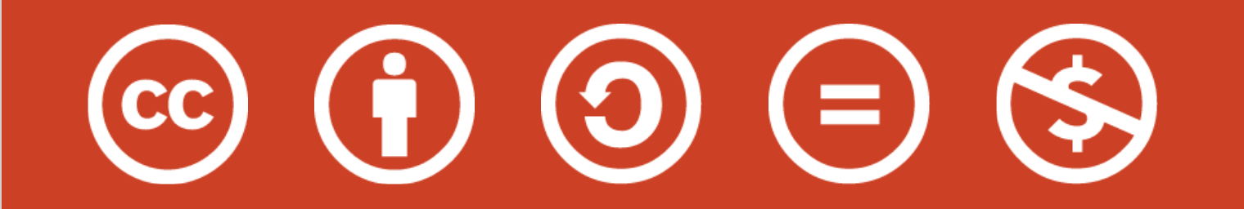

In addition to deciding whether you want to make your work available under a Creative Commons license, you also have the option to place an embargo on the public release of your work.

Signing a Publishing Contract

At its core, a contract is simply an agreement between parties to determine the legal rights and obligations they have to each other. Keep in mind this simple mnemonic: The contract RUNS the relationship, so make sure you read everything, understand what it means, negotiate for what you want, and save a copy of your signed agreement.

When an author signs a publishing agreement, she is frequently asked to transfer some or all of her rights under copyright to her publisher. And authors are often asked to sign away these rights “for the life of copyright,” which lasts for a very long time under today’s copyright laws—70 years after the death of the author. Once an author does sign away her rights, she can no longer exercise those rights herself, as they may belong exclusively to her publisher. This is one reason it is important to consider the terms of your contract carefully.
In addition to the grant of rights, a publication contract controls many other rights and obligations with respect to your work, including exclusivity, permissions, control over the look and feel of the work, and opportunities to get your rights back. For a deep dive into contract clauses that control these and other issues, together with ways to negotiate to make common clauses more author-friendly, check out the Authors Alliance guide to Understanding and Negotiating Book Publication Contracts.
Managing Your Scholarly Identity
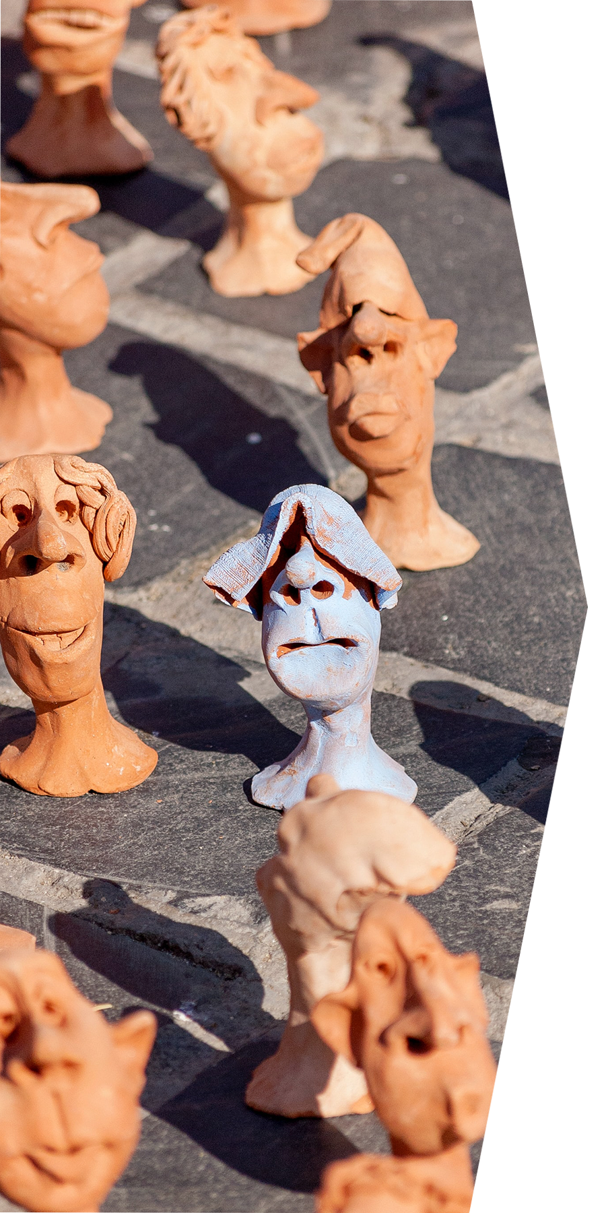
Your online scholarly identity consists of what people—other researchers, potential employers, funders, and students, for example—find when they search for you online. It includes things like your publications and presentations, fellowships and grants, courses taught, and research interests. It is important to manage your scholarly identity in order to distinguish yourself from other researchers (especially those with the same or similar names), increase the discoverability of your work (and ultimately its impact), and to grow your professional network. Maintaining an accurate, up-to-date online presence is one way of ensuring that your work is widely available to researchers, learners, and others who want access.
A good way to start actively managing your scholarly identity is to set up an ORCID identifier. ORCID is a nonprofit organization that assigns each researcher a unique persistent identifier. ORCID helps distinguish researchers with similar or identical names, and allows researchers to associate themselves with their work notwithstanding differences in spellings or translations of names across languages and changes to their name or affiliations over their career. ORCID identifiers are easy to get from orcid.org.
There are a number of other online tools that you might find beneficial to manage your scholarly identity, including Google Scholar, institutional and disciplinary repositories, academic networks, and social media.

Authors Alliance is grateful to Arcadia—a charitable fund of Lisbet Rausing and Peter Baldwin—for a grant that supported the creation of these materials.

