Copyright for Graduate Students
  - Presentation Notes

1. Copyright for Graduate Students
____________________________________________________

____________________________________________________

____________________________________________________

____________________________________________________________________________________

____________________________________________________________________________________

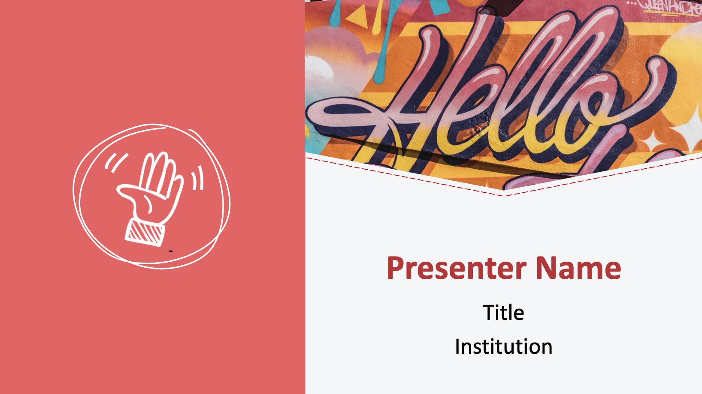
2. Hello

____________________________________________________

____________________________________________________

____________________________________________________

____________________________________________________________________________________

____________________________________________________________________________________

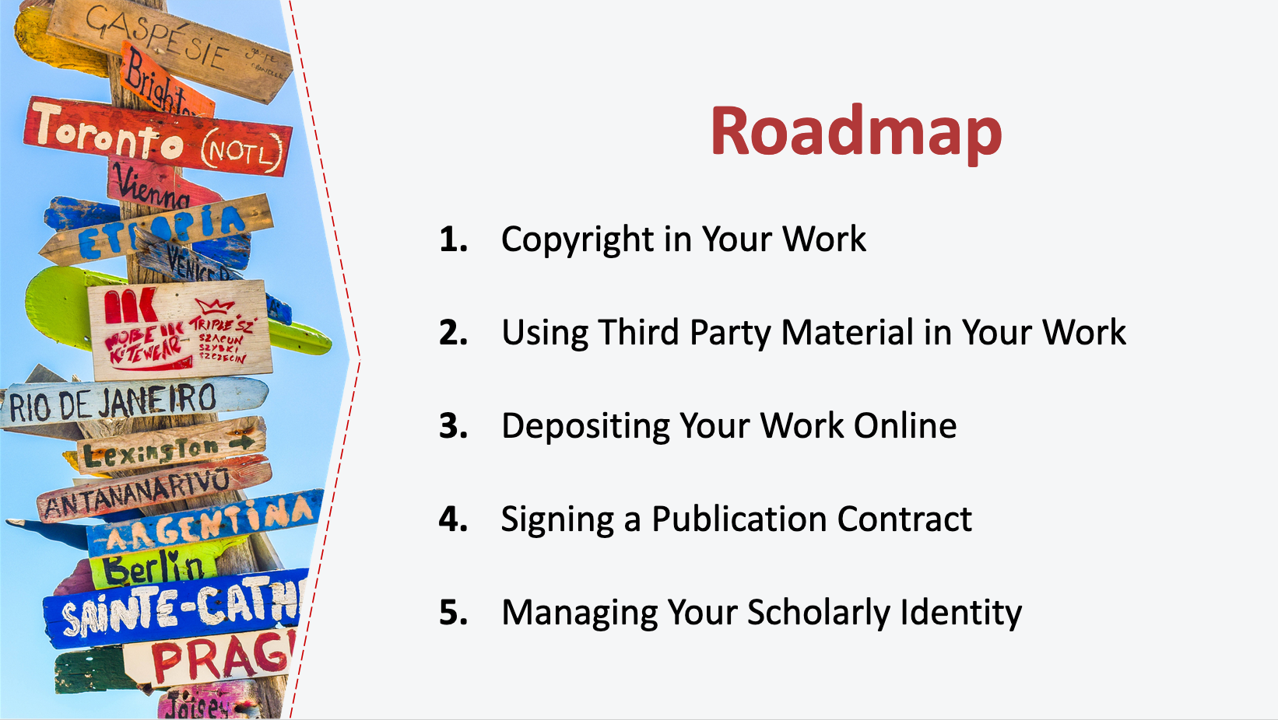
3. Roadmap

____________________________________________________

____________________________________________________

____________________________________________________

____________________________________________________________________________________

____________________________________________________________________________________

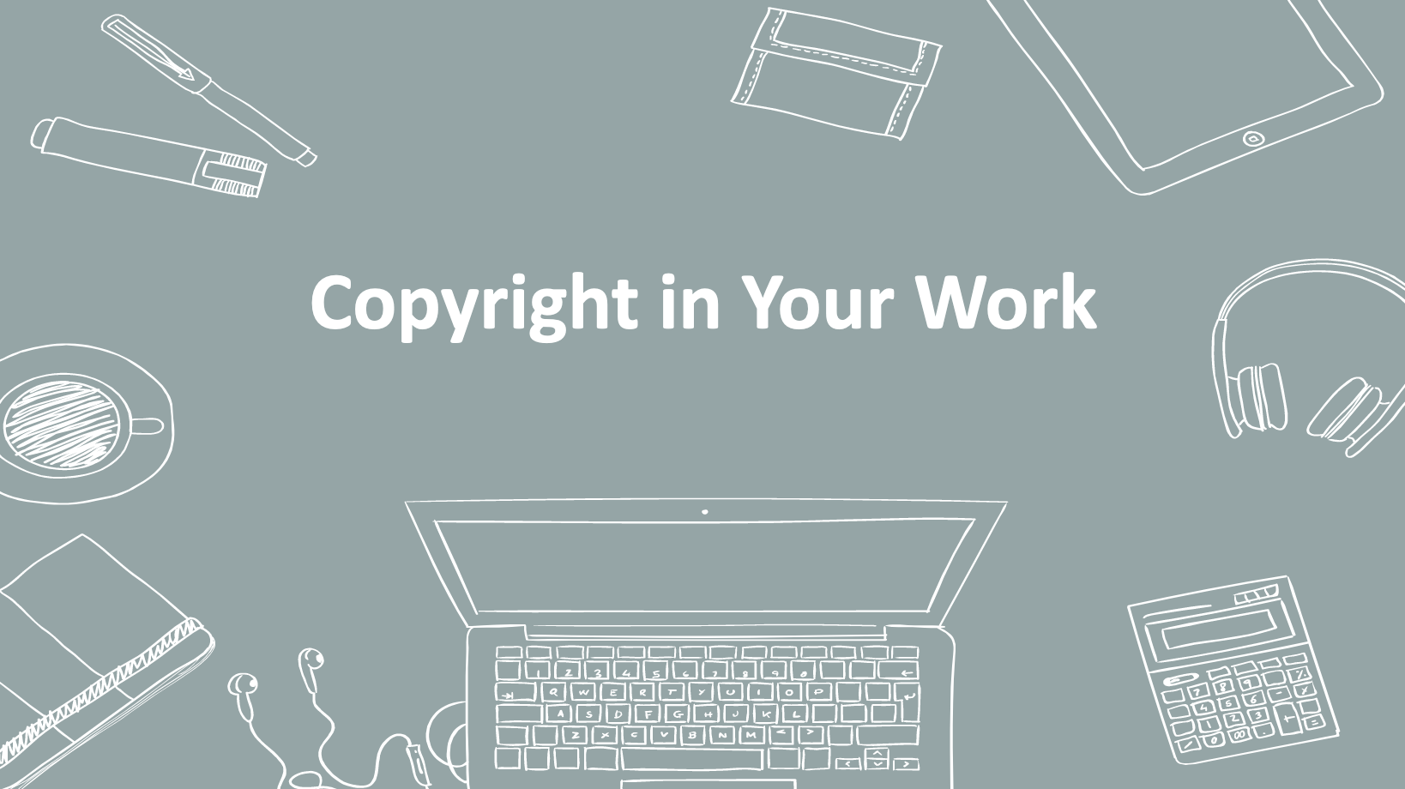
4. Copyright in Your Work

____________________________________________________

____________________________________________________

____________________________________________________

____________________________________________________________________________________

____________________________________________________________________________________

____________________________________________________________________________________

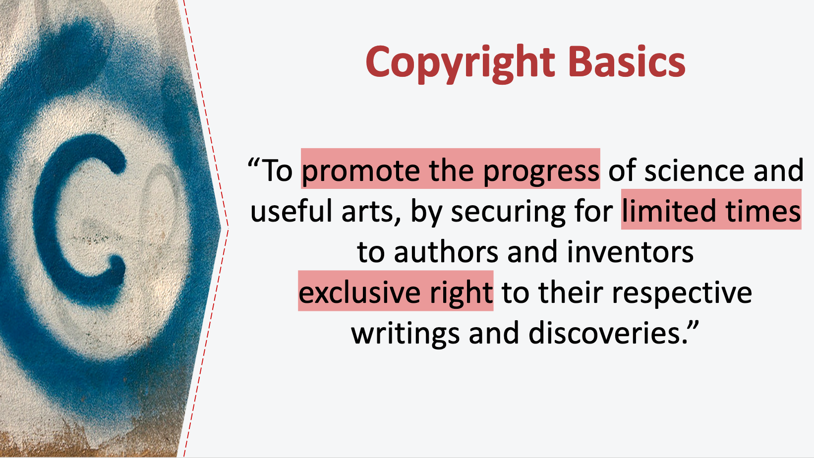
5. Copyright Basics

____________________________________________________

____________________________________________________

____________________________________________________

____________________________________________________________________________________

____________________________________________________________________________________

____________________________________________________________________________________

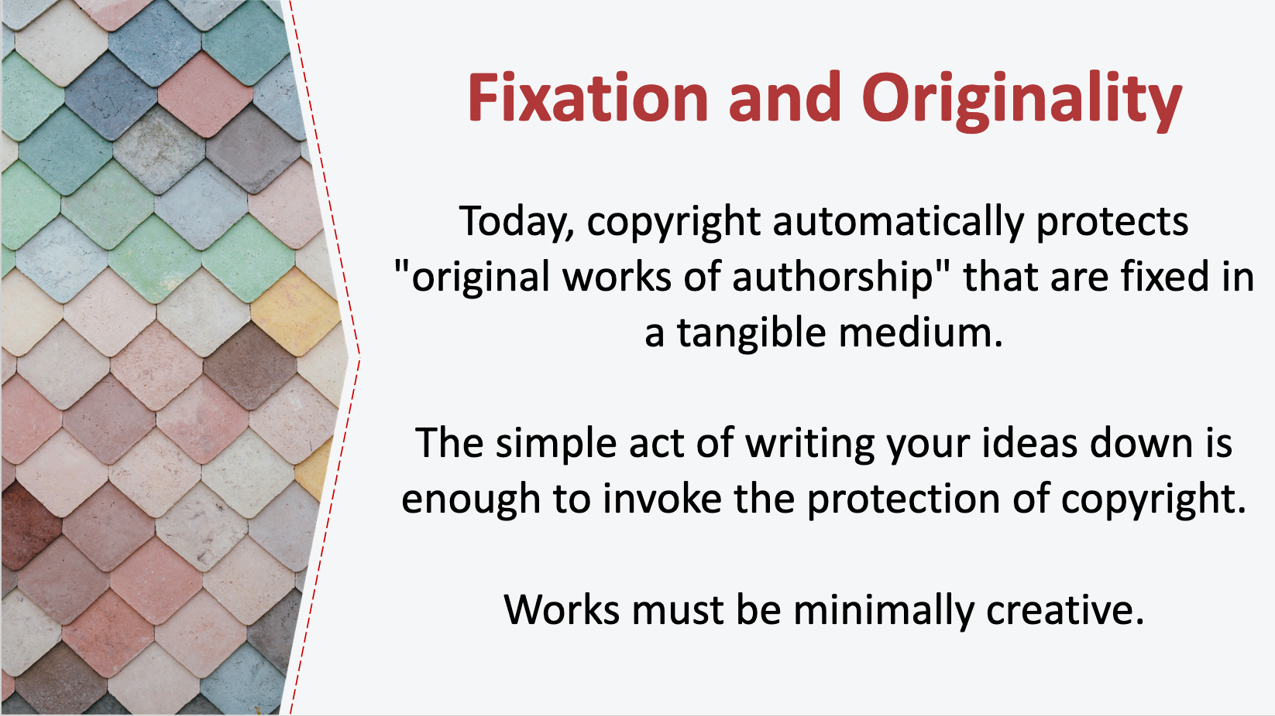
6. Fixation and Originality

____________________________________________________

____________________________________________________

____________________________________________________

____________________________________________________________________________________

____________________________________________________________________________________

____________________________________________________________________________________

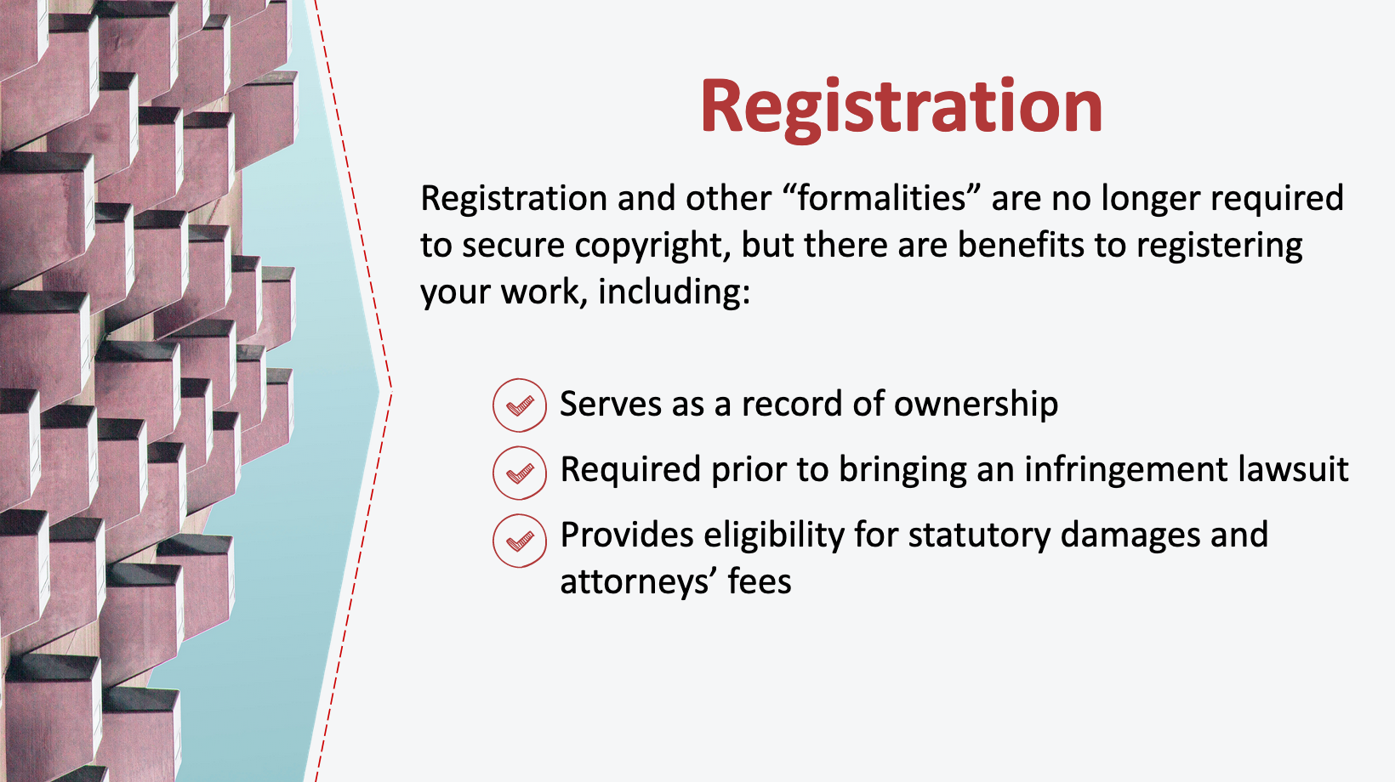
7. Registration

____________________________________________________

____________________________________________________

____________________________________________________

____________________________________________________________________________________

____________________________________________________________________________________

____________________________________________________________________________________

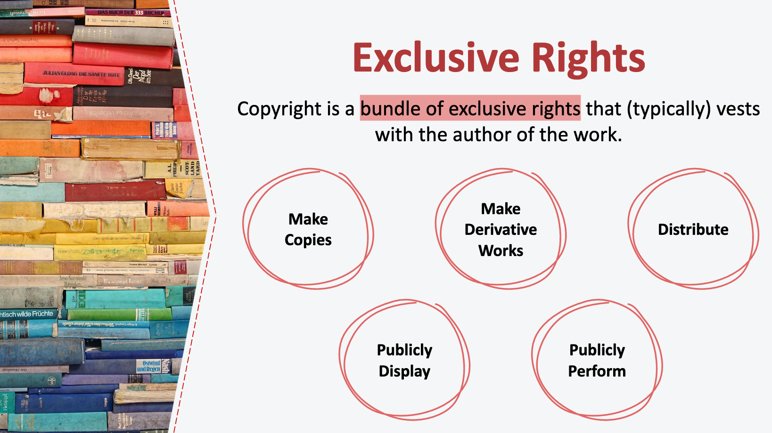
8. Exclusive Rights

____________________________________________________

____________________________________________________

____________________________________________________

____________________________________________________________________________________

____________________________________________________________________________________

____________________________________________________________________________________

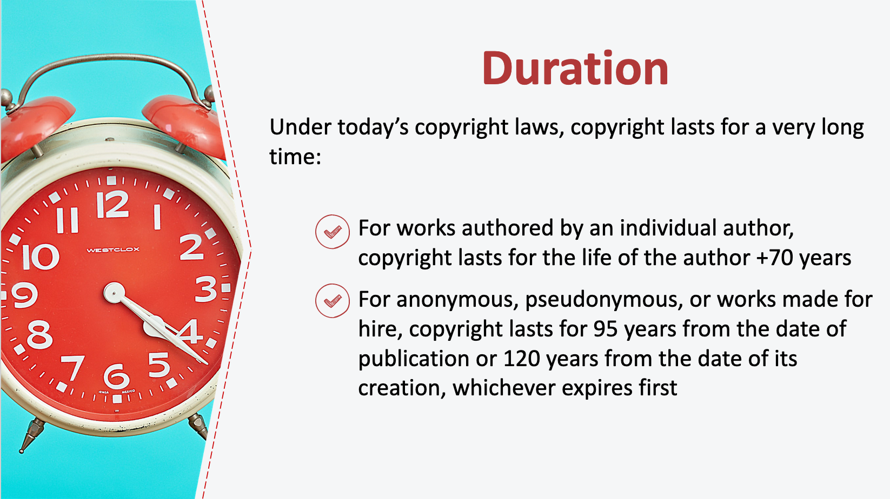
9. Duration

____________________________________________________

____________________________________________________

____________________________________________________

____________________________________________________________________________________

____________________________________________________________________________________

____________________________________________________________________________________

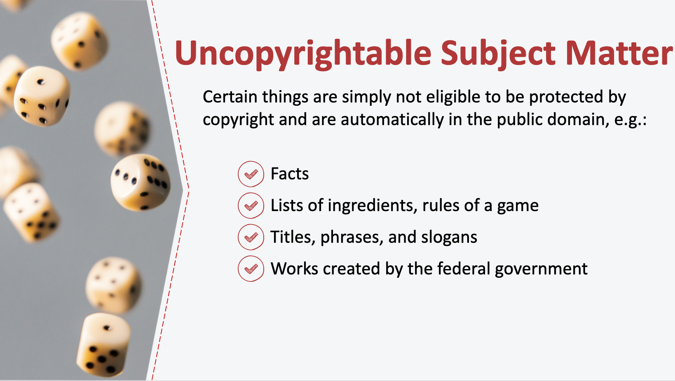
10. Uncopyrightable Subject Matter

____________________________________________________

____________________________________________________

____________________________________________________

____________________________________________________________________________________

____________________________________________________________________________________

____________________________________________________________________________________

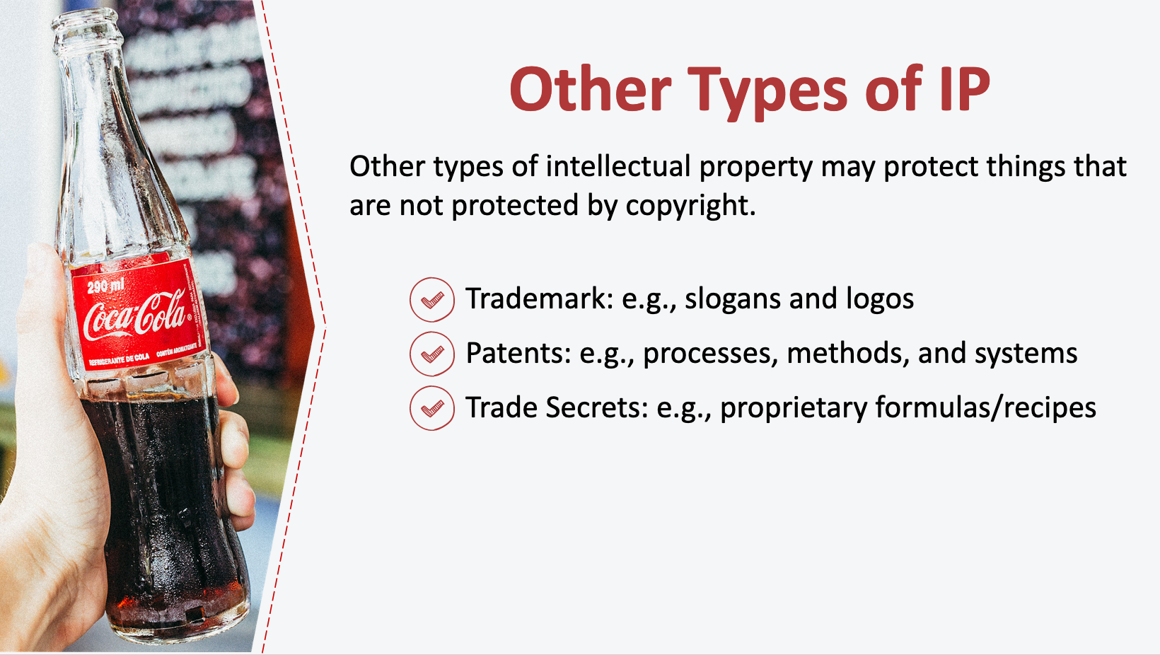
11. Other Types of IP

____________________________________________________

____________________________________________________

____________________________________________________

____________________________________________________________________________________

____________________________________________________________________________________

____________________________________________________________________________________

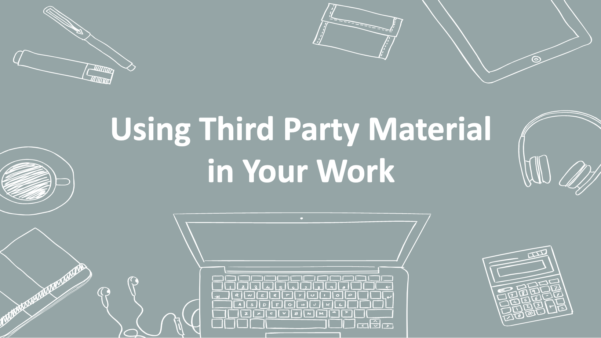
12. Using Third Party Material in Your Work

____________________________________________________

____________________________________________________

____________________________________________________

____________________________________________________________________________________

____________________________________________________________________________________

____________________________________________________________________________________

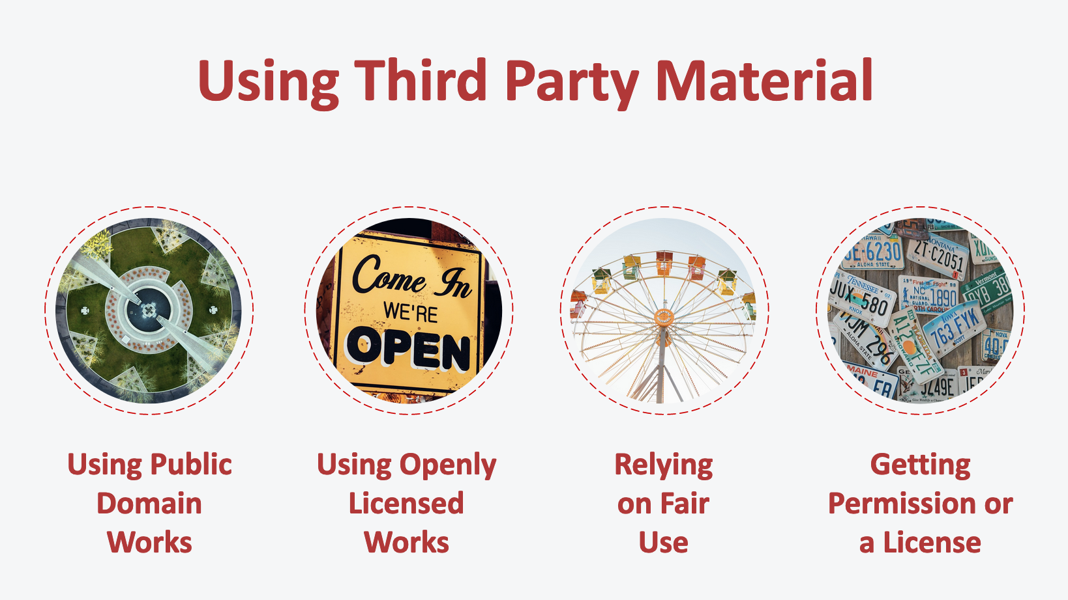
13. Using Third Party Material

____________________________________________________

____________________________________________________

____________________________________________________

____________________________________________________________________________________

____________________________________________________________________________________

____________________________________________________________________________________

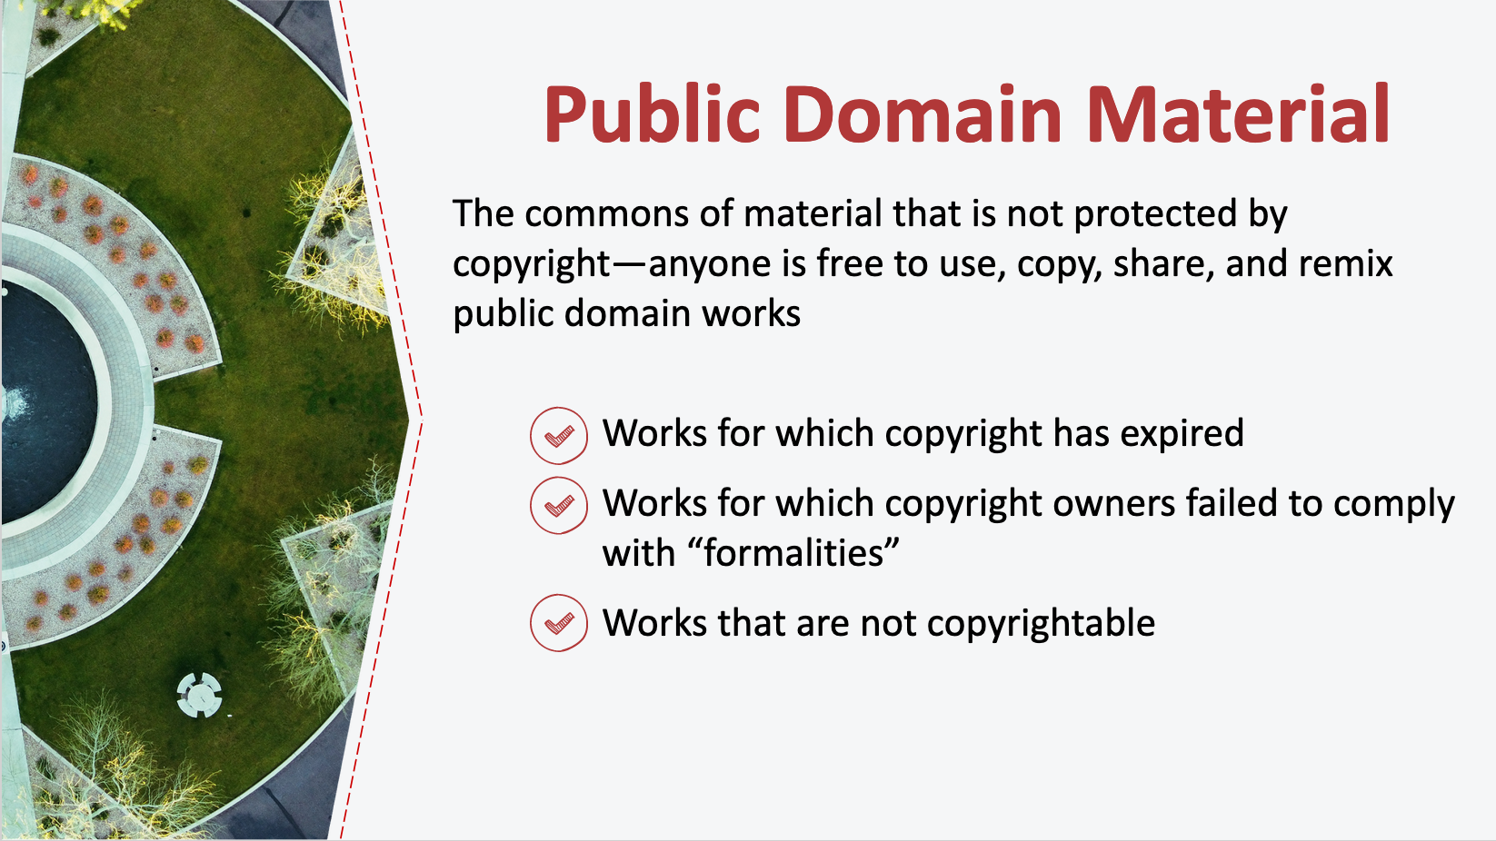
14. Public Domain Material

____________________________________________________

____________________________________________________

____________________________________________________

____________________________________________________________________________________

____________________________________________________________________________________

____________________________________________________________________________________

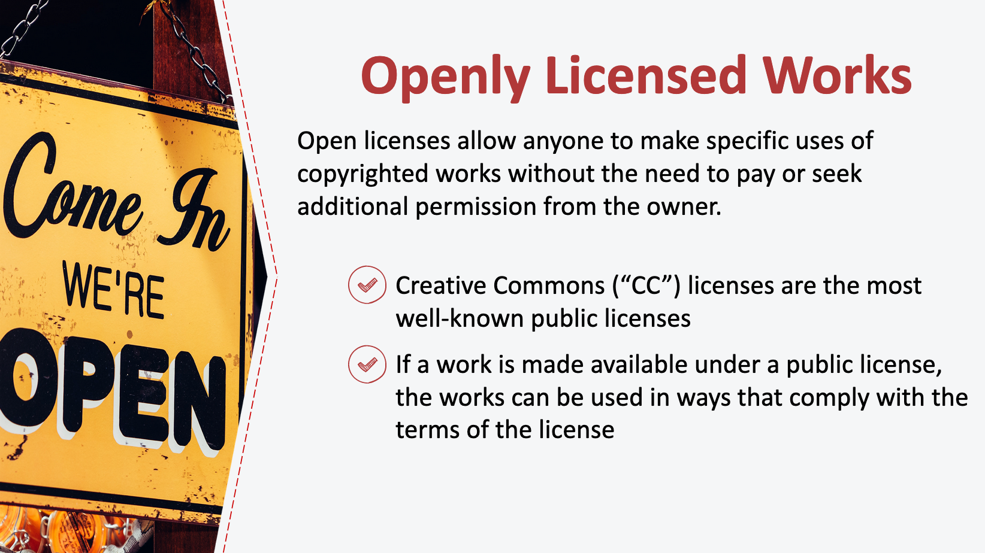
15. Openly Licensed Works

____________________________________________________

____________________________________________________

____________________________________________________

____________________________________________________________________________________

____________________________________________________________________________________

____________________________________________________________________________________

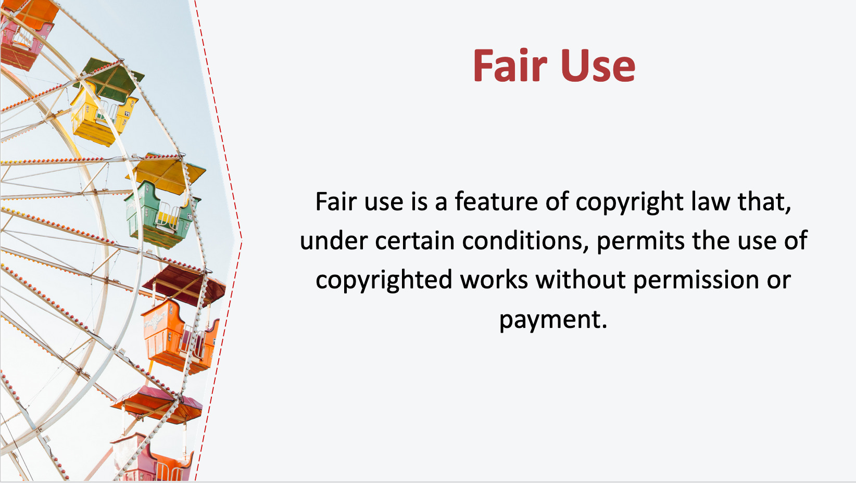
16. Fair Use

____________________________________________________

____________________________________________________

____________________________________________________

____________________________________________________________________________________

____________________________________________________________________________________

____________________________________________________________________________________

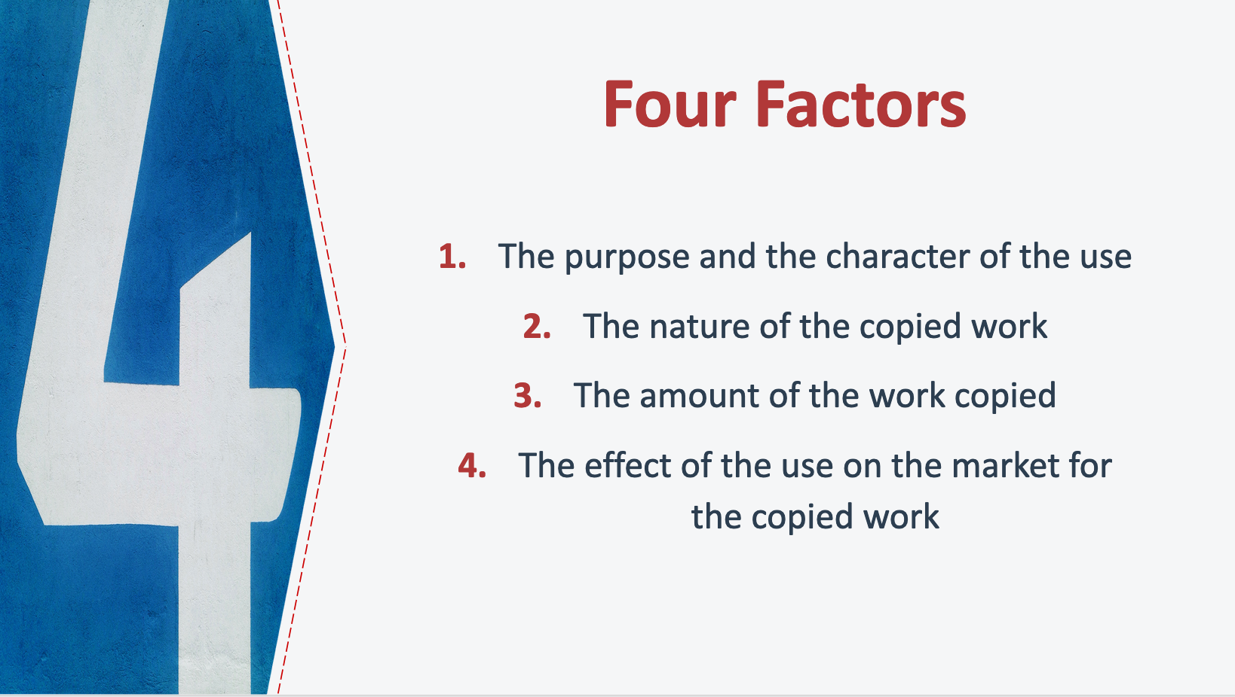
17. Four Factors

____________________________________________________

____________________________________________________

____________________________________________________

____________________________________________________________________________________

____________________________________________________________________________________

____________________________________________________________________________________

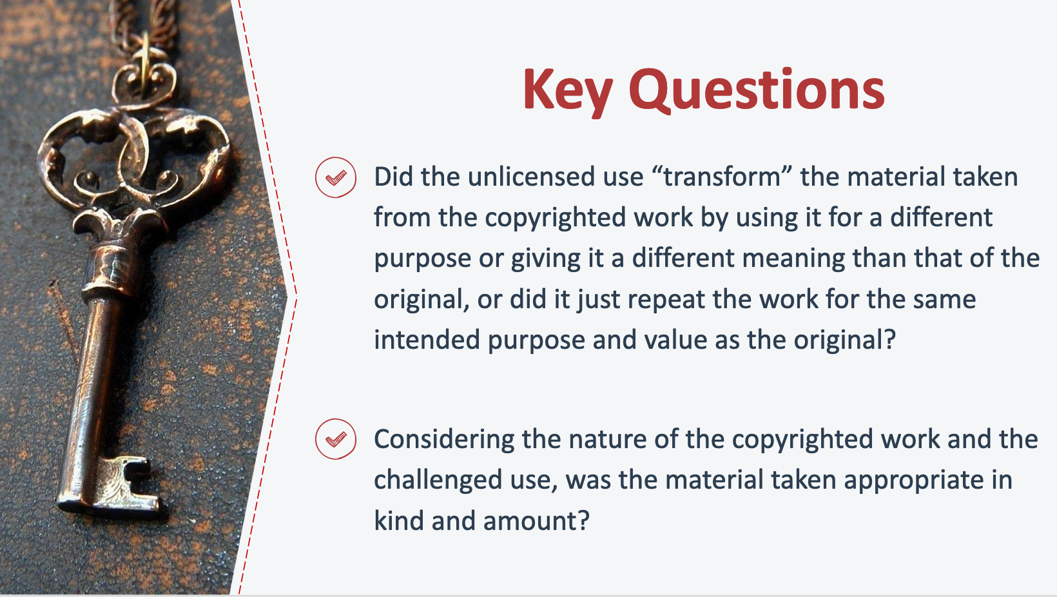
18. Key Questions

____________________________________________________

____________________________________________________

____________________________________________________

____________________________________________________________________________________

____________________________________________________________________________________

____________________________________________________________________________________

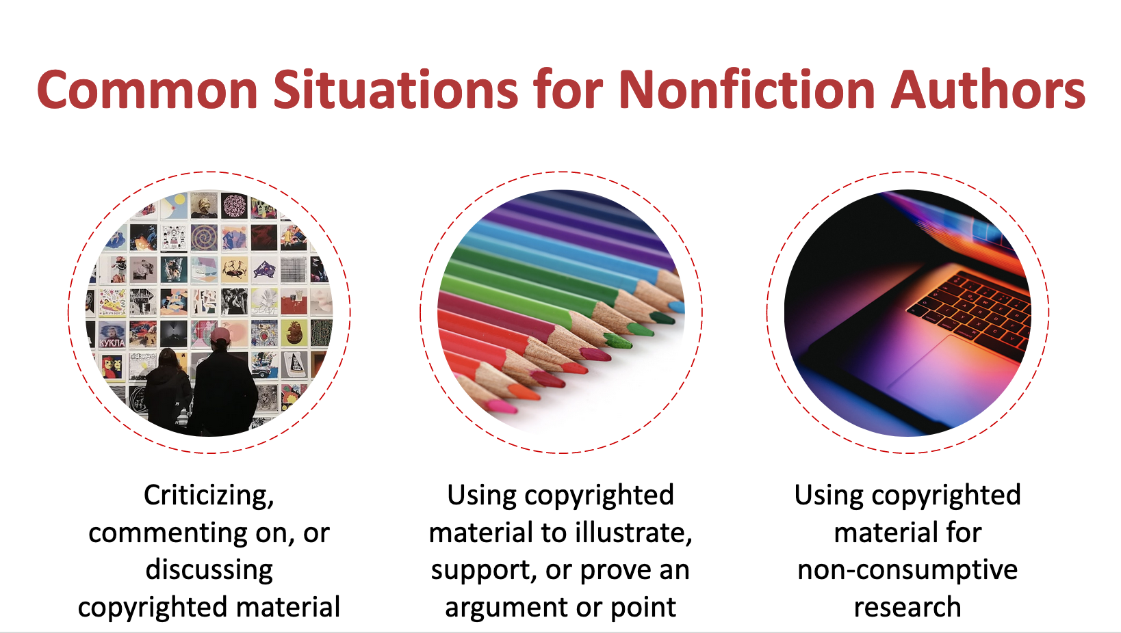
19. Common Situations for Nonfiction Authors

____________________________________________________

____________________________________________________

____________________________________________________

____________________________________________________________________________________

____________________________________________________________________________________

____________________________________________________________________________________

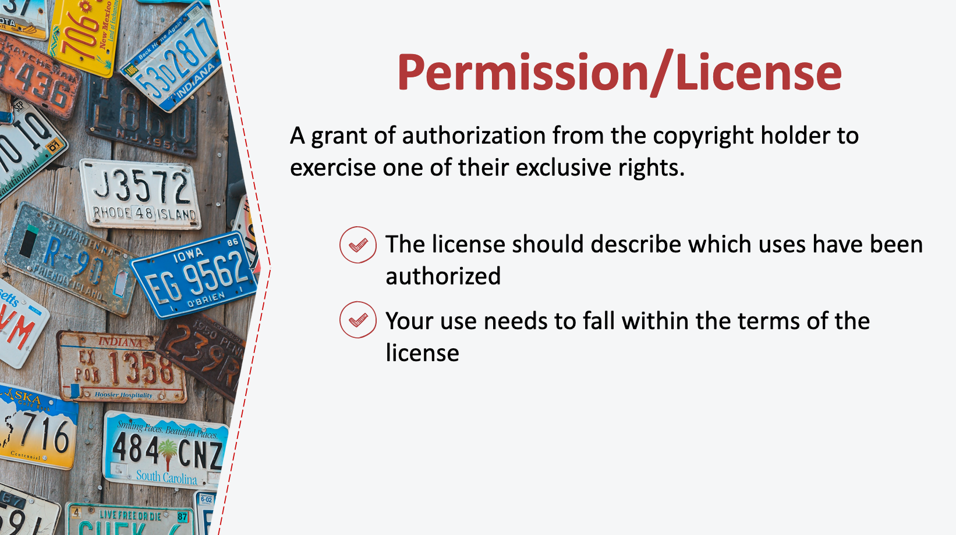
20. Permissions/License

____________________________________________________

____________________________________________________

____________________________________________________

____________________________________________________________________________________

____________________________________________________________________________________

____________________________________________________________________________________

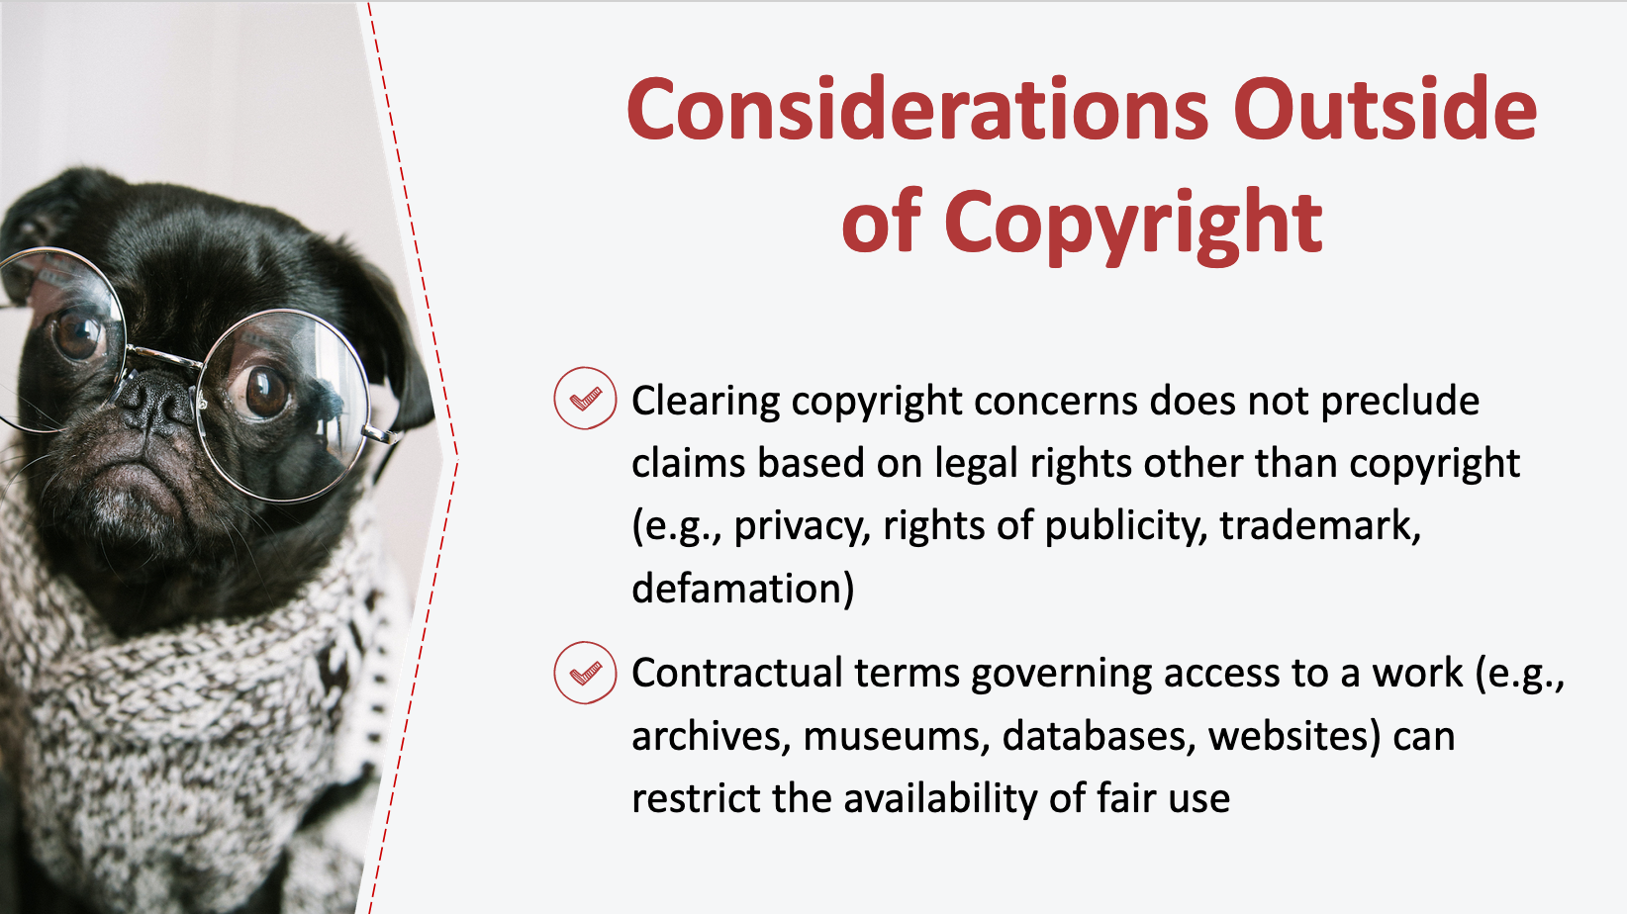
21. Considerations Outside of Copyright

____________________________________________________

____________________________________________________

____________________________________________________

____________________________________________________________________________________

____________________________________________________________________________________

____________________________________________________________________________________

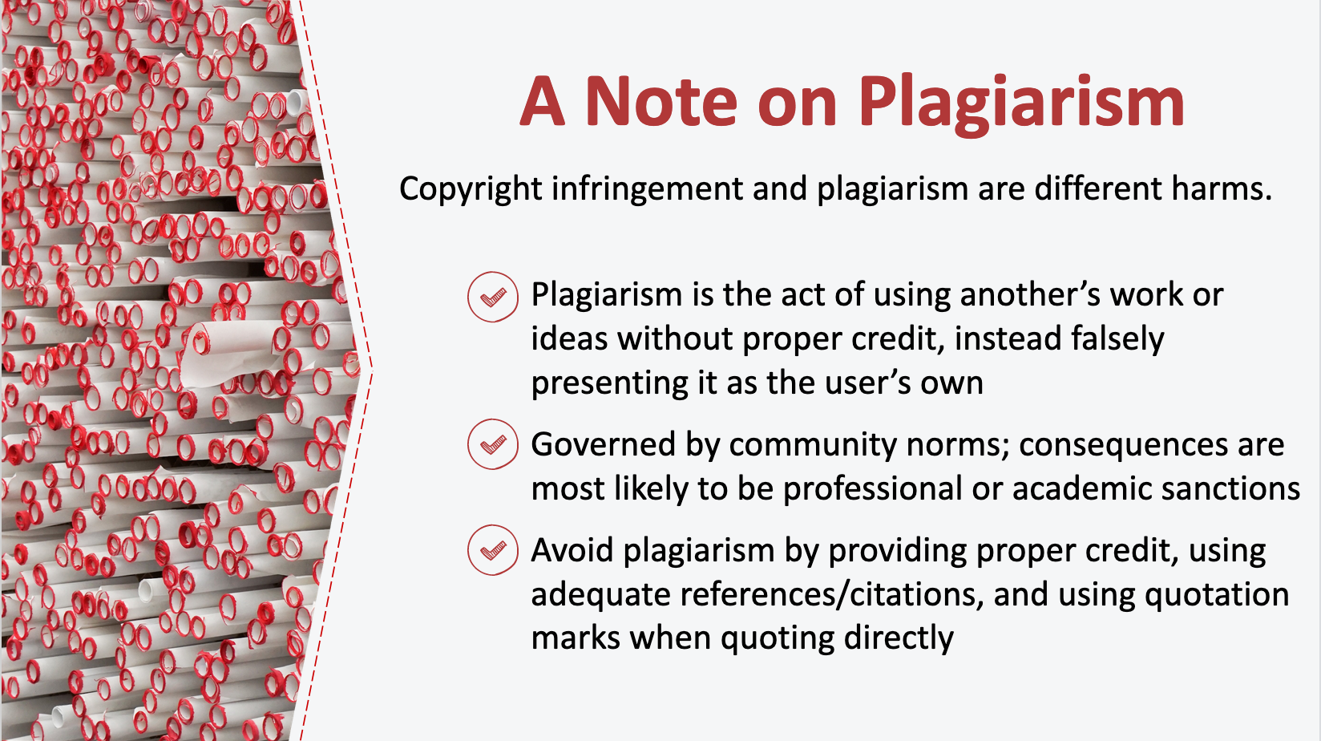
22. A Note on Plagiarism

____________________________________________________

____________________________________________________

____________________________________________________

____________________________________________________________________________________

____________________________________________________________________________________

____________________________________________________________________________________

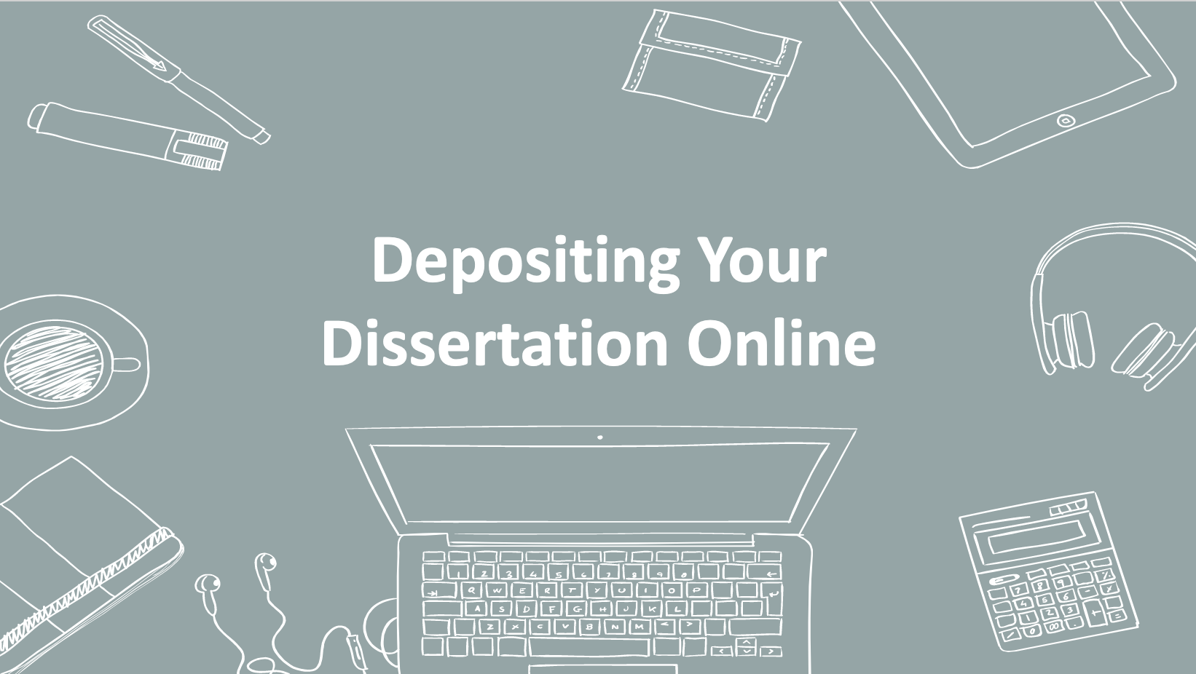
23. Depositing Your Dissertation Online

____________________________________________________

____________________________________________________

____________________________________________________

____________________________________________________________________________________

____________________________________________________________________________________

____________________________________________________________________________________

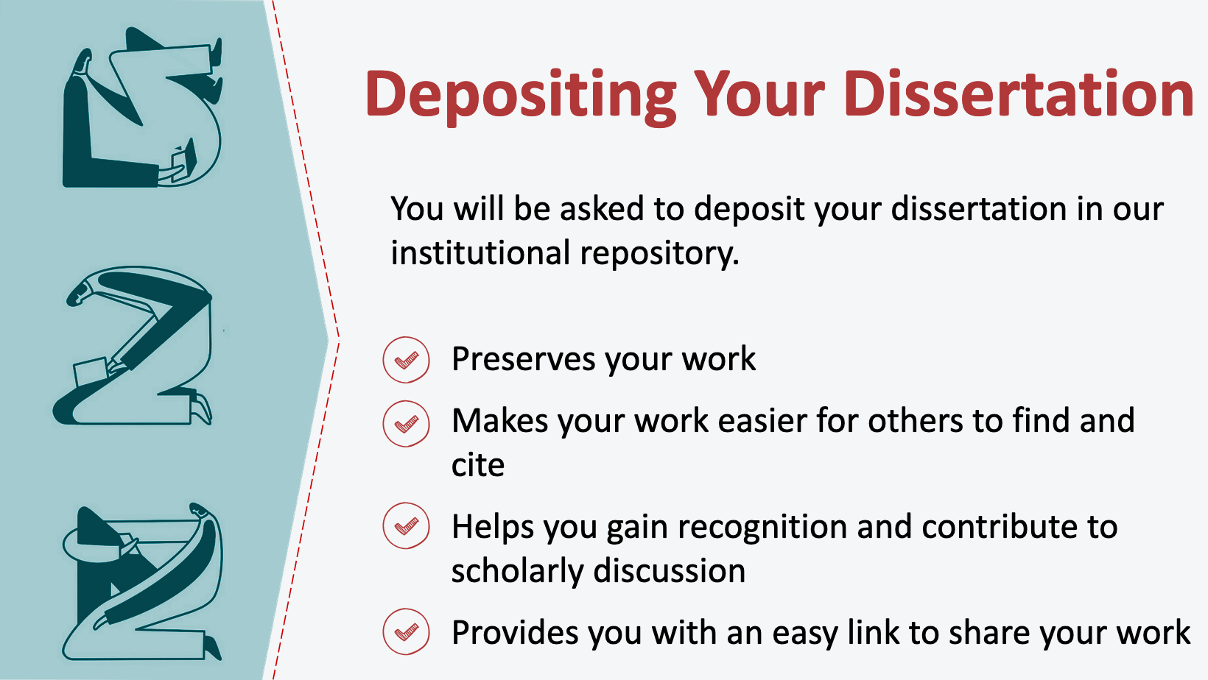
24. Institutional Repository

____________________________________________________

____________________________________________________

____________________________________________________

____________________________________________________________________________________

____________________________________________________________________________________

____________________________________________________________________________________

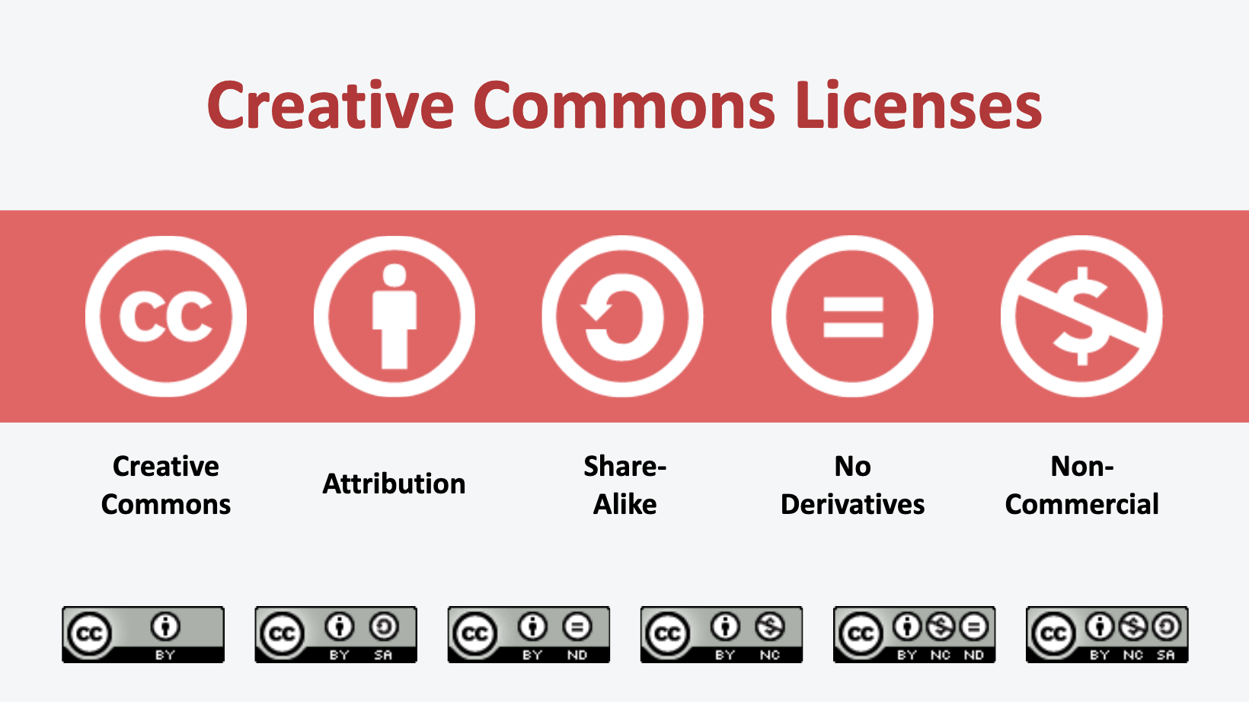
25. Creative Commons Licenses

____________________________________________________

____________________________________________________

____________________________________________________

____________________________________________________________________________________

____________________________________________________________________________________

____________________________________________________________________________________

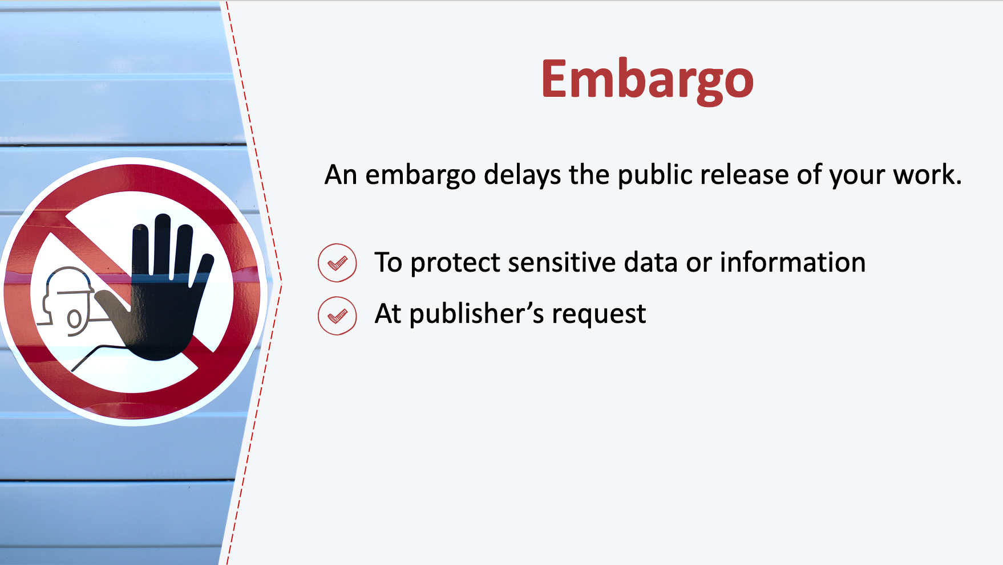
26. Embargo

____________________________________________________

____________________________________________________

____________________________________________________

____________________________________________________________________________________

____________________________________________________________________________________

____________________________________________________________________________________

27. Signing a Publication Contract

____________________________________________________

____________________________________________________

____________________________________________________

____________________________________________________________________________________

____________________________________________________________________________________

____________________________________________________________________________________

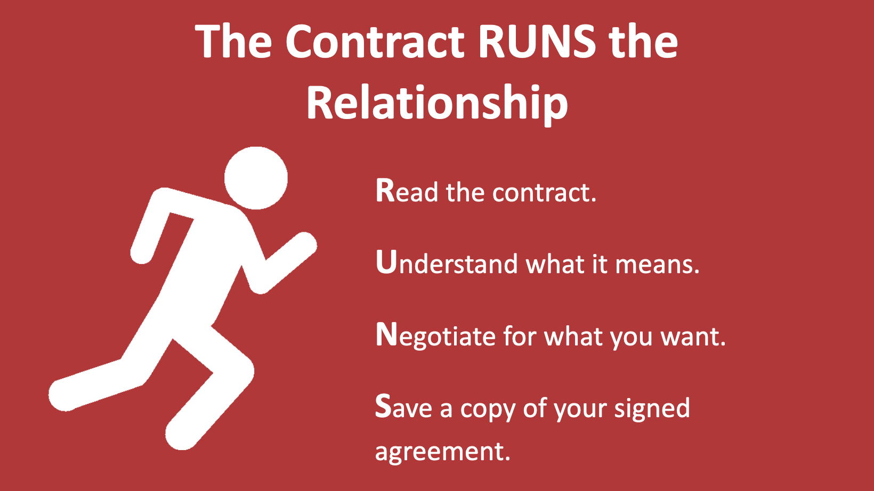
28. The Contract RUNS the Relationship

____________________________________________________

____________________________________________________

____________________________________________________

____________________________________________________________________________________

____________________________________________________________________________________

____________________________________________________________________________________

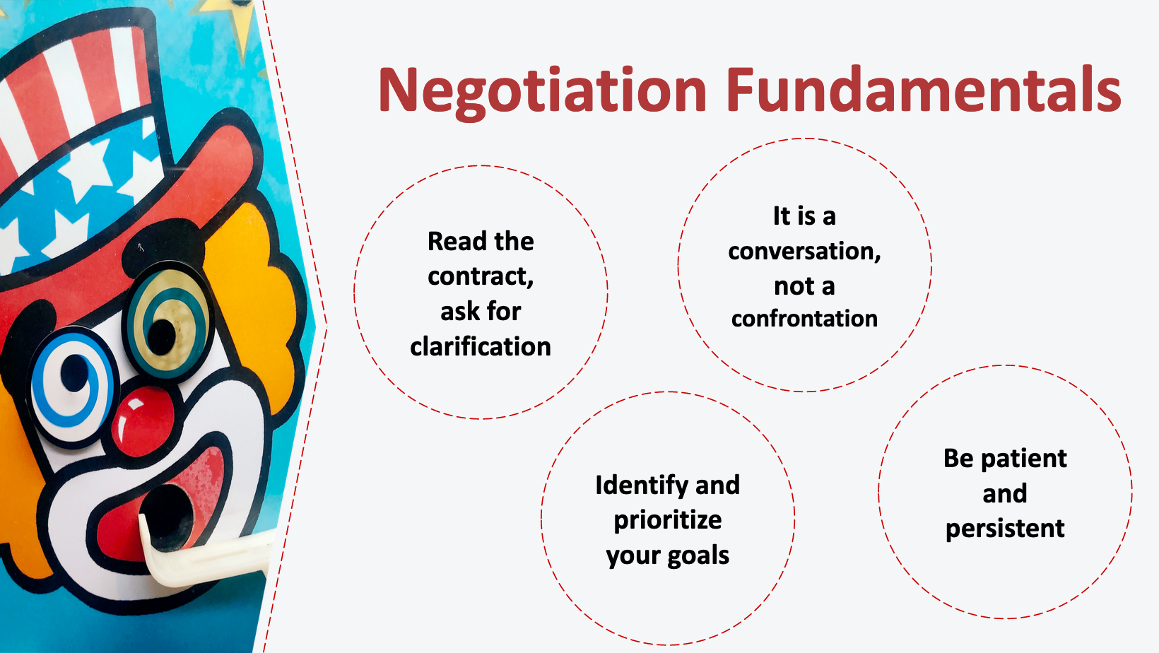
29. Negotiation Fundamentals

____________________________________________________

____________________________________________________

____________________________________________________

____________________________________________________________________________________

____________________________________________________________________________________

____________________________________________________________________________________

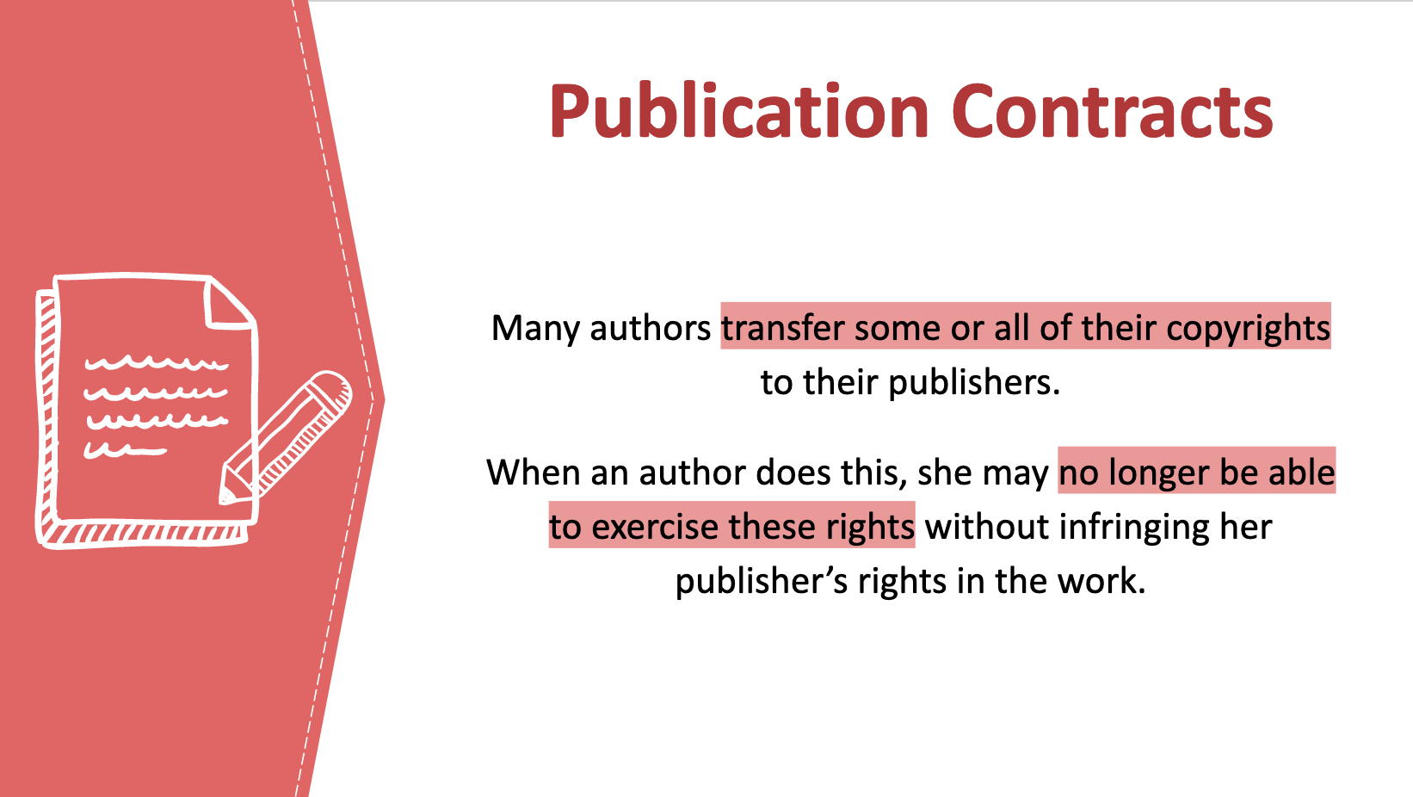
30. Publication Contracts

____________________________________________________

____________________________________________________

____________________________________________________

____________________________________________________________________________________

____________________________________________________________________________________

____________________________________________________________________________________

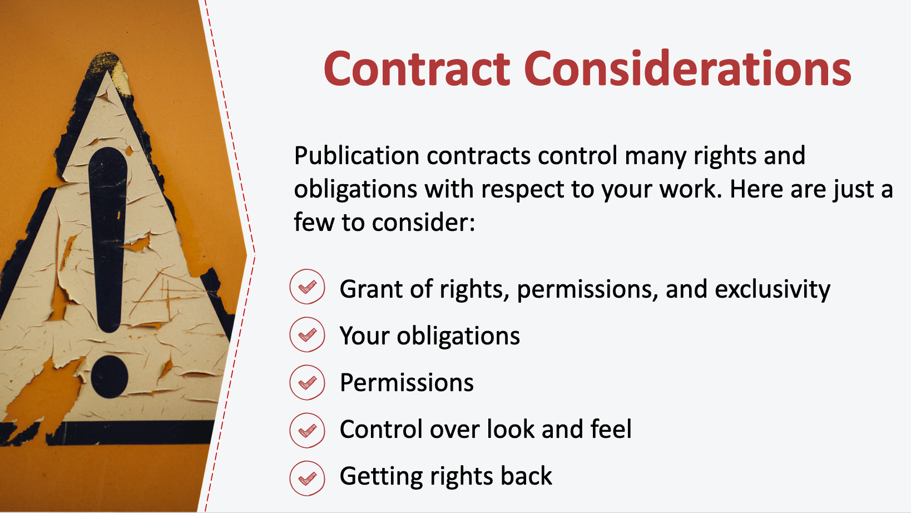
31. Contract Considerations

____________________________________________________

____________________________________________________

____________________________________________________

____________________________________________________________________________________

____________________________________________________________________________________

____________________________________________________________________________________

32. Managing Your Scholarly Identity

____________________________________________________

____________________________________________________

____________________________________________________

____________________________________________________________________________________

____________________________________________________________________________________

____________________________________________________________________________________

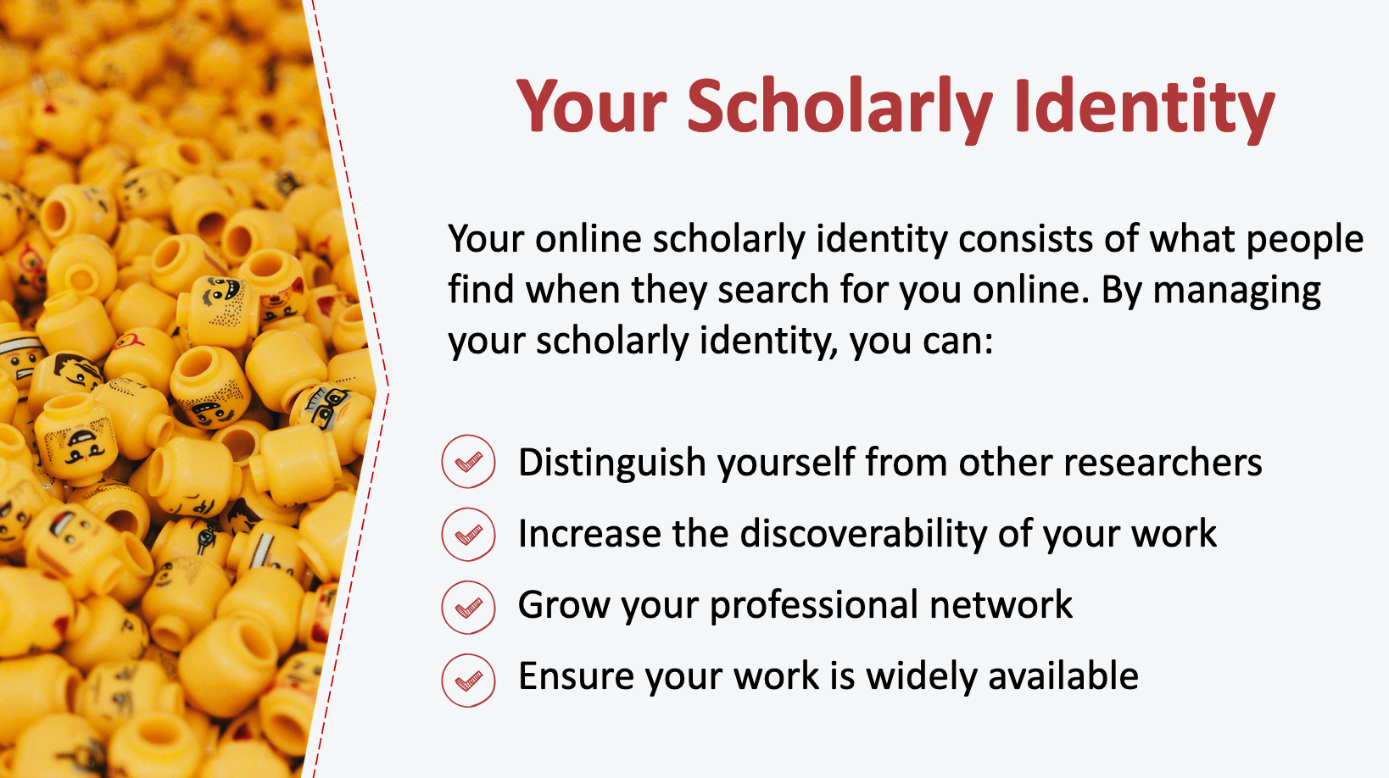
33. Your Scholarly Identity

____________________________________________________

____________________________________________________

____________________________________________________

____________________________________________________________________________________

____________________________________________________________________________________

____________________________________________________________________________________

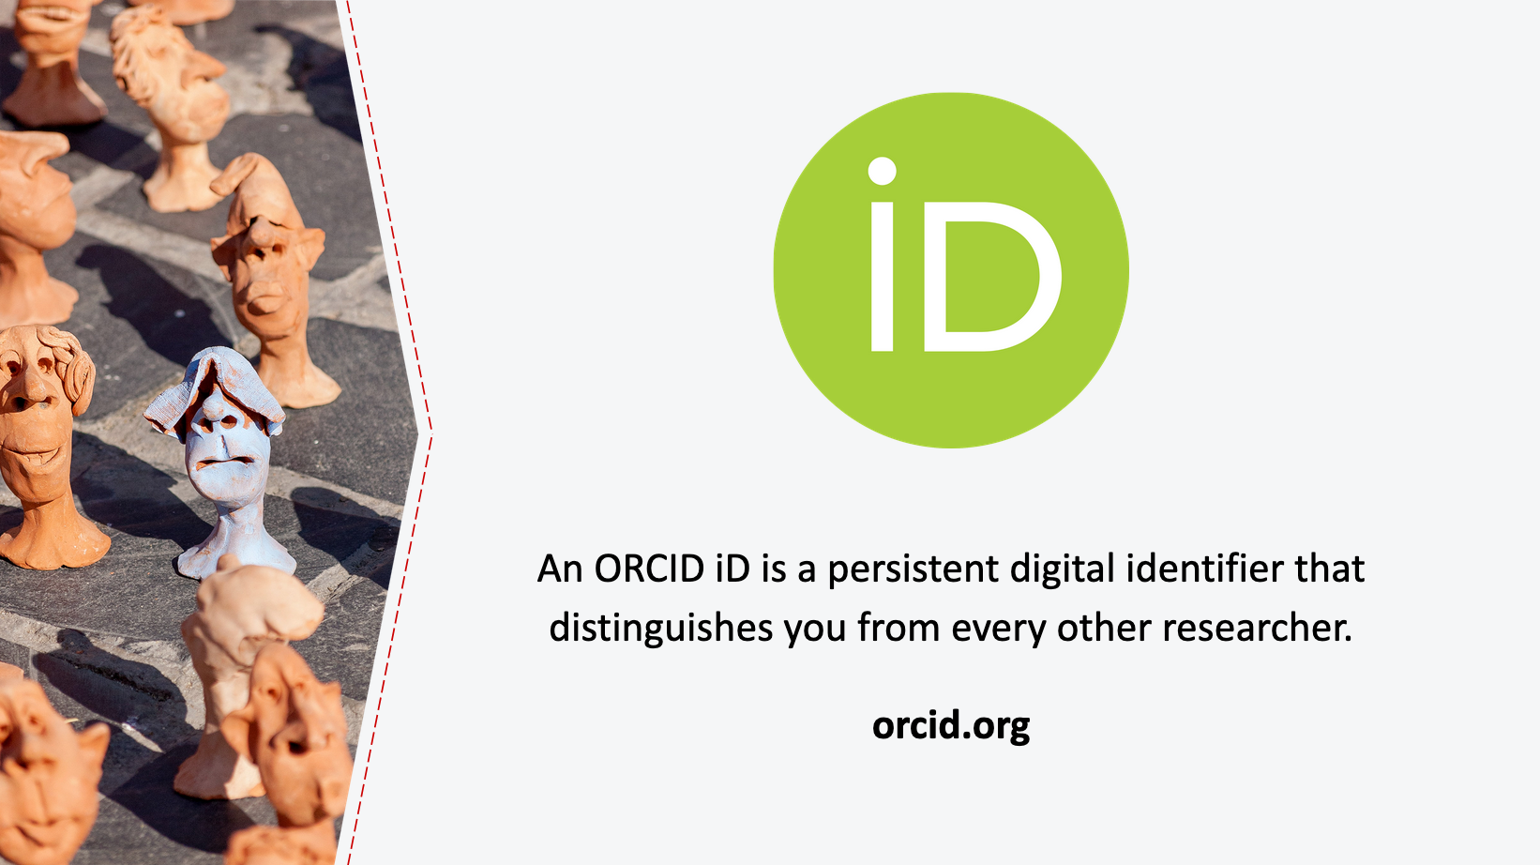
34. ORCID

____________________________________________________

____________________________________________________

____________________________________________________

____________________________________________________________________________________

____________________________________________________________________________________

____________________________________________________________________________________

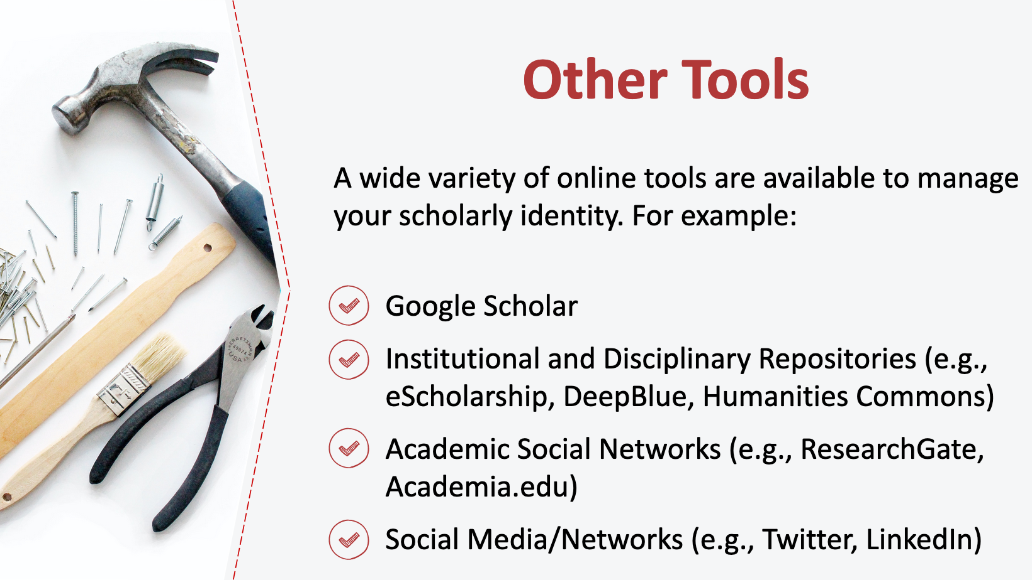
35. Other Tools

____________________________________________________

____________________________________________________

____________________________________________________

____________________________________________________________________________________

____________________________________________________________________________________

____________________________________________________________________________________

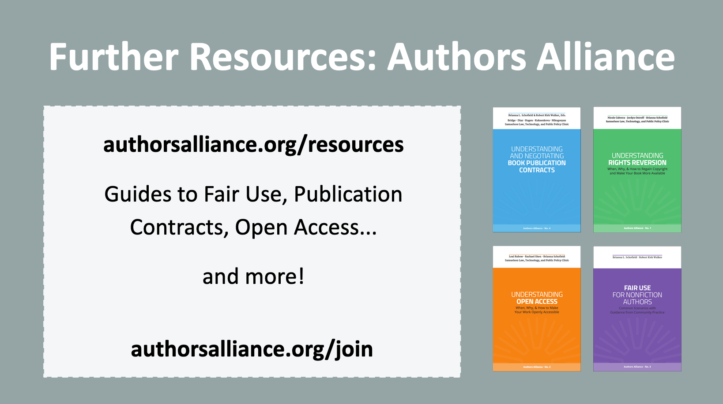
36. Further Resources

____________________________________________________

____________________________________________________

____________________________________________________

____________________________________________________________________________________

____________________________________________________________________________________

____________________________________________________________________________________

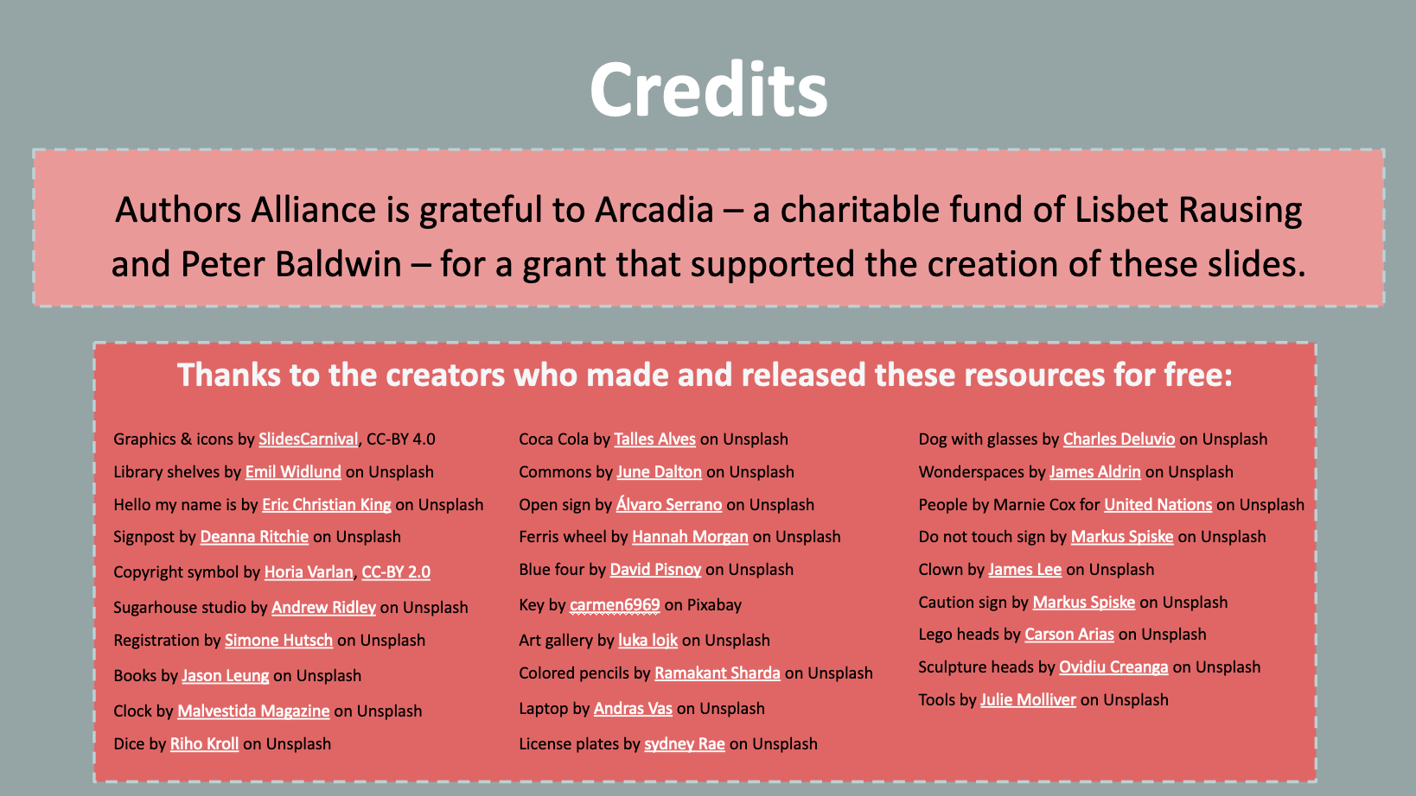
37. Credits

____________________________________________________

____________________________________________________

____________________________________________________

____________________________________________________________________________________

____________________________________________________________________________________

____________________________________________________________________________________

Authors Alliance is grateful to Arcadia—a charitable fund of Lisbet Rausing and Peter Baldwin—for a grant that supported the creation of these materials.

